***DOMAIN MODEL FOR CAPSTONE PROJECT***

***YUENGS AND WINGS***

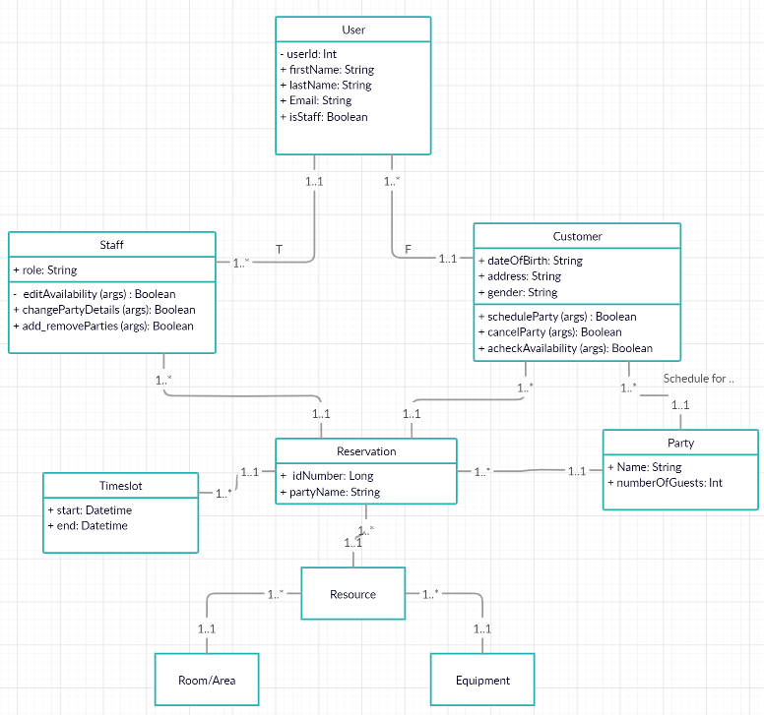***Group and Party Scheduler for Paramount Sports Complex***