Companies/ company analysis
When I click a hyperlinked company name in the companies page, it takes me to that company in the company analysis page (which is great) but the information doesn’t load unless I click to another company in the drop down and then back to the first company

Backtest
For the chart below:
Make the line chart full width of the page and also taller so I can see it?
Can you fit the line chart and table side-by-side easily?

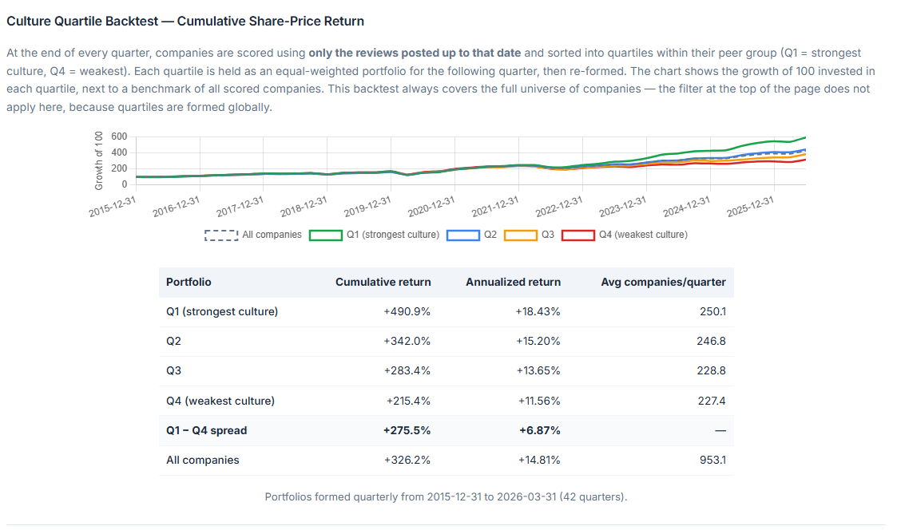

Culture dimensions
In the bar chart on the right, please reverse the colours of blue and purple. Currently, where the company is closer to the “blue axis” on the left, its shaded purple and vice versa – it will be more intuitive to reverse.
