General point
Now that we have defined peer groups, does it make more sense to focus on these peer groups instead of sector/ subindustry/ industry in the top selection drop down? Is this a more robust way to show the analysis given this is how the scores are calculated?

Overview
Please remove the references to the Schroders v2 framework throughout the dashboard. For example here “Culture is scored using the Schroders v2 framework — twelve bipolar dimensions scored…“ in the overview page, please replace with “Culture is scored using twelve bipolar dimensions scored…”
Please also add information to this page which can help explain the logic and approach. For example, the points about (i) needing a certain number of high quality reviews to include in the analysis, the backtesting methodology etc

Companies
The company names in this page are not linked to anything. Either delete the page or make the company names link via hyperlinks to the relevant page on “company analysis” and for that company to be selected by default in other pages (eg quarterly trends, culture dimensions)

Company analysis
This page still shows the Hofstede, MIT, Schroders and Combined score charts. Please just show the Schroders score, but call it “culture score” (as it will be the only one). Remove the other Hofstede and MIT charts from the page
We can show the timeseries chart (not currently populated – it should show the “point in time” culture scores over time for the selected company next to the dimensions chart (called “Culture dimensions” rather than “Schroders dimensions”) side by side.

Culture dimensions
Remove the circled text:
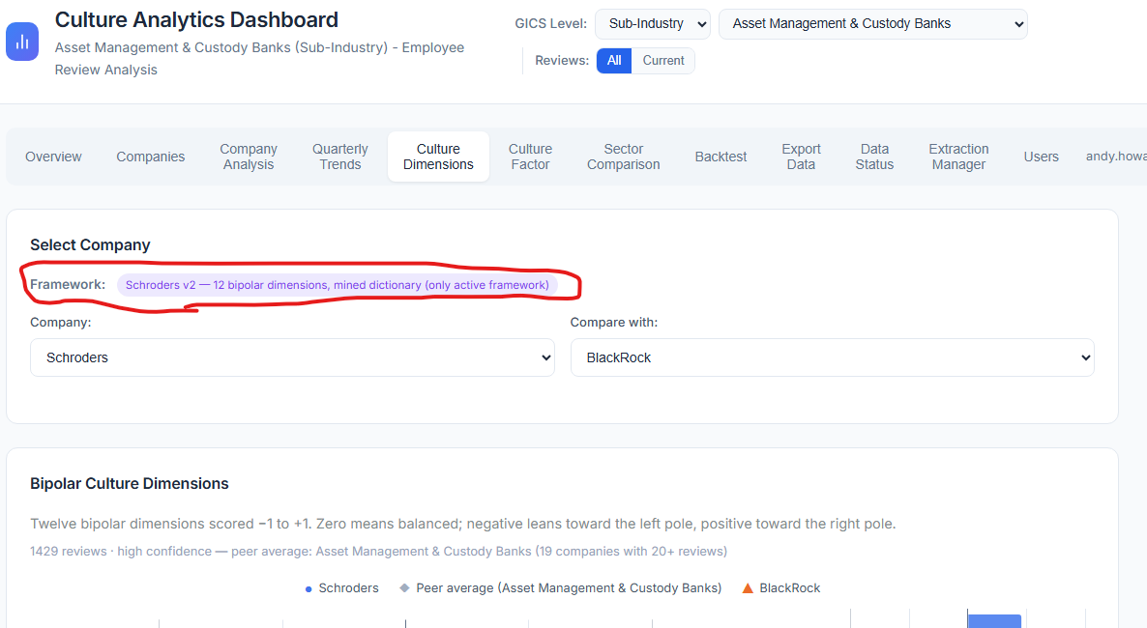

Culture factor
Please remove this chart from the page. I think its effectively replaced by the new backtest chart:
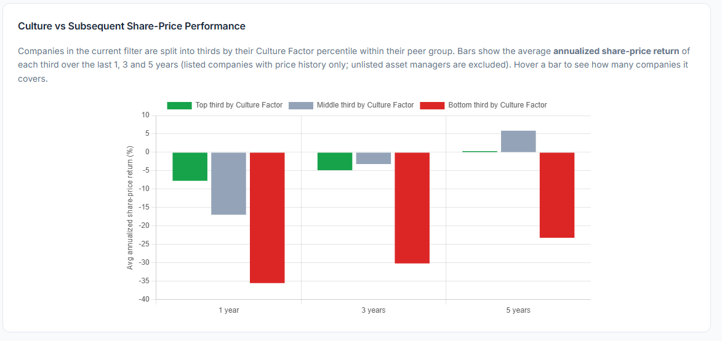

Can you add small “I” icons to the headings in this table and tool tips describing what each measure (column heading represents and means) in this table:
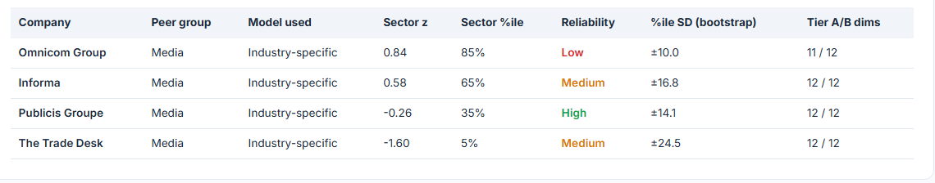

Insofar as the information in this table is company specific, should we move it to the “culture dimensions” page. Can we also add “I” tool tips to the headings in the table as above?
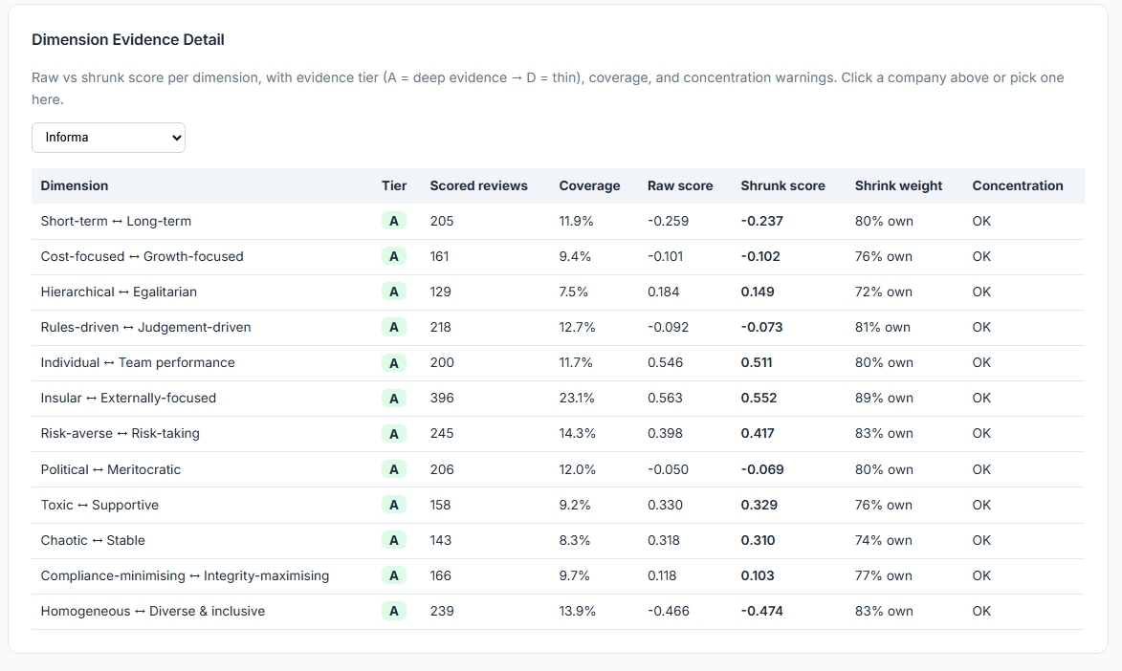

Sector comparison
Can you put the bubble charts at the top of the page. Instead of showing multiple charts, please create 3 drop down menus:
- X axis
- Y axis
- Bubble size
Where there are a range of measures in each drop down and the chart populates based on the selected options (or if the bubble option is left blank all the bubbles are the same size)

Why does the subindustry selected here say “ground transportation” when I have selected advertising in the top menu selection? This should not be a selectable drop down but instead be a fixed term that shows what ever sector/ industry/ subindustry has been selected in the top menu:
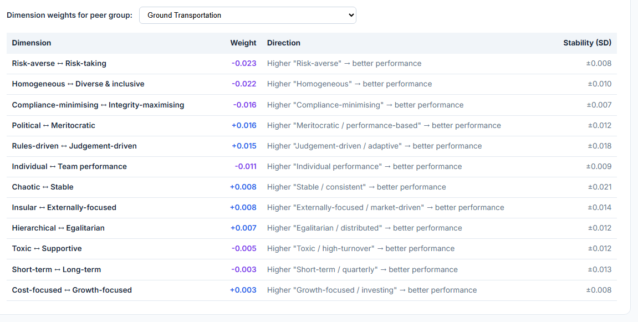

The table showing all of the peer groups should be under the scatter/ bubble chart

Backtest
Why doesn’t the chart populate given you said there are 475+ companies with full data to calculate this:
