Multi-Tenant Notification & Campaign Platform
Part 5 — System Design

Candidate: Boon Kien Peng (JP)
Track: Frontend Engineer (Part 0 + Part 1 + Part 2 + Part 5)
Date: 12 November 2026
Contents
1. Scope and assumptions
2. Architecture
3. Scaling
4. Reliability
5. Data strategy
6. Observability
7. Security

1. Scope and assumptions
This document answers the Part 5 brief: how the platform supports 10 million notifications per day with many tenants sending at the same time, how it behaves when things fail, and how data, observability and security are handled. Two of its clients are built in this submission: the Operations Dashboard (Part 1, ReactJS) and the Monitoring App (Part 2, React Native). The technology choices deliberately stay within the stack I work with day to day: Node.js / Express with TypeScript, PostgreSQL (Supabase), ReactJS and React Native. The design shows how far that stack can be taken before anything more specialised is needed.

Working assumptions
Assumption | Value used | Why it matters
Daily volume | 10M notifications/day | Baseline sizing
Average rate | ≈ 116 msg/s (10M ÷ 86,400) | Steady-state capacity
Peak factor | 10× → ≈ 1,200 msg/s | Campaigns cluster around business hours
Channel mix | SMS 40% · Email 40% · Push 20% | Sizes provider capacity per channel
Provider limit (brief) | 100 requests/min per channel per provider account | The real bottleneck (Section 3.2)
Provider behaviour (brief) | 15–25% failures, 50–200 ms latency | Drives retries and timeouts
Average attempts per message | ≈ 1.25 | Retry load and storage sizing
Tenants | Hundreds; a few very large (2M+ recipient campaigns) | Fairness and isolation

2. Architecture
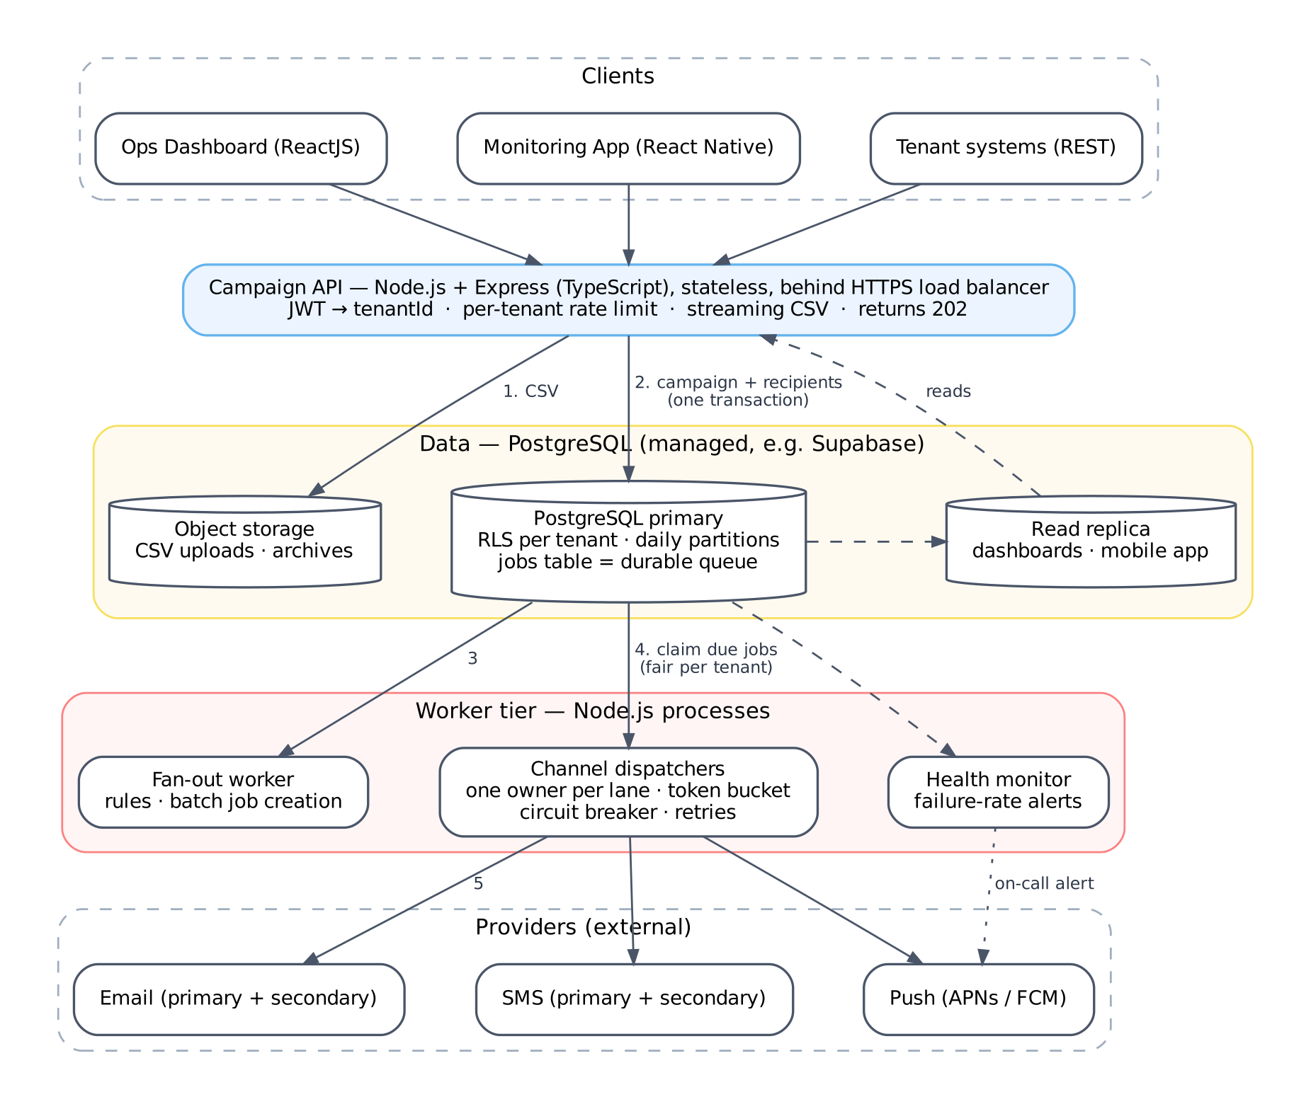
Figure 1 — Platform architecture. Numbers follow a campaign from upload to delivery.

Components
Component | Technology | Responsibility | Scales by
Campaign API | Node.js + Express (TypeScript) | Auth, tenant resolution, per-tenant rate limits, streaming CSV ingestion, 202 Accepted | More stateless instances behind the load balancer
PostgreSQL | Managed Postgres (e.g. Supabase) | System of record and durable job queue; RLS tenant isolation | Partitioning → read replicas → per-tenant databases (Section 5)
Object storage | Supabase Storage / S3-compatible | Raw CSV uploads, archived partitions | Managed
Fan-out worker | Node.js process | Applies business rules, creates one job per recipient in batches | More processes; each claims different campaigns
Channel dispatchers | Node.js processes | Send through providers within rate limits; retries; circuit breaking | One process per provider lane (Section 3.2)
Health monitor | Node.js process | Computes failure rates; sends on-call push alerts to the mobile app | Single active instance (leader lock)
Read replica | Postgres replica | Reads for the Operations Dashboard (Part 1) and Monitoring App (Part 2), kept off the primary | Add replicas

Request flow
Step | Stage | What happens
1 | Upload | Client calls POST /campaigns. The API verifies the JWT, takes tenantId from the token, streams the CSV to object storage and parses it row by row (never fully in memory).
2 | Persist | Campaign and recipients are written in batches inside one transaction. The API returns 202 Accepted with the campaign ID; nothing is sent during the request.
3 | Fan out | The fan-out worker claims the new campaign, runs the rules (opt-out → SKIPPED, quiet hours → DELAYED, credit → REJECTED, duplicate → DISCARDED) and inserts one PENDING job per recipient in batches of 1,000.
4 | Claim | Each dispatcher claims due jobs for its lane with SELECT … FOR UPDATE SKIP LOCKED, choosing tenants fairly (Section 3.3).
5 | Send | The dispatcher takes a rate-limit token, calls the provider behind a circuit breaker, and records the attempt and new status. Failures get a next_attempt_at with backoff.

Why PostgreSQL as the queue: jobs are created in the same database transaction as the campaign, so there is no window where a campaign exists but its jobs were lost, and no second system (broker plus outbox) to keep consistent. SKIP LOCKED lets many workers claim jobs concurrently without blocking each other. At ~1,200 msg/s peak, claiming in batches of 100 is about 12 claim queries per second, well within a single Postgres primary. Section 3.1 notes when this would need revisiting.

3. Scaling

3.1 Capacity at 10M notifications/day
Dimension | Average | Peak (10×) | Approach
Messages dispatched | 116/s | ≈ 1,200/s | Throughput is set by provider lanes, not by worker count (3.2)
Job claims | ≈ 1.2 queries/s | ≈ 12 queries/s | Batches of 100 with SKIP LOCKED
DB writes (job insert, status, attempt) | ≈ 350 rows/s | ≈ 3,600 rows/s | Multi-row inserts and batched status updates; connection pooling
Hot storage growth | ≈ 9 GB/day incl. indexes | — | Daily partitions, 30-day hot window (Section 5)
API instances | 2 | 4–6 | Stateless; CSV parsing is streamed so memory per request stays constant

When to revisit: if sustained throughput grows past what one Postgres primary handles comfortably (several thousand job writes per second), large tenants move to their own database (Section 5.2), and only then would a dedicated message broker be considered.

3.2 The real bottleneck: provider rate limits
Servers are not the constraint; the provider limit is. At 100 requests/min, one provider account sends 144,000 messages/day per channel. A 2M-recipient SMS campaign through one account would take about 14 days (2,000,000 ÷ 100 per minute = 20,000 minutes). The design therefore treats provider capacity as lanes:
Technique | Detail
Lane | One lane = one (provider account, channel) pair with its own limit of 100 requests/min.
Lanes needed | Lanes = target throughput ÷ per-lane limit. At the brief's limit, about 70 lanes cover 10M/day spread evenly. Real provider contracts usually allow far more per account, so the same formula gives much smaller numbers.
One owner per lane | Each lane is owned by exactly one dispatcher process, which holds a Postgres advisory lock for it. Because only one process sends on a lane, an in-memory token bucket (100 tokens/min, small burst) enforces the limit exactly, with no shared cache.
Failover | If the owning process dies, its database session ends, the lock is released, and another dispatcher takes over the lane within seconds.
Adaptive limit | A provider 429 or Retry-After temporarily lowers that lane's refill rate, so we stay under the provider's real limit even if it differs from the contract.
Pricing link | Tenant packages and quotas are tied to the lane capacity they consume.

3.3 Many tenants sending at the same time
Without fairness, one 2M-recipient campaign would fill the queue and every other tenant would wait behind it.
Mechanism | Detail
Weighted round-robin | When a dispatcher claims work, it picks the next tenant with due jobs for its channel in weighted rotation (e.g. Enterprise 4, Business 2, Starter 1) and claims a small batch from that tenant only.
Maximum share | While other tenants are waiting, no tenant gets more than about 40% of a channel's lanes. If the platform is idle, one tenant can use everything.
Priority for transactional | Messages flagged transactional (e.g. OTP) are claimed first, with about 15% of lane capacity reserved, so a marketing blast never delays an OTP.
Quotas | The credit check rejects campaigns beyond the tenant's monthly package before any jobs are created.

3.4 Back-pressure
Each stage only takes on work it can finish. Overload shows up as a growing backlog of PENDING rows in Postgres, which is durable, rather than as memory pressure or dropped messages.
Stage | Mechanism
API | Per-tenant request rate limit; 429 with Retry-After; maximum CSV size and row count per upload.
CSV ingestion | Streaming parser with a bounded buffer; rows inserted in batches of 1,000; memory use stays constant whatever the file size.
Fan-out | Creates jobs in batches and pauses when database write latency rises above a threshold.
Dispatchers | Claim only as many jobs as they hold tokens for; no in-memory queue that could grow without limit.
Scaling workers | Add dispatcher processes only up to the number of lanes; more processes than lanes adds nothing.

4. Reliability

4.1 When providers are down
Mechanism | Behaviour
Timeouts | 2 s connect / 5 s read. With 50–200 ms normal latency, a slow provider is detected quickly.
Circuit breaker per lane | Opens when more than 50% of calls fail over a 30-second window (minimum 20 calls). While open, no calls are made and jobs are rescheduled without using up a retry attempt. Every 30 s a few test requests check whether the provider has recovered.
Failover | When the primary provider's breakers are open, traffic moves to the secondary provider for that channel, gradually so we don't immediately hit the secondary's limit.
Both providers down | Jobs stay PENDING; the campaign shows as DEGRADED, not FAILED; on-call staff get an alert on the mobile app. Sending resumes automatically when a breaker closes. Nothing is lost because jobs live in Postgres.

4.2 Retry storms
A provider coming back from an outage is most at risk from our own retries. Retries are limited at several levels:
Control | Setting | Purpose
Exponential backoff with jitter | Random delay up to min(30 min, 30 s × 2^attempt) | Spreads retries out so they don't arrive in waves
Maximum attempts | 5, then status DEAD | Limits the cost of a recipient that will never succeed
Permanent errors | 4xx (e.g. invalid number) → DEAD immediately | Doesn't waste rate-limit tokens on hopeless retries
Retry budget | Retries use at most 20% of a lane's tokens | When failures spike, retries are slowed down, not multiplied
Breaker-aware | No retries while a lane's breaker is open | No retrying into a known outage
Manual retry | POST /campaigns/{id}/retry-failures resets DEAD jobs to PENDING | Goes through the same lanes and limits, so operators can't bypass them

4.3 Partial outages
Failure | Behaviour | Messages lost?
Dispatcher process crash | Claimed jobs have a 30-second lease; when it expires they return to PENDING and are picked up again. The lane lock is released and another process takes the lane. | No
API instance down | Load balancer stops routing to it; requests go to the other instances. | No
Postgres primary failover | Managed failover to standby (about 30 s). API write calls return 503 briefly; clients retry with an Idempotency-Key. Workers pause and continue from the durable job table. | No
Read replica lag | Dashboards and the mobile app show slightly older numbers; the app shows when data was last updated. | No
Object storage unavailable | Uploads fail fast with a clear error. The campaign is only created once the CSV is stored, so there are no half-created campaigns. | No
Health monitor down | Sending continues; alerts are delayed until a standby takes the leader lock. | No
Region outage | Restore from point-in-time backups in another region; recovery point of minutes, recovery time under an hour. | Minutes of status updates

4.4 No duplicate sends
Layer | Mechanism
Job creation | Unique constraint on (tenant_id, campaign_id, recipient_id, channel). Re-processing a campaign cannot create a second job for the same recipient.
API | Idempotency-Key header on POST /campaigns, kept 24 h; a client retry gets the original response.
Claiming | FOR UPDATE SKIP LOCKED plus a lease, so only one worker can hold a job.
Provider | An idempotency key derived from the job is passed to providers that support one.
Same content | Exact same message to the same recipient within 5 minutes is DISCARDED (checked against recent jobs by content hash).

Note: a guarantee of exactly one delivery through an external provider isn't possible in every case. If a worker crashes after the provider accepted a message but before we saved the result, the job can be retried. Provider idempotency keys close most of this gap; otherwise the system prefers delivering twice in rare cases over silently dropping a message.

5. Data strategy

5.1 Tables and partitioning
Every table has tenant_id, and every index used by tenant queries starts with it.
Table | Volume | Partitioning | Key indexes / constraints
tenants, campaigns | Small | None | campaigns(tenant_id, status, created_at)
recipients | Millions per campaign | By month | (tenant_id, campaign_id)
notification_jobs | 10M+/day | By day (created_at) | Unique (tenant_id, campaign_id, recipient_id, channel); partial index on due PENDING jobs by channel and next_attempt_at
delivery_attempts | ≈ 12.5M/day | By day | (job_id); (tenant_id, created_at)
campaign_stats | One row per campaign and channel | None | Sent/failed/pending counters updated in batches; dashboards never count millions of job rows
suppression_list | Grows slowly | None | Primary key (tenant_id, recipient_id, channel)

5.2 Scaling the database in stages
Each stage is added when a metric shows it is needed, not up front.
Stage | When | Change
1. Primary + read replica | From launch | Connection pooling; dashboards and the mobile app read from the replica; batched writes
2. Daily partitions | From launch | Old data is removed by dropping a whole partition (instant) instead of large DELETEs; the hot data stays small
3. Bigger primary | Primary CPU above ~60% sustained | Scale the managed instance vertically; simplest step with no code change
4. Dedicated databases for large tenants | A few tenants dominate writes | Move the largest tenants to their own Postgres database. Because every query already filters by tenant_id, the API only needs to route each tenant to the right database.

5.3 Retention
Data | Kept in Postgres | Archive | Notes
Jobs and attempts | 30 days | Compressed files in object storage, 13 months | Stored by tenant and date; restored on request for audits or billing disputes
Recipient contact data | Campaign end + 30 days | Not archived as-is | The archive keeps a hashed recipient ID, not the phone number or email
Message content | 30 days | Template ID only | Avoids keeping personal data in rendered messages
Logs | 14 days searchable | 90 days | Personal data masked before it is logged
Metrics | 15 days in detail | 13 months summarised | For capacity planning

Retention periods are configurable per tenant to match contracts and regulations. A request to delete a person's data removes their rows from Postgres; the archive only holds a hashed ID.

6. Observability

6.1 Metrics
Metric | How it is measured | Broken down by | Alert when
Throughput | Messages sent per minute | Channel, provider | Drops more than 50% while there is a backlog
Failure rate | Failed ÷ (sent + failed), excluding SKIPPED and DELAYED | Channel, provider, campaign | Above 20% for 5 minutes (same rule as the mobile app's red status)
Retry rate | Retries ÷ all attempts | Channel | Above 20% for 10 minutes
Queue backlog | Count of due PENDING jobs; age of the oldest one | Channel, tenant | Oldest due job older than 30 minutes
Processing latency | Time from job created to sent (p50 / p95 / p99); provider response time | Channel, priority | Transactional p95 above 10 s
Rate-limit pressure | Time spent waiting for a token | Lane | Lanes constantly saturated (more lanes needed)
Provider health | Circuit breaker state | Lane | Any breaker open for more than 2 minutes

Per-campaign numbers come from the campaign_stats table, which is what the dashboard and mobile app show. Platform metrics only use a few labels (channel, provider, lane), so the metrics system stays manageable as tenants grow.

6.2 Logs, tracing and alerting
Area | Approach
Structured logs | JSON logs with tenantId, campaignId, notificationId, retryCount, status and correlationId on every line.
Personal data | Masked before logging: phone +6012**678, email j*@example.com. Message bodies are never logged, only the template ID.
Tracing | The API creates a correlationId (or accepts the client's), returns it in a response header and stores it on the campaign and jobs, so one ID connects the upload, every job and every provider call.
Alerting | The health monitor sends alerts as push notifications to the on-call staff's Monitoring App (Part 2), so staff are alerted even when the app is closed.
Dashboards | Platform overview (throughput, failure rate, backlog), provider health per lane, and lane share per tenant to check fairness.

7. Security

7.1 Tenant isolation
Layer | Control
Identity | tenantId comes only from the verified JWT (stored in the user's app_metadata), never from the request body or URL.
Database | Postgres Row Level Security on every table: policies compare tenant_id with the tenant in the JWT. A bug that forgets a WHERE clause returns nothing rather than another tenant's data.
Service access | Workers use a server-only service key that is never shipped to clients. Database functions that need elevated rights are SECURITY DEFINER with a fixed search_path and check the tenant explicitly.
Storage | Uploads are stored under a tenant_id/ path with storage policies restricting each tenant to its own folder.
Noisy neighbours | Per-tenant API rate limits, quotas and fair scheduling, so one tenant cannot slow down others.
Encryption | HTTPS everywhere; data encrypted at rest by the managed database and storage.

7.2 API protection
Area | Control
Authentication | JWT login for the dashboard and mobile app; API keys for tenant systems, stored hashed and limited to what they need (e.g. send-only).
Edge | HTTPS only, security headers, per-tenant and per-IP rate limits, request size and CSV row limits.
Input validation | CSV checked against the expected columns; phone numbers and emails validated; templates rendered without running any code.
Secrets | Kept in the hosting platform's secret store, never in the repository or the mobile app.
Audit | Campaign creation, retries and suppression-list changes are recorded in an append-only audit table.
Compliance rules | Opt-out checks fail closed (if the list can't be checked, don't send); quiet hours use the recipient's time zone; personal data is masked in logs.

