Mandatory Project: Software Architecture of
the TM12 System
Mogens Habekost, Susie Agerholm Balle
Department of Computer Science, University of Aarhus
Aabogade 34, 8200 Aarhus N, Denmark
Gruppe: Spinebreaker
Student ID: 20070605, 19972253
Email: moh@solar.dk, susie.agerholm@gmail.com
H1. Architectural Description
18.09.2012

Abstract
The TM12 system implements an information system for supporting
tele medicine, i.e. patients making measurements in their homes for review
by general practitioners as well as hospital clinicians. This report gives a
software architecture description of an architectural prototype of the TM12
system. The techniques used for architectural description are taken from
[Christensen et al., 2012].

1. Introduction

Figure 1 shows a schematic overview of TM12:

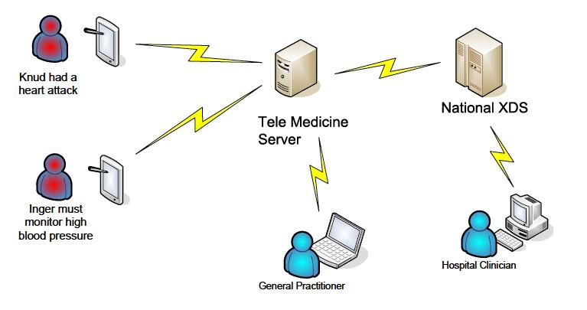
Figure 1: Rich picture of the TM12 architecture

TM12 is based on a device/tablet in the home that can make measurements of blood pressure and upload these to a TM12 web server. Such a measurement is denoted a tele observation or just observation. The software architect has made a decision to make the size of the message sent from home client to TM12 server small. The TM12 converts the observation into a standard format for clinical infor-mation, HL7 v.31, and stores it in an XDS2 storage system. A general practitioner can review observations for a patient using a webbrowser interface implemented on the TM12 server.

2. Architectural Requirements
For our purposes there is two main use case for the TM12 system:
- Tele observation upload: The patient makes a measurement in his/her
home and uploads it to the TM12 server.
- Tele observation review: The general practitioner reviews all tele-observations for at given patient in a given time interval using a webbrowser.

The major driving qualities attributes of the TM12 system are:
- Performance. TM12 should be performant so that a large number of patients may be part of the system.
- Modifiability. It must be possible to modify TM12 to include new types of
clinical measurements.
- Testability. TM12 is medical equipment, and there for the margin for error is smaller.

3. Architectural Description

3.1 Module Viewpoint

Overview – dependency between packages:

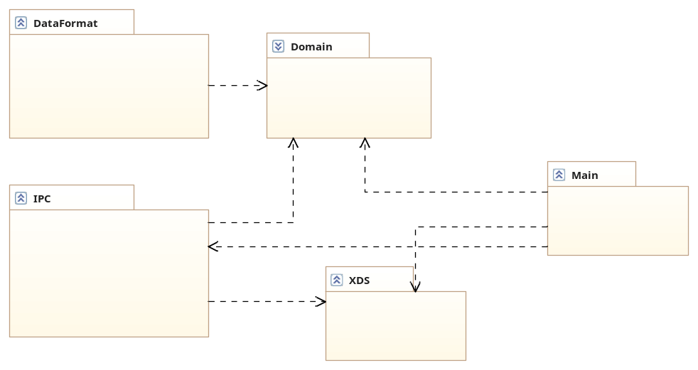

Pacakages:

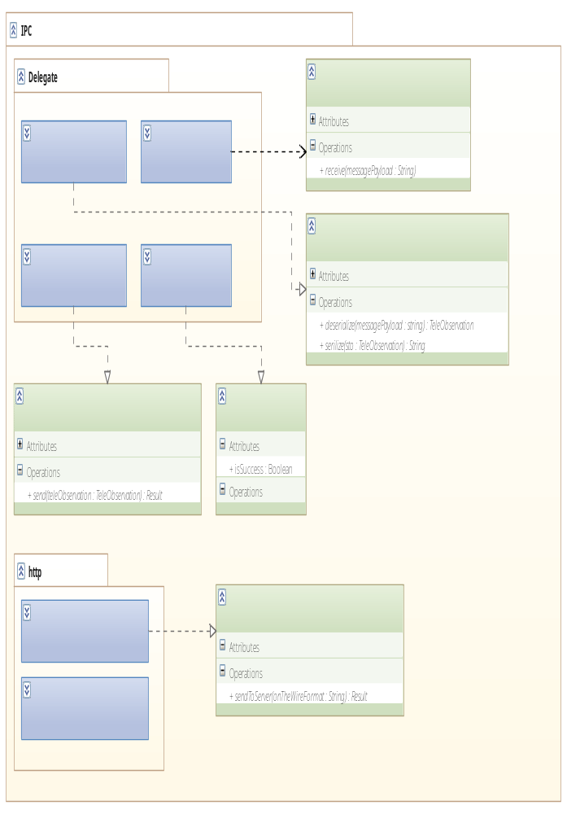

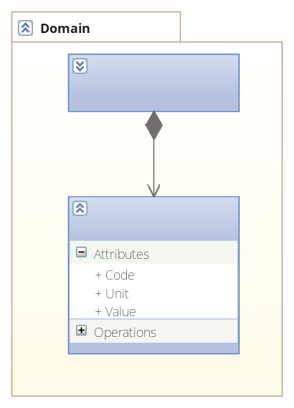

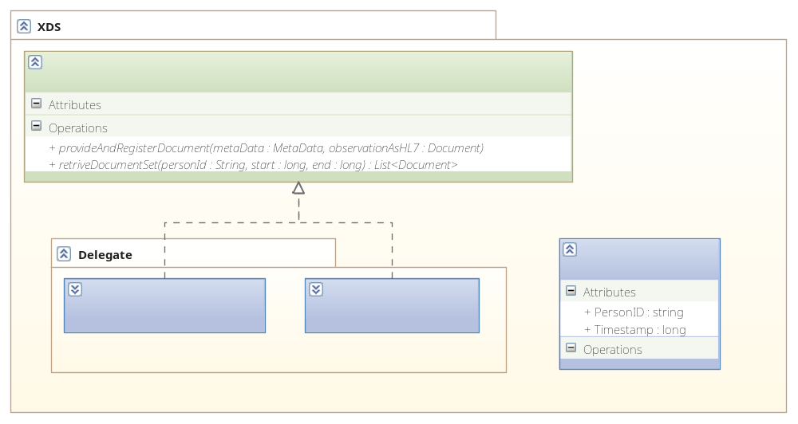
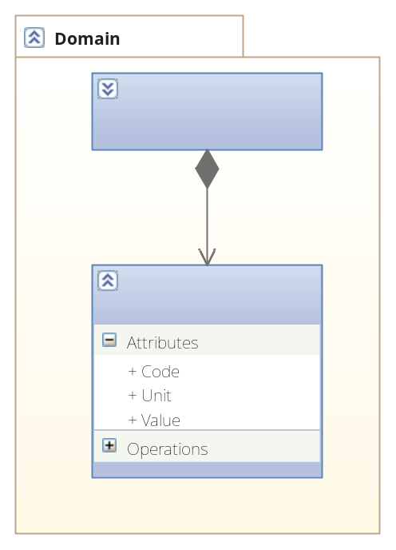

3.2 Component & Connector Viewpoint

Overview of active classes and responsibilities:
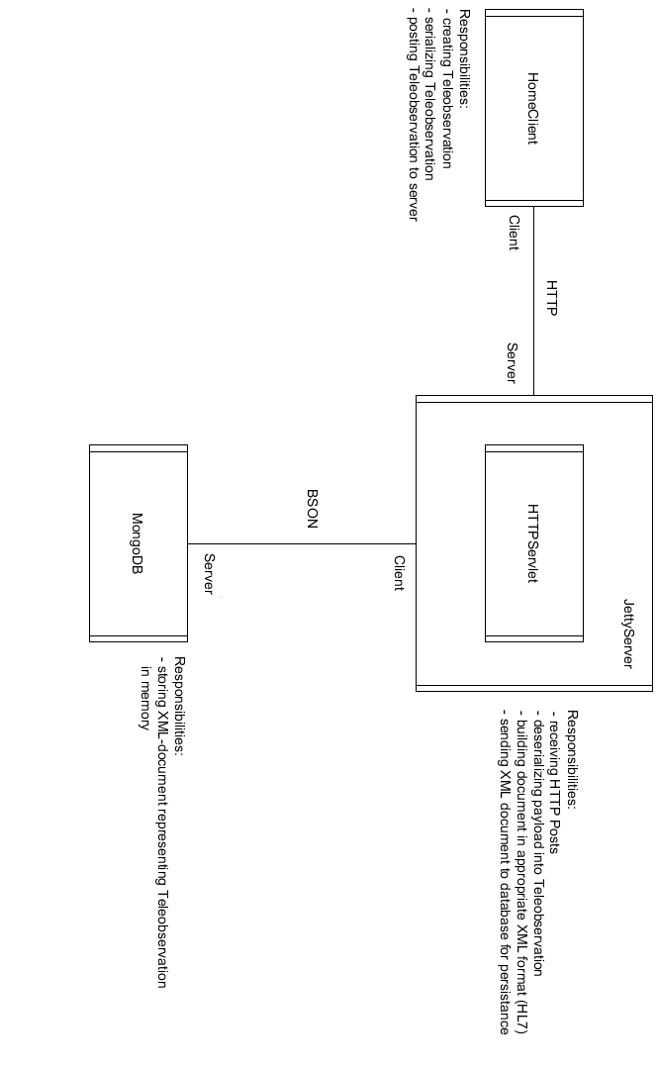

Sequence Diagram (selected classes): 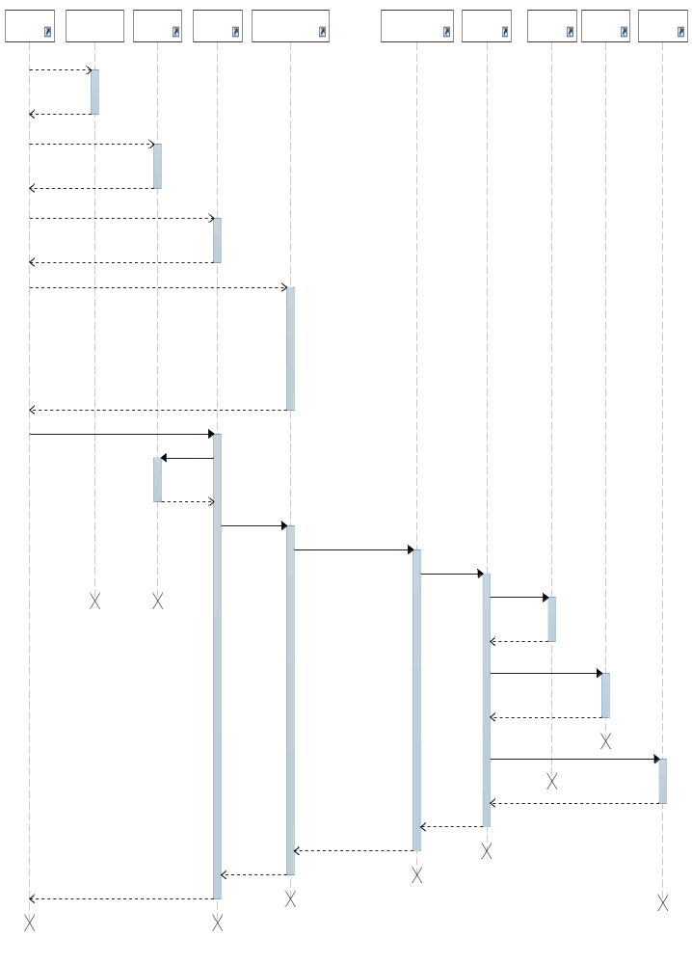

3.3 Allocation Viewpoint

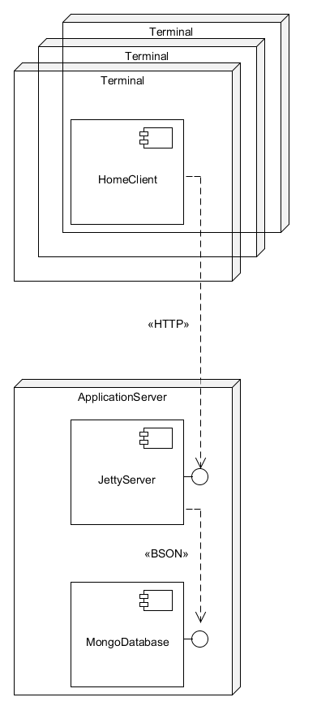

4. Discussion

Den abstrakte beskrivelse af begreberne 'elements, form og rationale' betyder, at der er et meget stort rum for fortolkning og dermed et stort potentiale for overlap mellem de tre kategorier. Alle elementer fra TM12 kan sagtens passes ind under mere end en kategori, alt efter hvordan man vælge at fortolke beskrivelsen - men her er vores bud :)

'Data elements' repræsenterer udvekslede data og udgøres groft sagt af klasserne fra domain package (Teleobservation, ClinicalQuantity)

'Processing elements' repræsenterer elementer, der 'transformerer data-elementerne' Det er klasser fra dataformat (builder, director)

'Connecting elements' er klasserne, der danner rammen om kommunikationen - IPC package, (serializer, forwarder, receiver) HomeClient, InterProcesConnector og HTTPServlet.

'Form properties' lægger en begrænsning på elementerne - vi går ud fra det skal være begrænsning i et arkitektonisk perspektiv. Vi har derfor valgt at koble den kvalitet til forskellen mellem interface og implementationsklasse, da det er denne kvalitet, der skiller de arkitektonisk betydende klasser (interfaces) fra klasser uden nogen arkitektonisk betydning (simple, implementerende klasser).
'Form relationships' lægger en begrænsning på elementernes placering i arkitekturen. Vi har derfor valgt at koble den kvalitet til evt. forhold omkring concurrency og de problemstillinger, der findes herunder.

Rationale: Beskrivelsen lægger op til en meget bred fortolkning af denne kategori - fra funktionelle aspekter til økonomiske. Vi har derfor valgt at sige at den kategori dækker over valget af infrastruktur bredt - en HTTP-baseret, client-server arkitektur som platform for dataudvekslingen.

5. References
[Christensen et al., 2012] Christensen, H. B., Corry, A., and Hansen, K. M. (2012).
An Approach to Software Architecture Description Using UML 2.3.
Technical report, Computer Science Department, University of Aarhus.

www.hl7.org
Cross-Enterprise Document System, wiki.ihe.net/index.php?title=Cross- Enterprise Document Sharing
These qualities will be operationalized in a later exercise

