# Use case diagram

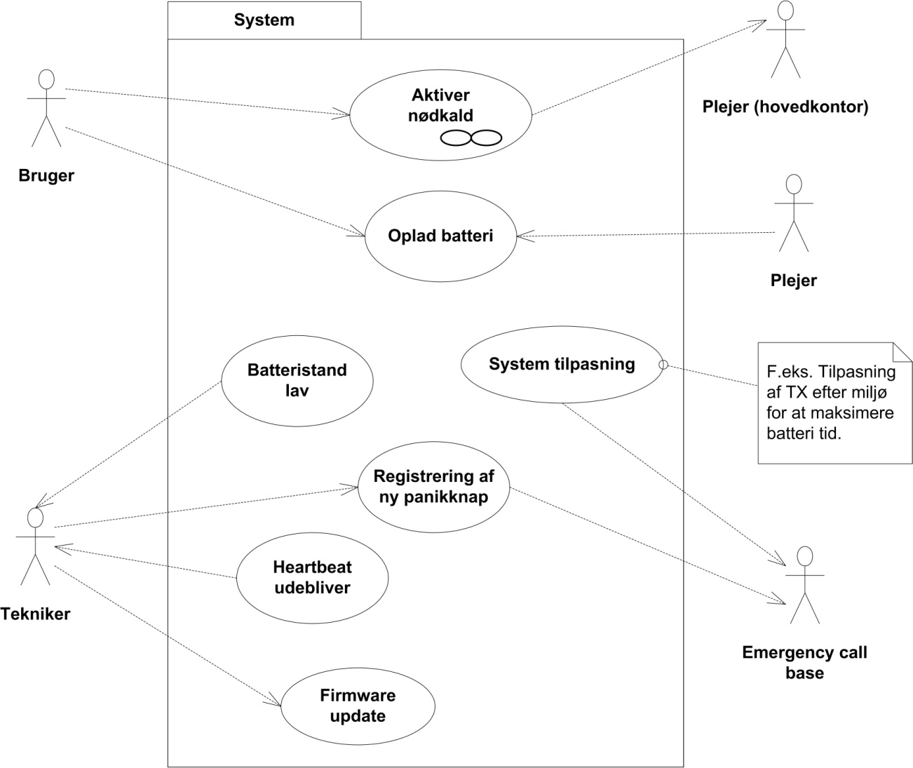



In the above all communication goes through the Emergency call base, yet where the communication is merely relayed to another actor the Emergency call base is not shown as part of the communication.

# Actor description

**Actor Name:**

Technician

**Type [primary / secondary]:**

Primary actor

**Description:**

The technician deals with the initial setup of the device as well as handles error conditions and firmware update. The Technician is typically an employee of the “Hjælpemiddelcentralen” in the local municipality. He is well skilled in the technical aspects of the device from a functional point of view as well as being equipped with a custom configuration and servicing tool allowing him the necessary interface to the device.

**Number of concurrent actors:**

Just one

**Actor Name:**

Plejer

**Type [primary / secondary]:**

Primary actor

**Description:**

The care giver is responsible for servicing the device under normal working conditions. This means ensuring that the device is recharged and responding to emergency calls issued by the care taker (dispatched by the head office).

The care giver only has a brief introduction to the device limited to expected battery life, warning indicates for battery level and usage (push button to get help).

**Number of concurrent actors:**

Just one

**Actor Name:**

Plejer (hovedkontor)

**Type [primary / secondary]:**

Primary actor

**Description:**

The care giver is responsible for receiving the emergency calls and dispatching a care giver.

The care at the main office is familiar with the administration system, and not the device itself.

**Number of concurrent actors:**

Just one

**Actor Name:**

Emergency call base

**Type [primary / secondary]:**

Primary actor

**Description:**

The emergency call base is responsible for forwarding the emergency calls, battery low status and missed heart beat warnings to the head office and also to maintain the audio communication between the head office and the device and to close the connection when no longer needed.

The emergency call base is paired with the device during configuration.

Finally the emergency call base is responsible for assisting the device in automatically determining the minimum required transmission power to conserve power.

**Number of concurrent actors:**

Just one

**Actor Name:**

Bruger

**Type [primary / secondary]:**

Primary actor

**Description:**

The care tager is responsible for the main interaction with the device and caries it on his or her person up to 24 hours a day.

The care giver only has a brief introduction to the device limited to expected battery life, warning indicates for battery level and usage (push button to get help).

**Number of concurrent actors:**

Just one

# Use case description

**Use Case #1: Aktiver nødkald**

**Goal:**

To obtain immediate aid from a care giver not presently in the vicinity.

**Description:**

The care taker activates the emergency button the device and is placed in verbal contact with a care giver, who comforts and aids her until a care giver arrives.

**Variations:**

If the emergency can be handled verbally without a care giver showing up in person then the emergency alarm may be cancelled from the central office.

**Initiation:**

This use case is activated by the care taker by pushing the button.

**Actors and Stake Holders:**

Bruger & Plejer

**Frequency:**

Rare (no more than 1-5 times a day, though up to a frequency of every 30 seconds should be supported).

**Non functional requirements:**

The care giver must be at the home of the care taker no more than 30 minutes from the activation of the emergency call. From this a requirement of a maximum delay from panic button activated to alarm is received by central office of 10 seconds.

A minimum verbal communication time of 5 minutes must be possible.

**Preconditions:**

The emergency call has been properly configured and has a sufficient battery charge.

**Main Scenario:**

1. The care taker activates the emergency call.
2. The head office responds and asks what the emergency is.
3. The care taker explains the emergency
4. The head office dispatched a care giver to the address of the care taker.
5. The head office calms the care taker and disconnects the emergency call audio.
6. The care giver arrives at the address of the care taker.

**[*Exception: Care taker is unable to respond*]**

3.A The care taker is unable to respond due to he or she being unconscious

4 – 6 Same as main scenario

**[*Exception: Emergency handled verbally*]**

4.A The head office is able to handle the emergency verbally and the emergency call is cancelled.

5 – 6 Not performed.

**[*Exception: Insufficient battery for audio*]**

3.A The head office is unable to communicate with the care taker

4,6 Same as main scenario

5. Ignored

**Use Case #2: Oplad batteri**

**Goal:**

To recharge the emergency call device batteries.

**Description:**

The care taker or the care giver places the device on a charging plate (e.g. an inductive plate) for charging and removes it when it is charged.

**Variations:**

If the care taker prefers to have an emergency call on at all times then a replacement unit is used while the other unit charges. Each care taker simply has two devices.

**Initiation:**

This care taker or care giver takes the device of the care taker and places it on the inductive plate.

**Actors and Stake Holders:**

Bruger & Plejer

**Frequency:**

Rare (no more than once a day or once after each emergency call).

**Non functional requirements:**

The unit must be able to fully charge in no more than 6 hours (a sleep between pee-breaks).

**Preconditions:**

None (an unconfigured emergency call device can also be recharged).

**Main Scenario:**

1. The care taker places the devices on the charging plate next to his or her bed after going to bed.
2. The care taker places the device back on him- or herself when he or she leaves the bed.

**[*Exception: Battery getting low*]**

1.A The care taker notices that the yellow LED is lighting up.

2. The care taker replaces the device with his or her spare and places the other device on the charging plate.

**[*Exception: Battery getting low 2*]**

1.A The care giver notices that the yellow LED is lighting up.

2. The care giver replaces the device with his or her spare and places the other device on the charging plate.

**[*Exception: Care giver replaces device*]**

1.A The care giver replaces the device with the spare while servicing the care taker and places the devices on the charging plate.

2. Not needed

**Use Case #3: System tilpasning**

**Goal:**

To lower the transmission power level to the lowest possible for the environment.

**Description:**

Automatically adjust the transmission strength to fit the environment and thereby lower power consumption.

**Variations:**

None

**Initiation:**

Initiated by any communication.

**Actors and Stake Holders:**

Emergency call base

**Frequency:**

Rare (same frequency as the communication).

**Non functional requirements:**

None

**Preconditions:**

The emergency call has been properly configured and has a sufficient battery charge.

**Main Scenario:**

1. An emergency call or other communication is initiated.
2. The emergency call device registers the receiving transmission strength and adjusts its transmission strength accordingly (as low as possible).
3. The emergency call device adjusts its transmission strength according to the BER to minimize power consumption.

**Use Case #4: Batteristand lav**

**Goal:**

To notify the technical staff that an emergency call button is about to become unoperational.

**Description:**

There are four battery levels “indicated by” the device.

1. Green/nothing – OK
2. Yellow – Please recharge (less than 6 hours of battery left)
3. Red – Low (less than 1 hour of battery left)
4. Off – device in-operational.

When the battery level becomes low the technical staff should be informed and may at first contact the care giver, who in turn may ask the care taker to please recharge his or her device.

**Variations:**

If the care taker is unable to replace the device themselves, the care giver may drive out to the care taker and replace the device for them.

If the device battery life has deteriorated with time the technician may drive out and replace the battery cell.

**Initiation:**

The emergency call device itself.

**Actors and Stake Holders:**

Tekniker

**Frequency:**

Rare (no more than once a day).

**Non functional requirements:**

The unit must be able to maintain minimally the functional life described above in the different states.

**Preconditions:**

The emergency call has been properly configured.

**Main Scenario:**

1. The emergency call device transmits information (via the emergency call base) to the technician on call about its low battery situation.
2. The technician contacts the care giver head office.
3. The care givers call the care taker in question (on the normal phone) and guides her through replacing the unit and charging the low one.

**[*Exception: Care taker cannot replace unit*]**

3.A A care giver is dispatched to replace the low unit and set it for charging.

**[*Exception: Battery getting low 2*]**

3.A The technician makes arrangements to go and replace the battery of the deteriorated unit.

3.B Same as 3.

3C. The technician replaces the battery unit as arranged in 3.A

**Use Case #5: Heart beat udebliver**

**Goal:**

To replace a defective unit

**Description:**

If an emergency call device stops sending heartbeats the technician must replace the unit and/or identify the problem (and solve it if possible – e.g. care taker has removed battery or has worn the device out of range)

**Variations:**

The problem may be rectified on the phone

**Initiation:**

The emergency call base

**Actors and Stake Holders:**

Tekniker

**Frequency:**

Rare (never to once a year per unit).

**Non functional requirements:**

None

**Preconditions:**

The emergency call has been properly configured.

**Main Scenario:**

1. The emergency call base discovers the the emergency call device has not transmitted a heartbeat in a timely manner.
2. The emergency call base transmits an alert to the technician on call.
3. The technician on call informs the care givers and makes arrangements to go and replace the defective unit.
4. The care givers contact the care taker (on the phone) and get an overview of the situation and makes arrangements for the replacement.
5. The technician replaces or fixes the defective unit.

**[*Exception: Problem can be handled on the phone*]**

5.A The problem can be rectified on the phone and the technician is cancelled.

**Use Case #5: Registrering af nu paniknap**

**Goal:**

To install a new emergency call device.

**Description:**

When a new emergency call device is issued to a care taker it must be configured to the emergency call base in the care takers home.

**Variations:**

The unit may also be configured for optimal battery life by identifying the worst case transmission requirements.

**Initiation:**

The technician

**Actors and Stake Holders:**

Tekniker

**Frequency:**

Rare (A few times per care taker).

**Non functional requirements:**

None

**Preconditions:**

None

**Main Scenario:**

1. The technician initiates the emergency call pairing on the emergency call base and the emergency call device.
2. The pairing is performed by the device and base and a notification of success is given.
3. The device is given to the care taker

**[*Exception: Configuration of worst-case TX*]**

3.A The technician moves to the furthest away part of the house (grounds)

3.B The technician initiates worst case TX configuration.

3.C The device measures optimal TX strength and stores it as its maximum TX strength (makes automatic adjustment of TX more effective).

3.D The device is given to the care taker

**Use Case #6: Firmware update**

**Goal:**

To update the firmware on the emergency call device.

**Description:**

If a bug is found or an optimization is implemented the firmware on an already deployed device may be updated on the fly.

**Variations:**

The unit may be updated by a special service tool and not “on-the-fly”.

The firmware update may fail.

**Initiation:**

The technician

**Actors and Stake Holders:**

Tekniker

**Frequency:**

Rare (A few times a year, yet support for more often should not be ruled out).

**Non functional requirements:**

A firmware update must be completed within 30 minutes.

**Preconditions:**

The emergency call has been properly configured and has a sufficient battery charge.

**Main Scenario:**

1. The technician makes arrangements with the care givers for when the device may be placed off-line for up to 30 minutes.
2. At the scheduled time the technician uses the link to the emergency call base to schedule a firmware update.
3. When the emergency call device contacts the emergency call base the next time (heartbeat only) it is informed of a pending firmware update.
4. The emergency call device updates its firmware and a success notification is sent to the technician.

**[*Exception: Special tool update*]**

1.A The technician connects to the emergency call device with his special tool (the device must be in possession (or at least proximity) ).

2.A The technician updates the firmware.

3 and 4 are not performed.

**[*Exception: Firmware update failure*]**

4.A The technician receives a detailed firmware update failure notification and the emergency call device reverts to its pre-update firmware (if the other firmware was ever in effect).

# Design constraints

1. The device itself must not weigh more than 125g
2. The device must not be larger than 40x60x15mm
3. The button must be at least 20x30mm or have a circumference of at least 75mm.
4. The devices battery life must be sufficient for at least 24 hours of stand-by (with heart beats) and a 5 minutes conversation. A graph showing the dimensions/weight vs. battery life should be shown starting at the smallest battery supporting the above time constraint and continuing until the size and/or weight constraint is reached.

# General consideration

1. Only the device should contact the base, never the other way around (to conserve power).