Programming Project
HotTargui
Contents

1 Assignment 4B 3
1.1 Peer to peer 3

Assignment 4B
Creating an architectural prototype may have more than one purpose
- Determine if a selected architecture meets the desired quality attributes.
- Compare a number of possible strategies with each other based on how well they meet a number of quality attributes.
This assignment focus on comparing three different approaches to creating a distributed version of HotTargui. In order to compare the prototypes we have to have something to evaluate them against, and this is where quality attributes comes in.
First we need to define which quality attributes are of interest and their relative importance, and then the individual architectural prototypes can determine how well the given architecture meets the quality attributes before finally comparing the results.
As we do not have have a stakeholder issuing requirements and helping us prioritise quality attributes we will instead focus on the advantages and disadvantages of the different architectures.

Peer to peer
The peer to peer architecture has certain advantages
- Identical code executing on all location – no server or master-appointment required.
- Possible increased performance (response-time) due to locally accessible data and validation.
- Unlike server solution discovery is required.
- Unlike hosted server all data must be replicated to all applications increasing requirement for application memory.
- Poor scalability - As the replication must be done to all applications the communication-requirements increase linearly with the number of applications. The server and hosted server the communication is constant with increasing connections.
- Simpler, as no server code must be written.
As we can see scalability is definitely not an advantage with peer-to-peer, yet as the number of players is fixed to a maximum of 4 this is not a huge problem. The peer-to-peer solution has its justification in the fact that it is simple; no dedicated server application required, no appointment of a host, just the “simple” synchronization of data.
When creating an architectural prototype it must be decided which aspects of the behaviour to validate/evaluate, as there may be several. In the peer-to-peer network there are at least two distinct areas; discovery and synchronization. Another might be game-play, but it is no different from the server or hosted-server solution so it is not very interesting from a comparison point of view.
Even though the discovery mechanism is quite interesting we choose to focus on the synchronization mechanism. There are several discovery protocols and even commercial implementations available for purchase, e.g. UPnP discovery or Web Service discovery. There is an important difference between LAN and WAN discovery, which has to do with reachability. LAN discovery (e.g. UPnP discovery) rely on LAN broadcasting mechanisms like UDP to notify interested parties of a newcomer to the network. This approach does not work on a WAN, as Firewalls and the sheer vastness of the network eliminates the broadcasting approach. For this reason a form of server-discovery is used, where the individual clients contact a central server to get a list of participants and also the receive notification about changes to the network layout. This approach is probably best know as the Napster-architecture.
In order to decide on discovery it is therefore important to determine the forms of use; Is the distribution of this game designed to be used on a LAN (e.g. 4 computers connected y a switch) or a WAN (e.g. 4 computers in different parts of the world connected by the Internet). As we have chosen to focus on the data synchronization and not the discovery for this architectural prototype, this issue can be postponed until later, as no matter how the discovery is done the outcome is the same; a list of addresses for the participants in the game.
We therefore design this architectural prototype on the premiss that this information already exist.
To create the architectural prototype we need to identify the relevant parts of the code. As we deal with synchronization we need all the domain data, which consists of the board information as well as the game state information.
This information is collected behind the interfaces Game and Board. We now have to consider the design principles we wish to employ. We can synchronize all state information for all classes, including the strategy patterns, which, in some instances, also contain state information. We can also choose to simply perform the same moves on all connected applications, thereby having the state-information update independently of each-other, yet as the applications are identical the resulting states will be synchronized.
The difference between the two options is in the dependencies, and may be seen in the below figures.

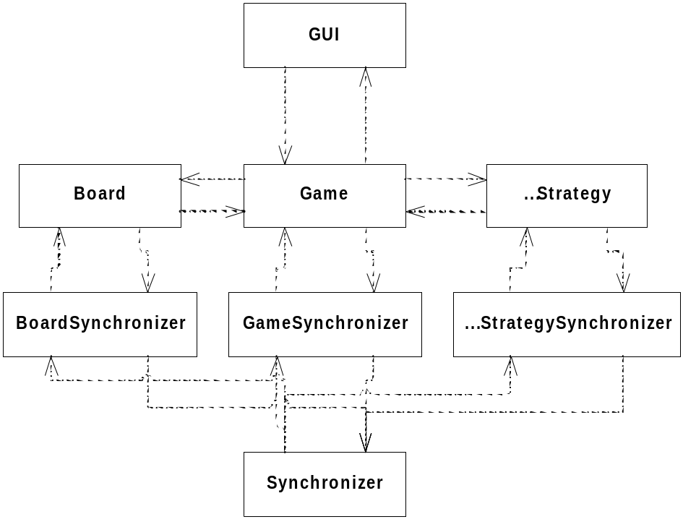
Figure 1: Data synchronization
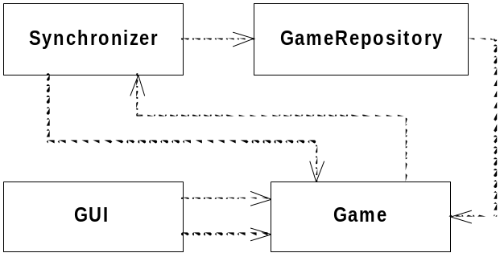
Figure 2: Action synchronization
Both approaches has advantages and disadvantages. The first, though it may seem more complicated, is actually more robust and simple to understand. When implementing data synchronization it is often beneficial to move the raw data values to a separate class.
This is not only an advantage of this, as it encapsulates the data, it also allows for replacing the storage from in-memory variables to a file or a database. This would make implementing a store and re-store functionality very simple allowing for a game to be paused and later picked up again. The disadvantage is that all data must be synchronized and that any change to the data must be evented through the game interface to any interested listeners. For this reason, and due to the fact that we have no requirement to store the game, we choose action synchronization.
Naturally action synchronization also has advantages and disadvantages. It rely on recreating the actions on all instances of the game, which may not always be possible. The game includes a die, which in its nature is unpredictable, so how would we reproduce the same die-roll on all applications? Luckily the die-roll has been abstracted away behind an interface for testing purposes, and due to the use of the repository pattern we are able to replace the die-roll strategy at runtime to one where we can control the outcome. Upon inspecting the Die interface we realise that there is an even easier solution, as the Die interface allows for the setting of outcome directly on the interface, and no strategy-replacement is needed.
In order to create the architectural prototype we have to strip down the existing code to only include the absolutely necessary and only implement what is required to show that the solution works. We also have to determine what we wish to measure; performance, communication requirements, responsiveness, ...
As we know that the issue with peer-to-peer lies in its scalability we choose to look at communication through-put in order to determine how it rates compared to one of the other solutions; server or hosted server.
Implementing the GameNetworkDecorator may be done in many ways, yet as we are performing a given action on multiple destinations, one approach is to use the decorator pattern, which allows us to intercept all actions on the Game interface and pass them on to the remote locations, or rather pass on the valid moves, as the peer-to-peer solution has the advantage of local validation and does therefore not need involvement of other parties in order to determine validity.
The decorator pattern is implemented by creating a new implementation of the Game interface, which simply forward all calls to the normal implementation, but then perform some operation either before or after the call. In our case we want to perform a synchronization of an operation if it succeeds (and if it changes the state or layout of the game). The synchronization-calls should always succeed if they succeeded locally, as the layouts are always identical.
This allows us to distribute all commands, but it does not handle the reception of the command. Here another pattern comes in handy; the Proxy pattern. By keeping a proxy of the remote Game implementations it is possible to perform the same calls remotely as was performed locally. This is also where the replacing of the die-roll strategy comes in handy.
First we will implement the decorator pattern, which for the simple actions requires code like:
public boolean buy(int count, Position deploy) throws RemoteException {
boolean res = game.buy(count, deploy);
if (res) {
Set<Game> coll = remoteGames.keySet();
Iterator<Game> itt = coll.iterator();
while (itt.hasNext()) {
Game g = itt.next();
g.buy(count, deploy); // No reason to look at return value
}
}
return res;
}
For the rollDie it is a little more complicated, but still managable, as shown here
public void rollDie() throws RemoteException {
game.rollDie();
int value = game.getDieValue();

Set<Game> coll = remoteGames.keySet();
Iterator<Game> itt = coll.iterator();
while (itt.hasNext())
{
Game g = itt.next();
GameRepository gr = remoteGames.get(g);
Die ds = null;
try {
ds = gr.getDieStrategy();
} catch (RemoteException e) {
e.printStackTrace();
}
// First we actually roll the die to ensure propper state change
g.rollDie();
// The we manually override its value with the value we want
ds.setValue(value);
}
}
The above implementation does require certain things to hold true. The Die implementation must work in the manor described (a call to setValue will ensure that a subsequent call to rollDie will result in this value, thereafter the die functionality returns to normal (random).
Similar may be done for the Cards, yet as these are not part of the implementation it is not needed and we can simply ignore the call.
Now for the implementation of the access to the remote game implementations. Here we use the Java RMI registry to perform the calls on the remote Game instances. In order for us to do this it is required to name the instances and to have these names known at start-up. We choose the simplest possible solution and uses a command line argument to differentiate the instances when they are registered with the RMI registry, and as we define the four possible arguments as ”red”, ”green”, ”blue”, and ”yellow” they can be connected at start-up.
Naturally this requires that they are all connected before the system is running. This is handled in the architectural prototype by having the initiating code first register its objects and then continuously attempt to get the three remaining remote objects until it is successful and first after that allow the game to continue. This should ensure that all games will be initialised approximately at the same time (when the last application is started). Naturally another argument could be used to indicate the number of players, so we do not have to test with four players all the time.
To interfaces Game, Die and GameRepository has to extend Remote and all methods in the interfaces must throw RemoteException. We could choose to update the existing code, but this would divert attention away from our purpose – the architectural prototyping of the peer-to-peer solution. We therefore design test-stubs for Game, Die and GameRepository, which only implements what is necessary to validate the networking functionality. These test-stub implementations must naturally implement the interfaces, but for java RMI to use them must also extend UnicastRemoteObject. Then they have to be exposed, and this is done in the GameInitializer code. The value types involved must also be updated to be Serializable (e.g. Position), and this is done. Player and Tile are interfaces, so they could also be stubbed, yet as none of the implementation requires tiles or players to be retrieved across the network they are simply ignored (remove from the architectural prototype code).
As the registration in the Java RMI registry is rather expensive we implement the test not as a true unit-test, but as a transition-tour. The difference between a unit test and a transition-tour lies mainly in the notion that the environment is not setup from scratch every time, rather a test-case manoeuvres the code back to its origin. An example of this may be testing a large SQL database. Instead of the following sequence (yes, it is not correctly formulated test-case names☺ ):
- insertionIntoDatabase
  - Create SQL database
  - Inserting an item in database
  - Validate that item was inserted
  - Delete SQL database
- renamingInDatabase
  - Create SQL database
  - Setup SQL database (insert item)
  - Rename item in database
  - Validate renaming
  - Delete SQL Database
We may optimise it by not deleting the database, but rather returning it to its origin:
- Initial Setup
  - Create SQL database
- insertionIntoDatabase
- Inserting an item in database
- Validate that item was inserted
- Remove item from database
- renamingInDatabase
- Setup SQL database (insert item)
- Rename item in database
- Validate renaming
- Remove item from database
- Final teardown
- Delete SQL Database
Now this is an optimization as the database is only created once, which is the resource-expensive part of the test. The reason it is called a tour can be just be hinted in the test cases, as we test more than just what we mention – we also test remove. By making the order of the test-cases of value it becomes even more apparent, and further optimization can be done:
- Initial Setup
  - Create SQL database
- insertionIntoDatabase
- Inserting an item in database
- Validate that item was inserted
- renamingInDatabase
- Rename item in database
- Validate renaming
- Final teardown
- Delete SQL Database
This naturally goes against the unit-testing principles, yet as it is a transition-tour and not a unit-test it is acceptable. The idea of a transition tour is defining a sequence of events which tests all transitions in the code, which for black-box testing basically means systematic testing of the interfaces (remembering to differentiate on input, output and interdependencies). The transition tour is not designed for black-box testing, but for white-box testing and it is meant to drive class or collection of classes to all its states using all possible transitions – at least if you want 100% transition coverage. Our requirements for the architectural prototype do not specify anything about coverage, so this is not a goal in our case – we are focussing on the synchronization. A call to one game must be performed on all games.
We therefore set up a test list (transition tour)
- Calling newGame on one Game will result in a call to newGame on all other games
- Calling move on one game will result in identical move on all other games.
- Calling invalid move on one game will not result in any activity on the other games.
- Calling buy on one game will result in identical buy on all other games.
- Calling invalid buy on one game will not result in any activity on the other games.
- Calling rollDie and getDieValue on one Game will give same value as all subsequent calls to getDieValue on all other games.
As the get-methods are only called locally, they are not interesting except to test the decorator pattern, but as this is not of interest here we stop at these six tests.

