Analysis of the exercise
With the new requirements to the door alarm we actually have a software system that varies along a set of distinct dimensions. These dimensions are:

- Keyboard panel layout (DK or US keyboard)
- Language (DK or US)
- Access (Simple, Local or Central)
- Logging (Logging or no logging)

Four dimensional spaces are quite difficult to show and understand on a two dimensional figure. So I we want to draw the dooralarm access in a variability space, we have to omit one dimension – for instance the keyboard panel (you could argue that the panel layout depends on the language?).

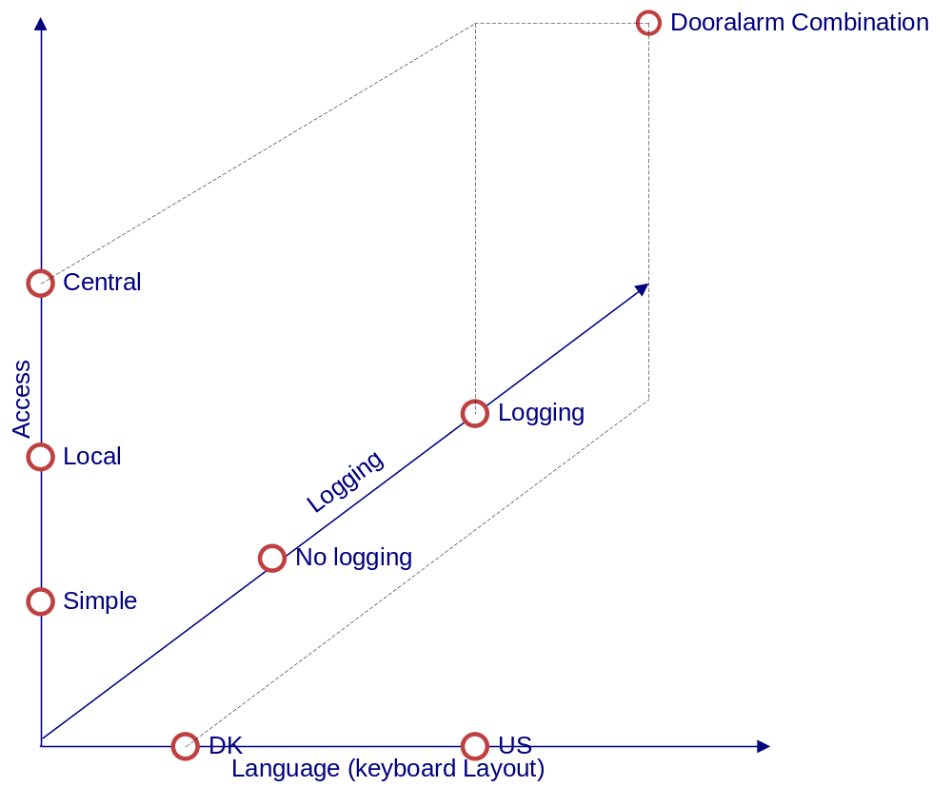

Taking all 4 dimensions into account gives us 2x2x3x2 = 24 combinations. If we should handle all these variants in a pure polymorphic way we would already end up with 24 dooralarm subclasses. When the dimensions are independent of each other you can take real advantage of the compositional design because independent dimensions are also independent dimensions in the production code.

The Compositional 3-1-2 process
- Consider What should be variable in your design

Behavior likely to change: Access (simple, local and central)

Additional behavior: Logging

- Program to an interface, not an implementation

The responsibility is (already) expressed by the DoorAlarmFactory interface

- Favor object composition over class inheritance

Refactor: Add Access creation into the DoorAlarmFactory interface

The logging behavior can be composed by putting an intermediate object with the same interface in front of the DoorAlarm object. This is the decorator pattern.

Iterations
Iteration 1: Introduce Access interface (already done)

Iteration 2: Update DoorAlarmFactory
- Introduce createAccessControl method on Factory with Fake-it implementation.
- Test case succeeded (manual inspection of GUI)

Iteration 3: Use createAccessControl method
- Refactor DoorAlarm to use the createAccessControl method to retrieve the Access instance.
- Test case failed (java crash)
- Move SimpleAccess instantiation to both Factory implementations (obvious implementation).
- Test case succeeded (manual inspection of GUI)
- Refactor Factory implementations to specify the access control used
  - DkDoorAlarmFactory -> DkSimpleDoorAlarmFactory
  - UsDoorAlarmFactory -> UsSimpleDoorAlarmFactory
- Test case succeeded (manual inspection of GUI)

It is now possible to replace the Access control by creating a implementation of the Access interface. Naturally this actual implementation should be postponed until the actual requirement exist (an actual customer request it). For this reason we will first implement the logging facility before moving on to implementing the other specific access control implementations.

Iteration 4: Introduce Decorator
- Create AccessLoggingDecorator class which implement Access and simply forward all calls to composite Access instance set in constructor (obvious implementation).
- Test case succeeded (manual inspection of GUI)

Iteration 5: Use Decorator
- Update ant script to start a DoorAlarm with simple access and logging.
- Test case failed (no Factory instance)
- Create new Factory instance which create the AccessLoggingDecorator with both a DK and Us.
  - DkSimpleLoggingDoorAlarmFactory (obvious implementation)
  - UsSimpleLoggingDoorAlarmFactory (obvious implementation)
- Test case failed (no logging file created)
- Implement simple file logging in AccessLoggingDecorator (obvious implementation)
- Test case succeeded (manual inspection of GUI and log file)

We could stop here, yet the last design (the decorator) is not very GoF, and it has an odd responsibility of forwarding Access calls and performing logging. For this reason we once again apply the 3-1-2 process as follow.

3. Consider What should be variable in your design

Behavior likely to change: The implementation of the Logging

1. Program to an interface, not an implementation

interface Logging
--- handle implementation of logging facility
+ log(string text)

2. Favor object composition over class inheritance

Refactor: Add Logger creation into the DoorAlarmFactory interface

Iteration 6: Define logging
- Define Logging interface
- Test case succeeded (manual inspection of GUI)

Iteration 7: Implement FileLogger
- Create implementation of Logger interface that simply log from file (Copy from other implementation - obvious implementation)
- Test case succeeded (manual inspection of GUI)

Iteration 8: Introduce Logging
- Update AccessLoggingDecorator to take Logging interface in constructor.
- Test case succeeded (manual inspection of GUI)
- Test case failed (java crash)
- Add creation of SimpleLogger to all Factory implementation that need a logger.
- Test case succeeded (manual inspection of GUI)

It is now possible to introduce multiple logging facilities by addition. Naturally at the moment we do not need any other Logging facility, so it is for future use.

Now all there is left is to implement the missing Factories.

Iteration 9: Local access - no logging
- Update ant script to start a DoorAlarm with local access and no logging.
- Test case failed (no Factory instance)
- Create new Factory instances which create the LocalAccess .
  - DkLocalNoLoggingDoorAlarmFactory (obvious implementation)
- Test case failed (java crash)
- Implement local access control (Stub it => obvious implementation)
- Test case succeeded (manual inspection of GUI and no log file)

Iteration 10: Central access - logging
- Update ant script to start a DoorAlarm with local access and logging.
- Test case failed (no Factory instance)
- Create new Factory instances which create the AccessDecoratorLogging.
  - UsCentralLoggingDoorAlarmFactory (obvious implementation)
- Test case failed (java crash)
- Implement central access control (Stub it => obvious implementation)
- Test case succeeded (manual inspection of GUI and no log file)

