Programming Project – Assignment 2 and 3
DeltaTargui
Contents

1 Introduction 3
2 Finding partition sets - distance 4
2.1 Partition table 5
3 Result of attack 5
4 Equivalence classes 6
5 Test cases 7
6 Boundary analysis 9
7 BetaTargui 10

New requirement: Randomized board

Analysis
In the AlphaTargui variant we introduced the BoardFactory interface. The BoardFactory describes the responsibilities of creating a Board. In AlphaTargui, we created an implementation of the BoardFactory named AlphaBoardFactory. The implementation placed all tiles on the board in a predefined way.
In the DeltaTargui, we want to randomize the positioning of the tiles on the board; hence we create a new implementation of the BoardFactory named DeltaBoardFactory. DeltaBoardFactory implements the algorithm defined in the project description. The algorithm is stated as:
- The saltmine is positioned in the center of the board.
- The different types of tiles are placed randomly on the board. The number of each tile type is predefined.
- Each corner tile is replaced with one of the four settlement tiles. The position is as follows:
  - Red settlement – Upper left corner (0, 0).
  - Green settlement – Upper right corner (0, 6).
  - Blue settlement – Lower left corner (6, 0).
  - Yellow settlement – Lower right corner (6, 6).
To take small steps and keep focus, the above steps are implemented in multiple iterations. In each step a requirement is implemented.
The test list contains a test that reads: “Tile positions matches specification”. This test definition is not very concrete and the test is therefore broken down into smaller tests, who match each of the three identified iterations.

Design choices
In AlphaTargui we already used the Abstract Factory pattern to support the implementation of the AlphaBoard. In DeltaTargui, we will simply implement the BoardFactory interface to support another variant of the board – DeltaBoard. The DeltaBoardFactory has responsibility of creating the board according to the DeltaTargui specification.
For the best implementation, we will analyze the AlphaTargui implementation to determine the variability points and how to create the new implementation. For this purpose, we will use the 3-1-2 process.
Variability points:
- Position of tile – random or fixed.
- Type of tile – differs between the types given in the requirements.

Position saltmine
For this iteration, we need to position the saltmine in the center position of the board according to the specification. For this purpose we add the test case ‘testSaltmineCenterPosition’ to the newly created TestDeltaBoard class. Testing for the position of the saltmine is simple:

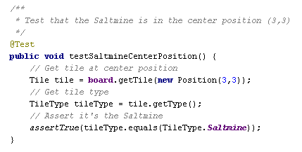

Position tiles randomly on board
In AlphaTargui, we created an instance of the BoardFactory with fixed positioning of the tiles. We generated test cases for the fixed positions.
Now, we have to generate random positions for the tiles, who we add to the board. Compared to the AlphaTargui, this serves a new problem. In AlphaTargui, a tile has the responsibility of knowing its own position. This means, that the board does not have any knowledge about where each tile type is positioned. The board can determine the type of the tile, position, owner and units on the tile by using the tile interface.
When we need to add tiles randomly to the board, we should not place a tile on the board, where a tile previously has been positioned. This is only the case when placing the settlements.
Lessons learned
When implementing this requirement, the first approach was to generate the positions, available for the tiles that should be positioned. Generating the positions was fairly simple with a double loop:
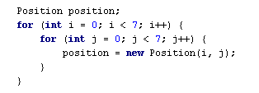
This loop created all the positions on the board. The positions were held in a collection, where each position was removed and assigned to a tile. Creating the tiles stated in table 2.1 in the requirements specification was simply a question of looping the number of times according to each specific tile and create the tile.
The created tiles were held in a collection. This collection was iterated an assigned a position from the available positions.
Although the algorithm for filling the board, there was not paid so much attention to the sequence of the steps, hence they were altered to the below mentioned for ease of implementation.
- Place the ‘Saltmine’
- Place the settlements on the predefined positions.
- Place the randomized tiles.
There were 49 available positions. Suddenly the createTiles() method started throwing IndexOutOfBounds exceptions. This was strange; because the test cases created for probing the number of each tile type was not revealing any defects. The correct number of tiles existed. Debugging the loops and reading the table again didn’t reveal anything.
OK, back to good old system out. Everytime a tile was created, a line with a description of the tile was printed. Before assigning positions to the tiles, the line count was 53. Not 49 as the available positions. Summing the numbers in table 2.1 also gave 53.
Reading the algorithm for populating the board revealed the defect; the settlements were to replace the four corner tiles, meaning that four random tiles were discarded from the game. Implementing this was thought to be simple, but later proven otherwise. As we removed positions from a collection upon tile creation, these positions were used and no longer available. How to reassign the pre-defined positions for the settlements?
A new solution was made: We created a simple deck interface with the responsibility of creating a deck of tiles according to the DeltaTargui specification.
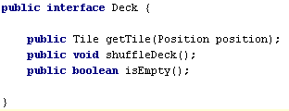
Internally, the deck implementation (DeltaDeck) consists of stack, which is given the tiles for the DeltaTargui specification.
A new implementation of the Tile interface was made (DeltaTile), where it’s possible to assign a position to a tile after creation. Randomness was made by using the Collections.shuffle method in Java. This method applies standard random behavior. The original object-oriented thinking is very much applied to this implementation. The deck is seen as simulation of a part of the physical world.
Another advantage of the new deck interface is that responsibility for creating the deck is separated out from the DeltaBoardFactory.
What we learned from this episode are:
- Read the specification, even small changes can mean a lot to the architecture.
- Making mistakes might lead to better software, as we were forced to think the things over again.
- Place test cases at the “right level”. In this case it was good that we tested for the amount of each tile type. This eventually led to a reveal of a defect. If we had tested for the amount of tiles on the entire board, this would probably not have happened.
- Test cases make code evolve and vice versa. The test cases we initially created revealed a defect. But as the code changed, some of the test became outdated. It’s not possible to test for a specific number of tiles, when some of tiles are randomly replaced. Though, the test cases are OK, when they are run before the tiles are replaced.
- Keep test cases isolated.
- Refactor step in TDD is important, as the “gold” is here. The reflections made here are very important for your code and often provides efficient code changes.

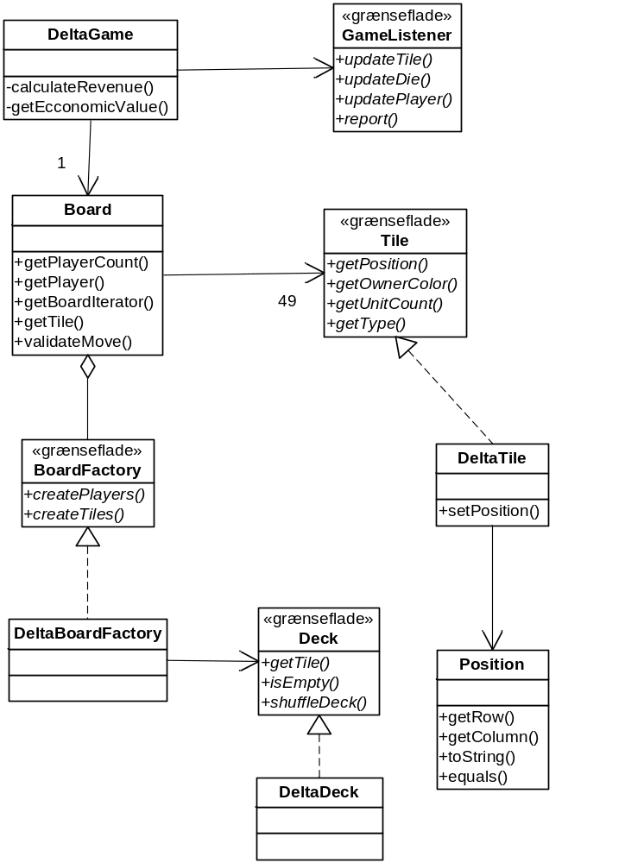

Position settlements
Position of the settlements was done as a step in the algorithm, where the randomized tiles were created. To place the settlements, each tile in the collection of tiles was tested for match of the settlements positions. The easiest solution here was to parameterize the positioning by using some conditional statements:
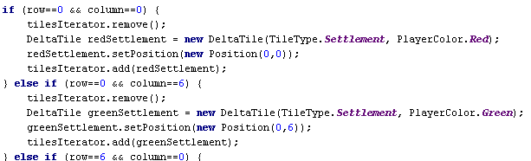

Conclusion
The new requirements for DeltaTargui was fairly easy to implement as we have made some good design choices when implementing AlphaTargui.
Benefits:
- Change by addition, as we add DeltaBoardFactory to create the tiles.
- Centralized responsibility for creating tiles and positions. The responsibility lies within the concrete implementation of the BoardFactory. This enhances code readability as the configuration code is defined in a single place.
Liabilities:
- Creating new variants based upon code in the DeltaBoardFactory (e.g. randomizing the tiles in another way) result in either to much responsibility placed in DeltaBoardFactory or code duplication.

New class diagram for DeltaTargui:

New requirement: Determine winner

Analysis

