Needed interfaces/classes
This is a standard observer pattern, meaning that it is possible to dynamically register a listener, which then is used to perform a call-back when an event occur; here a purchase on a PayStation.

It may be noted that the original observer pattern was pure eventing, meaning that no argument was passed in the notification, yet now it may be argued that the version with an argument is more common than the pure-event version. In this case it is a good idea for several reasons, due to the distributed nature of the observer, as it saves a network call. This is illustrated in Figure 1.

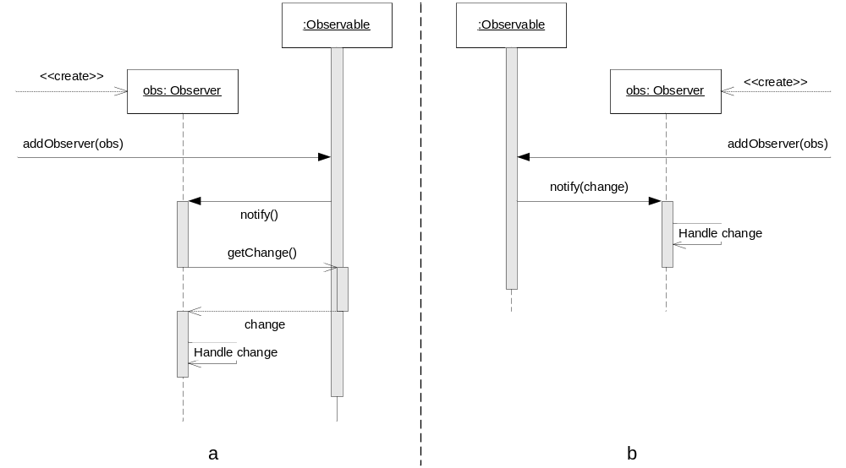
Figure 1 Pure eventing observer (a) versus notify with argument (b)

As it may be seen in Figure 1a, an extra call is performed, and if the Observable instance and the Observer instance is located on different hardware then this extra network call is quite expensive.

In the implementation in PS07 the design of Figure 1b is used, and we are therefore faced with three networked components:

Interface/class | Description
StatusObservable | This interface enables an Observer/Listener to be added (like the Observable instance in Figure 1b), and exposes the addStatusListener method. This is equivalent to the addObserver method in Figure 1b, and must be network enabled in order for an application located on a different hardware (or in a different process) than the StatusObservable instance. This is also the entry-point, and its instances must therefore be registered globally in a registry so it can be referenced externally.
StatusListener | This interface enables a StatusObservable to event back to the observer/listener (call-back). This interface is passed by reference in a networked call (addStatusListener) and therefore do not have to be manually added to the global registry. This is equivalent to the Observer in Figure 1b. The interface has a single method, update, which is equivalent to the notify method of Figure 1b. The update method parses a single argument of type StatusEvent.
StatusEvent | This is a class which is passed as argument to the update method of StatusListener, and contains the integers vacant and earned. This is equivalent to the change argument of Figure 1b. This class may be implemented as an interface, just like StatusListener and StatusObservable, and have the get-mothods network enabled, yet this would not be efficient, and it is much simpler to serialize and parse the data by value; sending two integers as opposed to sending an interface, which may be used to perform two network getValue calls which returns one integer each.

In order to expose an interface on the network using Java RMI the interface must extend the interface Remote, and all methods of the interface must throw the RemoteException. This means that the StatusObservable and StatusListener looks like this:

public interface StatusListener extends Remote {
/** invoked whenever a paystation changes state. */
public void update( StatusEvent event ) throws RemoteException;
}

public interface StatusObservable extends Remote {
/** Add a status listener to this instance */
public void addStatusListener(StatusListener listener) throws RemoteException;
}

The StatusEvent should be passed by value, which is done simply by having the class implement the Serializable interface, like this:

public class StatusEvent implements Serializable {
/** construct a properly initialized status event object */
public StatusEvent(int vacant, int earned) {
this.vacant = vacant;
this.earned = earned;
}

/** the number of vacant parking lots that this
pay station is associated with. */
public int vacant;
/** the amount of cents that this pay station has earned
since last being emptied. */
public int earned;
}

The above may also be shown graphically, as in

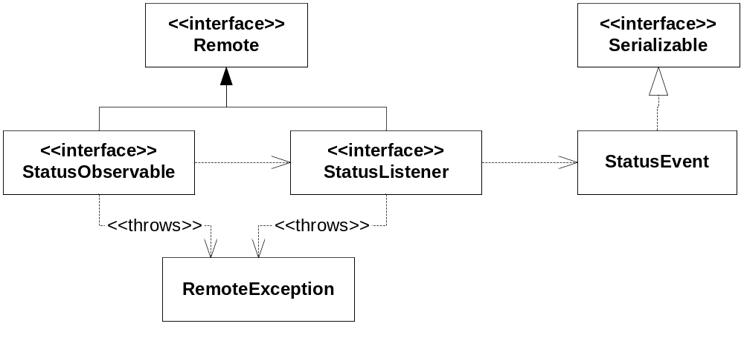
Figure 2 Network enabled interface and serializable data.

This allows the interfaces to be visible on the network, yet naturally this in itself is not enough, the interfaces must also be implemented and the instance added to the global registry.

In Java RMI the server may be generated using reflection, and it is therefore enough to have the implementing class extend the class UnicastRemoteObject, which is a kind of generic server proxy stub.

In the existing PayStation there are two classes, PayStationImpl and LabelUpdater, which implement the two interfaces, StatusObservable and StatusListener, respectively. The small class diagram above may therefore be extended as shown in Figure 3.

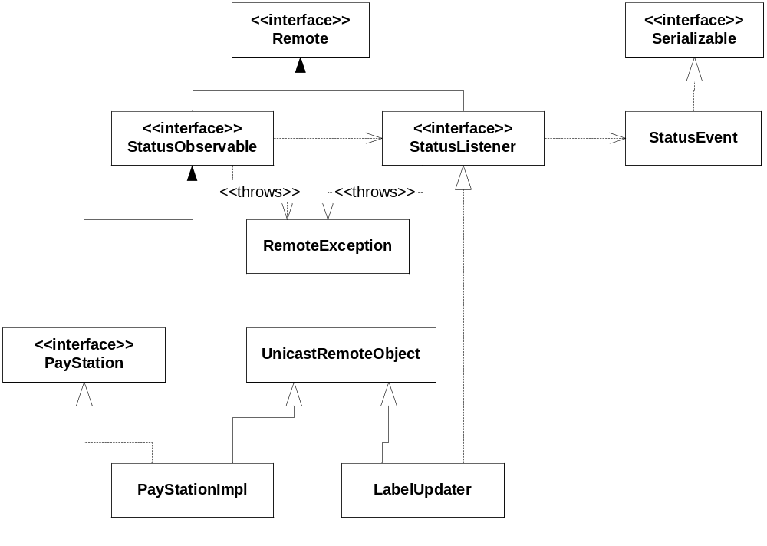
Figure 3 Network enabled interface, along with their implementers, and serializable data.

This allows the objects to be accessible from the network, yet the client side proxy is still undefined. In order to fix this use the Java RMI compiler; rmic. This takes a class file which implements the Remote interface and generates a proper client proxy stub.

Once this is done the interfaces may be exposed globally, so they may be extracted from the registry. There exist several registry implementations, yet here we use the Java RMI registry, and its API allow an object to be exposed globally through a static interface in the class; Naming.

Here it must be remembered that only StatusObservable needs to be exposed globally, as the StatusListener is given as argument to this interface, and is therefore exposed automatically. It is not exposed publicly, though, as it is not given a public name, and may therefore not be retrieved via Naming’s static interface, yet only through argument parsing to StatusObservable.

The actual exposure is done by calling Naming.rebind and supplying the location of the registry and the name of the object being exposed.

On the other side a previously exposed object may be retrieved by calling Naming.lookup, again giving the location of the registry and the name of the object to retrieve. The object must be added to the registry before this call is performed, as otherwise an exception is thrown.

Comments to Program
Implementing the above should be straight forward, yet unfortunately some problems arose. The Java RMI is unable to differentiate the interface inheritance in Figure 3, where StatusObservable is extended in PayStation before being implemented in PayStationImpl, and require that the PayStation interface is also exposed.

This is fixed by changing the interface hierarchy, as shown in Figure 4.

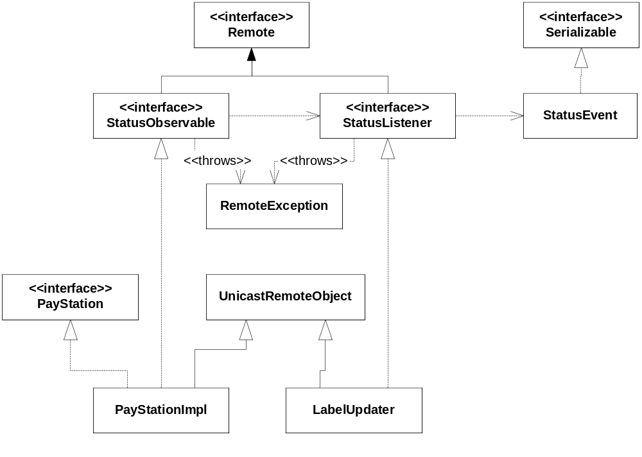
Figure 4 New interface/class design to allow Remote StatusObservable

This poses a problem in the existing unittest and these are updated to handle the new interface relation. Naturally this should warrant a re-design, yet as the assignment is Java RMI and not design; a nasty casting hack has been used to resolve the issue.

Second there was a problem executing the Echo example, and naturally therefore also the PayStation. This turned out to be a lack of a CLASSPATH environment variable, which should point to the location of the client proxy stubs. Once this was added the implementation worked.

In order to prepare the implementation for multiple instance realization a serial number was added to the command line to be merged with the object name when rebinding, in order to allow multiple instances by simply executing the same application multiple times with different serial number arguments.

Furthermore an argument was added to indicate the location of the RMI registry, so that it may be located at a central location, e.g. a single machine in the network.

Finally it was decided to make a single application, which, based on its command line arguments, would become a PayStation or a Monitor.

As a monitor may listen to multiple PayStations it should be possible to supply a list PayStations to listen to, which is again implemented as a command line argument indicating the serial numbers to listen to.

The specific location of the command line arguments, their syntax and the ant implementation of the execution is all described in the ant help, which may be extracted by writing “ant” in the PS07 directory (the root of the project). This also indicates what must be set up before the programs may be run.

Concurrency issues
Exposing an interface onto a network do not in itself open up any concurrency issues which do not exist already in a multi-threaded application with time-slicing activated.

There is, however, an issue with one of the synchronization mechanisms in Java, which must be addressed.

The method:

public synchronized int getValue() { x++; return x; }

Is a fine way of ensuring that x is protected from simultaneous access, resulting in a situation where the x returned may not be a nice collection of numbers increasing one with each return. This is due to the fact that the scheduler may schedule a thread out after the increment, yet before the return, allowing another thread to call getValue(), and thereby incrementing x again, before the original thread is scheduled back in and x is returned.

The problem with this synchronization in a Java RMI sense is in the nature of return. In a Java proxy the above would be translated to something like:

public void getValue()
{
// wait for incoming command from network
mutex.lock()
x++;
// transmit x to caller
mutex.unlock()
}

What happens if the caller dies while incrementing the x? This will make it impossible to transmit the reply, an exception is raised and the lock is never released, meaning that any subsequent call to getValue(), by another client, will block permanently.

A way to avoid this is to avoid using method wide synchronization and instead synchronize only what is needed. The above getValue may be implemented as:

public int getValue() {
mutex.lock();
x++;
int temp = x;
mutex.unlock();
return temp;
}

Why does this work? Because the temp variable is a local variable (stack variable in C++) and therefore unique to each caller!

This would be translated to something like this:

public void getValue()
{
// wait for incoming command from network
mutex.lock()
x++;
int temp = x;
mutex.unlock()
// transmit temp to caller
}

This means that it is irrelevant whether the transmission of the return value fails, as the lock has already been unlocked.

The above is of course more a discussion of an issue with Java RMI, than a look at concurrency issues.

There are two network enabled methods, and therefore two critical regions (from the network alone). In the code as a whole there are tons of concurrency issues.

The first method is the addStatusListener, which simply stores the reference to the StatusListener instance, be it remote reference (reference to client proxy) or local reference, in a list, which is then iterated when an event occur. No knowing the type of list (is it thread safe already?), and from a simple design rule stating that changing a list while it is being iterated is just bad form, this addition should be synchronized with the iteration method.

This iteration method is not in the interface, just like the list is not, as it is located in the implementing class. This means that the concurrency issue is in the PaystationImpl class, and a mutex lock should be implemented in the methods; addStatusListener and _notify(). Their now thread-safe implementation may be seen below:

private Mutex collectionMutex = new Mutex();
public void addStatusListener(StatusListener listener) throws RemoteException {
collectionMutex.lock();
listeners.add(listener);
collectionMutex.unlock();
}

private void _notify() {
collectionMutex.lock();
StatusEvent e = new StatusEvent(vacant, earned);
for( StatusListener l : listeners ) {
try {
l.update(e);
}
catch (RemoteException re) { }
}
collectionMutex.unlock();
}

The above protects from two concurrency issues. The first is in the addStatusListener itself, as multiple clients may call the method simultaneous, and it is not certain that the add call to the listeners collection is thread-safe.

The second is from the two methods both using the same collection, as these methods may also be called simultaneously.

The same issue are true for the actual update call, which may be called from multiple clients simultaneously. Below is the thread-safe version of the update method.

private Mutex updateMutex = new Mutex();
public void update(StatusEvent e) throws RemoteException {
updateMutex.lock();
eLabel.setText(" Reported Earning "+e.earned);
vLabel.setText(" Reported Vacant: "+e.vacant);
updateMutex.unlock();
}

When dealing with RMI there are two forms of protection; server side and client side. The update in the update method is pure server side, as it insures that the critical part of the update method may not be executed from the network simultaneously by multiple callers. It also protects from local callers, yet from an RMI perspective this is merely a bonus.

The client side concurrency protection may be seen in the _notify method, which ensures that one instance of the implementation of the StatusObservable interface (be it network client proxy or not), called from multiple threads, may not execute the l.update(e) methods from two threads simultaneously.

There is one more issue which have purposefully been left out, for simplicity, and that is the vacant and earned variables. These may also be accessed simultaneously, and should be protected. As these are never updated or read from the network it is safe to use the synchronized method, and the _notify() method should be updated as follow:

public synchronized Receipt buy() {
Receipt r = new ReceiptImpl(timeBought);
earned += insertedSoFar;
vacant --; // NOTE: Fake-it implementation!!!
timeBought = insertedSoFar = 0;
_notify();
return r;
}

private synchronized void _notify() {
collectionMutex.lock();
StatusEvent e = new StatusEvent(vacant, earned);
for( StatusListener l : listeners ) {
try {
l.update(e);
}
catch (RemoteException re) { }
}
collectionMutex.unlock();
}

Be advised that should any of the above methods need to be exposed across the network the above synchronization would not be safe, and another Mutex or a synchronize(this) inside the method, would have to be implemented.

The above code is not implemented and should be seen as high level pseudo-code, so syntactic or naming errors may occur.

Furthermore the design itself may also be updated to be more Concurrency friendly, yet this solution has not been considered further.

