Life-cycle problem
This problem arises when something is variable in the design, e.g. a Person changes state from Student to Teacher.

As inheritance is a strong binding it means that once a specific Person instance is created it can never change.

Person p = new Student(“Peter”, 28, 2007);

Assuming, for arguments sake, that a list of people exist:

ArrayList<Person> persons;

And the above Person p is inserted in the ArrayList, then the only way to change this person instance from a Student to a Teacher, if he graduates and gets hired by the school, is to remove the person object form the list, create a new Person instance which is a Teacher and copy the information to this new instance.

Person p = persons.get();
persons.remove(p);
Person newP = Teacher(p.firstName, p.age, 50000);
persons.add(pNew);

For solving this problem, the 3-1-2 process can be used as we (3) can identify something that varies in the design – e.g. the person’s roles. Therefore we must (1) program to an interface, not implementation and (2) favour object composition over object inheritance. This is what we will do in the following sections.

Context-problem
As mentioned in above the inheritance is a strong binding, and once a person is a Teacher it is not possible to change the type (or add to) the type of the instance, only replace the entire instance.

For this reason, with the inheritance structure, if a Teacher enrols in a course then the Person instance, which is a Teacher instance, must be replaced with something else. Now the question is what to replace it with. If the design is written in a language that supports multiple inheritance a new type may be created called StudentTeacher, as shown below.

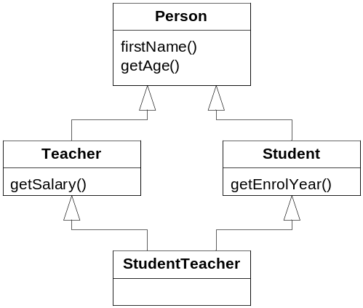

There are several problems with this, one of which being that not all languages support this.

An alternative solution, supported by more languages, is to use interfaces to represent the characteristics which are true for a Teacher and a Student and then allowing an instance to have all of these characteristics, as shown below in the “Role Subtype” pattern [Fowler97]:

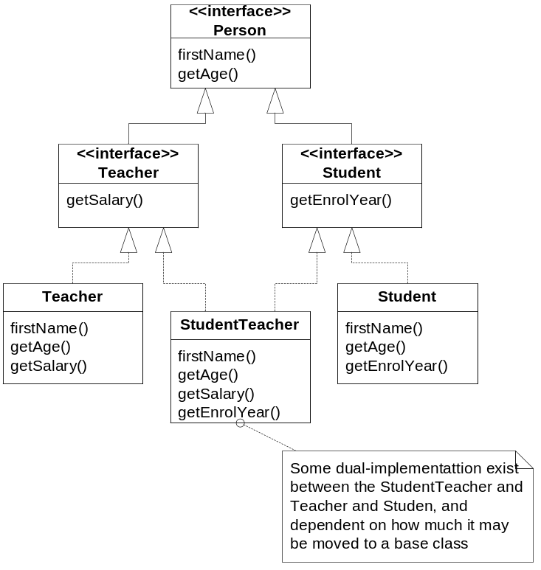

Also this pattern has its disadvantages, as also here the specific instance must be replaced for a Teacher to become a StudentTeacher. It also suffers from some risk of multiple implementations. Here a PersonBase class may be created which can be inherited from, yet if the hierarchy becomes bigger either a compositional approach has to be used or moving the implementation to utility-classes. The Compositional approach has the disadvantage that the StudentTeacher would have composite Student and Teacher instances which it can propagate its calls to, yet this is not efficient from a memory point of view, but also not from a logical, as now the instance holds other instances.

A solution to the above problem is to express the characteristics of the Teacher and Student in a “Role Object” pattern [Bäumer+99], as shown below
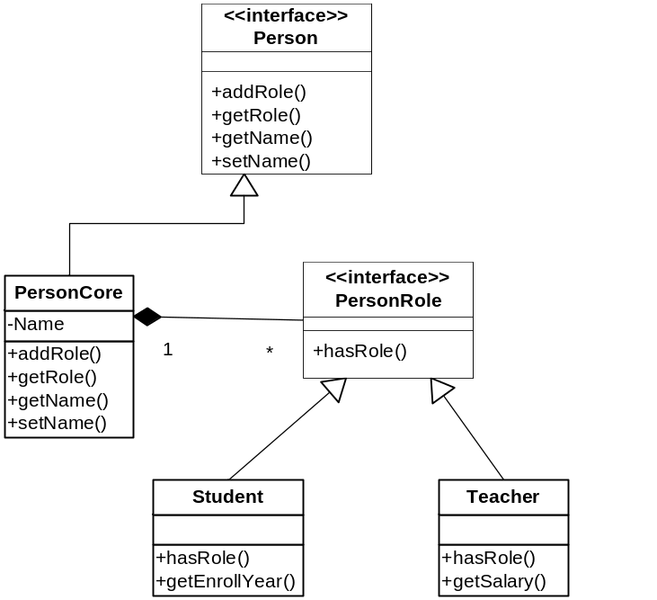

The above pattern is an extension of Fowlers Pattern [Fowler97] shown below:
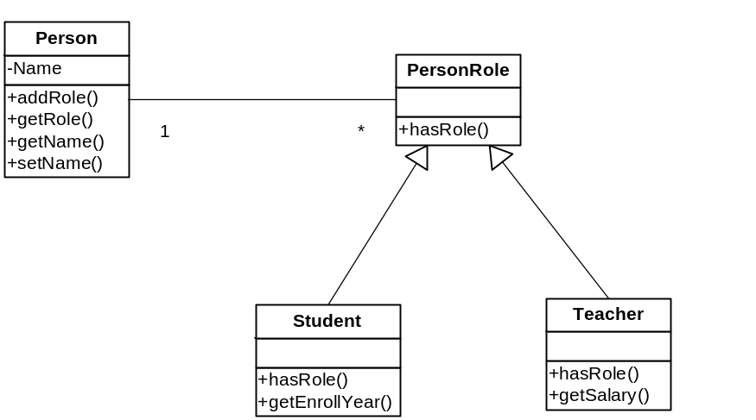

This will allow the instance of Person to never have to be removed as long as the person is attached to the institution, as clients ask the host object for the appropriate role to use a role’s features.

Person subject;
Student subjectStudent = (student) subject.getRole(“Student”);
Int year = subjectStudent.getEnrollYear();

Summary of context problem:
If there are significant common and shared behaviours between the roles as in this context, use either “Role Subtype” or “Role Object”. See [Fowler97] for other possibilities.
Use “Role Object” if there are lot of roles or new roles often appear.
If this isn’t the case, use “Role Subject”, especially if you roles have strong interdependencies.

Consistency problem
In this scenario the Person instance do not change type (e.g. from Student to Teacher) it only changes member data. This may be accomplished in a single operation by all three solutions mentioned above. Naturally the first requires that it is multiple virtual inheritance. In the second both Teacher and Student has a getName(), yet as they are interfaces there will only be one implementation; this is also the reason why virtual inheritance must be used in the first solution if programming C++. In the third solution the name is part of the Person class and is therefore directly changeable, yet if it was an attribute that should be changed then it is important that the information in the attribute do not exist in other attribute. Content dependency between attributes is not supported.

Some implementation.
A person can have one or more roles, and you have a list of persons:
ArrayList<Person> persons;
If you want to find all students, you have to search through the list:
foreach (Person p in persons)
{
if (p.hasRole(Student))
{
System.out.printLine(p.getName());
System.out.printLine(p.getRole(Student).getEnrolYear());
}
}
The same thing applies if you want to find a person with a certain name.
foreach (Person p in persons)
{
if (p.getName() = "Dennis")
{
Student s = p.getRole(Student);
if (s != null)
{
System.out.printLine(s.getEnrolYear());
}
Teacher t = p.getRole(Teacher);
if (t != null)
{
System.out.printLine(t.getSalary());
}
}
}
It’s therefore possible that the same person can be a student and teacher.

One of the problems which may occur with concurrency is if it was decided that instead of changing the type of instance, when a Teacher enrolled in a course, then an instance of the Student type was simply created and added to the list, so there was now two distinct instances, one Teacher and one Student, representing the same person. In this instance it would be impossible to update the name with a single call and the risk of inconsistency is great.

References
Fowler97 Martin Fowler. “Role Patterns”. Submitted to PLoP ’97. http://www.martinfowler.com/apsupp/roles.pdf.
Bäimer+99 Bäumer D,Riehle D, Siberski W and Wulf M. “The Role Object Pattern”, Plop ’97.
Revised version: http://www.riehle.org/computer-science/research/2000/plopd-4.pdf.

