Programming Project
HotTargui
Contents

1 Assignment 4B 3
1.1 Peer to peer 3
1.2 Domain Server 3
1.2.1 Propagation of server state changes 4
1.2.2 Invoking of game methods from ClientGUI 6
1.2.3 Implementation of architectural prototype 6
1.2.4 Comments to the progress of my hand-in 6

Assignment 4B

Peer to peer

Domain Server
Unlike peer-to-peer networks, where network information is uniquely decentralized, the network information stored on a centralized file server PC is made available to tens, hundreds, or thousands client PCs. A client-server network is capable of handling more amount of information flow that a peer-to-peer network might.
Below we have sketched a class diagram for a distributed client-server system based on RMI for HotTargui:
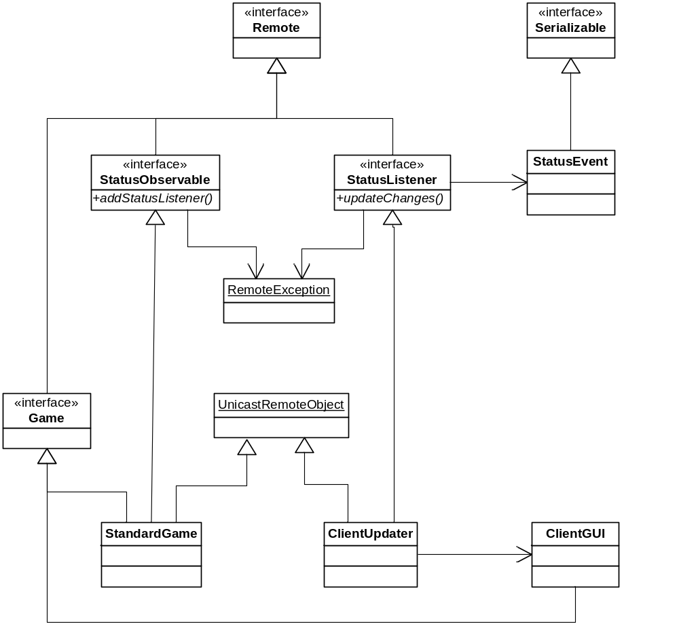

Propagation of server state changes

Propagation of server state changes to the clients is implemented with an observer pattern.

The StatusObservable interface (the subject role) enables an Observer/Listener to be added and is exposed by the addStatusListener method.

In order to expose an interface on the network using Java RMI the interface must extend the interface Remote, and all methods of the interface must throw the RemoteException.

This means that the StatusObservable looks like this:

public interface StatusObservable extends Remote {
/** Add a status listener to this instance */
public void addStatusListener(StatusListener listener) throws RemoteException;
}

The StatusObservable needs to be exposed globally, and this is done by calling Naming.rebind supplying the location of the registry and the name of the object. Something like:

clientGUI cGUI1 = new clientGUI();
try
{
StatusObservable so = (StatusObservable)cGUI.getGame();
// Expose game class
Naming.rebind("//" + host + "/" + playerColor + "HotTargui", so);
}
catch (exception-classname variable-name)
{
handler-code
}

On the other side a previously exposed object may be retrieved by calling naming.lookup. Something like:

TestGame tG1 = new TestGame();
try
{
StatusObservable so = (StatusObservable)Naming.lookup("//" + host +
"/" + playerColor + "HotTargui");
so.addStatusListener(tG1.getStatusListener());
}
catch (exception-classname variable-name)
{
handler-code
}

The StatusListener interface (the observer role) enables a StatusObservable to event back to the observer/listener (callback). This interface is passed by reference in a networked call (addStatusListener).

public interface StatusListener extends Remote {
/** invoked whenever a game changes state. */
public void updateChanges( StatusEvent event ) throws RemoteException;
}

The StatusEvent class, which is passed as an argument to the updateChanges method of StatusListener, contains a value for State. Parsing an argument by value is done by letting the class implementing the Serializable interface:

public class StatusEvent implements Serializable {
public StatusEvent(State state) {
this.state = state;
}
/** the state of the game */
public State state;
}

ClientUpdater implements StatusListener on the client site and receives the state changes.

To allow interfaces to be visible on the network, they must be implemented and the instance added to the global registry. In Java RMI the server may be generated using reflection and it is therefore enough to have the implementing class to extend the class UnitcastRemoteObject, which is a kind of generic server proxy stub.

This means that the ClientUpdater looks like this:

public class ClientUpdater extends UnicastRemoteObject implements StatusListener {
private State gameState;
public ClientUpdater(State gameState) throws RemoteException
{
super();
this.gameState = gameState;
}

public void updateChanges(StatusEvent e) throws RemoteException {
//To do
}
}

This constructor just invokes the superclass constructor, which is the no-argument constructor of the Object class. Although the superclass constructor gets invoked even if omitted from the ClientUpdater constructor, it is included for clarity.

Invoking of game methods from ClientGUI

To call game methods like rollDie() from ClientGUI it need a remote reference to server object.

public class ClientGUI extends JFrame implements Game {
}

This declaration states that the class implements the game remote interface and therefore can be used for a remote object.

Letting ClientGui implementing the game remote interface is not a good idea – not only because game.getState() conflicts with getState() in java.awt.Frame – it is just not good design. A Façade pattern might be a good solution - or if it should be more advanced - a Model-View-Controller pattern.

Implementation of architectural prototype
To create the architectural prototype we stripped down the code to domain data only, which consists of board and game state information. The data is collected behind the interfaces Game and Board.
New domain data files (StatusEvent.java, StatusListener.java and StatusObservable.java) are located in hottargui.domain.
New Client files (ClientUpdater.java and ClientGui.java) are located in hottargui.client.

Comments to the progress of my hand-in

Because of periods of stress I ran out of time. I was not able to catch up finishing the architectural prototype :-(

Only code in skeleton form for the architectural prototype has been produced, so the class diagram drawn for the distributed client-server system has not been verified.

Other things that has not been clarified:
- Which information beyond game state information should be exchanged between client and server?
- How do we find the players?

