DeltaTargui

New requirement: Randomized board

Analysis
In DeltaTargui some new requirements has arose. Amongst them is a requirement of creating a randomized board instead of the predefined board from AlphaTargui. For this change of requirements, an analysis is made to help determine the right way of implementing the new requirements.
It is noteworthy, that this requirement actually is a change of a previous defined requirement. The requirement is therefore considered as an addition to a requirement defined in the past – the new requirement is a variant of an older requirement.
Now that is clear, that the new requirement creates a variability point in our system, we sought out to find the best way of implementing the new requirement. For implementing the new requirement in a safe manner, we will use some principles for achieving a flexible design. The principles are:
- Change by addition, not modification. The code we produce for fulfilling the new requirement should be an extension of the existing code. The AlphaTargui code is considered stable and no further modifications should be made to the code base. A good reason for is that DeltaTargui is only one of the variants of the AlphaTargui code base. BetaTargui will also rely on the AlphaTargui, so if the AlphaTargui code base is changed, BetaTargui will surely run into trouble.
- Keep code open for extension. In the future, someone might want to create a variant over DeltaTargui – a variant of the variant. The DeltaTargui code should be implemented so it is possible to extend it without making modifications to the DeltaTargui code base.
Now that we setup some of the goals with the new variant, we will identify the variability points in the implementation using the 3-1-2 process.
- 3 – Encapsulate what varies. In this requirement it stands clear, that it is the layout of the board that varies. In AlphaTargui an abstract factory has been introduced to ease composition of the board. This factory is named BoardFactory and the responsibility is described as:
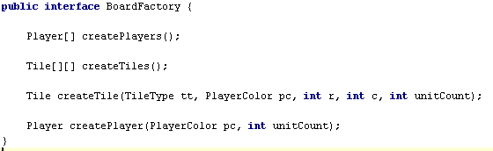

In AlphaTargui, we created an implementation of the BoardFactory named AlphaBoardFactory. The implementation placed all tiles on the board in a predefined way. The responsibility for creating the board was implemented directly in the AlphaBoardFactory.
1 – The DeltaBoardFactory should not be directly dependant on a implementation of the randomized board. Therefore, we chose to introduce the BoardLayoutStrategy interface. The strategy removes the responsibility of the board layout from the BoardFactory and delegates it to the chosen strategy.
2 – By letting the DeltaBoardFactory composite the tiles with help from the BoardLayoutStrategy, we make sure that it will be possible to e.g. change the board on runtime – e.g. there is not compile-time bindings as we only assume an implementation of the BoardLayoutStrategy. This gives us very loose coupling between the factory and the implementation.
In DeltaTargui we have chosen to make an implementation of the BoardFactory, DeltaBaordFactory and let the factory create the players and the board. The creation of the tiles is delegated to the BoardLayoutStrategy. For the DeltaTargui, the createTiles() is implemented in the RandomBoardLayoutStrategy. The method creates the tiles and places them randomized on the board. A snippet of the design is outlined below:

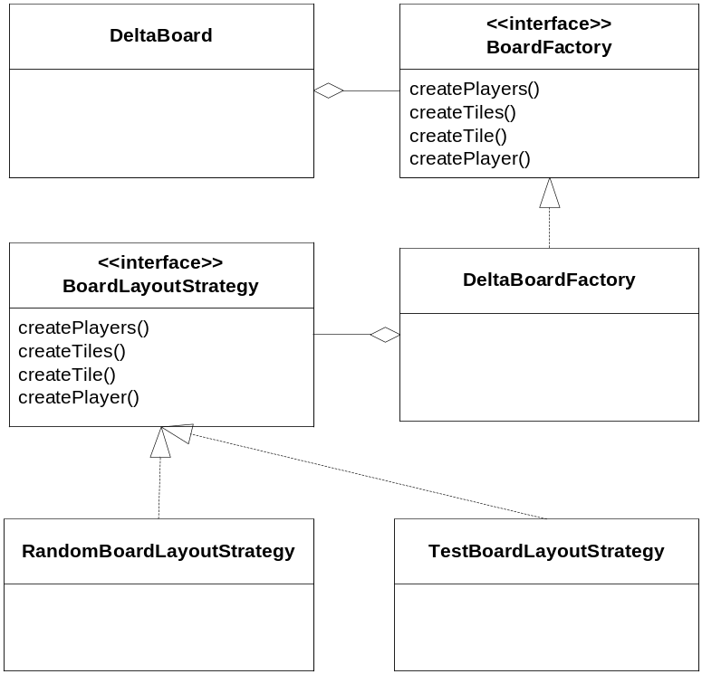

In DeltaTargui we could have chosen to implement the new requirement directly in a realization of the BoardFactory interface named DeltaBoardFactory. This would have made reuse of a certain layout for the board harder as it is hardcoded into the DeltaBoardFactory. Upon creation of the strategy for the board layout, it is also possible to create a strategy which makes it easier to test the board layout is as expected.
The code snippet for the DeltaBoardFactory is below:
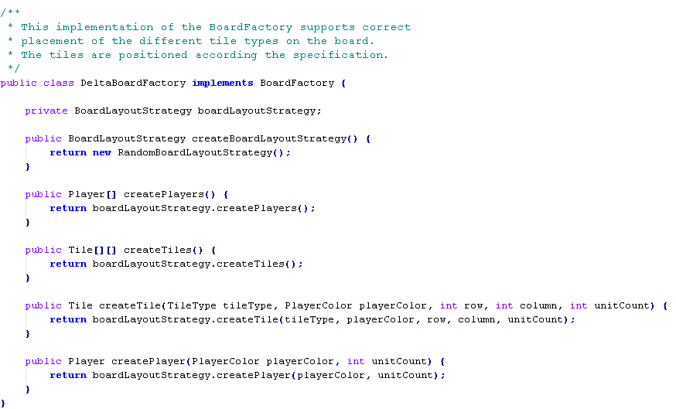
Upon implementing the strategy for the layout of the board we have noted some benefits and liabilities upon using the above mentioned design.
Benefits:
- Easy code extension. It is easier to extend the functionality of the variant as change by modification is used.
- Encapsulation of responsibility is very clear as each code block only has well-defined responsibility.
Liabilities
- Bloat of interfaces and implementations. Suddenly, it becomes very obvious why a good naming convention of the interfaces is needed. It does not take long before the code mass seems overwhelming.
- (Traceability) One might say that tracing each method call becomes difficult as the call is delegated on. A good class diagram is needed for this purpose.
- Difficult to explain to “the uninvited” – for a person new to the project it might be difficult to get an overview of the code.

Implementation
DeltaBoardFactory implements the algorithm defined in the project description. The algorithm is stated as:
- The saltmine is positioned in the center of the board.
- The different types of tiles are placed randomly on the board. The number of each tile type is predefined.
- Each corner tile is replaced with one of the four settlement tiles. The position is as follows:
- Red settlement – Upper left corner (0, 0).
- Green settlement – Upper right corner (0, 6).
- Blue settlement – Lower left corner (6, 0).
- Yellow settlement – Lower right corner (6, 6).
To take small steps and keep focus, the above steps are implemented in multiple iterations. In each step a requirement is implemented.
The test list contains a test that reads: “Tile positions matches specification”. This test definition is not very concrete and the test is therefore broken down into smaller tests, who match each of the three identified iterations.

Position saltmine
we need to position the saltmine in the center position of the board according to the specification. For this purpose we add the test case ‘testSaltmineCenterPosition’ to the newly created TestDeltaBoard class. Testing for the position of the saltmine is simple:

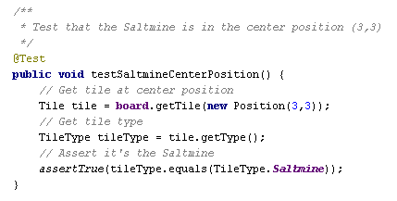

Position tiles randomly on board
In AlphaTargui, we created an instance of the BoardFactory with fixed positioning of the tiles. We generated test cases for the fixed positions.
Now, we have to generate random positions for the tiles, who we add to the board. Compared to the AlphaTargui, this serves a new problem. In AlphaTargui, a tile has the responsibility of knowing its own position. This means, that the board does not have any knowledge about where each tile type is positioned. The board can determine the type of the tile, position, owner and units on the tile by using the tile interface.
When we need to add tiles randomly to the board, we should not place a tile on the board, where a tile previously has been positioned. This is only the case when placing the settlements.

Lessons learned: Read specification carefully!
When implementing this requirement, the first approach was to generate the positions, available for the tiles that should be positioned. Generating the positions was fairly simple with a double loop:
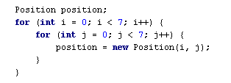
This loop created all the positions on the board. The positions were held in a collection, where each position was removed and assigned to a tile. Creating the tiles stated in table 2.1 in the requirements specification was simply a question of looping the number of times according to each specific tile and create the tile.
The created tiles were held in a collection. This collection was iterated an assigned a position from the available positions.
Although the algorithm for filling the board, there was not paid so much attention to the sequence of the steps, hence they were altered to the below mentioned for ease of implementation.
  - Place the ‘Saltmine’
  - Place the settlements on the predefined positions.
  - Place the randomized tiles.
There were 49 available positions. Suddenly the createTiles() method started throwing IndexOutOfBounds exceptions. This was strange; because the test cases created for probing the number of each tile type was not revealing any defects. The correct number of tiles existed. Debugging the loops and reading the table again didn’t reveal anything.
OK, back to good old system out. Everytime a tile was created, a line with a description of the tile was printed. Before assigning positions to the tiles, the line count was 53. Not 49 as the available positions. Summing the numbers in table 2.1 also gave 53.
Reading the algorithm for populating the board revealed the defect; the settlements were to replace the four corner tiles, meaning that four random tiles were discarded from the game. Implementing this was thought to be simple, but later proven otherwise. As we removed positions from a collection upon tile creation, these positions were used and no longer available. How to reassign the pre-defined positions for the settlements?
A new solution was made: We created a simple deck interface with the responsibility of creating a deck of tiles according to the DeltaTargui specification.
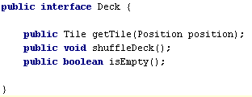
Internally, the deck implementation (DeltaDeck) consists of stack, which is given the tiles for the DeltaTargui specification.
A new implementation of the Tile interface was made (DeltaTile), where it’s possible to assign a position to a tile after creation. Randomness was made by using the Collections.shuffle method in Java. This method applies standard random behavior. The original object-oriented thinking is very much applied to this implementation. The deck is seen as simulation of a part of the physical world.
Another advantage of the new deck interface is that responsibility for creating the deck is separated out from the DeltaBoardFactory.
What we learned from this episode are:
  - Read the specification, even small changes can mean a lot to the architecture.
  - Making mistakes might lead to better software, as we were forced to think the things over again.
  - Place test cases at the “right level”. In this case it was good that we tested for the amount of each tile type. This eventually led to a reveal of a defect. If we had tested for the amount of tiles on the entire board, this would probably not have happened.
  - Test cases make code evolve and vice versa. The test cases we initially created revealed a defect. But as the code changed, some of the test became outdated. It’s not possible to test for a specific number of tiles, when some of tiles are randomly replaced. Though, the test cases are OK, when they are run before the tiles are replaced.
  - Keep test cases isolated.
  - Refactor step in TDD is important, as the “gold” is here. The reflections made here are very important for your code and often provides efficient code changes.

Lesson learned: Stable code base is needed!
Developing of the DeltaTargui was begun before the AlphaTargui code base was stable. We had chosen to make a copy of the AlphaTargui source and use the AlphaTargui code base for developing the new variant. Development of the new variant begun, but the interface of the BoardFactory had methods that changed signatures parallel to development of the DeltaTargui. So, a new feature was needed from AlphaTargui and the source code corresponding to AlphaTargui was updated from Subversion. Suddenly, some of the methods of the BoardFactory returned tiles in another way.
The solution was to be “interface-adherent” and comply to the specification posed by the interface.
This caused only minor annoyance, but looking at how few source files we have been developing in this project we can easily figure out what pain it might cause in larger projects.

Conclusion
The new requirements for DeltaTargui was fairly easy to implement as we have made some good design choices when implementing AlphaTargui.

