Qt 6.8.0 build from sources

build process on windows

Ahmad Rashed

2024

Contents

1. Description 1

2. Implementation 2

2.1. Prereq. 2

2.2. Global pointers 2

2.3. MFStartup function (mfapi.h) 3

2.4. MFCreateAttributes function (mfapi.h) 3

2.5. IMFAttributes interface (mfobjects.h) 4

2.6. IMFAttributes::SetGUID method (mfobjects.h) 4

2.7. IMFActivate interface (mfobjects.h) 5

2.8. MFEnumDeviceSources function (mfidl.h) 5

3. Source code of full example: 7

References 9

# Description

This document explains the building process of Qt 6.8.0 version from sources. Process steps are explained in detail [1] and [2]

# Environmet

To build Qt on your machine dependencies mentioned in [1] are needed.

# Building from sources

1. Search for VS Native Tools command prompt.

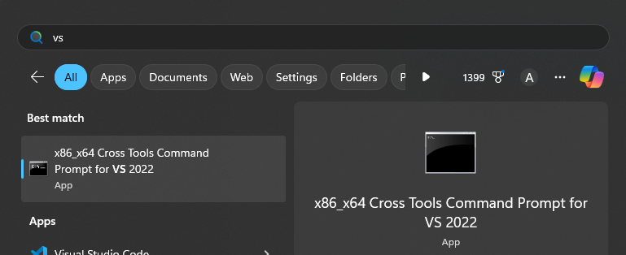

1. Navigate to ”C:\Program Files\Microsoft Visual Studio\2022\Professional\VC\Auxiliary\Build\” and run ”vcvarsall.bat amd64”

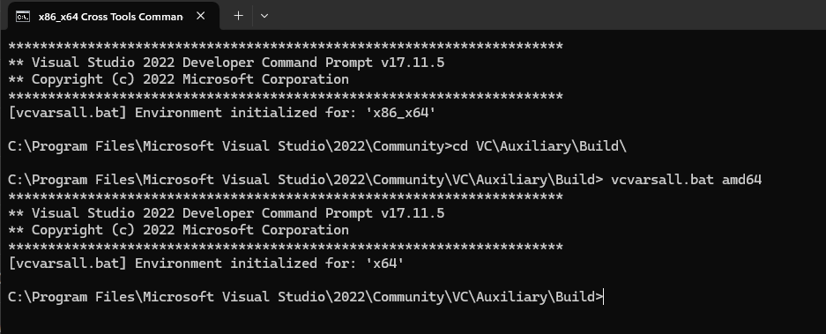

1. Navigate to the desired installation folder and clone qt repo.

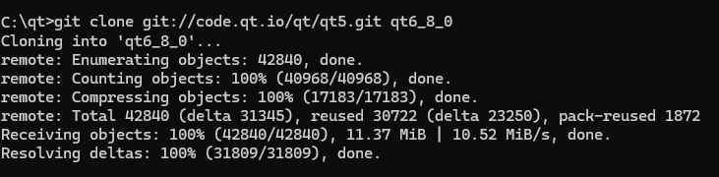

1. Navigate to the cloned repo. and checkout tag of the needed version

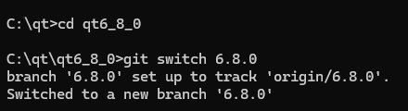

1. initialized and configure

> .\init-repository.bat

1. when finished do the following: (Configuration options can be found in qt official website)

> mkdir qt-build

> cd qt-build

> ..\configure.bat -prefix <destination> -platform win32-msvc -c++std c++20 -debug

1. After configuration build it:

> cmake --build .\ --parallel

1. Install it:

> cmake --install .\

# References

|  |  |
| --- | --- |
| [1] | Qt, "Building Qt 6 from Git," Qt, 03 10 2024. [Online]. Available: https://wiki.qt.io/Building_Qt_6_from_Git. [Accessed 27 10 2024]. |
| [2] | Qt, „Qt for Windows - Building from Source,“ Qt, [Online]. Available: https://doc.qt.io/qt-6/windows-building.html. [Zugriff am 27 10 2024]. |