Gear Indicator connection to a Kawasaki service connector
- Find service connector
99% Kawasaki bikes have service connector under the passenger seat. Type of the connector or its shape and color can be different in comparison with the one on the photo (Z750 -2008). Common feature of the connector: it is possible to push 4 into it.
- Remove the connector protector
On the top of service connector is the protector. Remove it and save it for future use if necessary.
- Connection
Connect indicator pins into service connector as displayed on the photo below.

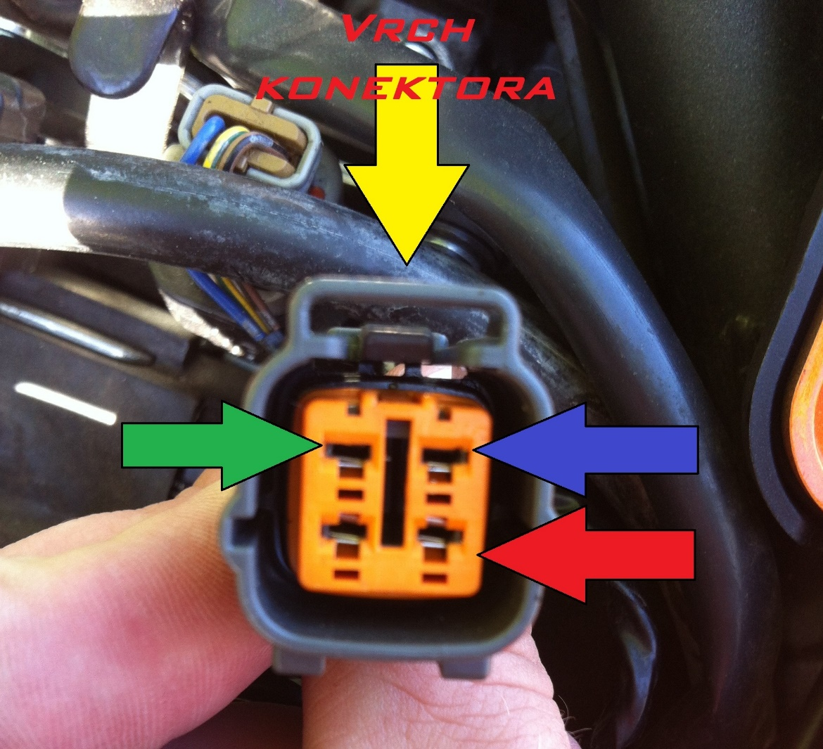
TOP OF THE CONNECTOR
KBUS`
GND
+12V

- Proper insulation
After correct connection of all pins into service connector ii necessary to proper insulate everything by PVC tape to avoid shortcut or contact with water.

Note:
In case of accidental short cut during the installation the protecting fuse of the service connector can be blown. It is recommended to lead the cable smoothly without sharp angles and avoid contact with hot parts of the bike’s engine.

