Gear indication installation guide for Kawasaki bikes
- Turn off ignition to prevent accidental protecting fuse blow during installation. (Better scenario would be additional work to change the fuse).

- Install the indicator to a suitable place
Select suitable place for installation to be visible during riding the bike. Ideal place is just beside the speedometer on the smooth plastic or metallic surface. Use degreasing agent to properly clean the surface. Remove the foil from the adhesive tape at the bottom of the indicator and place it to a desired location. Press and hold for about 10s (according to recommendation of 3M double-sided adhesive tape manufacturer).
- Find the service (diagnostic) connector
99% Kawasaki bikes have service connector under the passenger seat. Connector color can be various – grey, black, or transparent but it is always 4-pin connector.

- Fix the indicator cable
Indicator cable should be routed together with other bike cables up to the service connector. Don’t stretch the cable nor do sharp bends. Keep minimum radius 20mm. In case of installation to handlebars or any other movable part allow free cable move. Fix cable at multiple places by using plastic ties and route it up to service connector.
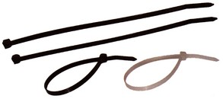
Avoid cable contact with hot parts of the engine to prevent its damage by heat.
- Remove service connector protector
Service connector can be equipped by protector. Remove it and save in case the indicator will be uninstalled in the future. The protector can look like this:
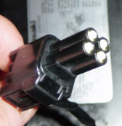
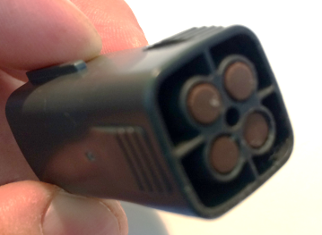

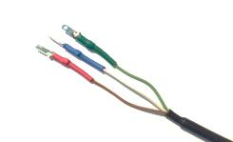
- Connect indicator cable to connector
Cable is ended by 3 colored wires – red, blue and green. Connect these wires as displayed on the picture below:
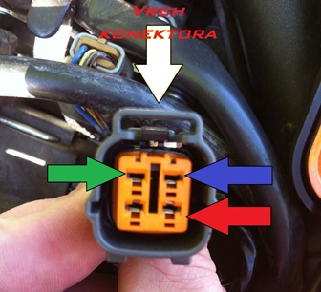

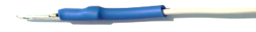
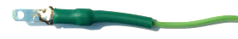

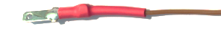

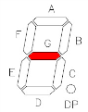
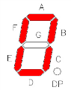
- Turn-on ignition
Indicator will show welcome message “LEtS ridE“ and consequently displays numbers from 0 to 6 and back 6 to 0. Then indicator starts to communicate to bike control unit (ECU). In case of correct installation and neutral gear set (even without running engine) should indicator show ‘0’ (neutral) or ‘-‘.

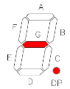
In case indicator showing ‘-‘ character together with ‘.’

it means indicator is not communicating to ECU. Check the connection again.
- Insulate and protect the connector with PVC tape
Turn-off ignition again. Insulate the connector by using PVC tape and fix wires inside the connector properly to avoid disconnection by vibrations. PVC tape also protects connector against water.

„ShiftLight“ function setup – RPM over limit indication
WARNING !
Pre-condition for the setup of this function is fully functional gear indication on your bike. If your gear indication works correctly, you can start „ShiftLight“ function setup.

Before the setup it is recommended to heat-up the engine to operation temperature to avoid negative impact of high RPM on the cold engine.

- Turn-off ignition.

- Disconnect green wire from the service connector. Rest of wires (red and blue) leave connected.
- Connect Green wire to the ground (- pole). Ideally connect Green and Blue wires together at the point of Blue wire connection to service connector. (It is enough to connect metal part of Green wire metal part with Blue wire metal part and hold it by hand).
- Turn-on ignition. Indicator will show “LEtS rIdE 1-2-3-4-5-6-5-4-2-1”. Wait 2-3 seconds until indicator shows ‘P’. That indicates that ShiftLight function setup mode is active.
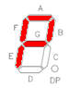

- Turn-off ignition.

- Connect Green wire back to service connector.
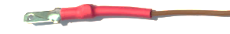
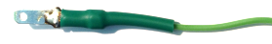
CONNECTOR TOP

- Turn-on ignition and start the engine immediately. Wait until indicator shows ‘P’. It indicates that ShiftLight function setup mode is active.
- Increase RPM to desired limit (>2000 RPM) and keep it for 3-4 seconds. ‘P’ displayed on the indicator will start blinking which indicates that RMP limit value was correctly stored to the memory.

- Turn-off ignition immediately to finish ShiftLight function setup correctly.

- Insulate the indicator’s connector by using PVC tape and fix wires inside the connector properly to avoid disconnection by vibrations. PVC tape also protects connector against water.

Set Gear Indicator to default setting (without ShiftLight function)
- Follow steps 1 to 5 of „ShiftLight“ function setup – RPM over limit indication.

- Leave Green wire disconnected from the service connector. Ensure that Green wire is air-gapped from any other part of the bike.

- Turn-on ignition and wait until indicator displays ‘P’.

- Wait another ~10 seconds until indicator displays ‘-‘ together with dot ‘.’

- Now is the Gear Indicator in default state (without ShiftLight function).

- Turn-off ignition.

- Connect Green wire back to service connector.

- Insulate the indicator’s connector by using PVC tape and fix wires inside the connector properly to avoid disconnection by vibrations. PVC tape also protects connector against water.

