Kenza FENJIRO

**The Situation of Moroccan Children**

horizontal line

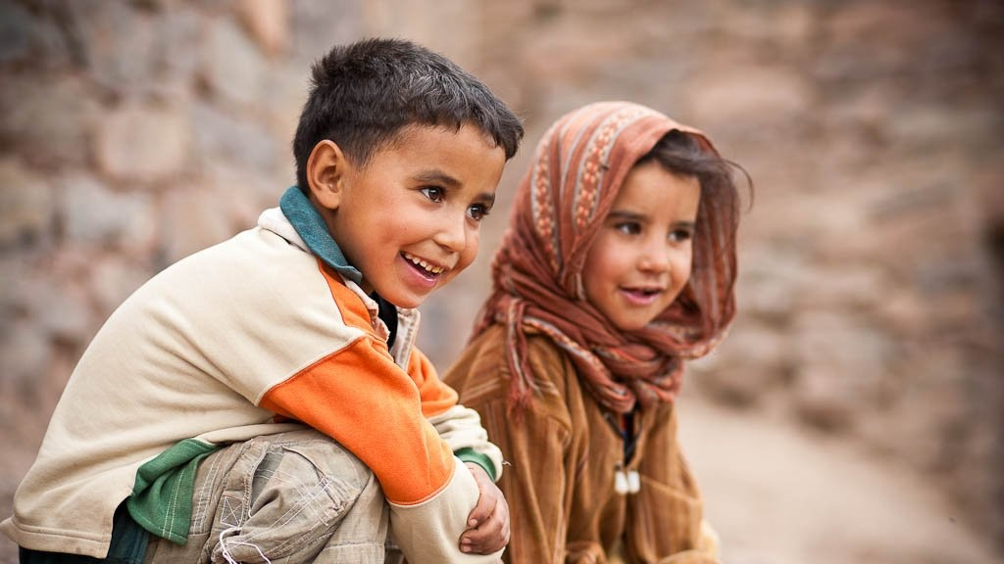

*The smile of Moroccan children.*

Knowing the current situation of Moroccan children is really important before acting, that’s why it is crucial to know some primary facts. First of all, almost a third of the Moroccan population is made up of children from 0 to 17 years old. But according to UNICEF (United Nations International Children's Relief Fund), nearly 12.1% of children are in a situation of poverty / monetary vulnerability and multidimensional poverty in at least one of the eight fundamental children’s rights (water, sanitation, housing, nutrition, health, medical coverage, education and information) which makes their education even more difficult. Indeed, in Morocco nearly one in two children drop out of school before entering high school for multiple reasons. Even though public school can be free, parents have to pay school supplies such as backpacks, notebooks, and books which can be a lot of expenses for those who can’t afford it. Moreover, the circumstances are not the same in city as well as in countryside, knowing that in rural areas, it’s more difficult for children to go to school because of the gender gap and lack of transports and schools in there. Unfortunately, the situation worsened especially during the global pandemic of covid-19: the most disadvantaged children were unable to continue their studies due to lack or insufficiency of necessary supports (smartphones, laptop, internet connection…). However, this position can change if we all pull together in order that every child prosper, study and become an efficient member in the future. Donation, orphan sponsorship, fund raising… all the initiatives coming from you can be beneficial. So let's not stand idly by and let’s help each other to make all the Moroccan children happy !

**References :**

* <https://aujourdhui.ma/societe/situation-des-enfants-au-maroc-le-rapport-choc-de-lunicef>
* file:///C:/Users/acer/Downloads/HCP-UNICEF_%20rapport%20sur%20l%E2%80%99impact%20de%20la%20COVID-19%20sur%20la%20situation%20des%20enfants.pdf
* <https://www.unicef.org/morocco/les-enfants-au-maroc>