Rhea SURAJ

**Biotechnology**

horizontal line

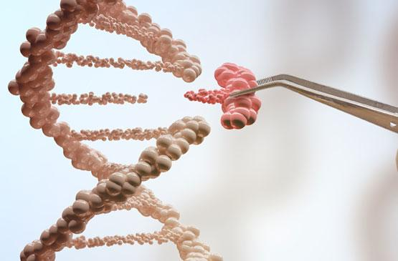

***Is genetic engineering a good idea?***

Biotechnology is a fascinating branch of applied science where living organisms or parts of living organisms are used to develop products and technology. It usually overlaps across fields like microbiology, biochemistry, genetics, pharmacology, etc. Biotech is taking nature’s most basic processes to introduce advanced technology. Pretty cool, right?

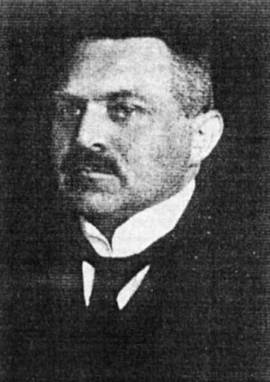**When did this start?**

Hungarian engineer Károly Ereky coined the term ‘biotechnology’ in 1919. However, people have been using this concept for a long time. Indeed, biotechnology goes as far back as 8000 BC - when cheese and bread were first invented! Both these inventions have enzymes and microbes that contribute to their productions; thus making them basic yet marvelous examples of biotechnology. Beer, wine and yoghurt were also early applications of biotech.

**Karoly Ereky**

**Zymology**

Fermentation is the chemical process of breaking down a substance by microorganisms. Zymology, also called zymurgy, is the science of fermentation. Yes, the applications for fermentation in biotech is so broad that it has an entire field of science fully dedicated to it.

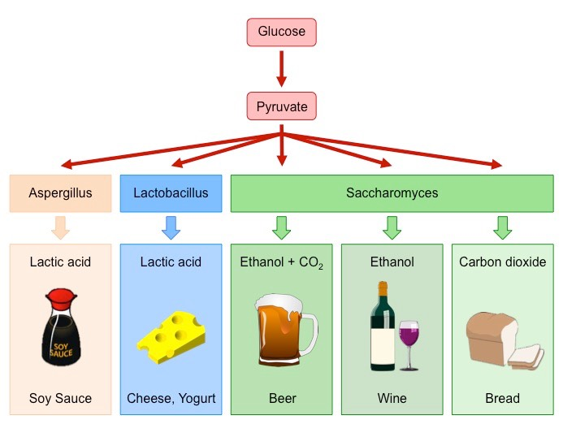So, what comes under this subject? Zymology includes distilling, brewing, wine making, etc. There are 3 major types of fermentation that divide zymology. Lactic acid fermentation, one of the oldest kinds, helps make products like pickle, kimchi, sauerkraut and yogurt. Second is alcoholic fermentation, the most well-known type, that helps produce ethanol in beer and wine. Finally, acetic acid fermentation. This type starts right after alcoholic fermentation and usually results in vinegar.

**Some examples of fermentation**

**Modern inventions**

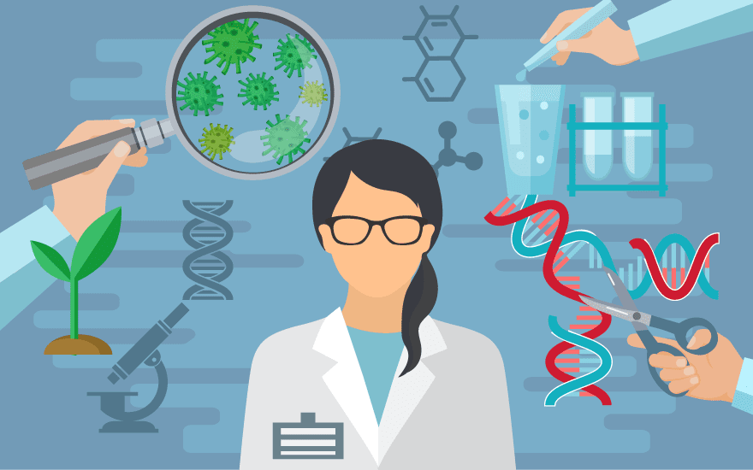After an enlightening and unknown start, biotechnology started picking up interest in the science field and scientists began extensive research on the same. The end of the World War II brought critical developments that paved the way to modern biotechnology and its achievements. Some inventions that have had a major impact are genetically engineered vaccines, gene therapy, artificial hormones, the list goes on. Synthetic human insulin was among the first major breakthroughs made in this field. People used insulin from the pancreases of animals to manage diabetes and similar conditions - until 1982. E. coli bacteria was used to produce the first genetically engineered synthetic “human” insulin in 1978. In 1982, Eli Lilly then sold the first commercially available, biosynthetic human insulin under the brand name Humulin. Vaccines developed from microorganisms and microbes like the measles vaccine, mumps vaccine, typhoid vaccine, etc. are also amazing examples of some modern developments in this field.

**Biotech and its uses**

**How does biotech help us?**

According to <bio.org>, there are currently over 250 biotechnology healthcare products and vaccines commercially available to people worldwide, many for previously untreatable diseases. Over 13.3 million farmers around the world use agricultural biotechnology to increase yields, prevent damage from insects and pests and reduce farming’s impact on the environment. And over 50 bio-refineries are being built across North America to test and refine technologies to produce biofuels and chemicals from renewable biomass, which can help reduce greenhouse gas emissions.   
Modern biotech helps combat rare diseases, create a greener manufacturing process, reduce our environmental footprint, etc. It is creating treatments to reduce health risks through side effects, improving efficiency of the manufacturing process, using biofuels to cut greenhouse gas emissions, providing foods free of allergens and toxins, reducing waste generation and so on.

**Is it *all* good?**

Despite the many advantages of biotechnology and its related products, there are a few drawbacks to the same. At the top of the list - ethics. The ethics in following biotechnological developments like cloning and gene modification have been the topic for debates for decades. The discussion mainly lies in the different methods and practices used in the research for these topics.   
Second, the expenses. Research, machinery required, and approval for the commercialization of just one product can cost a lot. According to a study in 2011, the cost of discovery, development and authorization of a new plant biotechnology trait introduced between 2008 and 2012 is US$136 million. Not to mention the time to implement these changes in healthcare and other fields. Initiation of these products to the commercial launch is over 13 years.

The third concern over biotech is the uncertainty of its long-term and side effects. Although the direct improvements are obvious, they may not only affect the future in unforeseen ways but also bring about unwanted changes in the lifestyle and general health of the people.

**Conclusion**

Biotechnology and its developments have had a significant impact on the world for a long while now. It continues to improve the world and make our lives easier. Despite its inconveniencies, it comes with various advantages, benefits and the power to change the world. It is up to us, as humans and individuals, to decide how we use this extraordinary field!

**References**

* Zahra N. *Introduction to Biotechnology.* Research. University of the Punjab, 2015
* Phillips McDougall. *Getting a Biotech Crop to Market***.** Study, 2011.
* Joseph Stromberg. *A History of Biotechnology in Seven Objects.* [Online] Available from: <https://www.smithsonianmag.com/smithsonian-institution/a-history-of-biotechnology-in-seven-objects-180947559/> [Accessed 30th July 2021]
* Linda Hall Library. *Fermentation Science.* [Online] Available from: <https://libguides.lindahall.org/fermentation> [Accessed 30th July 2021]
* Biotechnology Innovation Organization. *What is Biotechnology?* [Online] Available from: <https://www.bio.org/what-biotechnology> [Accessed 30th July 2021]