Derive g wrt N1

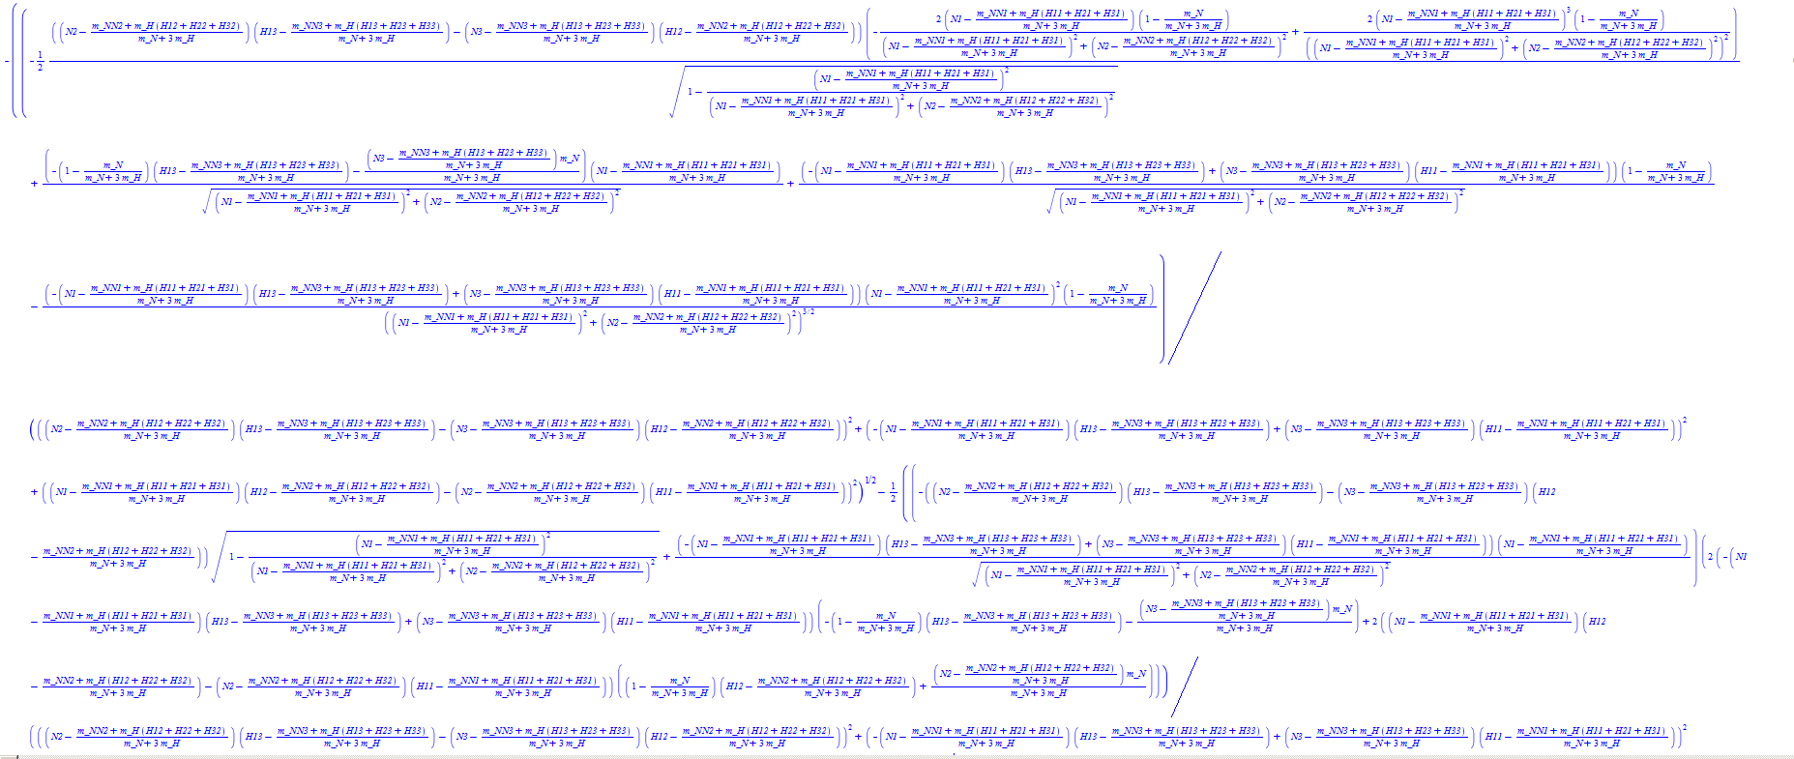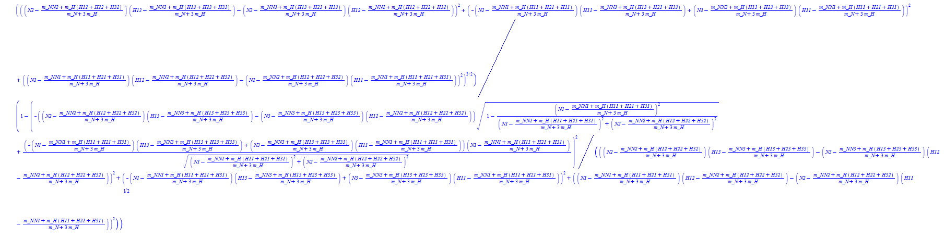

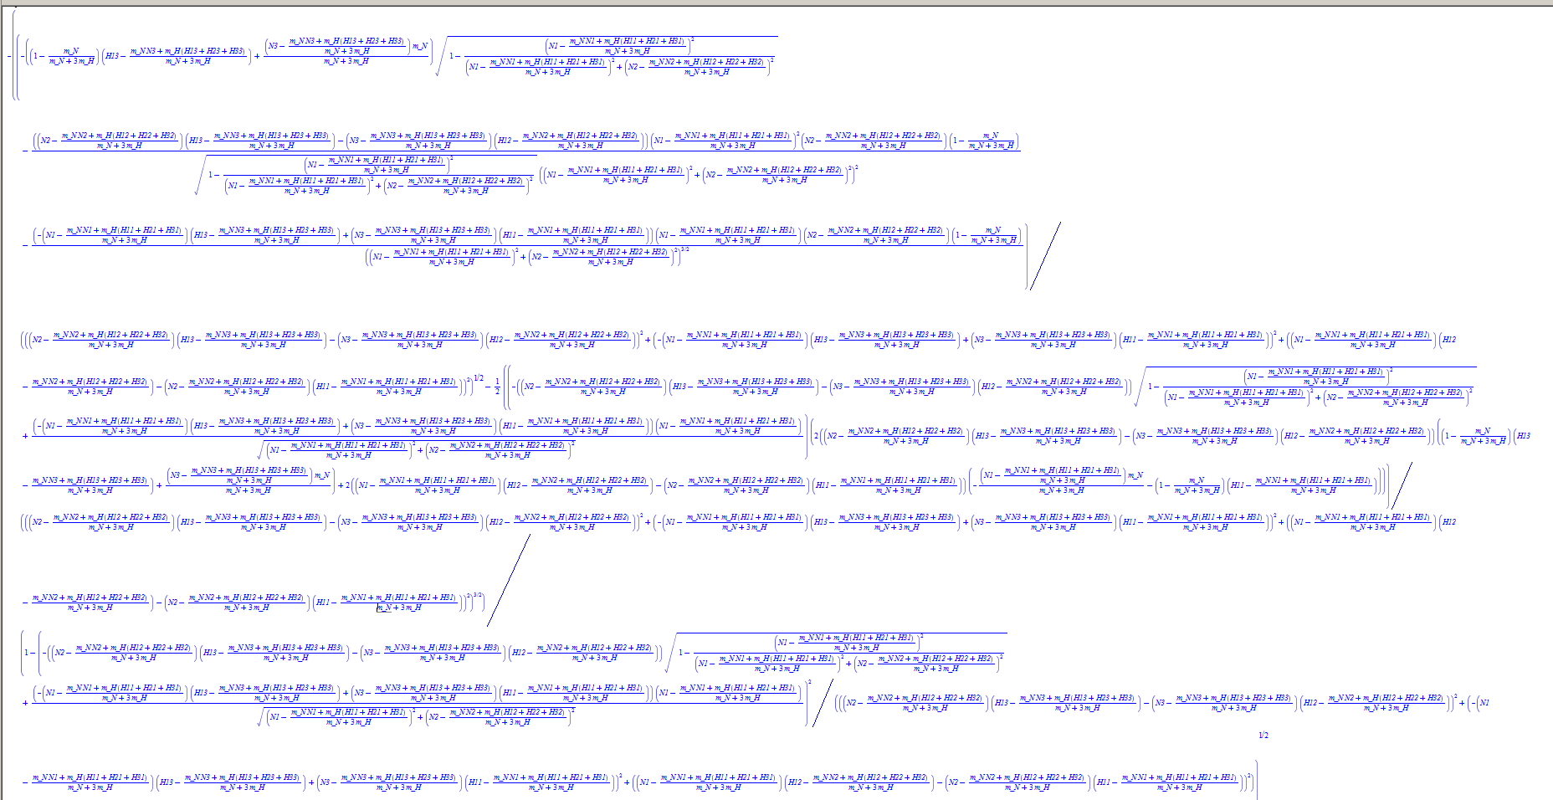Derive g wrt N2

t38 = H12 - t28;

t40 = t29 * t11 - t13 * t38;

t44 = t31 * t31;

t50 = H11 - t21;

t52 = -t22 * t11 + t13 * t50;

t53 = t52 * t22;

t54 = sqrt((double) t31);

t61 = t40 * t40;

t62 = t52 * t52;

t65 = t22 * t38 - t29 * t50;

t66 = t65 * t65;

t67 = t61 + t62 + t66;

t68 = sqrt((double) t67);

t74 = -(double) t40 * t35 + (double) t53 / t54;

t88 = t74 * t74;

t3 = 1 / (m_N + 3 * m_H);

t5 = -t3 * m_N + 1;

t10 = t3 * (m_N * N3 + m_H * (H13 + H23 + H33));

t11 = H13 - t10;

t13 = N3 - t10;

t16 = t3 * t13 * m_N + t5 * t11;

t21 = t3 * (m_N * N1 + m_H * (H11 + H21 + H31));

t22 = N1 - t21;

t23 = t22 * t22;

t28 = t3 * (m_N * N2 + m_H * (H12 + H22 + H32));

t29 = N2 - t28;

t30 = t29 * t29;

t31 = t23 + t30;

t35 = sqrt((double) (1 - t23 / t31));

t92 = sqrt(0.1e1 - t88 / (double) t67);

t95 = -((-(double) t16 * t35 - (double) t40 / t35 * (double) t23 / (double) t44 * (double) t29 * (double) t5 - (double) t53 / t54 / (double) t31 * (double) t29 * (double) t5) / t68 - t74 / t68 / (double) t67 * (double) (t40 * t16 + t65 * (-t22 * t3 * m_N - t5 * t50))) / t92;

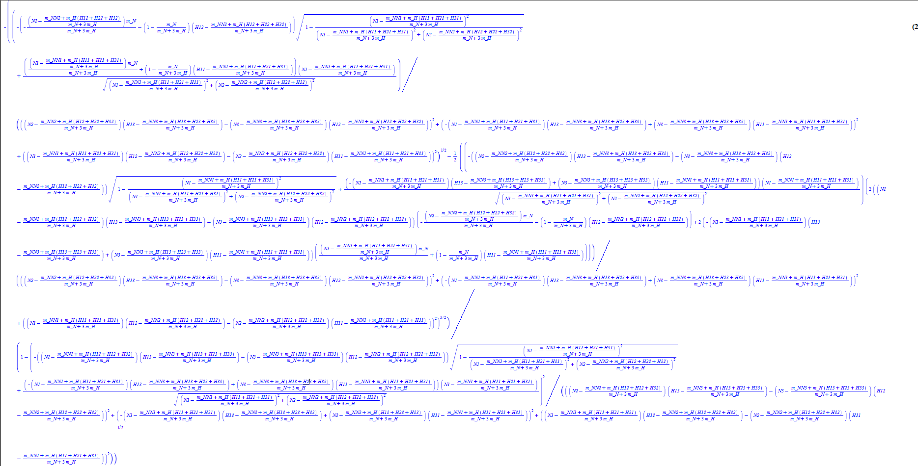Derive g wrt N3

t38 = 0.1e1 / t37;

t45 = t3 * (m_N * N3 + m_H * (H13 + H23 + H33));

t46 = H13 - t45;

t48 = N3 - t45;

t50 = -t48 * t14 + t9 * t46;

t51 = t50 * t50;

t54 = -t22 * t46 + t48 * t33;

t55 = t54 * t54;

t59 = (int) pow((double) (t22 * t14 - t9 * t33), (double) 2);

t60 = t51 + t55 + t59;

t61 = sqrt((double) t60);

t67 = (double) t54 * (double) t22 * t38 - t29 * (double) t50;

t77 = t67 * t67;

t81 = sqrt(0.1e1 - t77 / (double) t60);

t3 = 1 / (m_N + 3 * m_H);

t8 = t3 * (m_N * N2 + m_H * (H12 + H22 + H32));

t9 = N2 - t8;

t13 = -t3 * m_N + 1;

t14 = H12 - t8;

t16 = -t9 * t3 * m_N - t13 * t14;

t21 = t3 * (m_N * N1 + m_H * (H11 + H21 + H31));

t22 = N1 - t21;

t23 = t22 * t22;

t24 = t9 * t9;

t25 = t23 + t24;

t29 = sqrt((double) (1 - t23 / t25));

t33 = H11 - t21;

t35 = t22 * t3 * m_N + t13 * t33;

t37 = sqrt((double) t25);

t84 = -(((double) t35 * (double) t22 * t38 - (double) t16 * t29) / t61 - t67 / t61 / (double) t60 * (double) (t50 * t16 + t54 * t35)) / t81;