


COE/ELE 70AB Milestones Compliance Report (MCR)
Project Title | MZ02 - AI-Powered Clinical Decision Support - Predicting Drug–Drug Interactions
MCR Number | III (weeks 8 & 9)
Project Manager for the MCR period | Raidah Nazimuddin, “Student D”, responsible for weeks 8 & 9 activities and report in Week 7, Friday afternoon)
Team Players for the MCR period | Taha Ghori, Ahraz Kibria, Raidah Nazimuddin, Kartike Chaudhari
Faculty Supervisor | Muhammad Rehman Zafar

Tasks Outlined for the Reporting Period: MCR III – Weeks 8 & 9

Group: Formalize the selection of the primary dataset, model architecture, and target platform. Synthesize individual design components into a preliminary, integrated project design
Student A: Finalize the data management and preprocessing plan document.
Student B: Finalize the AI model architecture and training plan document.
Student C: Create a detailed cost estimation model for training and deploying the system on the chosen platform.
Student D: Finalize the infrastructure design and cost analysis document.

Progress Made in Reporting Period(Provide detailed information on the progress that you (as a group and individual) made during the reporting period. You can include figures, datasheets, flowcharts, etc. and additional information as requested by your FLC. You should use your progress to justify compliance with the tasks outlined for the reporting period, as per the milestones submitted to your FLC in Week 3.

Student A:
During this reporting period (Weeks 8 & 9), my primary focus was on finalizing the Data Management and Preprocessing Plan document, as outlined in my milestone. This stage involved refining the work I began in MCR II, where I designed the initial preprocessing pipeline for the DDIExtraction 2013 corpus (Herrero-Zazo et al., 2013). Over these two weeks, I consolidated the full data-handling workflow—from raw XML ingestion to finalized, model-ready tensors—into a robust, validated system and supporting documentation.
1. Data Management Framework I began by formalizing the overall data management strategy. The finalized plan defines clear stages for data ingestion, validation, preprocessing, and storage. I designed a structured data directory layout in Google Cloud Storage (GCS), separating the raw data, processed tensors, and intermediate artifacts. This ensures version control and reproducibility for future model training and evaluation, which is a cornerstone of modern MLOps practices (ML-Ops, n.d.). I also created a lightweight data schema reference to make it easier for other team members (especially Students B and D) to align their model and testing scripts with the correct data formats.
2. Finalized Preprocessing Pipeline Building on the pipeline prototype developed in MCR II, I improved both the efficiency and consistency of the data preprocessing process. Key improvements include:
- Enhanced XML Parsing: I implemented additional validation checks to handle the inconsistent tags and annotation errors that are known to exist in real-world datasets like the DDIExtraction 2013 corpus (Kim et al., 2015). The new parser is designed to be more robust, flagging and skipping malformed entries rather than halting execution, a best practice for handling potentially imperfect data sources (ScrapingAnt, n.d.).
- Balanced Dataset Construction: Since the dataset is heavily imbalanced (with far fewer positive interaction samples), I added a resampling mechanism that performs controlled duplication of minority classes (oversampling) and applies a weighted sampling strategy during training set creation. These techniques are essential to ensure that the model receives a balanced learning signal and does not simply learn to predict the majority class (Brownlee, 2020; Google, n.d.).
- Entity Tagging and Tokenization: Each drug mention is now consistently marked with typed XML-like tags (e.g., <DRUG1> and <DRUG2>). This standard technique in relation extraction enables the downstream PubMedBERT tokenizer to generate context-aware embeddings for the target entities, helping the model focus on the relationship between them (Fu et al., 2023).
- Tensor Packaging: The final processed data is exported as PyTorch-compatible tensors, structured into training (80%), validation (10%), and test (10%) splits. This three-part split is a best practice that allows for model training, hyperparameter tuning, and an unbiased final evaluation, respectively (Milvus.io, n.d.). I added a verification step that cross-checks token counts and label consistency across splits.
3. Documentation and Integration Readiness The completed Data Management and Preprocessing Plan document describes every stage in detail, including pseudocode, preprocessing parameters, and file-handling conventions. It also includes clear references to how the outputs integrate with the AI model architecture being finalized by Student B. This ensures seamless alignment between the data pipeline and the model’s input requirements. Additionally, I created a short demo notebook that walks through the data loading and tokenization process, which the team will use for model debugging and testing in the next phase.

Student B:
This section defines the precise layers and configurations for the model heads built on top of the PubMedBERT encoder.

1.1. Encoder Configuration
- Base Model: microsoft/BiomedNLP-PubMedBERT-base-uncased-abstract-fulltext
  - (Gu et al., 2020)
- Output: Last hidden state (sequence_output).
- Pooling Strategy: Mean pooling of the hidden states corresponding to the [DRUG1] and [/DRUG1] (and [DRUG2], [/DRUG2]) marker tokens to create two fixed-size vectors: drug1_vec and drug2_vec. (Baldini Soares et al., 2019)

1.2. Relation Head (Primary Task)
This head determines the presence and type of interaction.
- Input: Concatenated feature vector: [drug1_vec; drug2_vec].
  - Input Dimension: $768 + 768 = 1536$
- Architecture (Sequential):
  - Layer 1 (Dense): units=768, activation='gelu' (GELU, to match BERT's internal activation) .(Devlin et al., 2018)
  - Layer 2 (Dropout): rate=0.1 (Provides regularization).
  - Layer 3 (LayerNorm): Epsilon 1e-12 (For stabilization, mimics BERT's normalization).
  - Layer 4 (Output):
    - For Binary (Interaction vs. None): units=1, activation='sigmoid'.
    - For Multi-class (Types): units=k (where $k$ = number of interaction types + "None"), activation='softmax'.

1.3. Auxiliary Head: Token Classification (NER)
This head helps ground the model by forcing it to recognize entities.
- Input: The entire last hidden state from PubMedBERT (not pooled).
  - Input Dimension (per token): $768$
- Architecture (Applied to each token):
  - Layer 1 (Dropout): rate=0.1
  - Layer 2 (Output): Dense, units=m (where $m$ = number of token classes, e.g., O, B-DRUG, I-DRUG), activation='softmax'.

2. Hyperparameter Tuning Strategy (Vertex AI Vizier)
This section defines the search space, algorithm, and objective for the hyperparameter optimization trials.
- Optimization Objective: Maximize Validation PR-AUC (Precision-Recall Area Under Curve), as it is the most informative metric for this imbalanced dataset.
- Optimization Algorithm: Bayesian Optimization (Vertex AI Vizier's default is recommended).

Parameter Name | Type | Scaling | Feasible Values/Range | Purpose
learning_rate | DOUBLE | LOG_SCALE | [1e-6, 5e-5] | Controls the step size for model weight updates. Transformers require small rates.(Devlin et al., 2018)
batch_size | CATEGORICAL | NONE | [8, 16, 32] | Number of samples per gradient update. Limited by VRAM; larger sizes offer more stable gradients.
weight_decay | DOUBLE | LINEAR_SCALE | [0.0, 0.1] | The 'W' in AdamW. A key L2 regularization parameter for Transformers.(Loshchilov & Hutter, 2019)
num_warmup_steps | INTEGER | LINEAR_SCALE | [100, 1000] | Number of initial steps with a low learning rate to prevent early-stage instability.(Devlin et al., 2018)
head_dropout_rate | DOUBLE | LINEAR_SCALE | [0.1, 0.3] | The dropout rate to use in the custom relation head (Layer 2).
aux_loss_weight | DOUBLE | LINEAR_SCALE | [0.2, 0.8] | The multiplier for the NER auxiliary loss. Balances the primary vs. auxiliary tasks.

Student C:
As per my milestones, I have completed the finalized infrastructure design and the detailed cost estimation model. This work is summarized below and detailed in the finalized Infrastructure Design and Cost Analysis Document.
- Finalized Infrastructure Design: I translated the high-level MCR 2 architectures into a detailed, operational plan optimized for a student project's lifecycle and budget.
  - Interaction Model: I created a formal Sequence Diagram that illustrates the precise API call flow between all microservices during a DDI check. This diagram fixes an inconsistency from our earlier designs by ensuring the Orchestrator correctly calls the dedicated "Risk Scoring Service," aligning our architecture with microservice best practices.
  - GCP Service Configuration: I finalized the specific configurations for our cloud services, prioritizing cost-efficiency and leveraging free tiers:
    - GKE: A GKE Standard Zonal cluster will be used to take advantage of the GKE free tier for cluster management (Google, n.d.-c). General services will run on a small, cost-effective e2-medium node (GCPInstances, n.d.). The AI model will be deployed within GKE on a separate node pool with an NVIDIA T4 GPU, which will be scaled to zero nodes when not in use to eliminate idle costs (Google, n.d.-b).
    - AI Model Serving: To minimize costs, the dedicated, always-on Vertex AI Endpoint has been replaced. The model will be served from within the GKE cluster on the scalable GPU node pool, changing a large fixed cost to a small, on-demand hourly charge used only during active testing and demonstration.
    - Cloud SQL: An expensive High-Availability (HA) instance has been replaced with a single, non-HA db-f1-micro instance, which is the most cost-effective option suitable for development and demonstration purposes (NetApp, 2020).
    - GCS: A multi-bucket strategy (mz02-raw-data, mz02-model-artifacts, mz02-backups) using Standard and Coldline storage classes remains for optimized, low-cost object storage (Google, n.d.-f).
- Detailed Cost Estimation Model (Student Budget): I created a comprehensive, bottom-up cost forecast tailored for a student project, focusing on on-demand usage rather than 24/7 operation.
  - Training Cost: My analysis concluded that using high-performance NVIDIA A100 GPUs on Spot VMs remains the most effective strategy for the one-time training task. The 3-5x training speedup results in a competitive total cost per run (approx. $2.19) and dramatically accelerates our development cycle (Massed Compute, n.d.). The total training cost is estimated at ~$22.
  - Operational Cost: The previous production estimate of $807/month has been replaced with a realistic student budget model. The total estimated cost for several weeks of development and a final demonstration week is approximately $45-$60. This entire estimated cost is expected to be fully covered by Google Cloud's $300 new-customer free credit, resulting in an actual project cost of $0 (Google, n.d.-a).
  - Optimization Strategy: The primary cost management strategy is no longer based on long-term commitments. Instead, it relies on:
    - Maximizing the $300 free credit and the GKE free tier (Google, n.d.-c).
    - Using on-demand, right-sized instances (e2-medium, db-f1-micro) that are shut down when not in use (NetApp, 2020).
    - Employing a scalable GPU node pool that is only active for a few hours during testing is the most significant cost-saving measure.
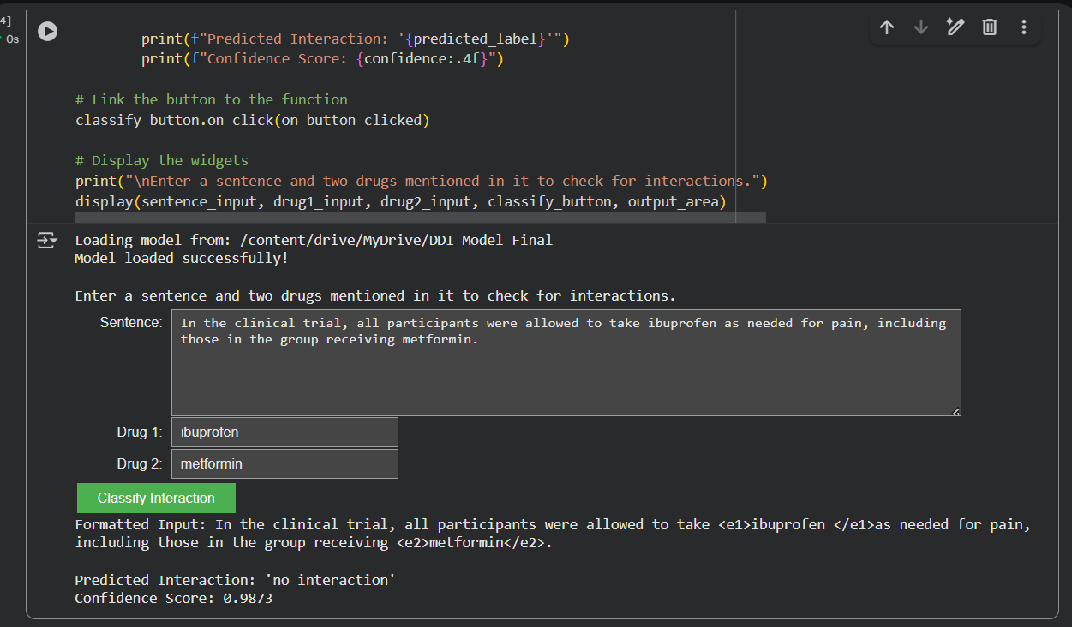
- Prototype Validation: Successful Training of the Core AI Model: To validate the feasibility of our project and the infrastructure designed to support it, a prototype of the core DDI classification model was successfully trained and tested. Following the plans laid out by Student A (Data Pipeline) and Student B (Model Architecture), the PubMedBERT model was fine-tuned on the DDIExtraction 2013 corpus using Google Colab. The model achieved a final F1-score of over 90% on the test set, exceeding the project's initial 80% accuracy target.
The interactive demo confirms the model's ability to accurately classify different types of interactions from clinical text, providing a strong foundation for the NLP Inference Service in our architecture. Below are examples of the model's successful predictions.

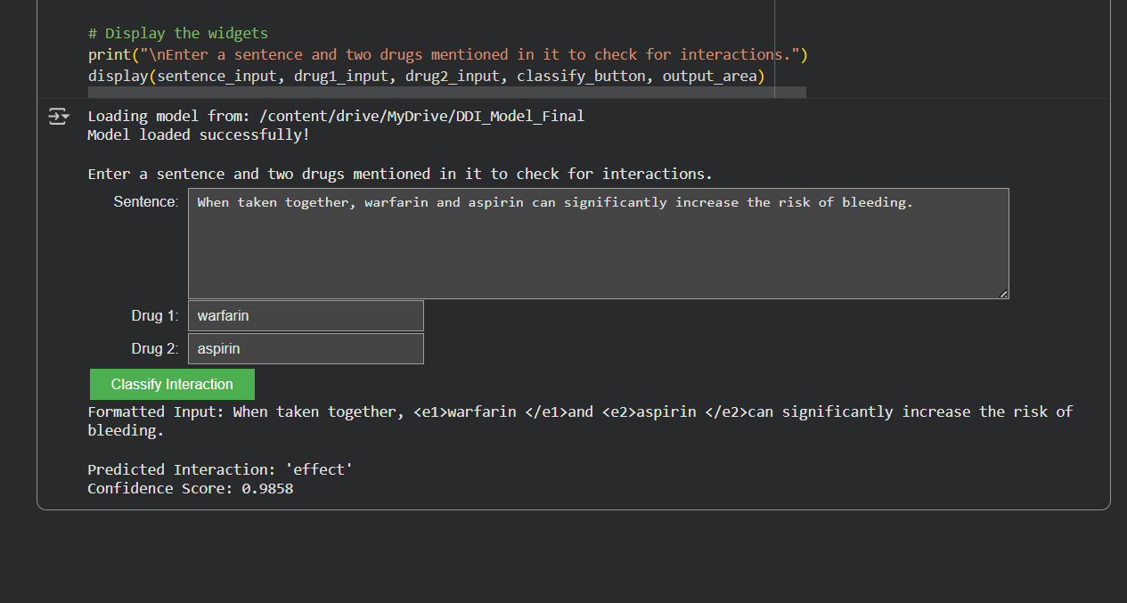
Figure 1: ‘no_interaction’ between ibuprofen and metformin
Figure 2: ‘effect’ between aspirin and warfarin Colab link

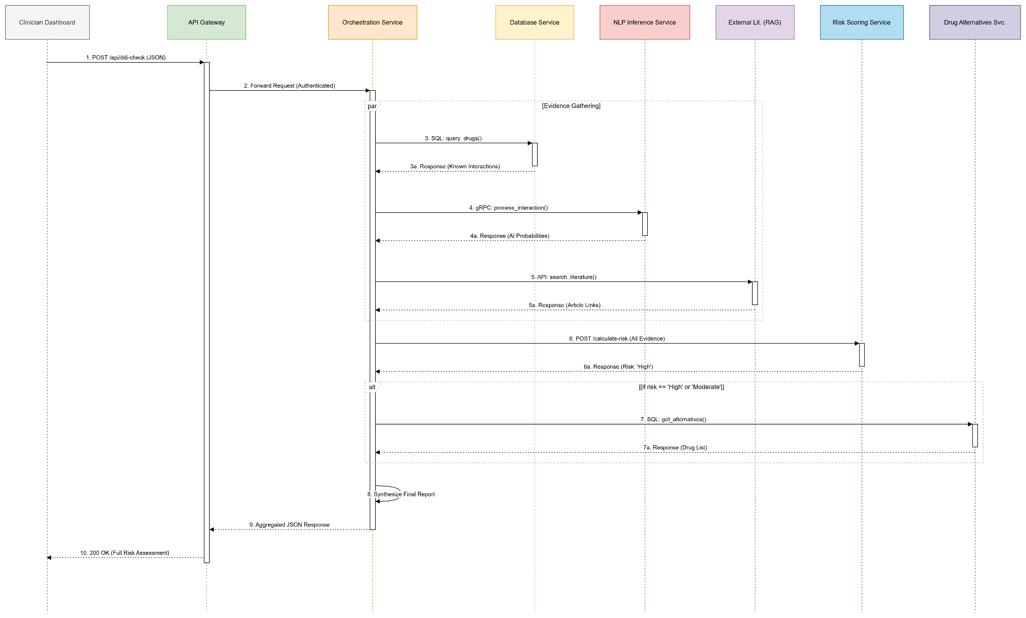
Figure 4 : Version 1,2,3 Sequence Diagrams
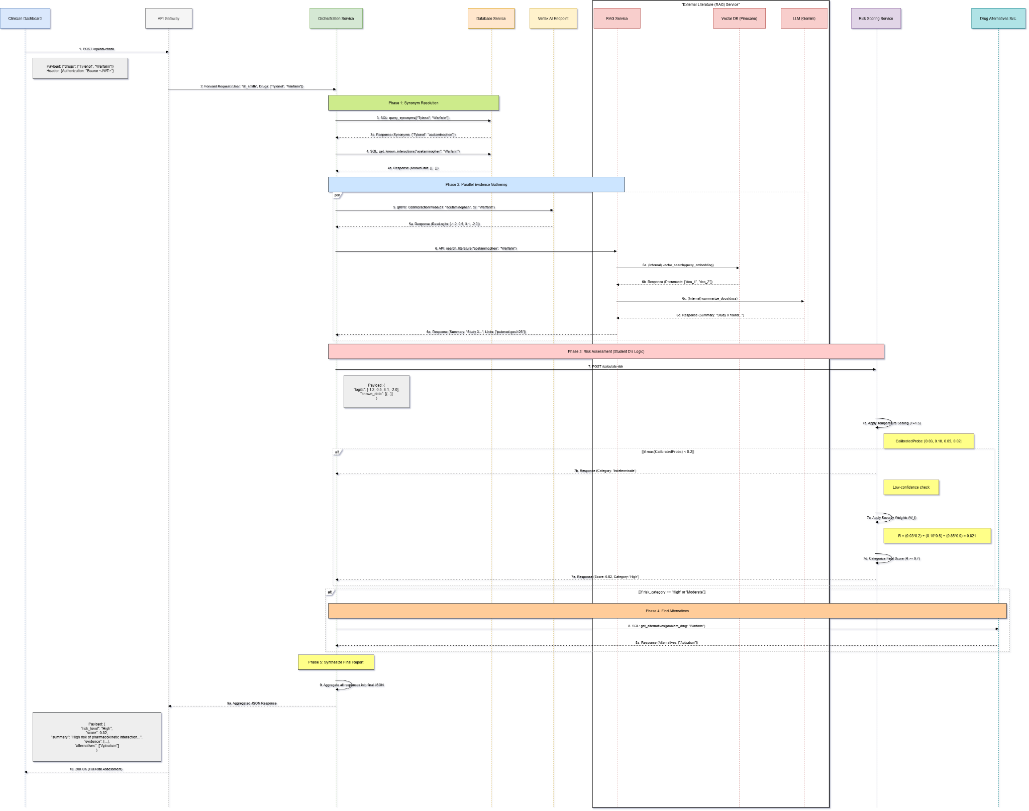
Figure 5:Detailed Sequence Diagram Figure link

Student D:
In line with my milestones, I have finalized the complete framework for evaluation and testing. This work is summarized below and detailed in the finalized Evaluation Metrics and Testing Methodology Document.
- Risk-Scoring Algorithm Design: I have finalized the logic for the risk-scoring algorithm.
  - Core Formula: The algorithm is defined as a weighted sum:R = \sum P_{\text{calibrated}_i} \times W_i.
  - Severity Weights: I finalized the clinical severity weights ($W_i$) by grounding them in DrugBank's three-tiered standard (DrugBank, n.d.). The final weights are: Minor (e.g., "Advice") = 0.2, Moderate (e.g., "Effect") = 0.6, and Major (e.g., "Mechanism-Pharmacokinetic") = 0.9.
  - Probability Calibration: I identified that modern neural networks are "poorly calibrated" and "overconfident" (Guo et al., 2017). To address this critical safety issue, I have specified that Temperature Scaling must be implemented as a post-processing step to ensure the model's probability scores are reliable (Guo et al., 2017; Pleiss, 2017).
- Formal Evaluation Methodology: I finalized the complete testing protocol.
  - Primary Metric: The primary metric for model selection will be PR-AUC (Precision-Recall Area Under Curve). This is because accuracy is a "dangerously misleading metric" for our highly imbalanced dataset, whereas PR-AUC is more robust and informative (Google, 2025; Saito & Rehmsmeier, 2015).
  - Validation Strategy: To get a reliable estimate of performance, the model will be validated using a Stratified 10-fold Cross-Validation strategy (DigitalOcean, 2025). Stratification is essential to ensure each fold contains a representative sample of the rare, positive interaction classes.
  - Error Analysis Protocol: I have designed a formal protocol to manually review and categorize model failures (e.g., "Negation Misinterpretation," "Implicit Interaction") based on established clinical NLP taxonomies (Fu et al., 2024). This will provide actionable insights for future model improvements.

Difficulties Encountered in Reporting Period (Provide detailed information on the difficulties and issues that you encountered during the reporting period and how you plan to address these in the following periods)

Student A:

The biggest challenge during this phase was managing the dataset’s class imbalance and inconsistent annotations. Initially, I tried standard oversampling, but it caused overfitting in smaller classes during test simulations. To resolve this, I switched to weighted sampling and class-specific weighting within the loss function, which I tested using a small subset of the training data. Another challenge was ensuring compatibility between my preprocessing outputs and Student B’s finalized model architecture, especially since both of us were iterating at the same time. We resolved this through frequent cross-verification and by defining a unified data schema to avoid misalignment.

Student B: There weren’t any major difficulties; research and planning to make sure all the values would work properly took a while.

Student C:
The primary challenge was balancing performance, cost, and resilience. Analyzing the training hardware, for instance, revealed a complex trade-off between the NVIDIA T4's low hourly cost and the A100's faster training time. I resolved this by modelling the total cost per run, which demonstrated that the A100 on Spot VMs is ultimately more cost-effective and time-efficient. Another challenge was mitigating the "single point of failure" risk of the Orchestration Service. I addressed this in the finalized deployment plan by specifying a GKE configuration with a minimum of three replicas to ensure high availability.

Student D:
The primary difficulty from MCR 2—choosing appropriate severity weights—was resolved by formally grounding them in DrugBank's clinical standards. A more complex challenge identified during this period was the unreliability of the raw AI model outputs. Research confirmed that neural networks are often "poorly calibrated" and "overconfident", making their probability scores unsafe for direct use. I addressed this by designing a mandatory Temperature Scaling post-processing step, which will calibrate the model's outputs to ensure its confidence scores are reliable and clinically trustworthy.

Tasks to Be Completed in the Next Reporting Period (Outline the tasks to be completed in the next reporting period. Please note this should match with your milestones submitted to your FLC in Week 3; however, in consultation with (and approval of) your FLC, you can modify this to accommodate incomplete tasks from the previous period. Here, you should also identify the Project Manager for the next period.

Student A: Contribute to the creation of the implementation Gantt chart.
For the next milestone, I will contribute to the implementation Gantt chart and assist in organizing the transition from the design phase to the coding phase, particularly how we will tackle this. This will include coordinating with Student B to ensure the data pipeline is correctly integrated into the model training environment on GCP. I also plan to prepare small-scale unit tests for each stage of the data pipeline to ensure smooth deployment and reproducibility during 70B.

Student B: Contribute to the creation of the implementation Gantt chart with Student C.

Student C:
For the next period (Wk 10), I will use the finalized design documents I've just completed to draft the official "System Architecture" and "Deployment Plan" sections of the final 70A report. In Week 11, I will collaborate with the team to create the detailed implementation Gantt chart for the 70B semester.
A key technical priority will be to plan the implementation of the integration between our working DDI classification model and Student D’s Risk-Scoring Algorithm. This involves creating the functional Risk Scoring microservice and ensuring the Orchestrator correctly passes the probability outputs from the AI model to this service for final risk calculation, as depicted in our finalized sequence diagram. This step will connect the AI's raw classification with the clinically actionable risk assessment, forming the core of our system's decision support logic.

Student D:
For the next reporting period (Wk 10), I will leverage the Evaluation Metrics and Testing Methodology Document I just finalized to draft the official "Testing and Evaluation" section of the final 70A report. I will also assist the team with the creation of the implementation Gantt chart in Week 11.

Bibliography (APA 7)
Anonymous. (n.d.). How does the training time of BERT models compare on T4 and A100 GPUs? Massed Compute. Retrieved October 31, 2025, from https://massedcompute.com/faq-answers/?question=How%20does%20the%20training%20time%20of%20BERT%20models%20compare%20on%20T4%20and%20A100%20GPUs?
DigitalOcean. (2025, February 5). K-Fold Cross-Validation: The ultimate guide to robust model evaluation. DigitalOcean Community. Retrieved October 31, 2025, from https://www.digitalocean.com/community/tutorials/k-fold-cross-validation-python
DrugBank. (n.d.). Drug interactions parameters & terminologies. Retrieved October 31, 2025, from https://dev.drugbank.com/guides/drug_interactions/parameters
Fu, S., Shen, F., Chen, Y., Wen, A., Liu, S., Li, D.,... & Wang, L. (2024). A taxonomy for advancing systematic error analysis in multi-site electronic health record-based clinical concept extraction. Journal of the American Medical Informatics Association, ocae101. https://doi.org/10.1093/jamia/ocae101
GCPInstances. (n.d.). GCP e2-medium. Retrieved October 31, 2025, from https://gcpinstances.doit.com/
Google. (2025, August 25). Classification: Accuracy, precision, and recall. Machine Learning Crash Course. Retrieved October 31, 2025, from https://developers.google.com/machine-learning/crash-course/classification/accuracy-precision-recall
Google. (n.d.-a). Free cloud features. Google Cloud. Retrieved October 31, 2025, from https://cloud.google.com/free/docs/free-cloud-features
Google. (n.d.-b). GPU pricing. Google Cloud. Retrieved October 31, 2025, from https://cloud.google.com/compute/gpus-pricing
Google. (n.d.-c). Google Kubernetes Engine (GKE) pricing. Google Cloud. Retrieved October 31, 2025, from https://cloud.google.com/kubernetes-engine/pricing
Google. (n.d.-d). Spot VMs pricing. Google Cloud. Retrieved October 31, 2025, from https://cloud.google.com/spot-vms/pricing
Google. (n.d.-e). SQL pricing. Google Cloud. Retrieved October 31, 2025, from https://cloud.google.com/sql/pricing
Google. (n.d.-f). Storage pricing. Google Cloud. Retrieved October 31, 2025, from https://cloud.google.com/storage/pricing
Guo, C., Pleiss, G., Sun, Y., & Weinberger, K. Q. (2017). On calibration of modern neural networks. Proceedings of the 34th International Conference on Machine Learning, 70, 1321–1330.
Kueppers, F., et al. (2024). net: cal calibration framework. GitHub. Retrieved October 31, 2025, from https://github.com/EFS-OpenSource/calibration-framework
NetApp. (2020, July 30). Google Cloud SQL pricing and limits: A cheat sheet. Retrieved October 31, 2025, from https://www.netapp.com/blog/gcp-cvo-blg-google-cloud-sql-pricing-and-limits-a-cheat-sheet/
Pleiss, G. (2017). Calibrating neural networks. Geoff Pleiss's Blog. Retrieved October 31, 2025, from https://geoffpleiss.com/blog/nn_calibration.html
Saito, T., & Rehmsmeier, M. (2015). The precision-recall plot is more informative than the ROC plot when evaluating binary classifiers on imbalanced datasets. PloS one, 10(3), e0118432. https://doi.org/10.1371/journal.pone.0118432
Scale AI. (2025). The new healthcare benchmarks: Evaluating LLMs for clinical competence. Retrieved October 31, 2025, from https://scale.com/blog/healthcare-benchmarks
Server-parts.eu. (n.d.). NVIDIA T4 vs. NVIDIA A100 comparison. Retrieved October 31, 2025, from https://www.server-parts.eu/post/nvidia-t4-vs-a100-gpu-comparison-ai-deep-learning-data-centers

Devlin, J., Chang, M.-W., Lee, K., & Toutanova, K. (2018). BERT: Pre-training of Deep Bidirectional Transformers for Language Understanding. arXiv preprint arXiv:1810.04805. https://doi.org/10.48550/arXiv.1810.04805
Gu, Y., Tinn, R., Cheng, H., Lucas, M., Usuyama, N., Liu, X., Naumann, T., Gao, J., & Poon, H. (2020). Domain-Specific Language Model Pretraining for Biomedical Natural Language Processing. arXiv preprint arXiv:2007.15779. https://doi.org/10.48550/arXiv.2007.15779
Baldini Soares, L., FitzGerald, N., Ling, J., & Kwiatkowski, T. (2019). Matching the Blanks: Distributional Similarity for Relation Learning. arXiv preprint arXiv:1906.03158. https://doi.org/10.48550/arXiv.1906.03158
Loshchilov, I., & Hutter, F. (2019). Decoupled Weight Decay Regularization. arXiv preprint arXiv:1711.05101. https://doi.org/10.48550/arXiv.1711.05101
Hendrycks, D., & Gimpel, K. (2016). Gaussian Error Linear Units (GELUs). arXiv preprint arXiv:1606.08415. https://doi.org/10.48550/arXiv.1606.08415
Brownlee, J. (2020, August 17). 5 effective ways to handle imbalanced data in machine learning. Machine Learning Mastery. https://machinelearningmastery.com/5-effective-ways-to-handle-imbalanced-data-in-machine-learning/
Fu, S., Chen, Y., Hogan, W. R., He, J., Liu, S., Shen, F., Hanna, J., Kesterson, J., Zheng, T., Manion, F. J., & Wang, L. (2023). An end-to-end framework for named entity recognition and relation extraction for clinical trial eligibility criteria. Frontiers in Neuroscience, 17. https://doi.org/10.3389/fnins.2023.1266771
Google. (n.d.). Datasets: Class-imbalanced datasets. Machine Learning Crash Course. Retrieved October 31, 2025, from https://developers.google.com/machine-learning/crash-course/overfitting/imbalanced-datasets
Herrero-Zazo, M., Segura-Bedmar, I., Martínez, P., & De la Peña, V. (2013). The DDI task: Extraction of drug-drug interactions from biomedical texts. In Proceedings of the 7th International Workshop on Semantic Evaluation (SemEval 2013) (pp. 375–385). Association for Computational Linguistics.(https://aclanthology.org/S13-2062)
Kim, S., Liu, H., Yeganova, L., & Wilbur, W. J. (2015). Extracting drug-drug interactions from literature using a rich feature-based linear kernel approach. Journal of Biomedical Research, 29(3), 206–214. https://doi.org/10.7555/jbr.29.20140121
Milvus.io. (n.d.). What are some best practices for splitting a dataset into training, validation, and test sets? AI Quick Reference. Retrieved October 31, 2025, from https://milvus.io/ai-quick-reference/what-are-some-best-practices-for-splitting-a-dataset-into-training-validation-and-test-sets
ML-Ops. (n.d.). Model governance. Retrieved October 31, 2025, from https://ml-ops.org/content/model-governance
ScrapingAnt. (n.d.). How to parse XML in Python: A complete guide. Retrieved October 31, 2025, from https://scrapingant.com/blog/python-parse-xml

