You will create a game or simulation using Java and the Greenfoot package. http://www.greenfoot.org/

- Project Proposal
Use Greenfoot to create an image of what a typical screen of your game might look like. Take a screenshot of this image. Use your image to describe how your game and works. Your proposal should answer the following questions:

- A Title (NOT: “Computer Game”, but “LunarLander”).
- Include Your Name.
- What is the purpose or objective of your game and how do you achieve it(e.g. Pop balloons)?
- What is the incentive for doing well in the game? What makes it addictive? (e.g. Getting a high score)?
- Describe any other aspect that you want to incorporate into the game.

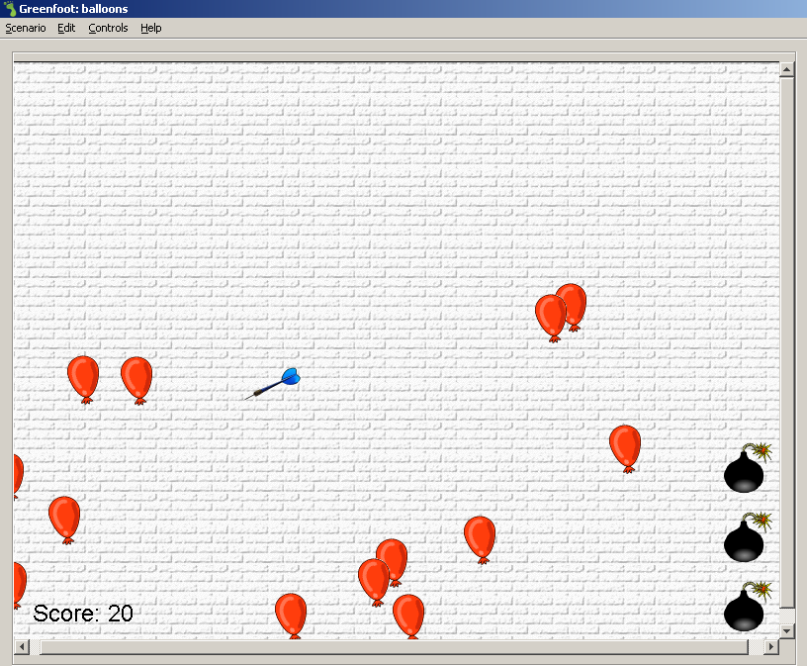
User moves dart around with mouse.
User pops these balloons by clicking on them.
Drag a bomb onto the screen to blow up many balloons.
Balloons go up the screen at increasing speeds depending on the score.
You get 20 points per red balloon that is popped.

- Program in Progress
Your program will be checked for progress in the remaining weeks. Your program must always be accessible in class (NOT ONLY AT HOME). Your program must always show good programming techniques and documentation during the coding stage, not just after you’ve finished making it!

- Final Submission of Project
Zip-up your greenfoot project and upload to the moodle.

Criteria | Level 1  (50 – 59%) | Level 2  (60 – 69%) | Level 3  (70 – 79%) | Level 4  (80 – 100%)
Conventions  The use of meaningful names and data types for variables, fields, methods and classes. | Seldom uses proper data types for variables in programs. Many cases of improper naming. | Uses proper data types for some variables in some programs. Uses proper naming conventions some of the time. | Uses proper data types for most variables in most or all programs. Uses proper naming conventions in most of the time in most or all programs. | Proper and appropriate data types are used for all variables in all programs. Uses proper naming conventions in all programs.
Organization  The logical flow of the program. Simple and understandable object-oriented setup of classes. | Seldom uses good coding structure for programs. Most code is hard to follow and is not easy to read debug. Comments are missing and do not contribute to understanding the program. No attempt has been made to modularize code using classes. No objects are defined in hierarchies. | Sometimes uses good coding structure. Code is sometimes easy to read and debug. Comments sometimes contribute to understanding the program flow, but could be more helpful. Some attempt has been made to modularize code using classes.  Objects are defined, but could be better organized. | Uses good coding structure most of the time. Code is almost always easy to read and follow and debug. Comments often contribute appropriately to the understanding of the program and code. Classes are somewhat clear, logical and structured properly and appropriately. Objects are defined and contribute somewhat to high-level understanding of the code. | Good coding structure is used for all programs. Code is always easy to read, follow and debug. Comments always contribute appropriately to the understanding of the program and code. Classes are clear, logical and structured properly and appropriately. Objects are well defined and contribute to high-level understanding of the program code.
Efficiency  The effective use of loops, selection, and other constructs to simplify coding. | Algorithms are not very efficient. Inefficient coding occurs in 4 or more programs or sections of a program. | Algorithms are sometimes always efficient. Inefficient coding occurs in 2 to 3 programs or sections of a program. | Algorithms are almost always efficient. Inefficient coding occurs in, at most, 1 program or section of a program. | Efficient algorithms and code are always used.
Execution  Proper output and execution of a program given appropriate input parameters. | Many errors were detected during the sample runs. In most cases, output is not what was expected for most programs. | Three or four errors were detected during the sample runs. Output is sometimes what is expected for that program. | One or two errors were detected for the sample runs. Output is often what is expected for that program. | No errors were detected for any of the sample runs in any of the programs. Output is as expected for every program.
Content  Interface, graphics and visual appearance. | The interface is functional. Little attempt ahs been made to make the program visually appealing. | The interface is functional. Graphics are somewhat clear and appropriate. | The interface is somewhat easy to use and understand. Most graphics are clear and appropriate. | The interface clean and is easy to use and understand. All graphics are clear and appropriate.

