imgPrcsngC — Jupyter Kernel Reference
Files, architecture, annotated script sections, and full GDB cell examples

Architecture — files and how they connect
Every file the script creates, which tool owns it, and how they interact at cell execution time.

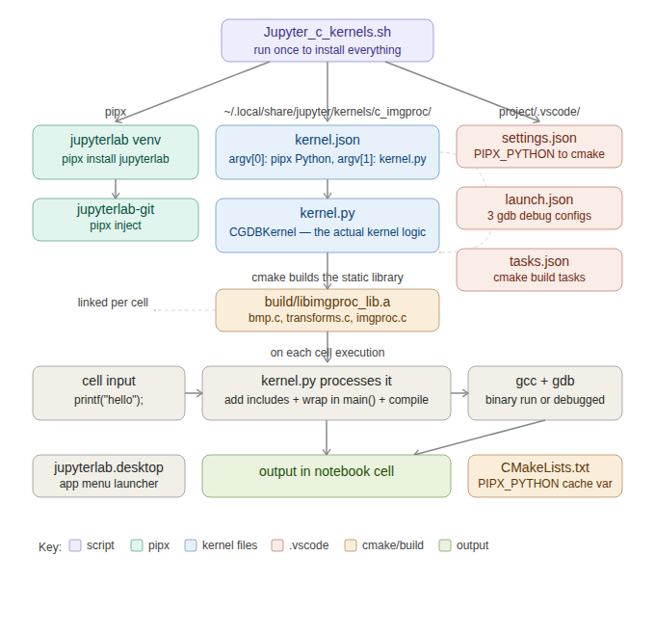
File / Location | Purpose
jupyterlab venv | Isolated Python env. PIPX_PYTHON points to its interpreter.
kernels/c_imgproc/kernel.json | Tells Jupyter/VSCode how to launch the kernel. argv[1] = absolute kernel.py path.
kernels/c_imgproc/kernel.py | CGDBKernel: auto-includes, auto-main wrapping, GDB magic.
build/libimgproc_lib.a | Static library linked by gcc on every cell execution.
.vscode/settings.json | Always overwritten. Passes PIPX_PYTHON to cmake.
.vscode/launch.json | Three F5 gdb debug configurations.
.vscode/tasks.json | cmake build tasks bound to launch.json via preLaunchTask.
jupyterlab.desktop | App menu launcher: starts jupyter lab, opens browser.

Annotated script sections

Config and path variables
Override IMGPROC_SOURCE_DIR at run time if your project lives elsewhere.

IMGPROC_SOURCE_DIR="${IMGPROC_SOURCE_DIR:-$HOME/Projects/imgPrcsngC}"
IMGPROC_BUILD_DIR="${IMGPROC_BUILD_DIR:-$IMGPROC_SOURCE_DIR/build}"
IMGPROC_LIB="$IMGPROC_BUILD_DIR/libimgproc_lib.a"
KERNEL_INSTALL_DIR="$HOME/.local/share/jupyter/kernels/c_imgproc"

Note: KERNEL_INSTALL_DIR is hardcoded because VSCode does not support the {resource_dir} placeholder. The absolute path is the only approach that works in both JupyterLab and VSCode.

kernel.json — how the kernel is launched
{
"display_name": "C (imgPrcsng)",
"argv": [
"$PIPX_PYTHON", <- absolute pipx Python (not system python3)
"$KERNEL_INSTALL_DIR/kernel.py", <- absolute path, VSCode needs this
"-f", "{connection_file}"
],
"language": "c"
}

kernel.py — _build_source (auto-includes and auto-main)
Transforms a bare cell into a complete .c file before handing it to gcc.

AUTO_INCLUDES = [
"#include <stdio.h>", "#include <stdlib.h>",
"#include <string.h>", "#include <math.h>",
'#include "bmp.h"', '#include "imgproc.h"', '#include "transforms.h"',
]

def _build_source(src):
pre_lines = [l for l in src.splitlines() if l.strip().startswith('#')]
code_lines = [l for l in src.splitlines() if not l.strip().startswith('#')]
include_block = [inc for inc in AUTO_INCLUDES # skip already-present ones
if not _has_include(src, inc.split()[1])]
include_block.extend(pre_lines)
if _has_main(src):
return '\n'.join(include_block) + '\n\n' + src
indented = '\n'.join(' ' + l if l.strip() else '' for l in code_lines)
return ('\n'.join(include_block) + '\n\n'
+ 'int main(void) {\n' + indented + '\n return 0;\n}\n')

cmake — builds the static library only
cmake -S "$IMGPROC_SOURCE_DIR" -B "$IMGPROC_BUILD_DIR" \
-DCMAKE_BUILD_TYPE=Debug \
-DPIPX_PYTHON="$PIPX_PYTHON" \ # stored in cmake CACHE STRING
-GNinja
cmake --build "$IMGPROC_BUILD_DIR" --target imgproc_lib

GDB magic commands — reference
Magic commands go at the top of a cell, one per line, before any C code. They are stripped before compilation.

Command | What it does
%break <N> | Set a breakpoint at line number N inside the compiled cell binary
%break <fn> | Set a breakpoint when function fn() is called
%watch <x> | Pause whenever variable x changes value
%print <x> | Print expression x when a breakpoint or watchpoint is hit
%clear | Remove all active breakpoints and watches
%help | Display the command reference table in the cell output

Important: Breakpoints and watches persist across cells for the lifetime of the notebook session. Use %clear to reset them before starting a new debugging sequence.

GDB command examples in cells

%help — show the command reference
Run %help alone in a cell to print the reference table.

In [1]:
%help
┌──────────────────────────────────────────┐
│ C (imgPrcsng) Kernel — Debug Commands │
├──────────────────────────────────────────┤
│ %break <N> pause at line N │
│ %break <fn> pause at function fn() │
│ %print <x> print x when paused │
│ %watch <x> pause when x changes │
│ %clear remove all breakpoints │
└──────────────────────────────────────────┘

%break <N> — breakpoint at a line number
Set a breakpoint at a specific line in the cell. Lines are numbered from 1 starting at the first non-magic line (after the kernel adds includes and main()).

Note: Line numbers refer to the compiled source that gcc sees, which includes the auto-prepended includes. Add 8–10 to your cell line number to account for them, or use %break with a function name instead to avoid guessing.

Example — break at line 3 of the cell body, then inspect a local variable:

In [2]:
%break 3
%print n

int total = 0;
for (int n = 0; n < 5; n++) {
total += n;
}
printf("total = %d\n", total);
📍 Breakpoint set at line 3 (total: 1)

📍 Breakpoint hit:
▶ Here: main() — line 3
line 3: total += n;

🔍 Value: 0

📦 Local variables:
n = 0
total = 0

Tip: The breakpoint fires on the first iteration (n=0). Run the cell again with %break 3 still set to see it fire again. Use %clear between runs to reset.

%break <fn> — breakpoint at a function
Break when a named function is called. This is more reliable than line numbers because it does not depend on the auto-include offset.

Example — break when bmp_load() is called from a cell:

In [3]:
%break bmp_load
%print "filename"

BmpImage *img = bmp_load("test.bmp");
printf("width: %d, height: %d\n", img->width, img->height);
bmp_free(img);
📍 Breakpoint set at function 'bmp_load' (total: 1)

📍 Breakpoint hit:
▶ Here: bmp_load() — line 12 (in bmp.c)

🔍 Value: 0x7ffd... "test.bmp"

📦 Local variables:
filename = 0x7ffd... "test.bmp"
img = 0x0

Example — break on a transform function, then step through:

In [4]:
%break apply_fft
%print width
%print height

BmpImage *img = bmp_load("test.bmp");
double *out = apply_fft(img->data, img->width, img->height);
printf("FFT complete\n");
bmp_free(img);
free(out);
📍 Breakpoint set at function 'apply_fft' (total: 1)
🔍 Will print: width
🔍 Will print: height

📍 Breakpoint hit:
▶ Here: apply_fft() — line 47 (in transforms.c)

🔍 Value: 640
🔍 Value: 480

📦 Local variables:
data = 0x55a3...
width = 640
height = 480
n = 0

%watch <x> — pause when a variable changes
Pause execution whenever the named variable's value changes. Useful for tracking down where a value is being corrupted or updated unexpectedly.

Example — watch a pixel value change during processing:

In [5]:
%watch pixel

BmpImage *img = bmp_load("test.bmp");
uint8_t pixel = img->data[0];
printf("before: %d\n", pixel);
invert_image(img);
pixel = img->data[0];
printf("after: %d\n", pixel);
bmp_free(img);
👁️ Watching 'pixel' (total: 1)

👁️ Variable 'pixel' changed:
Old: 128
New: 127

before: 128
after: 127

Example — watch a pointer for unexpected NULL assignment:

In [6]:
%watch result

double *result = NULL;
BmpImage *img = bmp_load("test.bmp");
result = run_transform(img->data, img->width * img->height);
printf("result[0] = %f\n", result[0]);
free(result);
bmp_free(img);
👁️ Watching 'result' (total: 1)

👁️ Variable 'result' changed:
Old: 0x0
New: 0x5589a3c12040

result[0] = 0.031250

%print <x> — print an expression when paused
%print queues expressions to be evaluated by gdb at the moment a breakpoint or watchpoint fires. You can print variables, array elements, struct fields, or any valid C expression.

Example — print struct fields at a breakpoint:

In [7]:
%break process_image
%print img->width
%print img->height
%print img->data[0]

BmpImage *img = bmp_load("test.bmp");
process_image(img);
bmp_free(img);
📍 Breakpoint set at function 'process_image' (total: 1)

📍 Breakpoint hit:
▶ Here: process_image() — line 23 (in imgproc.c)

🔍 Value: 640
🔍 Value: 480
🔍 Value: 128 '\200'

Example — print an array slice using a gdb expression:

In [8]:
%break apply_fft
%print data[0]@8

BmpImage *img = bmp_load("test.bmp");
double *out = apply_fft(img->data, img->width, img->height);
bmp_free(img);
free(out);
📍 Breakpoint set at function 'apply_fft' (total: 1)

📍 Breakpoint hit:
▶ Here: apply_fft() — line 47 (in transforms.c)

🔍 Value: {128, 201, 97, 43, 18, 255, 76, 33}

Tip: data[0]@8 is gdb's array slice syntax: print 8 elements starting at data[0]. Use it to inspect a buffer without printing the whole array.

Combining multiple commands
All magic commands in a cell are processed before compilation. Order does not matter — %break, %watch, and %print can be mixed freely.

Example — break at two functions, watch a counter, and print a value:

In [9]:
%break bmp_load
%break process_image
%watch error_count
%print img->width

int error_count = 0;
BmpImage *img = bmp_load("test.bmp");
if (!img) { error_count++; }
else { process_image(img); bmp_free(img); }
📍 Breakpoint set at function 'bmp_load' (total: 1)
📍 Breakpoint set at function 'process_image' (total: 2)
👁️ Watching 'error_count' (total: 1)

📍 Breakpoint hit:
▶ Here: bmp_load() — line 12 (in bmp.c)

📍 Breakpoint hit:
▶ Here: process_image() — line 23 (in imgproc.c)

🔍 Value: 640

%clear — remove all breakpoints and watches
Breakpoints and watches accumulate across cells. Always run %clear before starting a new debugging sequence, or you will get unexpected pauses from stale breakpoints set in earlier cells.

In [10]:
%clear
🗑️ All breakpoints and watches cleared.

After %clear, cells run without any gdb involvement — output is immediate with no breakpoint pauses:

In [11]:
BmpImage *img = bmp_load("test.bmp");
printf("loaded: %d x %d\n", img->width, img->height);
bmp_free(img);
loaded: 640 x 480

Automatic crash detection (no command needed)
If a cell crashes with a signal (SIGSEGV, SIGABRT, SIGFPE, SIGBUS), the kernel automatically reruns under gdb and shows the backtrace. No magic command is needed.

In [12]:
// Deliberately crash: dereference a null pointer
BmpImage *img = NULL;
printf("width: %d\n", img->width);
💥 CRASH: Segfault — bad pointer or out-of-bounds index.

▶ Here: main() — line 3
#1 do_execute() — line 231 (in kernel.py)

📦 Local variables:
img = 0x0

In [13]:
// Integer divide by zero
int a = 10;
int b = 0;
printf("result: %d\n", a / b);
💥 CRASH: Arithmetic error — e.g. division by zero.

▶ Here: main() — line 4

📦 Local variables:
a = 10
b = 0

Day-to-day workflow

Task | What to do
Edit source files | Edit bmp.c, transforms.c, imgproc.c in VSCode
Rebuild the library | cmake --build ~/Projects/imgPrcsngC/build --target imgproc_lib
Run a cell | Write bare C — no #include or main() needed
Debug in a cell | %break my_function, run the cell, inspect locals
Debug full executable | F5 in VSCode → Debug imgPrcsng
Debug a scratch .c file | Open file, F5 → Debug current test
Clear stale breakpoints | %clear in a new cell before starting fresh
Reinstall everything | bash Jupyter_c_kernels.sh (safe to re-run)

Tip: Re-running the script purges the previous install and rebuilds everything. launch.json and tasks.json are preserved — delete them first if you want fresh copies. settings.json is always regenerated.

