**Test report - TODO List App**

**Author:** Maciej Zbydniewski

**Environment:** Windows 10, Chrome ver. 108+, active Internet connection

**Application description:** TODO List App is a simple application to manage your time by adding to-do tasks to a list.

*Due to the lack of specification or any other documentation, I decided to get to know the app by doing exploratory testing. The tests took me about 3 hours, excluding writing this report.*

*During the tests I performed functional and non-functional tests. I presented comments and bug reports later in this document.*

*I decided not to create bug reports for every single minor defect, as some of them may be working as designed or a single sentence comment is more than enough to understand what is wrong, in my opinion.*

**UX/performance comments**

* Added tasks aren’t sorted chronological and there is no functionality allowing to do so.

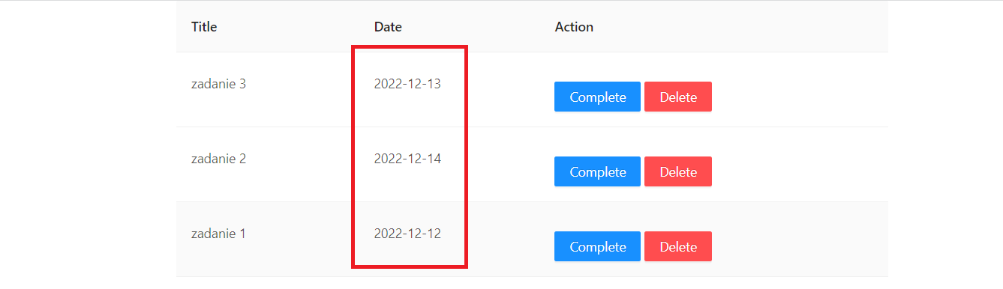

* UI looks clumsy and it gets stretched while you add more tasks. There should be less tasks visible on 1 page (5 or so). It’s unintuitive. The columns also stretch out depending on the length of the title. I would need to ask if it’s like that by design.

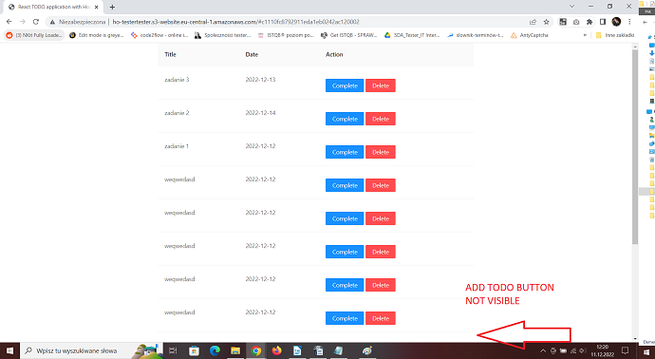

* No functionality of adding the task start time – just the date. Also, the date format looks like US date format – yyyy/mm/dd. I would need to ask if it should be like that by design.
* ‘Complete’ and ‘Delete’ buttons are a little bit misplaced, there aren’t aligned with the information in other columns.
* There is no ID of the added tasks – I would need to get the information if it’s like that by the design.
* You need to set the date while adding the first task – there is no preset date in the calendar window (for example today’s date). I would need to ask if it’s like that by the design.
* Very high (or even none) limit to the characters you could put in ‘Title’ box – I tried 1600 characters and the task was added successfully. The UI stretches out and the application becomes unusable in any comfortable way.

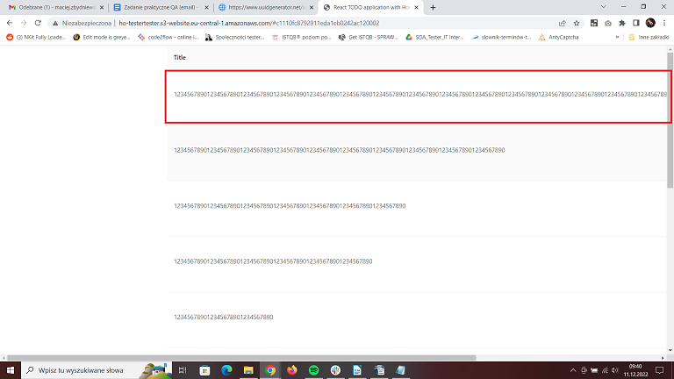

* Toast messages about creating, completing or deleting tasks are displayed in not very convenient place on the screen – especially when there are at least 10 tasks added.

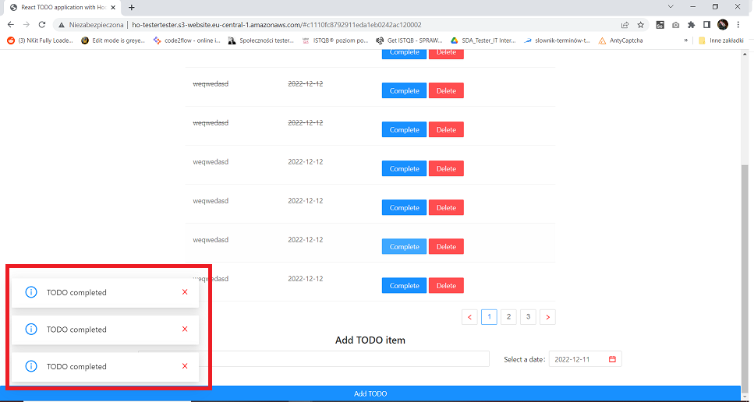

* Toast messages could have had colors corresponding to the type of information they give – green for confirmation of adding, blue for completing and red for deleting.
* You can only check last 30 added tasks, but you can add more than 30. Pagination ends at 3. I would need to ask if it works as designed.
* The message next to ‘Title’ box is wrong – it says ‘Length must be more than 5’, whereas 5 characters are enough to make a title valid. The message should say ‘Length must be more than 4’ or ‘Length must be equal to or greater than 5’.

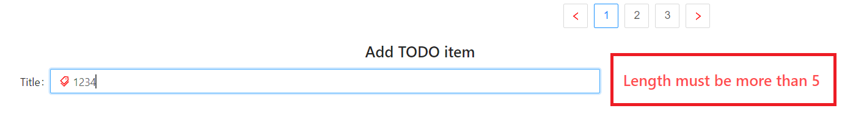

* When you click on ‘Complete’ button on a completed (crossed) task the toast message ‘TODO completed’ prompts – it shouldn’t, as the task has already been checked as completed.
* There is no functionality for editing the tasks’ titles and dates.
* Completed tasks should have a little ‘done icon’ next to them, besides being crossed out. I would have to ask if they lack this icon by design.
* The application works slowly and is not very responsive, in general way. When you try to delete tasks quickly the app tends to slow down and it makes the deleting process rather uncomfortable.
* You can add more than 1 task with the same name and same date, I’m not sure it’s working as designed.

**Bug reports**

*All of the bugs were reproduced on Windows 10, Chrome browser ver. 108+ with active Internet connection. Priority 1-5, where 1 is lowest and 5 is highest. If I were to use Jira or other reporting tool, I would include information about environment or preconditions in every bug report separately.*

**ID 1**

* Add TODO button active, even tho the date for the task wasn’t selected

Priority 3/5

**Description:** after adding at least one task, deleting the text from ‘Title’ box and typing the title for the new task the Add TODO button is active, even if you didn’t select a date for a new task. The date is being copied from the previous task added.

Steps:

1. In ‘Title’ box type ‘breakfast’

2. Select a date by clicking ‘Today’ from ‘Select a date’ box

3. Click ‘Add TODO’ button to add a task to the list, ‘TODO added’ toast message prompts

4. Delete all of the text from ’Title’ box and type ‘lunch’

**Actual result:**

‘Add TODO’ button is active, even tho the date for new task wasn’t selected. After clicking the button the new task is being added with the date of previously added task.

**Expected result:**

‘Add TODO’ button is inactive until you select a date for the new task.

**Attachments:**

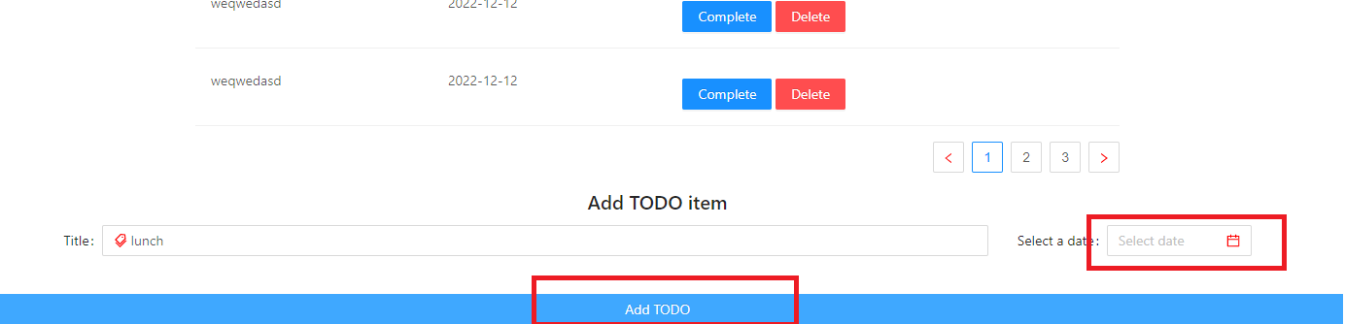

**ID 2**

* Adding a task with past date is possible

Priority 2/5

**Description:** you can add a task with past date selected.

Steps:

1. In ‘Title’ box type ‘breakfast’

2. Select the date as 6 December 2022

**Actual result:**

‘Add TODO’ button is active, even tho the date for new task is in the past. The task is being added with the selected date.

**Expected result:**

‘Add TODO’ button is inactive until you select a valid date – today or in the future.

**Attachements:**

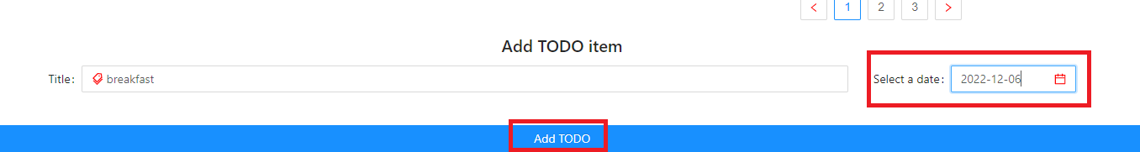

**ID 3**

* After adding a task and being inactive for a period of time API isn’t responding – code 401

Priority 5/5

**Description:** after performing at least one API request – POST (Add TODO), PATCH (Complete) or DELETE (Delete) – and some inactivity time (between 30 and 120 seconds) API stops responding – every request ends with 401 code. The inactivity time for the bug to happen varies.

Steps:

1. In ‘Title’ box type ‘breakfast’

2. Select a date by clicking ‘Today’ from ‘Select a date’ box

3. Click ‘Add TODO’ button to add a task to the list, ‘TODO added’ toast message prompts

4. Wait for at least 60 seconds

5. Find your previously added task and click ‘Complete’

**Actual result:**

The toast message ‘TODO completed’ prompts, but the task isn’t crossed out. The devtools console shows code 401 related to your PATCH (Complete) request.

**Expected result:**

The task is being crossed out and toast message ‘TODO completed’ prompts, the devtools ‘Network’ tab shows code 200 as that request was successful.

**Attachements:** 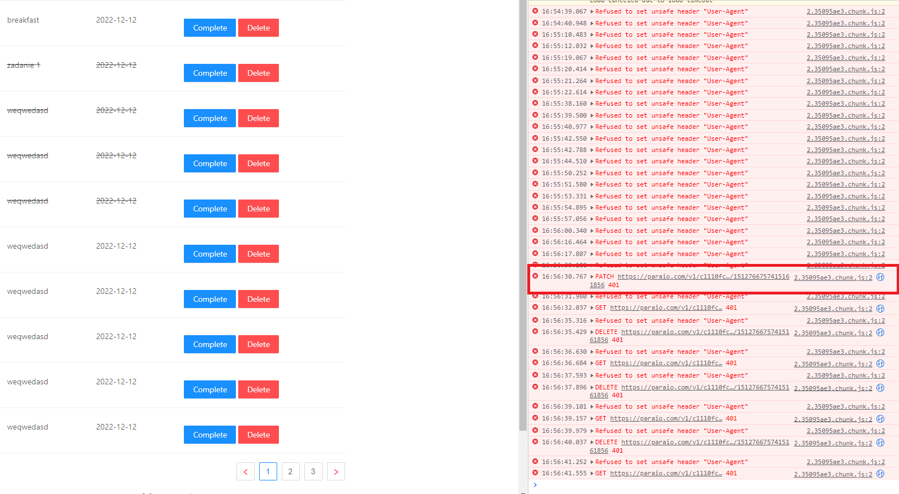

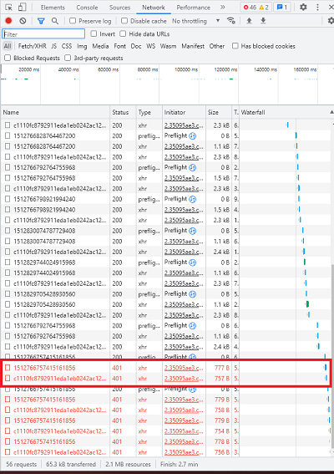

**ID 4**

* After an API request browser’s devtools ‘Console’ tab shows error

Priority 4/5

**Description:** after making any API request, like POST, PATCH or DELETE, the devtools console shows an error message even tho network tab shows code 200 – success.

Steps:

1. Open browser devtools by hitting F12 key, chose ‘Console’ tab

2. In application’s ‘Title’ box type ‘breakfast’

3. Select a date by clicking ‘Today’ from ‘Select a date’ box

4. Click ‘Add TODO’ button to add a specified task

**Actual result:**

The ‘TODO added’ toast message prompts, the task shows on the list of tasks, but ‘Console’ tab in browser’s devtools shows an error message - „Refused to set unsafe header „User-Agent””. The ‘Network’ tab shows code 200, as the request was successful.

**Expected result:**

The ‘TODO added’ toast message prompts, the new task shows on the list of tasks, there is no errors in ‘Console’ tab of brower’s devtools.

**Attachements:**

