Some may ask what is the A.I. doing in AHRSYS – it depends

Assuming a scanner design [web crawler, spider, bot] where each row is devoted to a symbol [searching and collecting, along with other A.I. parameters], results in research that forms an opinion database in regards to financial reports, income-tax, news [even collect weather conditions data or target Entrepreneurs]. The point is that whatever is custom programmed in the OFdriver [to observe or to scan] including auto trading, can be viewed by user in real time [with one click on the symbol “LIB”] as a visual representation designed in the library – the analytics [specifically correlated to the driver].

**Why GUI or UI is misunderstood or too generic?** [it is not generic even if MS windows, MAC, Apple or Linux, whatever OS is a choice]

While looking at the ribbon and window representation of a blank list, one would ask how is that possible?: [see vizual_01ribbon.pdf]

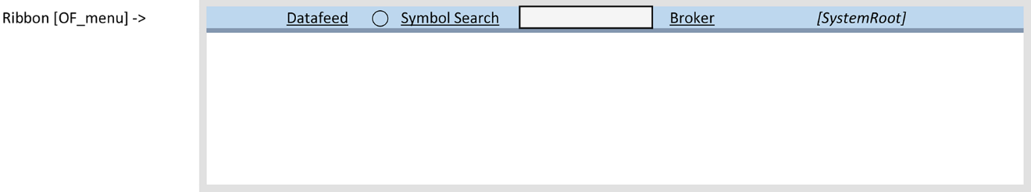

Should a branded platform decides to include a top menu utility for creating a project, the user would select: [otherwise consider a wizard/install]

**Project > New > Enter Project Root Name:** [AHRSYS]

The code should take care of creating a folder structure, add to the folder structure the necessary files and popup a window **where [SystemRoot] will show [AHRSYS]** – AHR said “I prefer C, C++ so be careful what else you want for a system.”

Note: [SystemRoot] can be linked to display the content folder with any file-management software [consider even an icon on the desktop]

**Datafeed** is a link to “detail utility window” used to establish a data connection. [consider a DatafeedProfileManager]

**⃝** is a the alert of the Datafeed state indicating either good/fault/no connection

**SymbolSearch** and its **search-box** is the very known utility to search and select a symbol [should data connection exist]

– upon selecting a symbol: [the code is expected to perform]

1. Create a folder structure for the particular symbol [under SystemRoot]
2. Add a mock_default in the structure
3. Display the symbol on the list and copy mock_default files
4. The mock_default files in the OFdriver will feed back to the list signal/alerts/param [add functionality to such row]
5. (to early to detail but to note the necessity to sort such list should be considered)

**Broker** is a link to establish a BrokerProfile similar with Datafeed it is a utility popup window [a profile; or BrokerProfileManager]

* If no BrokerProfile is selected will default in PaperTrading

Next is to take a look at content of the OF_list – REM: every row in the list is a Symbol with its own physical structure [library and driver]

Note: it is strongly advised to keep OFdriver as the responsible module [code] to create functionality to its related row in the OF_list

See vizual_02content.pdf “particular to Of_list [Data Rows] ->”

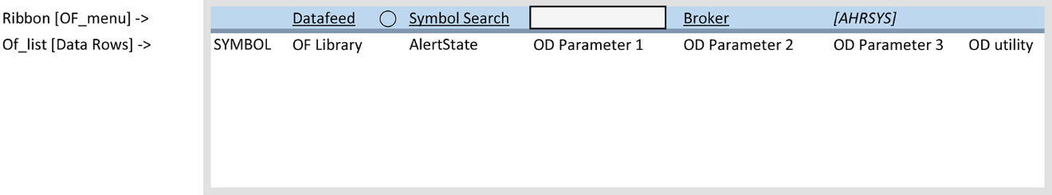

**Symbol** [SYMBOL] it is a field with properties but more essential is to tell where is coming from – user selected such symbol from a datafeed DB. Accordingly the symbol field should resemble the user action datafeed and symbol. Both very pertinent to trading. From the programming prospective is an embedded name. AHR suggested [in case IQfeed connection] IQF_symbol where _symbol part of the embedded name is what IQF designed/created for a symbol. Now that we have a unique name we can find some functionality for it. It will be insulting to detail but few points is desired:

* Is it a read only or w/action behind such field? A read only is the minimum required but to put some action in such field is a choice of the programmer/coder to find utility. One may suggest to call the OF_SymbolManager but more specific is to delete or manage such row. I am not the programmer to tell you how far I could manage a row as visually represented above. Delete/Edit is just a suggestion and should affect the structure at the folder level. REM: delete is simple task but edit requires a depth of how far you need to edit to ensure functionality [do not engage edit if you do not know the depth required before losing functionality]

**OF library** [OF_LiB] ok it is a field again! But what it does if not denoting at the structural-level a location/path to a particular library – Give me the libs! One may scream. Well, AHR said, don’t scream because this the button will deploy the libs on the screen – nothing more, and I mean all of them to be found in chartsLIB. There is to note specifically in prior reading that this the action to load/reload/refresh a library. Well the process is not entirely limited to “nothing more” entails to also clean/close symbol-session of opened library if any. Needless to say is to close the LIB as was called a session running on OF_symbol. Scream again clear my screen RAM/cache and anything before load/reload/refresh – clean session and give me the LIB is more correct and a good scream to consider.

OF library is the place to find a study, charting, detail-analytics-on-a-particular-symbol, [a] number of charts etc. -- TRUE: At the programming level one may consider that the action is sent to the driver to know what to load if all or a particular name in the library. But it logically defaults to all and leads to custom if something else is desired.

**AlertState** – to me [AHR] is insulting to detail but again I’ll make the point – this the feedback received [by the row] from its driver to inform the user to have a look at detail [a signal to trade or not that requires detail analytics before placing the trade-order] – the mock_default includes the working-example and how to even install third party code.

**OD parameter** [#] is a feedback from the driver to link/alert or else be dead stay blank as it is reserved for custom programming. Hum, some may say to call the notepad and record in the user-journal some event [the user needs to mark particular to his work], observation or bad language and error occurred. AHR said: I would allow any bad expression in circumstances where the datafeed-state is faulty – and no limits in circumstances when the user is with active orders on the screen. Is that generic enough for you? – Functionality, if not generic may be the idea of linking to an external api than can pop some news, connect to community related or else let me know how you doing… may suffice on why custom parameters function is found in a driver.

**OD utility** – here we are! Arrived to the conclusion that the utility of the driver must exist to show visually in a chart or else build your own of what is that drives the library besides the signal/alerts/param in the list. – will let you know as it is a lot of custom thinking. However, the design in AHRSYS calls for coding and a visual representation of the driver. The user will click on such field to view only the representation at minimum an example in the mock_default.

**Other notes:**

The branded platforms mostly offer a library of chars and studies some even shows a populated workspace but none absolutely none will do what AHRSYS calls for. AHR said: “direct me to at least to read that the branded platform approach is to create a [interactive] “watchlist” in the workspace they provide and how interactive that is. And further to note, are done, with a few clicks – how productive from the user point of view. And yet, thinking of third party custom programming offering, AHR said “you miss me pal – limitless custom opportunities under AHRSYS and remember the focus on how quick the user may use your work”!!! … “what do you know, I may even trade today” [w/ a Monte Carlo version].

“Here what is bother me since some will ask how you manage such list” -- OK manage the list is same as assuming utility to (a) top level “ribbon item” (b) list content “rows” (c) list content “columns” the rest is history repeating – to note, one will manage columns in next version of AHRSYS. For productivity reason I would elaborate that once a symbol is selected the top level is locked as a result the user only can delete the rows and/or the root – else, learn to back up and start over is more productive. And that doesn’t mean I have no solution on how to handle interchangeable items of top-level or content. The customer service will ask such questions and the answer is not bad language but obvious, you are not in the position to ask such questions.

How are you today, mr./ms/mrs. Reader?

AHR 20180619b

PS: generic is when most if not all branded platforms designed what you see in AHRSYS as top-level [ribbon] or non-interchangeable items glued to the platform not to the user!!! What about if is to run two AHRSYS-like sessions with different top-level items? Solution does exist -- on development side of what is to load/reload/refresh [if not scream, I am out of memory]. To also note that what is called herein “non-interchangeable items”, solution to make them interchangeable exist but not desired at the moment. To also mention that top level items comes with the project not with the platform. As such the user desire to deploy a project and all sorts of custom programming.