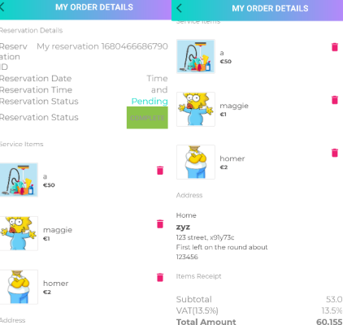

SuperCleaner is a mobile application designed to simplify the process of booking valuable services , in this case cleaning services, for a small enterprise. The app offers an easy-to-use platform for users to reserve services in their local area and provides an intuitive dashboard for the enterprise to manage and administer the services they offer, a shopping cart, where users can select and purchase multiple services, as well as a payment gateway to complete transactions.
App should run with no additional configuration from the user.
For admin view, please use :
email: testadmin0@testadmin0.com
Password:123456

