University of Central Punjab
Faculty of Information Technology
DevOps Fundamentals – Spring 2026

Assignment 04 – CI/CD Pipeline Integration
Total Marks: 100 | Weeks Covered: 10–14 | CLO: CLO2

GROUP DETAILS

Sr # | Student Name | GitHub Username | Role | Assigned Page | Branch Worked On | Screenshots
1 | Ahsan Malik | ahsan-2004 | Team Lead | index.html | main, develop | YES

Student ID: L1F22BSSE0147
GitHub Repository URL: https://github.com/ahsan-2004/taskflow-cicd
Deployed Application URL: https://taskflow-cicd.onrender.com
Docker Hub: https://hub.docker.com/r/ahsan200/taskflow-cicd

REPOSITORY SETUP

I created a brand new public GitHub repository named taskflow-cicd from scratch. No existing repository was reused or forked. A develop branch was created from main and set as the default working branch for all team contributions.

Branch Protection Rules were applied on the develop branch requiring at least one pull request review and the CI status check to pass before any merge is allowed. This ensures code quality is maintained throughout the development process.

The initial repository structure was set up by committing style.css (shared stylesheet), Dockerfile (nginx-based containerization), and all 5 HTML pages directly to the develop branch as the Team Lead setup responsibility.

GITHUB DEVELOPMENT ENVIRONMENT & SECRETS

A GitHub Environment named 'development' was created under Repository Settings → Environments. Three secrets were configured as described below:

Scope | Secret Name | Value / Description
Repository | DOCKERHUB_USERNAME | ahsan200 (Team Lead's Docker Hub username)
Repository | DOCKERHUB_TOKEN | Personal Access Token generated from Team Lead's Docker Hub account
Environment (development) | RENDER_DEPLOY_HOOK_URL | Deploy hook webhook URL from the Render web service

CI PIPELINE – .github/workflows/ci.yml

Trigger: pull_request event targeting the 'develop' branch only

The CI workflow runs automatically whenever a team member opens a Pull Request targeting the develop branch. It performs the following steps in order:

Step 1 – Checkout: Checks out the repository code using actions/checkout@v3
Step 2 – Docker Login: Authenticates with Docker Hub using the DOCKERHUB_USERNAME and DOCKERHUB_TOKEN repository secrets
Step 3 – Build Image: Builds the Docker image from the Dockerfile in the project root
Step 4 – Tag Image: Tags the image with 'latest' and also with the short commit SHA (github.sha) for version tracking
Step 5 – Push Image: Pushes both tagged images to Docker Hub under ahsan200/taskflow-cicd

CD PIPELINE – .github/workflows/cd.yml

Trigger: push event on the 'develop' branch (automatically fired when a PR is merged)

The CD workflow runs automatically whenever a Pull Request is merged into the develop branch. It performs the following steps:

Step 1 – Checkout: Checks out the repository code using actions/checkout@v3
Step 2 – Declare Environment: The job specifies environment: development so the RENDER_DEPLOY_HOOK_URL secret is accessible
Step 3 – Deploy: Sends an HTTP POST request to the Render deploy hook URL using curl -X POST
Step 4 – Confirm: Outputs a timestamped message confirming that deployment was triggered successfully

VERIFICATION SCREENSHOTS

Screenshot 1: GitHub Repository Secrets (DOCKERHUB_USERNAME & DOCKERHUB_TOKEN)

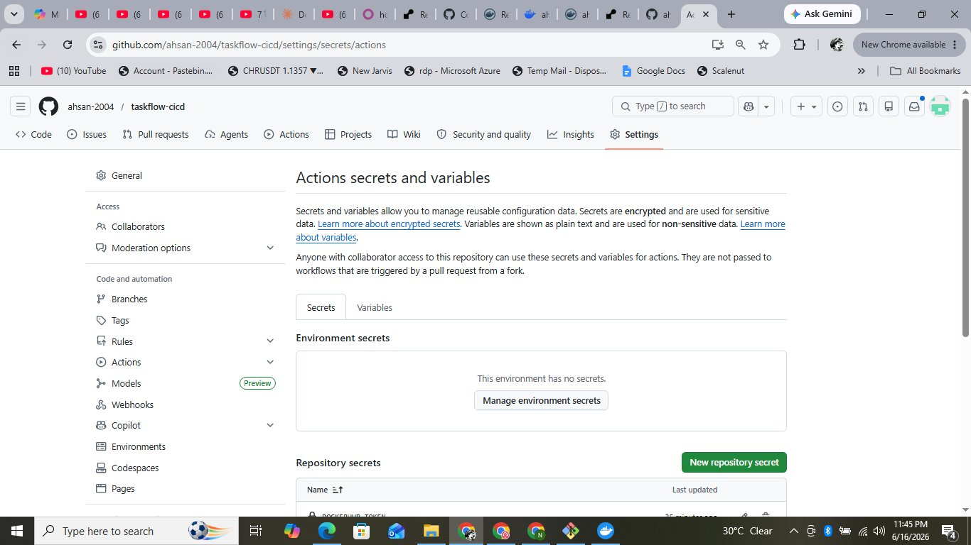
Fig 1 – GitHub Actions Secrets showing DOCKERHUB_USERNAME and DOCKERHUB_TOKEN configured as repository-level secrets
Screenshot 2: GitHub 'development' Environment with RENDER_DEPLOY_HOOK_URL

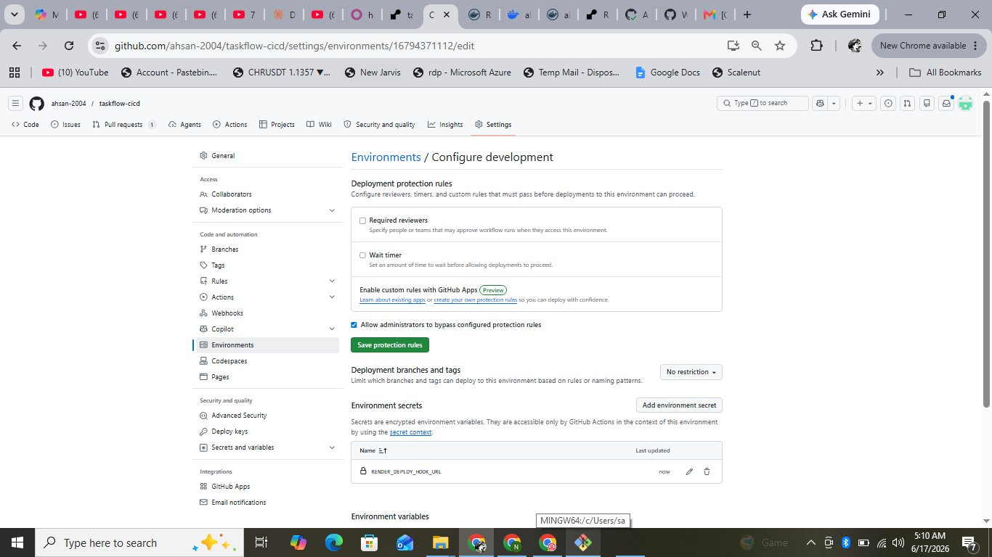
Fig 2 – GitHub Environment 'development' showing RENDER_DEPLOY_HOOK_URL configured as environment-level secret
Screenshot 3: CI Workflow Run – Triggered by Pull Request (All Steps Green)

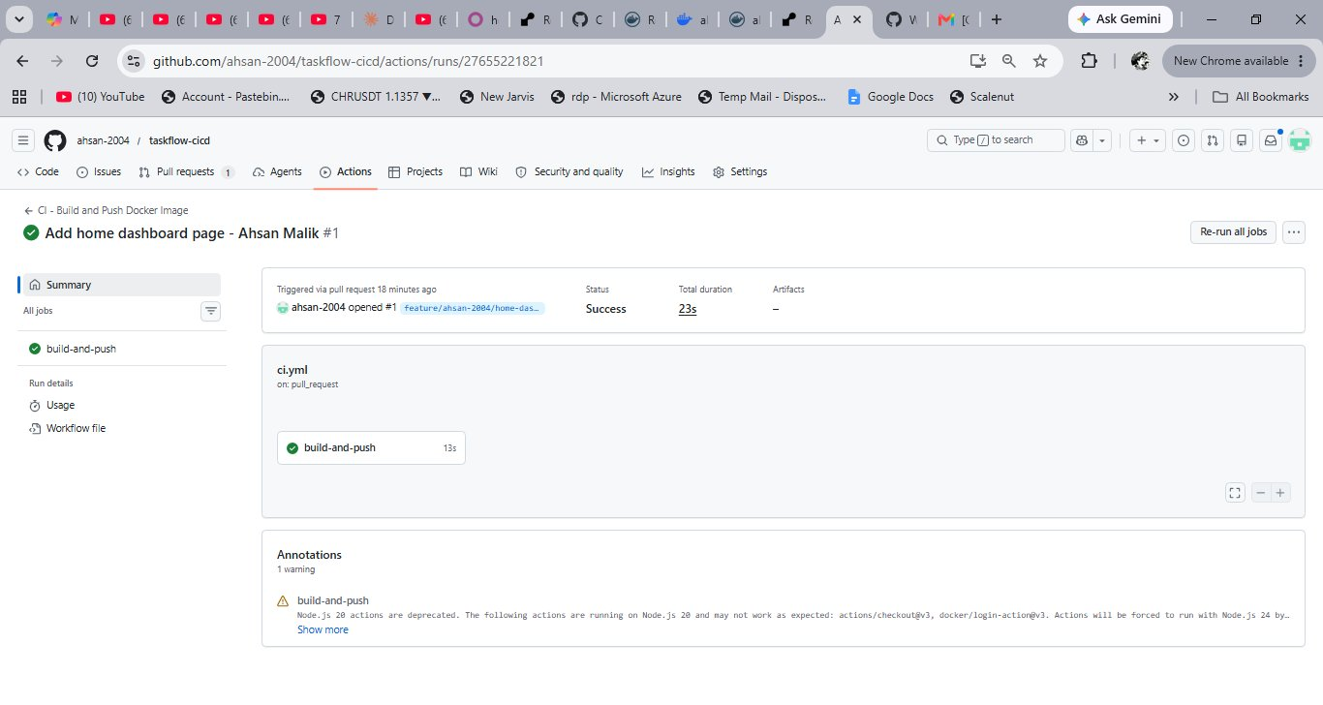
Fig 3 – CI workflow 'Add home dashboard page – Ahsan Malik' triggered by PR #1, Status: Success, Duration: 23s
Screenshot 4: Docker Hub Repository – Pushed Image with Tags

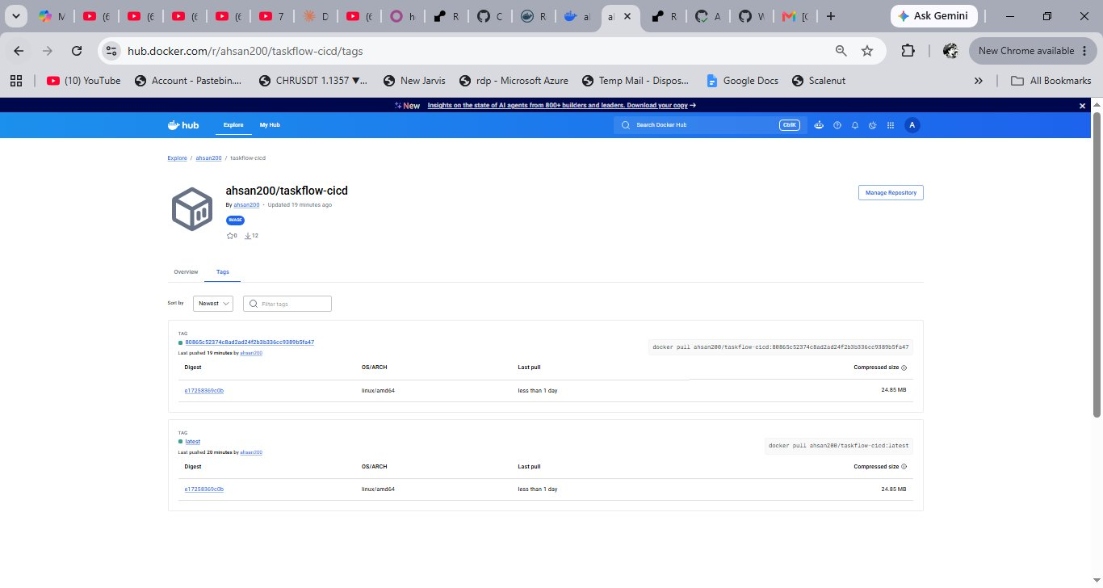
Fig 4 – Docker Hub repository ahsan200/taskflow-cicd showing 'latest' and commit SHA tags pushed successfully
Screenshot 5: CD Workflow Runs – All Triggered by Push to develop

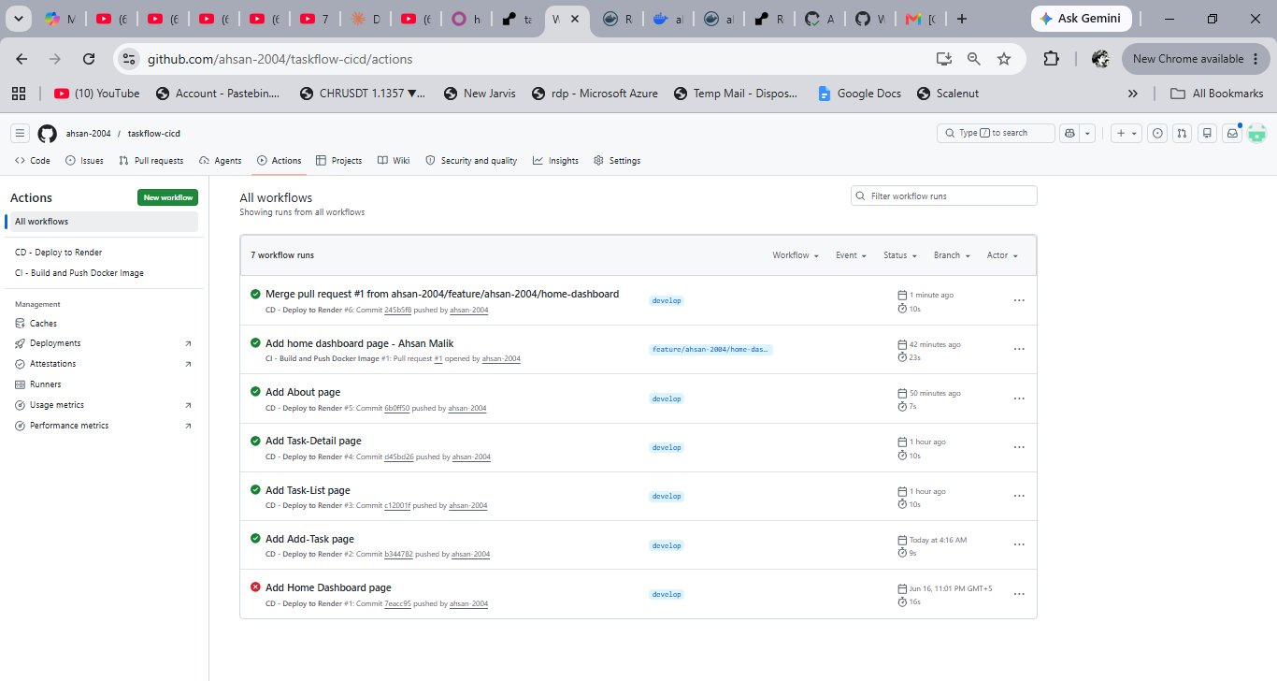
Fig 5 – GitHub Actions showing 6 workflow runs, all green. CD pipeline triggered on every merge to develop branch
Screenshot 6: Live TaskFlow Application on Render – All 5 Pages Accessible

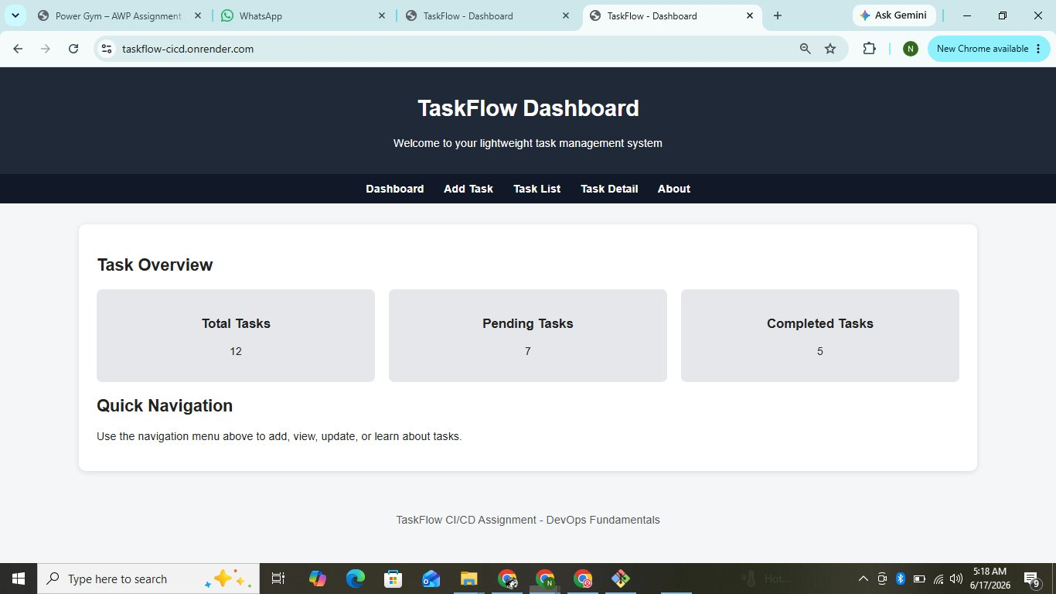
Fig 6 – Live TaskFlow app at https://taskflow-cicd.onrender.com showing Dashboard with navigation to all 5 pages
Screenshot 7: GitHub Repository File Structure

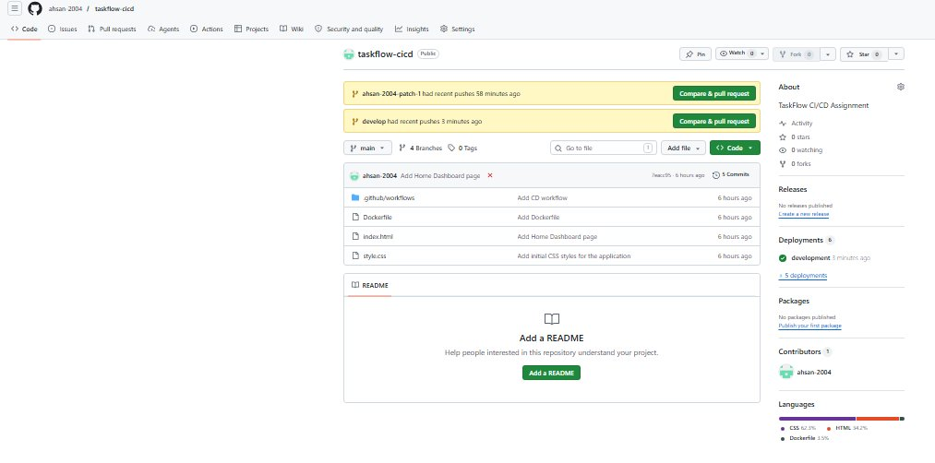
Fig 7 – GitHub repository showing all required files: .github/workflows, Dockerfile, HTML pages, style.css

INDIVIDUAL REFLECTION

Ahsan Malik – L1F22BSSE0147 – Team Lead

This assignment was honestly one of the most challenging but also the most rewarding things I have done in this course. Setting up the CI/CD pipeline from scratch using GitHub Actions, Docker Hub, and Render taught me how real DevOps workflows actually function in practice rather than just theory.

As Team Lead, I was responsible for everything from creating the repository and configuring branch protection rules to writing both the ci.yml and cd.yml workflow files and managing all the secrets. The trickiest part was understanding how the CI and CD pipelines are separate but connected — the CI builds and pushes the Docker image on a PR, and the CD deploys to Render when that PR is merged. Keeping them as two separate workflow files with different triggers was something that took me a while to fully understand.

I also ran into a real issue with Docker Desktop on my local machine not being able to connect to Docker Hub due to network restrictions. But that actually helped me understand something important — GitHub Actions runs on remote Ubuntu servers, so my local network problems had no effect on the pipeline at all. Once I pushed the code and the CI ran on GitHub's servers, everything worked perfectly.

Building all 5 HTML pages of the TaskFlow application and linking them to a shared stylesheet also showed me how a consistent design system works across multiple pages. Overall this assignment gave me genuine hands-on experience with containerization, automated testing, and deployment pipelines that I know will be useful in my career.

REPOSITORY STRUCTURE

File / Folder | Purpose
index.html | Home / Dashboard – task summary, welcome message, navigation links
add-task.html | Add Task – form with title, description, due date, priority fields
task-list.html | Task List – table of tasks with All/Pending/Completed filter buttons
task-detail.html | Task Detail – full task info with mark complete and delete options
about.html | About – app description, purpose, and usage guide
style.css | Shared stylesheet – consistent look and feel across all pages
Dockerfile | nginx:alpine based containerization of the web application
.github/workflows/ci.yml | CI workflow – triggered on pull_request to develop branch
.github/workflows/cd.yml | CD workflow – triggered on push/merge to develop branch

Assignment 04 – CI/CD Pipeline Integration | DevOps Fundamentals Spring 2026 | University of Central Punjab

