Software Requirements Specification (SRS)
Project: UAE Limousine Fleet Management & ERP System
1. Project Overview
The objective is to build a centralized, automated web dashboard and driver mobile app for a UAE-based limousine company. The system will automate financial settlements (Cash vs. Credit), track vehicle and HR liabilities, integrate with government compliance systems (Abu Dhabi ITC LES, Dubai RTA/MOI), and monitor fleet security via telematics.
2. High-Level System Architecture Flow
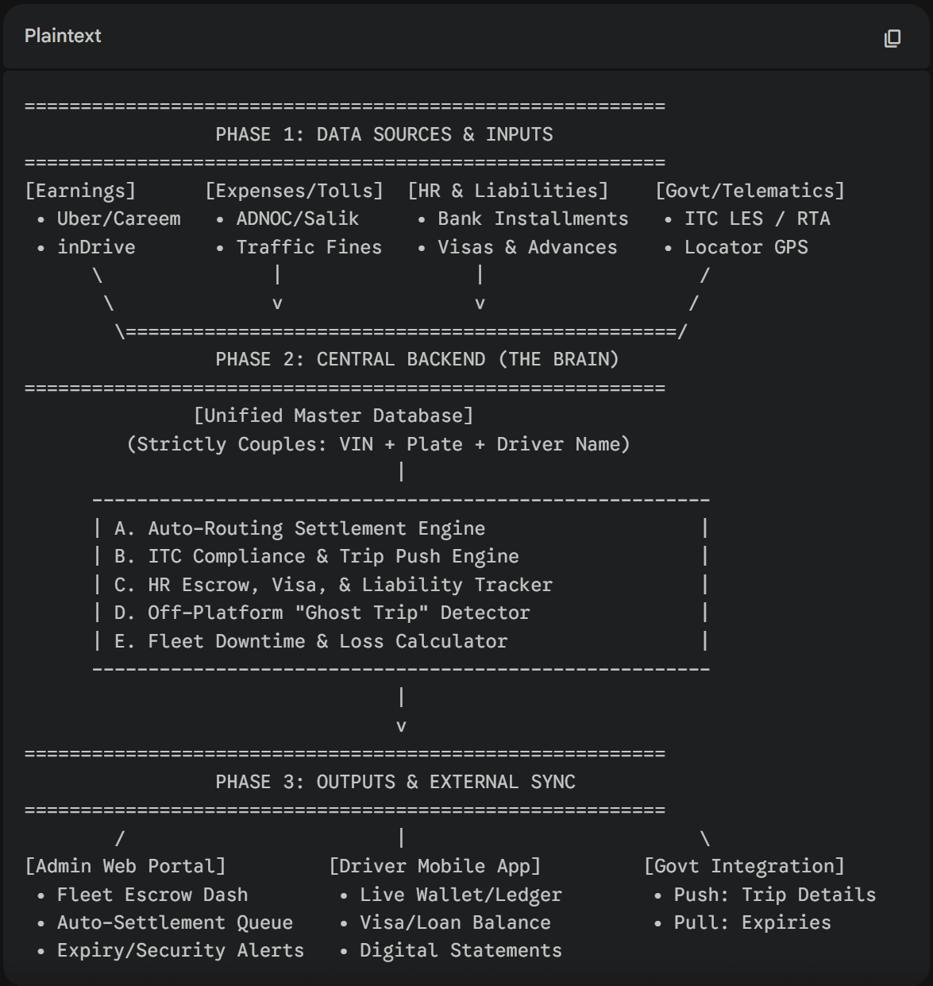

3. Core Modules & Feature Requirements
Module 1: The Unified Master Database (Strict Coupling)
- 1.1 Strict 1:1 Pairing: The database must strictly link a vehicle's Chassis Number (VIN) and Plate Number directly to a specific Driver Profile (Name, Labor Card, Emirates ID, Driver Permit Number).
- 1.2 Automated Expense Routing: All external fines, Salik tolls, and ADNOC fuel charges pulled via API must automatically route to the currently paired driver's ledger.
- 1.3 Reassignment Logging: If a driver is swapped, the system must timestamp the uncoupling. Expenses before the timestamp go to Driver A; expenses after go to Driver B.
Module 2: Automated Driver Settlement Engine
- 2.1 Cash vs. Credit Reconciliation: The system must pull earnings from Uber, Careem, and inDrive. It must offset "Cash Collected" (driver owes company) against "Credit Card Earnings" (company owes driver) to calculate the net wallet balance.
- 2.2 Variable Auto-Deductions: Automatically deduct ADNOC fuel, Salik, Darb, traffic fines, and logged maintenance (e.g., Engine Oil) from the driver's gross earnings.
- 2.3 Fixed Vehicle Deductions: Automatically deduct recurring monthly fees, including:
  - Vehicle Bank Loan Installment / Monthly Rent.
  - Number Plate Charge (Company Service Fee).
- 2.4 Sinking Fund (ITC Renewal): The system must act as an escrow, deducting a set amount (e.g., 625 AED/month) to build up the annual 7,500 AED ITC permit renewal fee.
- 2.5 HR Liability Amortization: The admin inputs a total Visa/Labor Card cost (e.g., 8,500 AED). The system auto-deducts a fixed monthly installment (e.g., 500 AED) until the outstanding balance reaches zero, at which point the deduction automatically stops.
Module 3: Government Compliance & Licensing (ITC LES / RTA)
- 3.1 API Authentication: Must connect to the Abu Dhabi ITC Licensing & Enforcement System (LES) using JWT Token-based authentication.
- 3.2 Automated Expiry Pull (Inbound): * Query getVehiclePermits API to fetch RegistrationExpiryDate, InsurancePolicyNumber, and check if PermitStatus is "Suspended" or IsEligibleForTrip is "No"
  - Query getDriverPermits API to monitor LicenseExpiryDate, EmiratesIDExiryDate, and PermitStatus.
- 3.3 Live Trip Push (Outbound): For private/cash trips, the system must automatically format and push trip data to the saveTripDetails API. Mandatory JSON payload fields include VehiclePermitNumber , DriverPermitNumber , PickupTime , GPS Coordinates , Distance , and TotalAmount.
- 3.4 Dispatch Blocker: If APIs detect an expired license, expired insurance, or "Suspended" permit, the system must visually flag the asset in Red and push an alert to block dispatch.
Module 4: Security, Fines, & Downtime Management
- 4.1 Fine & Black Point Integration: Pull traffic fines via UAE MOI/Police APIs. Auto-assign the fine to the driver based on the 1:1 database coupling. Track cumulative black points and trigger a "Danger Zone" alert at 18 points.
- 4.2 Ghost Trip Detector (Anti-Theft): Cross-reference Locator GPS movement against Uber/Careem/inDrive trip logs. Flag unaccounted vehicle movement (e.g., >0 km/h and >5 km with no active app trip) as a "Ghost Trip" on the admin dashboard for penalization.
- 4.3 Physical Downtime & Loss Calculator: * Trigger: If GPS shows 0 km movement for 24+ hours, prompt the admin to flag the car (e.g., "In Workshop - Accident").
  - Action: The system calculates the daily financial bleed (Monthly Bank Installment + Insurance ÷ 30) and displays the accumulating loss on the dashboard until the car moves again.
Module 5: User Interfaces
- 5.1 Admin Web Dashboard: Cloud-based portal for dispatchers and accountants. Includes Master Financial Ledger, GPS Fleet Map iframe, Dispute/Ticket queue, and ITC Error Queue (for failed trip pushes).
- 5.2 Driver Mobile App (iOS & Android): A portal for drivers to view:
  - Live Net Wallet Balance (Cash vs. Credit).
  - Real-time toll and fuel logs.
  - Outstanding Debt Tracker (Visa remaining balance, ITC Escrow balance, Bank loan balance).
  - Automated Monthly PDF Statements.

