Boolean-Based Blind SQL Injection — Practical Walkthrough
This walks through the actual attack step by step, with screenshots from the lab. See README.md in this folder for the underlying theory.

Step 1: Observe the Baseline Behavior
First, load the site fresh — no "Welcome back" message appears, since this is treated as a new visit.
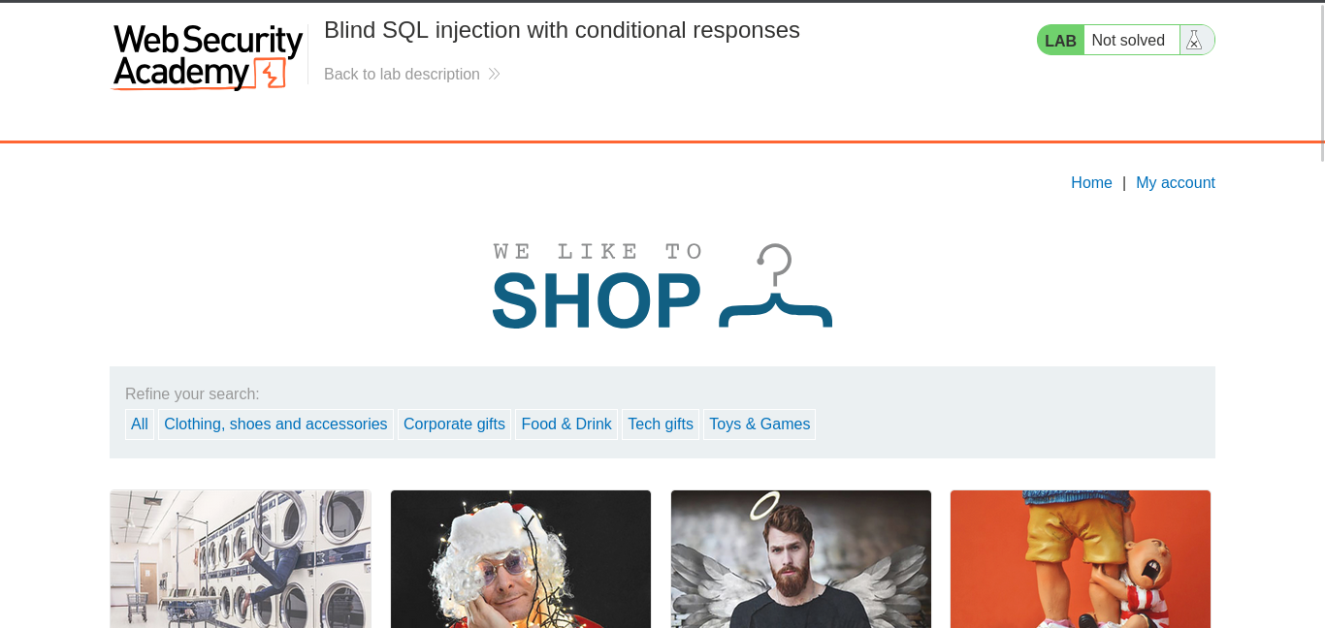

Reload the page. This time, "Welcome back" appears — the app recognized the tracking cookie from the first visit.
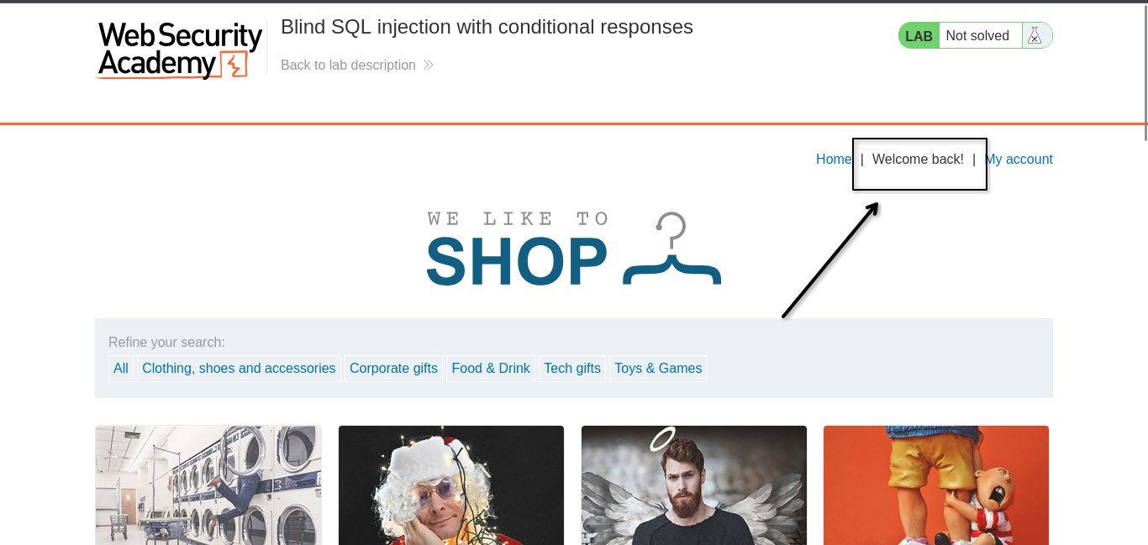
This confirms the app's behavior changes based on the TrackingId cookie — exactly the kind of signal blind SQLi relies on.

Step 2: Intercept Traffic in Burp Suite
Open Burp Suite and intercept the request so we can see and edit the TrackingId cookie directly.
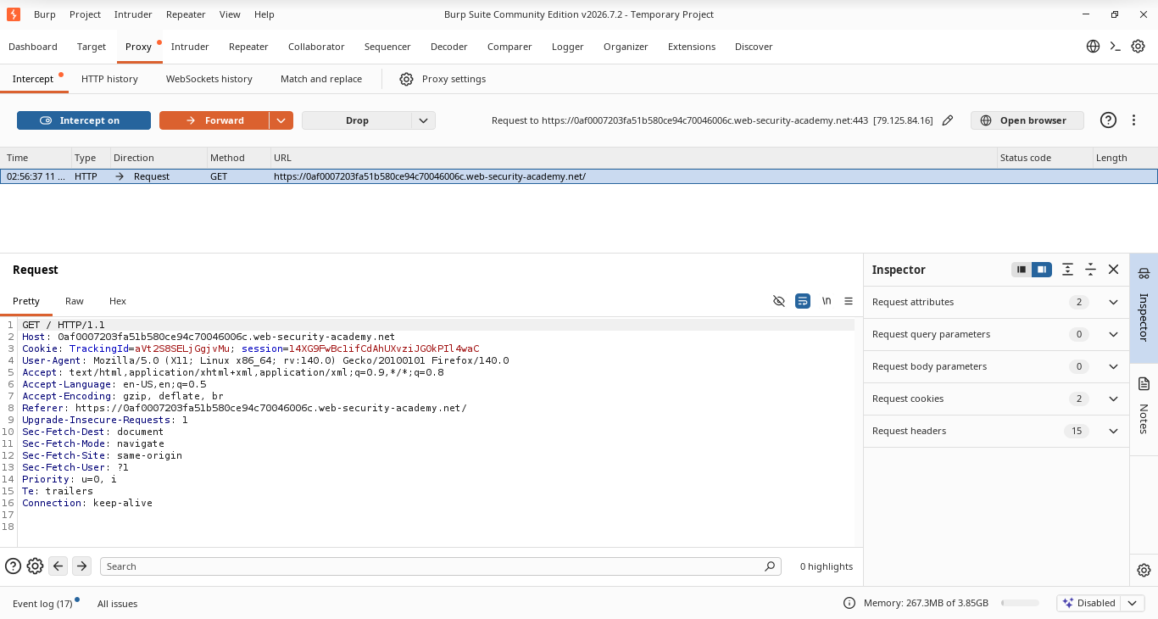
Send the intercepted request to Repeater, so it can be edited and re-sent repeatedly without needing to reload the page each time.
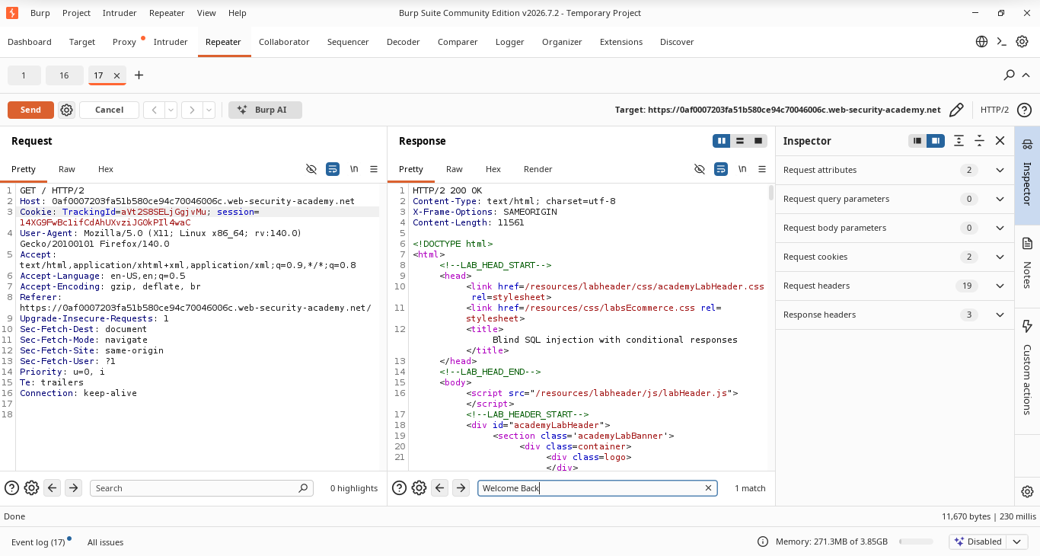

Step 3: Confirm the Boolean Signal
Send the request normally first, with a grep-match filter set for "Welcome Back" in Repeater's options. One match, HTTP 200 — this is the baseline true case.
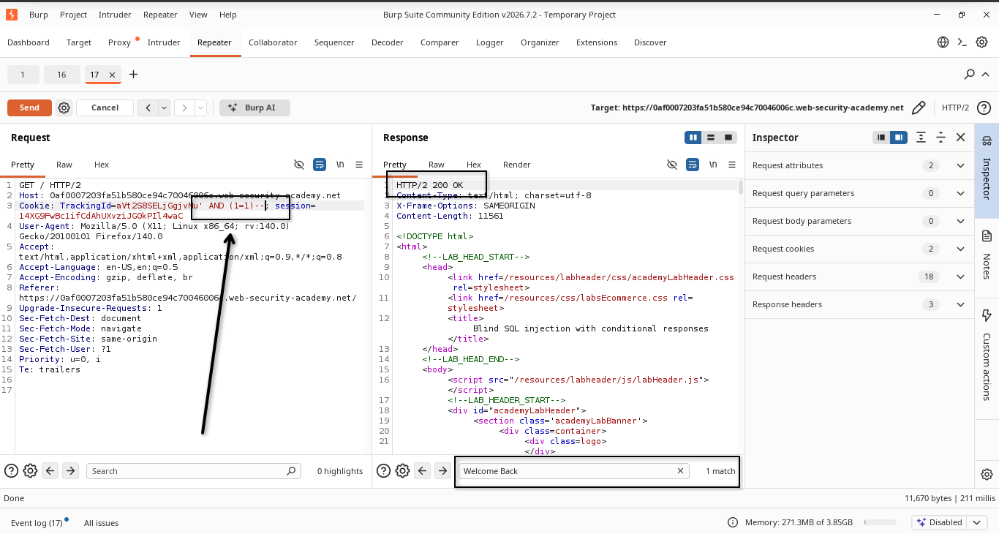
Now inject a true condition onto the tracking ID:
Cookie: TrackingId=xyz' AND '1'='1

No error, and "Welcome back" still appears — the true condition passed through cleanly.

Now flip it to a false condition:
Cookie: TrackingId=xyz' AND '1'='2

This time "Welcome back" disappears. Falsifying the condition breaks the match against the real tracking ID stored server-side, so the app no longer recognizes the session.
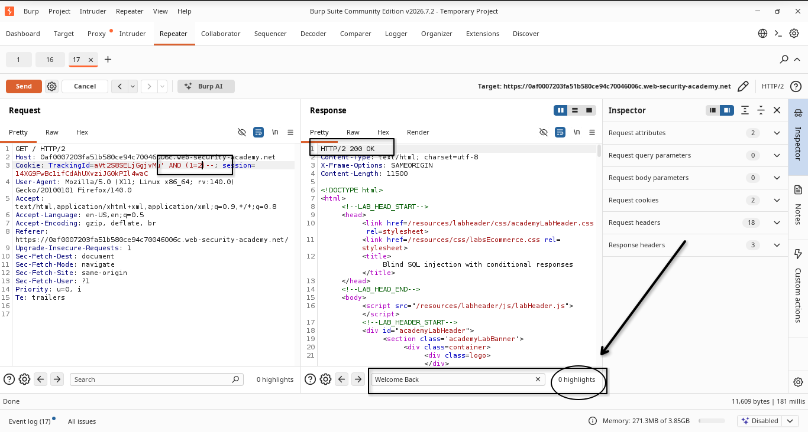
This confirms we have a reliable true/false oracle to work with.

Step 4: Confirm the Table and Columns Exist
Test whether the users table exists:
' AND EXISTS(SELECT 1 FROM users)--

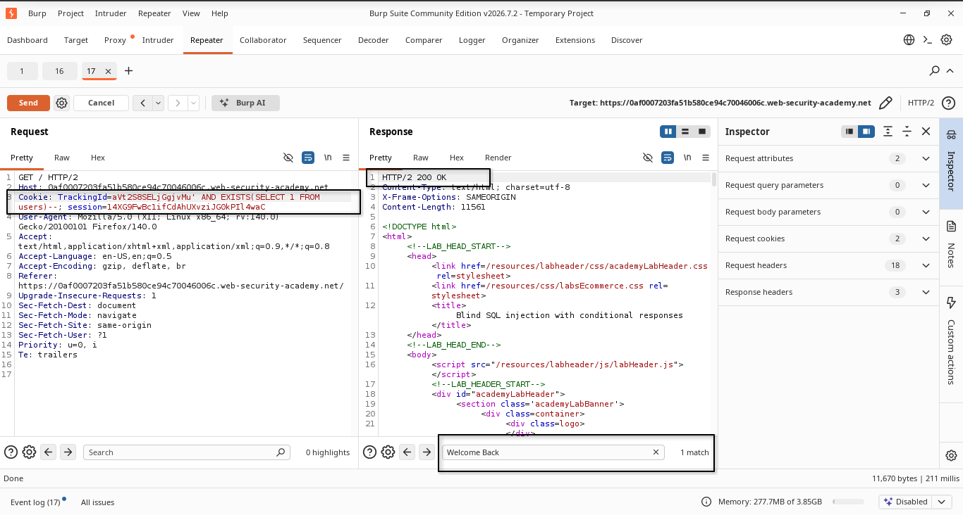
Then confirm the username and password columns exist, by swapping the column name in the same style of payload and checking for the same true/false signal.
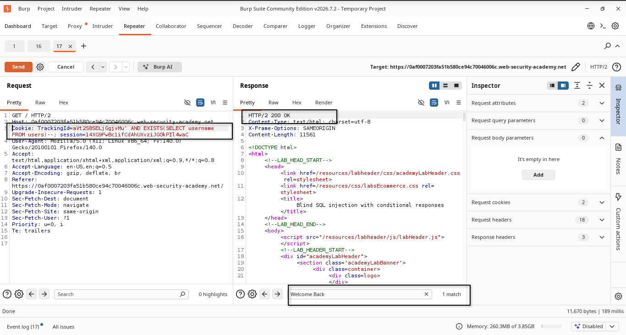

Step 5: Find the Password Length
Before extracting characters, we need to know how long the password is. Manually sending one request per length guess is slow, so this step moves to Intruder to automate it.
The payload:
' AND LENGTH((SELECT password FROM users WHERE username='administrator')) > §1§--
Set up a Sniper attack with a numeric payload set from 1 to 30 — each request substitutes a different number in place of the length check, and Intruder sends them all automatically.
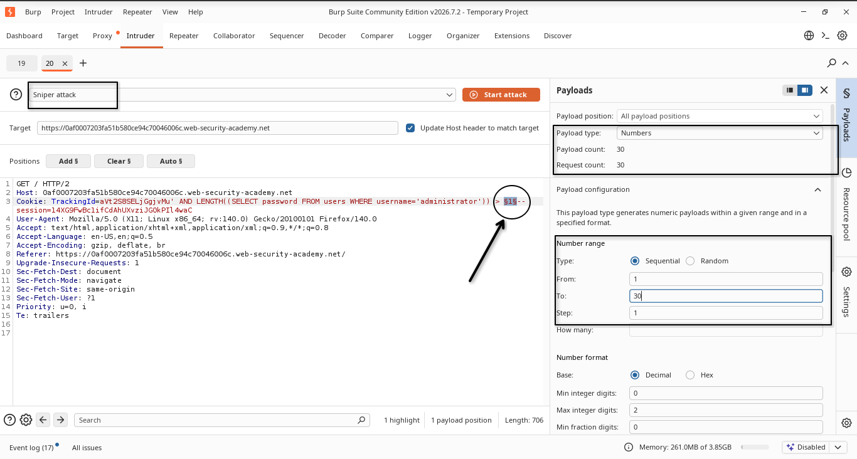

Reviewing the results with the "Welcome back" grep filter still applied: requests up through length 19 return a match (true), and 20 onward returns no match (false). That means the true/false boundary sits at 19 → 20, so the password is 19 characters long.
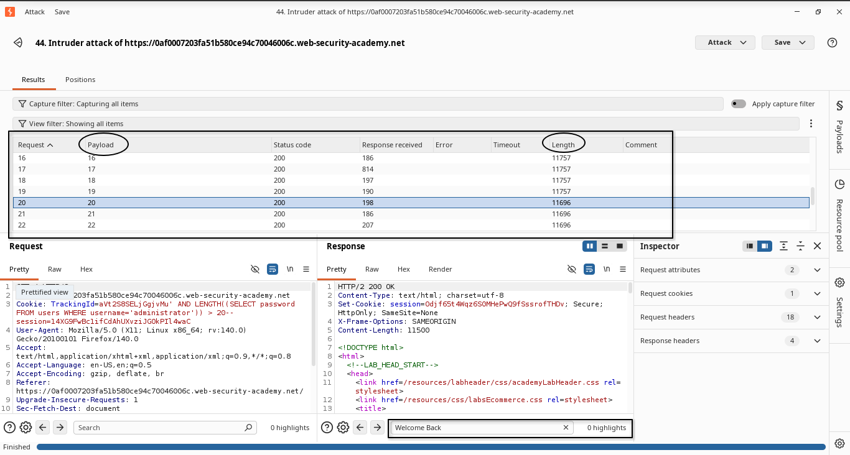

Step 6: Extract the Password
Manually testing every character position through Burp's free Intruder is slow — Burp intentionally throttles Community Edition to push users toward the paid version. Instead, this step uses a Python script that sends the requests directly and applies binary search per character.
You only need two values from Burp: the current TrackingId prefix and session cookie. Paste them into the script's configuration fields.
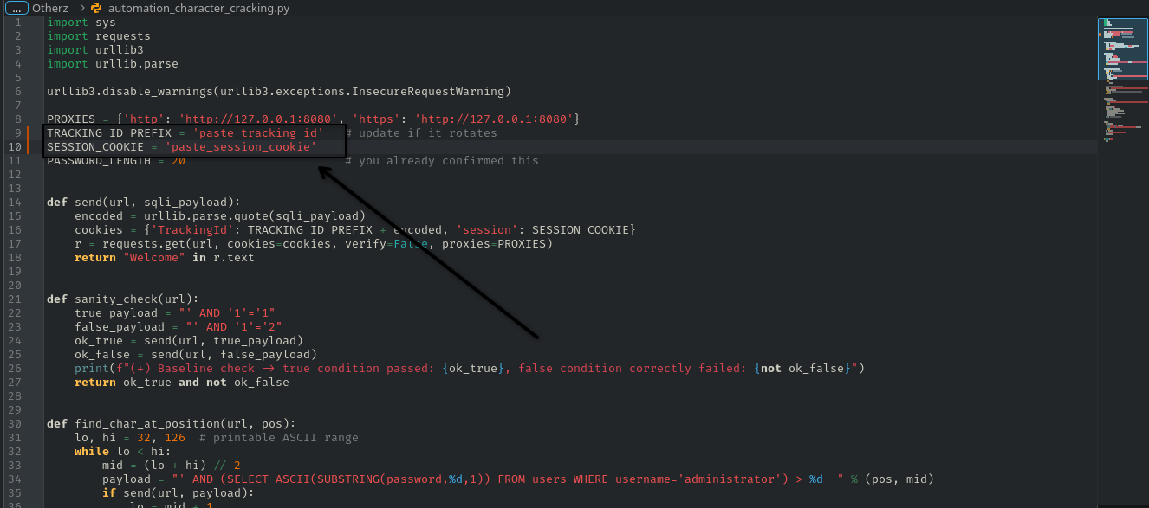
Then run the script from the terminal, passing the lab URL as the argument:
python ./blind_sql_injection_BF_script.py "https://your-lab-id.web-security-academy.net/"

Step 7: Log In
With the extracted password, log in as administrator on the site.
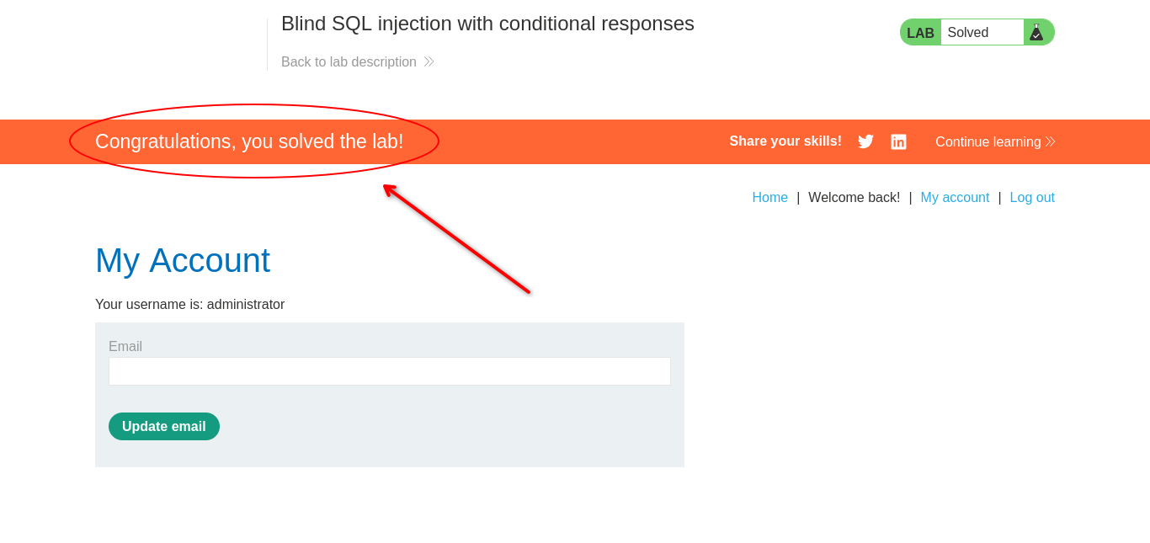
Lab solved.

Notes
- The TrackingId and session values shown in these screenshots are tied to a single, short-lived lab instance and expire automatically — they're not usable outside that session.
- See extract_password.py in this folder for the full automation script used in Step 6.

