SOFTWARE ADJUSTMENT ON SALES UNIT [23 January 2018]

A)

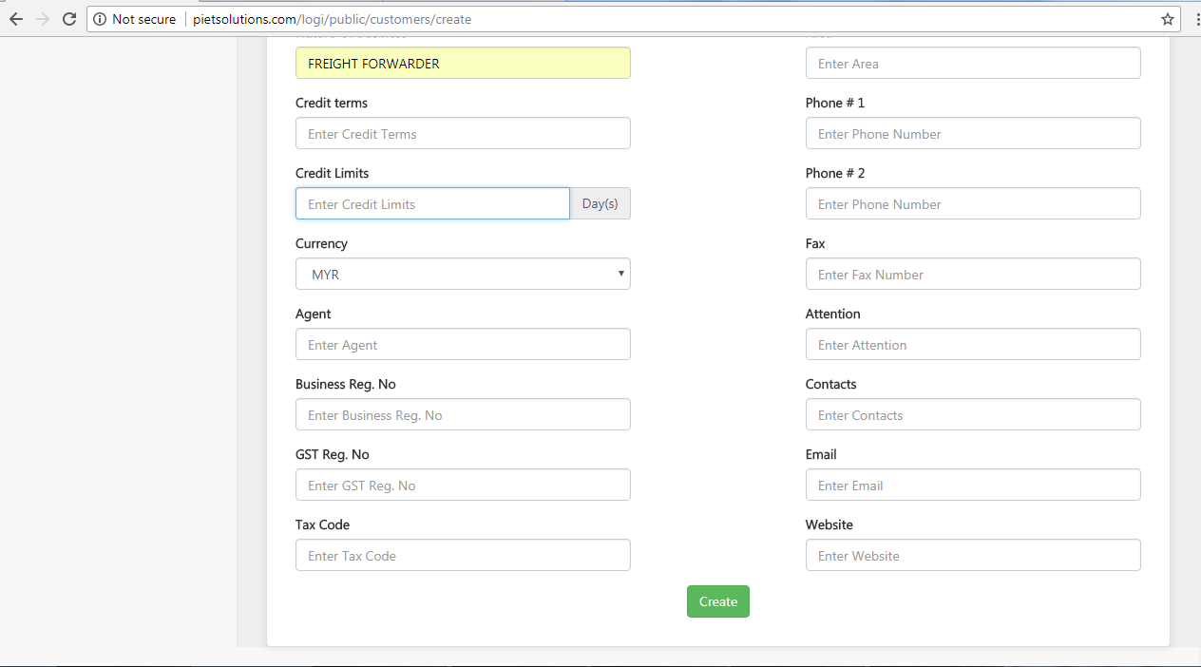

“Days” is the unit for “Credit term” meanwhile the unit for Credit Limit is “MYR” or “SGD”

B)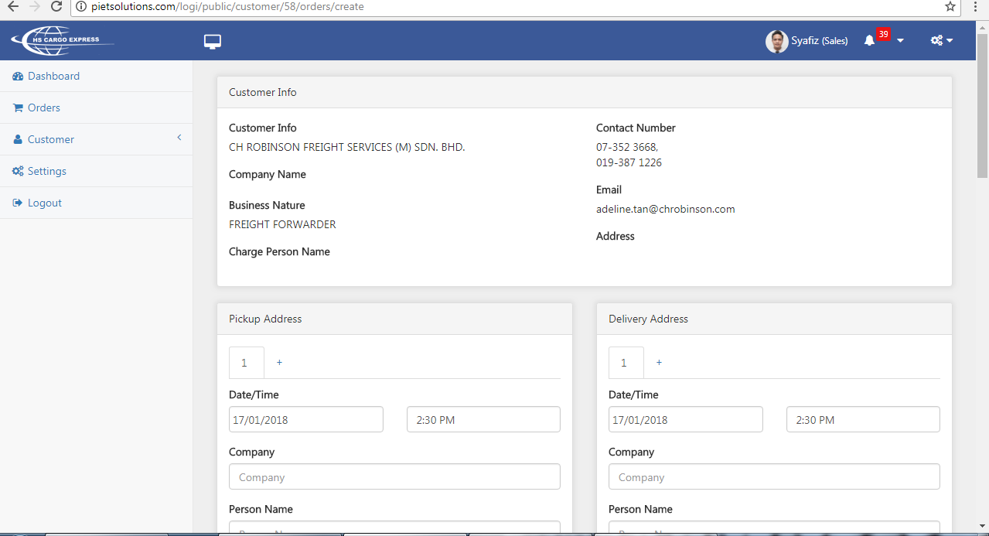

1) Can change customer info to Company name as it display the company name

2) Insert **in charge person name** as the name not appear here

In previous feedbacks we updated Booking Details > Person Incharge to requestor. There is no any field with label person incharge. So want to make sure that we need to show Booking Details > Requestor there which was previously titled as Person Incharge

3) The address is not displayed as discussed earlier the software will require to display company address not the billing address.

E)

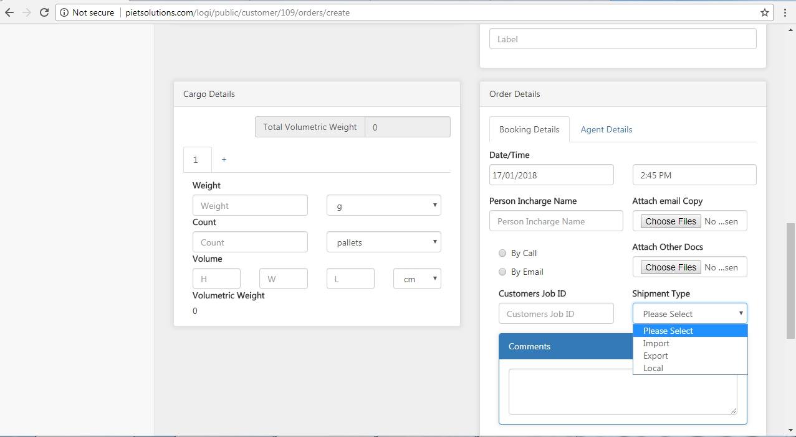

1. We would like to add one more shipment type = Bonded. Thus, shipment type are as below:

* Import
* Export
* Local
* Bonded