1. In dashboard, remove “customers contacted” and “resolve issues”
2. For operations dept dashboard, show number of pending orders on dashboard and when clicked, goto orders list page with pending orders only
3. In system settings (from admin panel) provide an option to set manual starting point for order ID… right now order IDs start with 1 and increment on each order, create a numeric box in admin panel to let them change the starting point to n and then auto increment from that point. also put a check when they enter n, so it doesn’t conflict with existing order IDs.
4. Create a reminder system that will send reminder alert to specific dept(s) to update status after a set time. Here is the working:
   1. In admin panel, under system settings 🡪 order statuses with each order status create two fields. One to set reminder duration (n hours) and second is the departments selection box through which they can select appropriate departments (multi selection)
   2. When an order is set to a specific status (e.g. Pending) after a set duration (from new field mentioned above, e.g. every 4 hours) it will send an alert to update the status to specified department(s)
   3. In alerts system (for this type of reminder alerts) instead of stacking new items in list simply replace existing ones with new timestamp
5. When an alert is clicked it points to the main page but not exact panel, for example booking detail update will take you to that order but not the booking detail subpanel. Fix this issue
6. With alerts system, when a single alert is clicked all notifications are also cleared. It should only clear the clicked one.
7. Alerts list should only show last 2 days alerts
8. Divide orders list into pages like other lists on system and selection box for records per page
9. With the increasing number of records this system is getting slower now, so implement AJAX like dynamic loading on orders list
10. In orders list table make the first column dynamic. They can select between pickup date (default selection, first one in case of multiple), delivery date, order creation date
11. In orders list, previously there was a sorting option on each column, make it that way again. Move the separate filter fields to the columns like in excel:

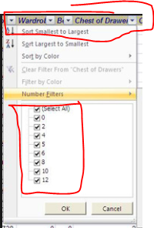

On top u see columns with filter button and when clicked it will show options

And provide filter on date (selected type), type, Status and routes (for city only, not the complete address). Possibly make filters on top of column instead of separate fields and make it multi option selectable like in the link below

<https://codepen.io/elmahdim/pen/hlmri>

with all unique values of that column with an option “All” on top (default) of the list

date field filter options can be like this:

Today (Default)

Yesterday

Single date: <Date selector>

Range: <Date range selector>

1. In new schedule, add sub-contractor name with vehicle plate number like following:

JHQ2273 – XYZ company

1. In customers list table only show company address in Address column
2. Make ongoning and archived orders dynamic throughout the website. Don’t show any fake data anywhere on system
3. In new order under booking date, add a checkbox to enable / disable for booking date and time fields. When checked only then they can modify booking date otherwise booking date is disabled (default). This will allow them to input the data of an order today, which will actually start at the set time. The working is explained below
4. Make the following statuses permanent (because system is accessing these directly) so admin won’t be able to change:

Initiated, Pending, Driver Assigned

|  |  |  |
| --- | --- | --- |
| **Order Status** | **Description** | **When to change** |
| Initiated | System has the order data but the order is not placed yet. First status of any order | When an order is created and the check box from point above is checked. Also check if booking date is not reached yet (i-e. now() is not equal to booking date/time) |
| Pending | Order is started and no driver is assigned yet | When booking date is reached. if there is no change in booking date (i-e. booking date checkbox unchecked) it means booking is started on same time as this order is created, which will put the order directly to pending status instead or initiated |
| Driver assigned | A driver/ truck is assigned | When a new schedule is added |

1. On top of order page show order timeline in horizontal axis like below

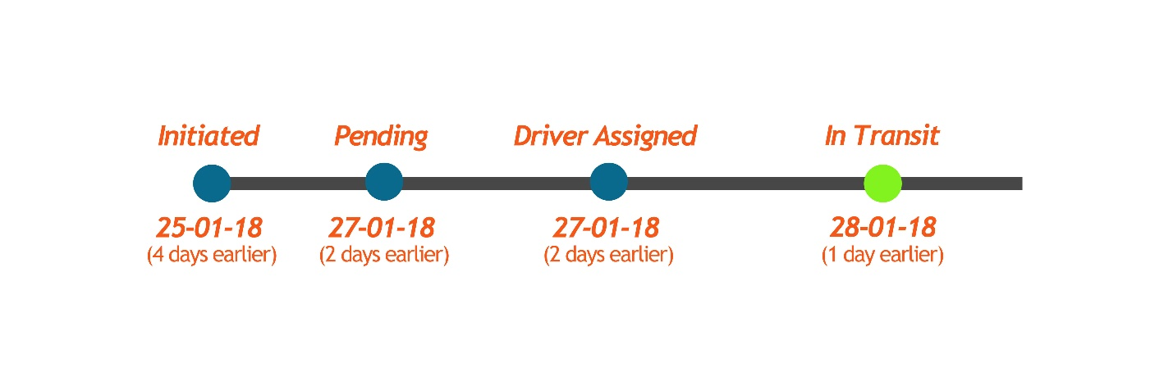

1. Change delete button color to red
2. “Clone” order should goto new order and copy all details into text boxes instead of creating new order. It will only create new order when generate order button is clicked
3. Set time zone to Malaysia (GMT+8)