SOFTWARE ADJUSTMENT FOR OPERATION UNIT [17 January 2018]

A) Order list

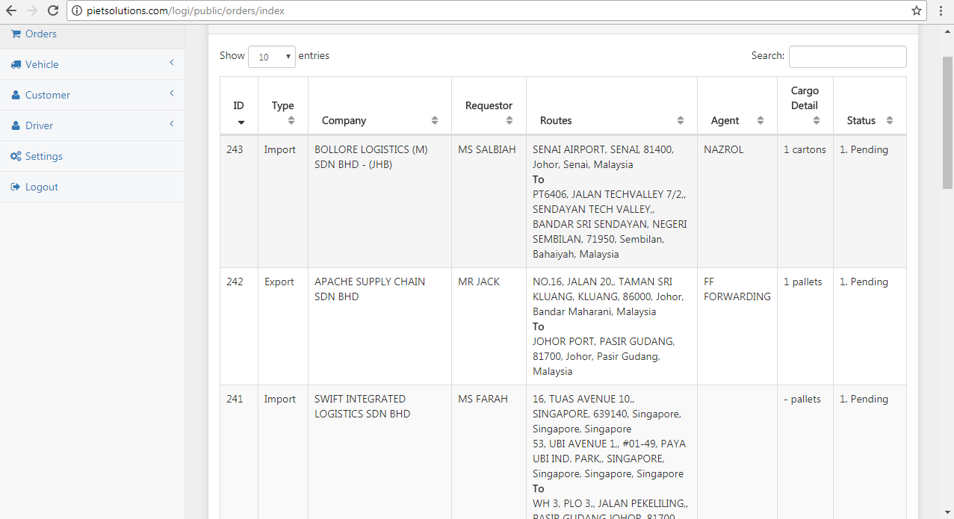

|  |  |  |  |  |  |  |  |  |  |
| --- | --- | --- | --- | --- | --- | --- | --- | --- | --- |
| ID | Type | Company | Requestor | Routes | Agent | Truck Size | Driver | Quantity | Status |
|  |  |  |  |  |  |  |  |  |  |
|  |  |  |  |  |  |  |  |  |  |

1. ID : Temporarily need to **manually key in**
2. Type : Import/Export/Local/**Bonded (**New to be added)
3. Requestor: One who give the order
4. Company : Company of requestor
5. Routes : Collection point to Drop point
6. Agent : Appointed agent (can be more than 1)
7. Truck size : 1 ton to 40ft (key in by operation for a particular order)
8. Driver : Assigned driver
9. Quantity : Number of cargo
10. Status : Hourly change by operators

Truck size: Do I add a new field in order panel for truck size? If ‘yes’ then please explain that in which do I add this ‘truck size’ field.

Status need to change every hour and irregularities will add by operators.

B) Routes (on order list)



1. I think we need to find a solution to **distinguish a two** collection/delivery points when on display (for example adding a slash (/) between the points).
2. We request to **put only the company name** of collection/delivery point with their location (*On orders display, full address is unnecessary and only the company name and its location is important (i.e Technocom System , Tebrau 1*) )

A Location

Er Company name

C) Truck size

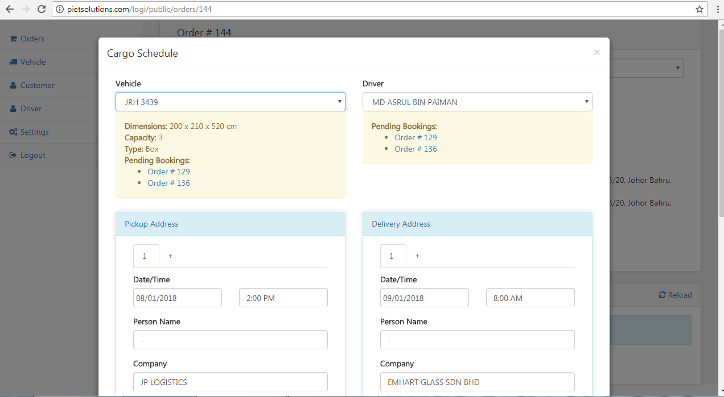

1. Add on new form for “ **truck size**”. Take note that truck size can be varied based on order given even when the truck use is not related to truck size.

Truck size can be:

* 1 ton
* 3 ton
* 5 ton
* 8 ton
* 10 ton
* 40ft

D) Assigning driver for order

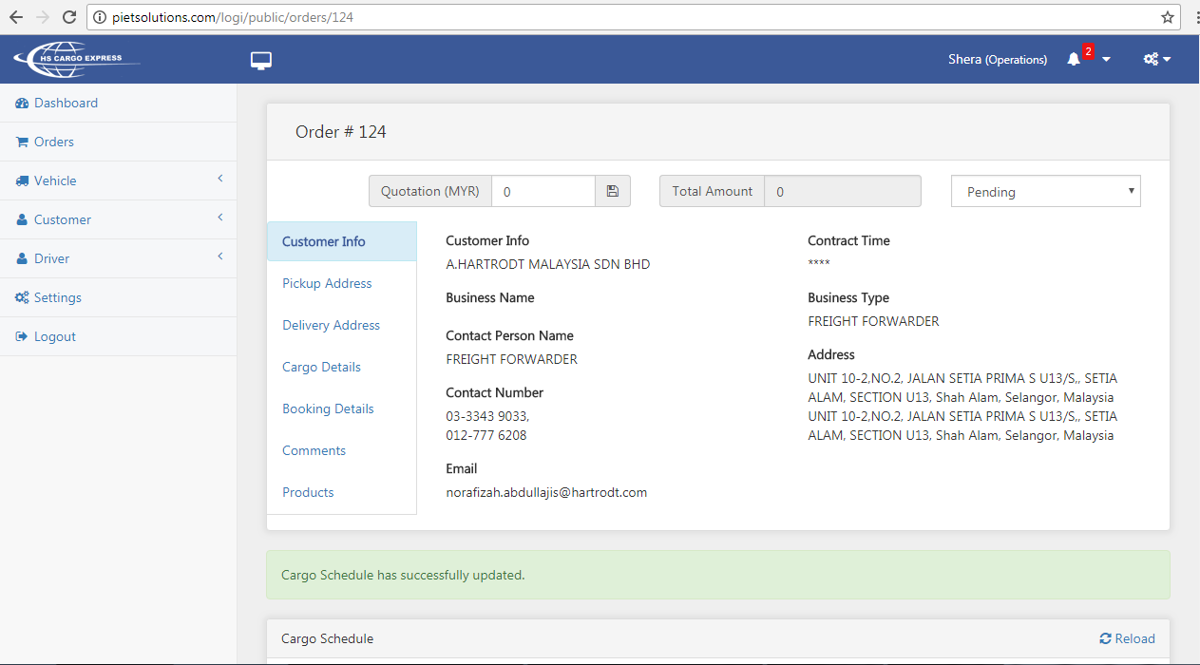

Operation unit will assigned driver based on orders created.

We need a faster and more efficient key in procedure.

I suggest the display will **return to order list** after driver had been assigned as above.

The order will displayed together with the **assigned driver** of the particular order.

E)

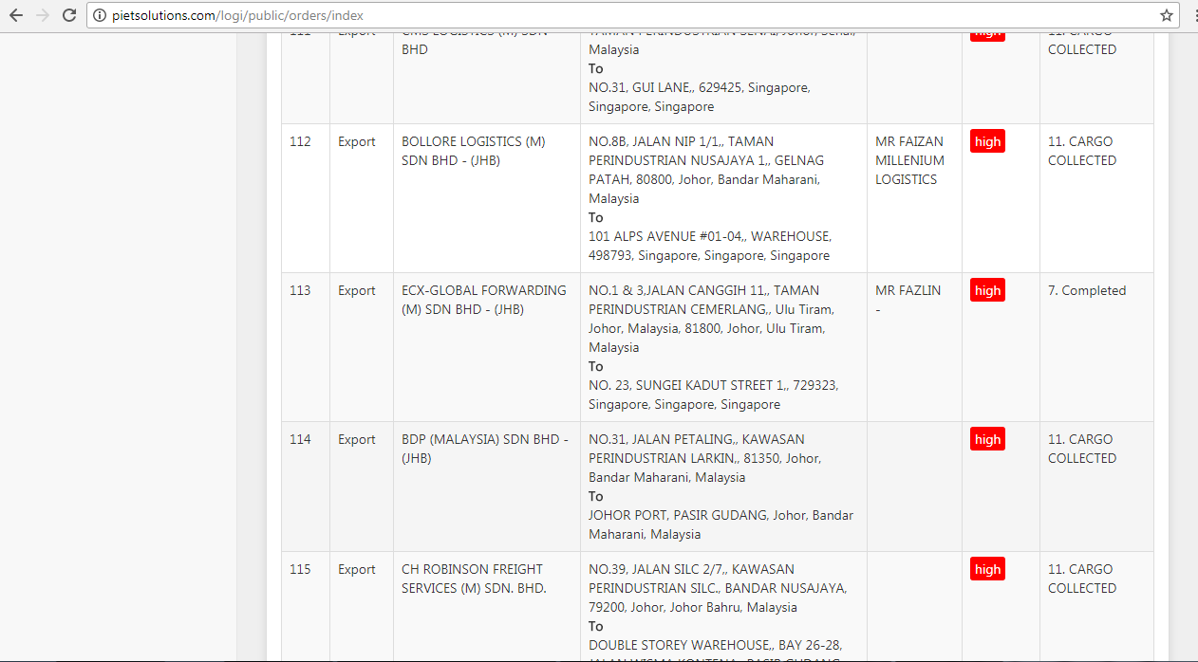

Operation unit can change the job status only from the order list **without entering the whole order detail.**

Operator will need to keep changing job status hourly. Thus, we suggest for the software to **remind operators** to change the status every hour.

For example, a notification may be appear to remind operators to change status.

The objective here is to remind operators and instruct operators to change order status otherwise the software will jammed or etc.

F) Daily order on orders still on pending

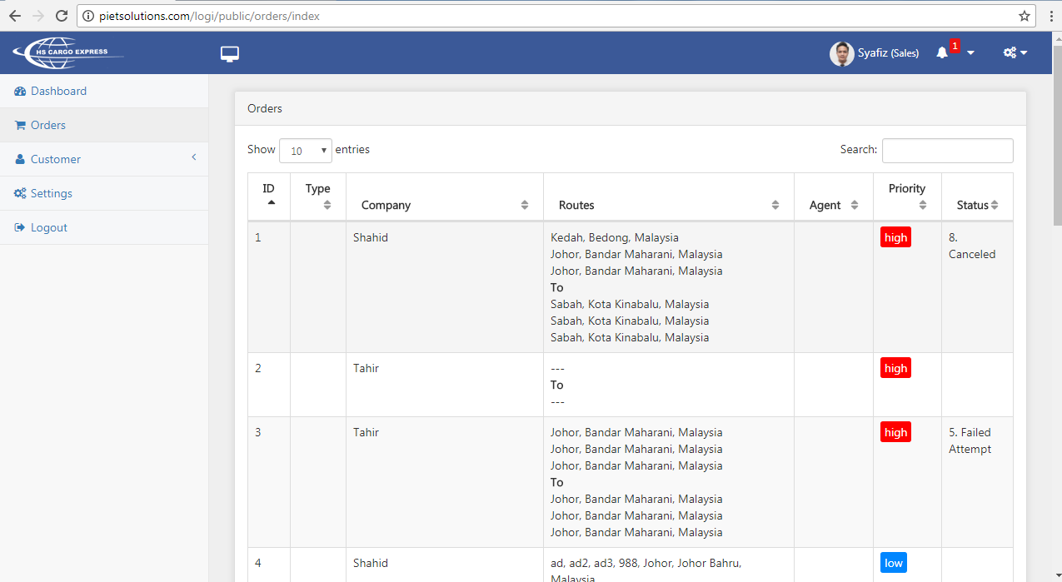

1. As per discussion, we need a **daily orders** on display for an easier operating procedure

G) Highlighted order

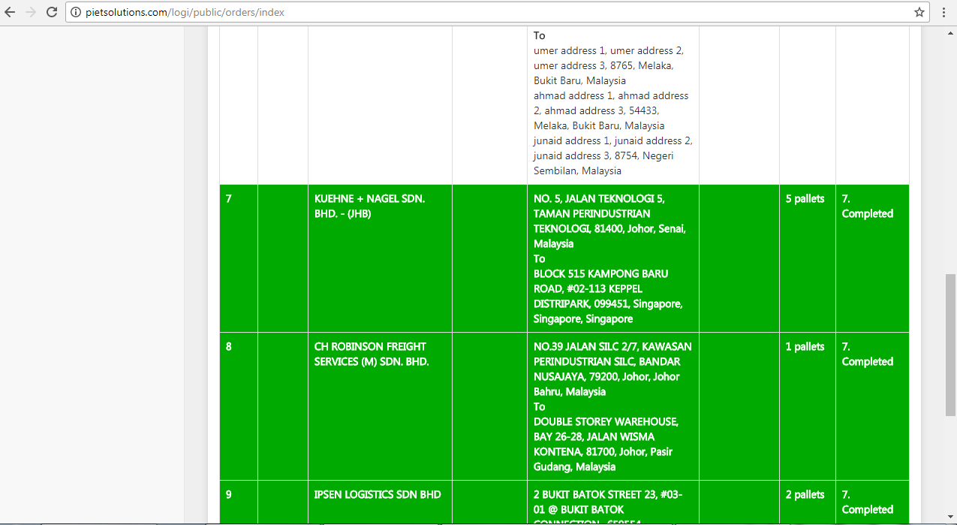

Highlighted orders for cancelled and completed is okay. But the colour is too bright. As you can see, we cannot barely read the order when highlighted as above.

H) Header

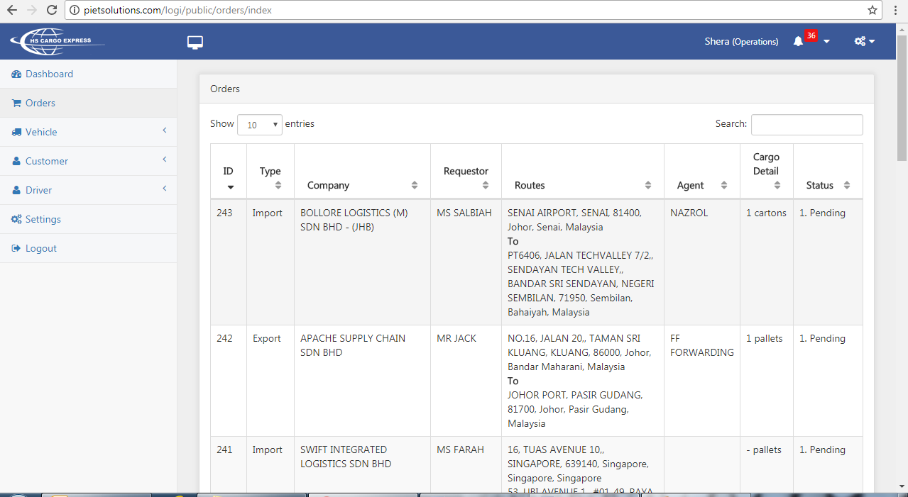

When scrolling the order, we cannot know the header as it disappear after scrolling down. It will easier if the header can follow as the order scroll down.