**Practical Workbook**

**Microprocessor & Assembly Language**



|  |  |
| --- | --- |
| STUDENT NAME: | Muhammad Ahsan Khan |
| STUDENT ID: | **FA17-BSCS-0061** |
| SECTION: | **AM** |
| Signature of Faculty: | **______________________________________** |

**Mohammad Ali Jinnah University**

**Department of Computer Science**

**Lab # 06**

EXERCISE:

1. Perform AND Operation and mention which of the flags are affected after OR operation:
2. Value1 = 35h and Value2 = 10h  
   Affected Flags: ___ ZF PF IF
3. 1101 and 0110  
   Affected Flags: __ SF IF
4. Var1 = 15 and Var2 = 18h  
   Affected Flags: IF
5. Perform OR Operation and mention which of the flags are affected after AND operation:
6. Val1 = 105h OR Val2 = 18h

Affected Flags: CF SF PF AF IF

1. 1011011 OR 101101

Affected Flags: IF

1. 20 OR 10

Affected Flags: PF IF

1. Write two examples of converting a number into its negative. Write complete code.

**Example 1:**

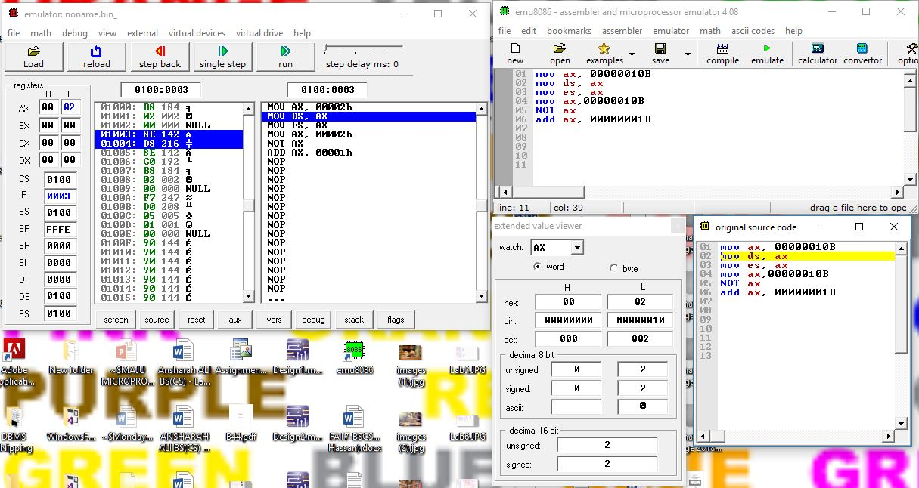

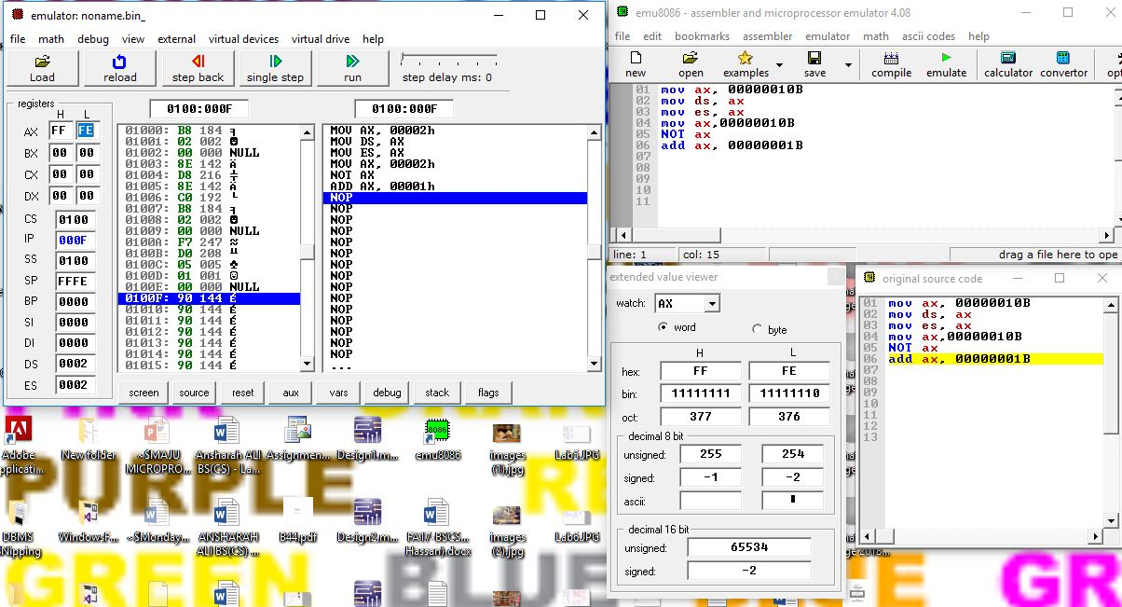

**Example 2:**



