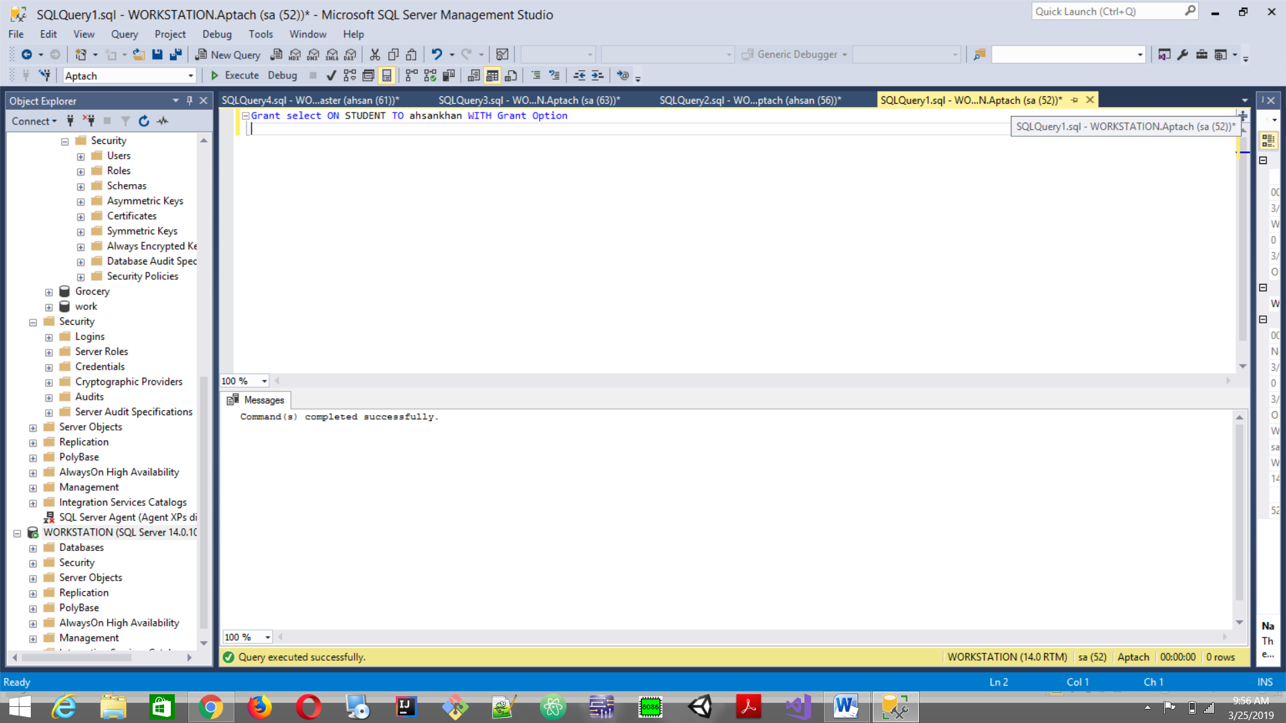

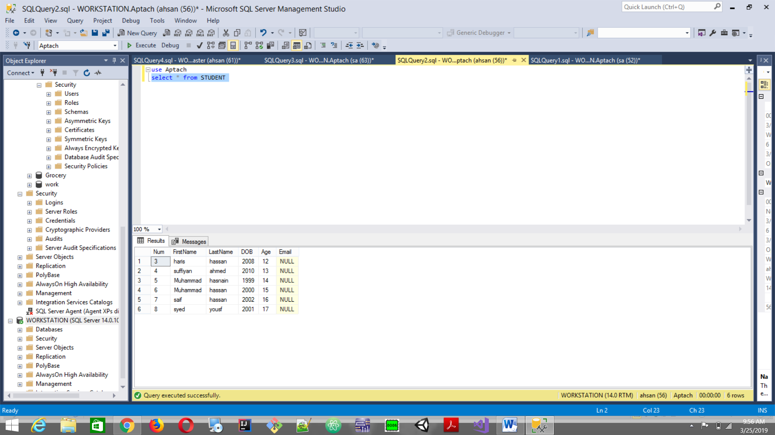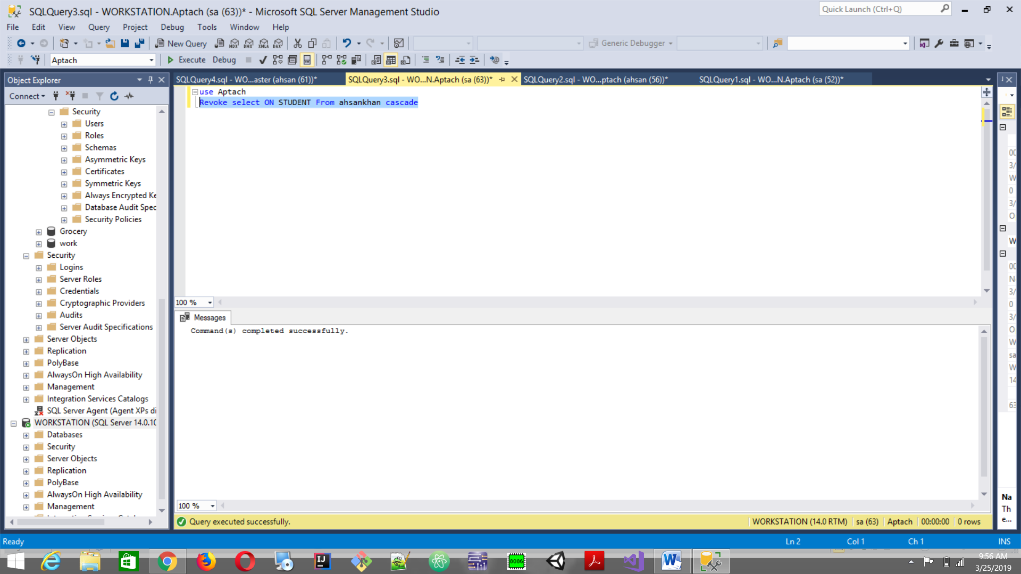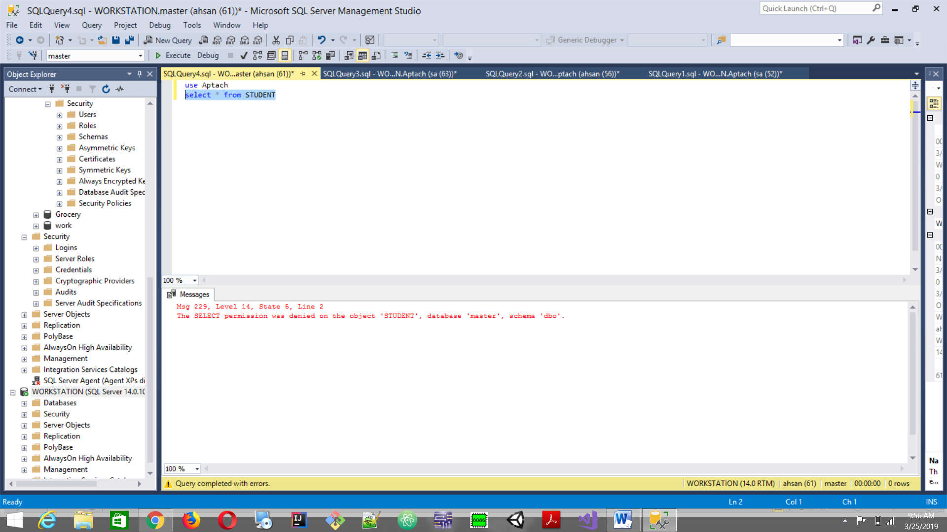

* Grant select ON STUDENT TO ahsankhan WITH Grant O­ption
* use Aptach
* select \* from STUDENT
* use Aptach
* Revoke select ON STUDENT From ahsankhan cascade
* (Not part of code )Miss at this point I run the querry without cascade it runs but it display that select cascade option to revoke access so it put cascade next to user name and it works perfectly.
* use Aptach
* select \* from STUDENT