**EXORDIUM**

**In the name of Allah, the Compassionate, the Merciful.**

**Praise be to Allah, Lord of Creation,**

**The Compassionate, the Merciful,**

**King of Judgment-day!**

**You alone we worship, and to You alone we pray for help,**

**Guide us to the straight path**

**The path of those who You have favored,**

**Not of those who have incurred Your wrath,**

**Nor of those who have gone astray.**

**DEDICATION**

I dedicate this project to God Almighty my creator, my strong pillar, my source of inspiration, wisdom, knowledge and understanding. He has been the source of my strength throughout this program and on His wings only have I soared. I also dedicate this work to my university and teachers; Dr Naveed Malik and Sir Bilal Hashmi they have encouraged me all the way and their encouragement has made sure that I give it all it takes to finish that which I have started.

**ACKNOWLEDGEMENT**

First of all, I would like to thank God for giving me a good health to undergo this 6 month development Program. Next is, I would like to thank my university who giving us a chance as a student to gain an experience in real working world. Thank a lot for providing us world class foreign qualified teachers and due to their programming knowledge and the way they teach us allow me to develop my project by myself. Thank a lot IT Department, and the supervisor who is always available to reply our queries.

In addition, I would like to thanks my supervisor, Sir Haseeb Akmal who always available to help us and guide me the way the project working, giving me the best moral support. Then I would like to thank to my other university friends and senior students, who have helped me in order to complete this project.

Finally, Thanks to all my family and friends who have helped me a lot in giving their opinions and moral support. Last but not least, I would like to thank all the people who involved in during my project development period.**PREFACE**

This project report has been prepared in partial fulfillment of the requirement for the project development. For preparing the report I have gathered related knowledge and information from handouts and from different websites. The blend of knowledge and how the project was made, which tools, methods and tools I used is presented in this project report. The rationale behind preparing the Project Report is to study the project development process and the flow of final product.

The Project Report starts the simple introduction of the project and also covers the general information of the development life cycle and the usage scenario. The information presented in this report is obtained from the previously developed software requirement specification document and design document with addition to the changes in the final project.

**TABLE OF CONTENTS**

|  |
| --- |
|  |

CHAPTER NO. 1

gathering & Analyzing info 9

1.1 Introduction………………………………………………………......... 10

1.2 purpose…………………………………………………………………….10

1.3 scope……………………………………………………………………….10

1.5 use cases and usage scenarios…………………………………………10

1.5.1 Use Case Diagrams………………………………………………10

1.5.2 Usage Scenarios………………………………………………….11

1.6 supplementary requirements………………………………………....18

CHAPTER NO. 2

planning the project 19

2.1 Introduction……………………………………………………………..20

2.2 Methodology……………………………………………………………20

2.3 Available Methodologies……………………………………………20

2.4 Chosen Methodology………………………………………………….20

* 1. Reasons for Chosen Methodology…………………………………...20
  2. Work Plan………………………………………………………………….21

2.7 Project Structure……………………………………………………...22

2.7.1 Project Schedule (Submission Calendar)……………………..22

CHAPTER NO. 3

designing the project 23

3.1 Introduction………………………………………………………………...24

3.2 Entity Relationship Diagram (ERD)…………………………………….24

3.3 Architectural Representation (Architecture Diagram)…………..24

3.4 Dynamic Model: Sequence Diagrams……………………………………25

3.5 Object Model/Logical Model: Class Diagram……………………….29

3.6 Database Model (Database Diagram)…………………………………..30

3.7 Graphical User Interfaces……………………………………………….30

Chapter no.4

DEvelopment 35

4.1 Development plan (Architecture Diagram)…………………………..36

**CHAPTER 1**

Gathering & Analyzing Info

* 1. **Introduction**

This chapter is about information gathering and analysis, In which we see that how can we obtain information from usage scenarios.

* 1. **Scope**

In this chapter we will analyze the use cases and usage scenarios and some supplementary requirements to gather basic usage information about our product.

* 1. **Purpose**

Purpose of this chapter is to gather information in order to develop successful final product.

* 1. **Use Cases and Uses Scenarios**
     1. **Use Case Diagram**

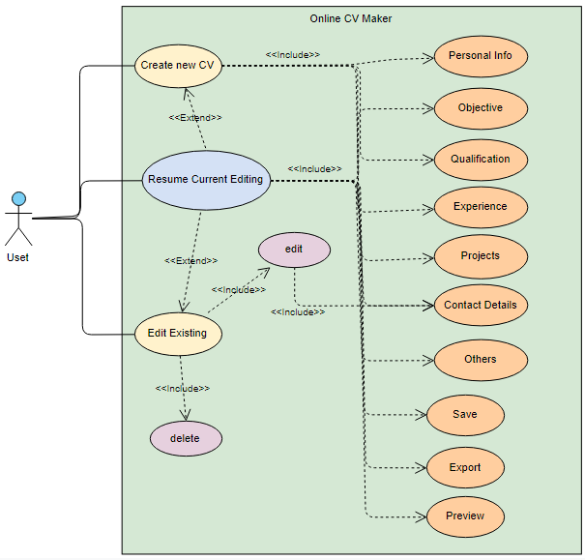

**1.5.2 Usage Scenarios**

|  |  |  |
| --- | --- | --- |
| **Use case Title** | Create New CV | |
| **Use case ID** | OCVM-1 | |
| **Actor** | User | |
| **Description** | Create new CV use case will allow the user to build a new CV. | |
| **Pre Condition** |  | |
| **Post Condition** | After entering all the information user will be able to preview, save and export newly created CV | |
| **Task Sequence** | | **Exceptions** |
| 1. This use case starts when user wants to build a new CV. 2. After invoking this use case user will be asked to enter CV name. 3. After entering unique name user will be directed to the CV creating interface. | | 1. If file name entered by user not unique then system will show the message “Resume is already exist use another name”. |
| **Author** | BC160200498 | |

|  |  |  |
| --- | --- | --- |
| **Use case Title** | Edit Existing | |
| **Use case ID** | OCVM-2 | |
| **Actor** | User | |
| **Description** | Edit CV use case will allow the user to edit previously created CV. | |
| **Pre Condition** | The CV that we are going to edit was saved in the system database. | |
| **Post Condition** | After invoking this use case user will be directed to list of saved CVs. | |
| **Task Sequence** | | **Exceptions** |
| 1. After invoking this use case user will be directed to list of saved CVs. 2. After invoking this use case, the information entered by the user will be overwrite in the database system. 3. After editing the CV user will be able to save or export. | | 1. If any necessary field remains empty while entering or editing information, then system will display appropriate message. |
| **Author** | BC160200498 | |

|  |  |  |
| --- | --- | --- |
| **Use case Title** | Edit | |
| **Use case ID** | OCVM-2.1 | |
| **Actor** | User | |
| **Description** | This use case will show against all the saved CVs list, means all the CVs in saved list will contain this use case. When user will invoke this use case then the particular CV will be selected for editing. | |
| **Pre Condition** | The CV that we are going to edit was saved in the system database. | |
| **Post Condition** | After invoking this use case user will be able to edit any field of the CV. | |
| **Task Sequence** | | **Exceptions** |
| 1. After invoking this use case user will be directed to the CV creating interface.. 2. After invoking this use case, the information entered by the user will be overwrite in the database system. 3. After editing the CV user will be able to save or export. | | 1. If any necessary field remains empty while entering or editing information, then system will display appropriate message. |
| **Author** | BC160200498 | |

|  |  |  |
| --- | --- | --- |
| **Use case Title** | Delete | |
| **Use case ID** | OCVM-2.2 | |
| **Actor** | User | |
| **Description** | This use case will show against all the saved CVs list, means all the CVs in saved list will contain this use case. When user will invoke this use case then the particular CV will be deleted from the database and would not available for further editing. | |
| **Pre Condition** | The CV that we are going to delete was saved in the system database. | |
| **Post Condition** | After invoking this use case the CV will be deleted from the database and would not be available for further editing. | |
| **Task Sequence** | | **Exceptions** |
| 1. After invoking this use case user will be asked if he really want to delete the file or not. 2. If user tap on ok the CV will be delete from the database. 3. If user will tap on ‘cancel’ then the delete operation will be postponed. | |  |
| **Author** | BC160200498 | |

|  |  |  |
| --- | --- | --- |
| **Use case Title** | Resume current editing | |
| **Use case ID** | OCVM-3 | |
| **Actor** | User | |
| **Description** | This use case would be invisible at the start, but when user will invoke any of the two use case whether it Create new CV or Edit Existing then this use case will be visible. Basically this use case is created for providing forward functionality. | |
| **Pre Condition** | Any one from the two use case whether it is Create new CV or Edit Existing should has been invoked. | |
| **Post Condition** | After invoking this use case user will directed to the CV creating activity from the main activity with some saved information. | |
| **Task Sequence** | | **Exceptions** |
| 1. After invoking this use case user will be directed to the CV creating activity with some saved information. | |  |
| **Author** | BC160200498 | |

|  |  |  |
| --- | --- | --- |
| **Use case Title** | Personal Info | |
| **Use case ID** | OCVM-4 | |
| **Actor** | User | |
| **Description** | After invoking this use case user will be able to enter his personal information. | |
| **Pre Condition** | User should be in the system. | |
| **Post Condition** | After entering all the information in personal info activity user will need to tap on save button to save the information and processed to the other use case. | |
| **Task Sequence** | | **Exceptions** |
| 1. After invoking this use case user will be directed to the personal info interface. 2. After entering all the information in personal info activity user will need to tap on save button to save the information | | If user not put information correctly then CV format may cause difficult to understand. |
| **Author** | BC160200498 | |

|  |  |  |
| --- | --- | --- |
| **Use case Title** | Objective | |
| **Use case ID** | OCVM-5 | |
| **Actor** | User | |
| **Description** | After invoking this use case user will be able to enter the desire objective statement. | |
| **Pre Condition** | User should be in the system. | |
| **Post Condition** | After entering objective statement user will need to tap on save button to save the objective and processed to the other use case. | |
| **Task Sequence** | | **Exceptions** |
| 1. After invoking this use case user will be directed to the objective statement interface. 2. After entering objective statement user will need to tap on save button to save the objective statement. | | 1. If user leaves the objective fields empty then the only objective heading will show on the resulted CV. |
| **Author** | BC160200498 | |

|  |  |  |
| --- | --- | --- |
| **Use case Title** | Qualification | |
| **Use case ID** | OCVM-6 | |
| **Actor** | User | |
| **Description** | After invoking this use case user will be able to enter his academic qualification information. | |
| **Pre Condition** | User should be in the system. | |
| **Post Condition** | After entering all the information user will need to tap on save button to save the information and processed to the other use case. | |
| **Task Sequence** | | **Exceptions** |
| 1. After invoking this use case user will be directed to the qualification info interface. 2. After entering all the information user will need to tap on save button to save the information | | 1. If user leaves all the fields empty then the only heading will show on the resulted CV. |
| **Author** | BC160200498 | |

|  |  |  |
| --- | --- | --- |
| **Use case Title** | Experience | |
| **Use case ID** | OCVM-7 | |
| **Actor** | User | |
| **Description** | After invoking this use case user will be able to enter his professional experience information. | |
| **Pre Condition** | User should be in the system. | |
| **Post Condition** | After entering all the information user will need to tap on save button to save the information and processed to the other use case. | |
| **Task Sequence** | | **Exceptions** |
| 1. After invoking this use case user will be directed to the experience info interface. 2. After entering all the information user will need to tap on save button to save the information | | 1. If user leaves all the fields empty then the only heading will show on the resulted CV. |
| **Author** | BC160200498 | |

|  |  |  |
| --- | --- | --- |
| **Use case Title** | Projects | |
| **Use case ID** | OCVM-8 | |
| **Actor** | User | |
| **Description** | After invoking this use case user will be able to enter his projects details. | |
| **Pre Condition** | User should be in the system. | |
| **Post Condition** | After entering all the information user will need to tap on save button to save the information and processed to the other use case. | |
| **Task Sequence** | | **Exceptions** |
| 1. After invoking this use case user will be directed to the projects info interface. 2. After entering all the information user will need to tap on save button to save the information | | 1. If user leaves all the fields empty then the only heading will show on the resulted CV. |
| **Author** | BC160200498 | |

|  |  |  |
| --- | --- | --- |
| **Use case Title** | Contact Details | |
| **Use case ID** | OCVM-9 | |
| **Actor** | User | |
| **Description** | After invoking this use case user will be able to enter his contact details information. | |
| **Pre Condition** | User should be in the system. | |
| **Post Condition** | After entering all the information user will need to tap on save button to save the information and processed to the other use case. | |
| **Task Sequence** | | **Exceptions** |
| 1. After invoking this use case user will be directed to the contact info interface. 2. After entering all the information user will need to tap on save button to save the information | | 1. If user leaves all the fields empty then the only heading will show on the resulted CV. |
| **Author** | BC160200498 | |

|  |  |  |
| --- | --- | --- |
| **Use case Title** | Other | |
| **Use case ID** | OCVM-10 | |
| **Actor** | User | |
| **Description** | After invoking this use case user will be able to enter his **skills**, **interests** and **hobbies**. | |
| **Pre Condition** | User should be in the system. | |
| **Post Condition** | After entering all the information user will need to tap on save button to save the information and processed to the other use case. | |
| **Task Sequence** | | **Exceptions** |
| 1. After invoking this use case user will be directed to an interface in which he will be able to enter his skills interests and hobbies. 2. After entering all the information user will need to tap on save button to save the information | | 1. If user leaves all the fields empty then the only heading will show on the resulted CV. |
| **Author** | BC160200498 | |

|  |  |  |
| --- | --- | --- |
| **Use case Title** | Save | |
| **Use case ID** | OCVM-11 | |
| **Actor** | User | |
| **Description** | After invoking this use case CV will be stored on database aswell as in mobile storage in PDF format. | |
| **Pre Condition** | All information should be saved from each activity. | |
| **Post Condition** | After saving the CV user will be able to preview, export and edit the CV any time. | |
| **Task Sequence** | | **Exceptions** |
| 1. After invoking this use case CV will be stored on database aswell as in mobile storage in PDF format. | |  |
| **Author** | BC160200498 | |

|  |  |  |
| --- | --- | --- |
| **Use case Title** | Preview | |
| **Use case ID** | OCVM-12 | |
| **Actor** | User | |
| **Description** | This use case will allow the users to preview their newly created or edited CV in PDF format. | |
| **Pre Condition** | Save CV use case should be invoked. | |
| **Post Condition** | System will display CV in PDF format. | |
| **Task Sequence** | | **Exceptions** |
| After invoking this use case user system will display the CV in PDF format and user will be able to save this PDF file in his device. | |  |
| **Author** | BC160200498 | |

|  |  |  |
| --- | --- | --- |
| **Use case Title** | Export | |
| **Use case ID** | OCVM-13 | |
| **Uses** | 1. Export To FaceBook 2. Send Through mail | |
| **Actor** | User | |
| **Description** | This use case will allow the users to send their CV on FaceBook or mail. | |
| **Pre Condition** | System should be connected to the internet. | |
| **Post Condition** | System will sends user CV at their desire medium. | |
| **Task Sequence** | | **Exceptions** |
| After invoking this use case user will be able to:   * Export to FaceBook * Send through mail | | To export CV at FaceBook or send through mail, user device should be connected to the internet. Otherwise system will raise an appropriate exception. |
| **Author** | BC160200498 | |

**1.6 Supplementary requirements**

1. The application will only run on such device that has android OS installed.
2. There would be two options at the start in the application, first option will be “Create New CV” and the second option will be “Edit existing CV”.
3. All information entered by the user will be store in a database that is accessible any time by the application user.
4. The application will have various buttons like preview, save and export.
5. User will be able to change or update his/her information any time.
6. To export C.V at FaceBook or send through email, the user mobile device should be connected to the internet.

**CHAPTER 2**

Planning the Project

* 1. **Introduction**

The Online CV Maker Project Plan will provide a definition of the project, including the project’s goals, methodologies, work plan and project structure. Additionally, the Plan will serve as a helper to meet the deadlines by providing a timeline of work flow of the project.

* 1. **Methodologies**

There are several number of Software Development Lifecycle methodologies available that are commonly used in software development projects, each having its strengths and weaknesses and suitable in different situation.

* 1. **Available Methodologies**

There are many existing methodologies exist such as:

* Build-and-fix model
* Waterfall model
* Rapid prototyping model
* Incremental model
* Extreme programming
* Synchronize-and stabilize model
* Spiral model
* Object-oriented life-cycle models
* Two or more methodologies can also be combined like vu process model combines Waterfall and Spiral model.
  1. **Chosen Methodologies**

Here in the development of this project as per requirement I will adopt **VU process model** methodology.

**Vu process model** is proposed software engineering process by virtual university of Pakistan which is the combination of waterfall model and spiral model in software development.

* 1. **Reason for Chosen Methodologies**

Basically, a process model explains the simplified description of software processes in iteration to avoid maximum risk. Combination of both waterfall and spiral model is called hybrid approach of system development that maximize the quality of system and minimize the disadvantages and risk. VU process model has five phases which further divides the waterfall processes. These processes are in iteration until system meets to client requirement.

Diagram of VU Process Model:

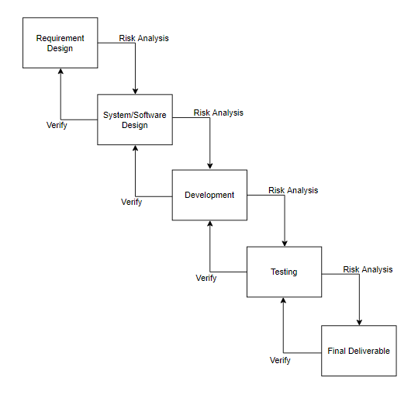

The idea behind this model is that to get the benefits of both these models. Essentially, Water Fall Model is a framework for software development in which development proceeds sequentially through a series of phases, starting with system requirements analysis and leading up to product release and maintenance, whereas the key characteristics of spiral model is risk management at regular stages in the entire software development cycle.

* 1. **Work Plan**

The work plan of this project is described in the following gantt chart.

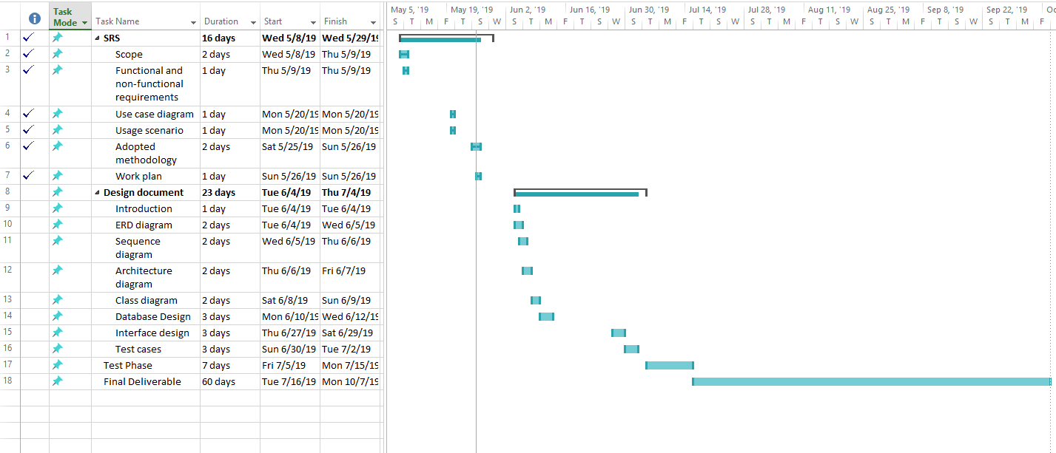

* 1. **Project Structure**

Each project has its unique characteristics and the design of an organizational structure should consider the organizational environment, the project characteristics in which it will operate, and the level of authority the project manager is given. A project structure can take on various forms with each form having its own advantages and disadvantages. One of the main objectives of the structure is to reduce uncertainty and confusion that typically occurs at the project initiation phase. The structure defines the relationships among members of the project management and the relationships with the external environment. The structure defines the authority by means of a graphical illustration called an organization chart.

In this project I am working individually that’s why all its developing and organizing component is handled by myself solely. So there’s no need to describe the team structure.

* + 1. **Project Schedule (Submission Calendar)**

|  |  |  |  |  |
| --- | --- | --- | --- | --- |
| **Sr.** | **Title** | **Start date** | **End date** | **Submission date** |
| 1 | Software Requirements and Specification document (SRS) | Mon 06 May, 2019 | Mon 03 Jun, 2019 | Mon 26 May, 2019 |
| 2 | Design Document | Tue 04 Jun, 2019 | Thu 04 Jul, 2019 | Thu 04 Jul, 2019 |
| 3 | Test Phase | Fri 05 Jul, 2019 | Mon 15 Jul, 2019 | Mon 15 Jul, 2019 |
| 4 | Final Deliverable | Tue 16 Jul, 2019 | Mon 07 Oct, 2019 | Mon 07 Oct, 2019 |

**CHAPTER 3**

Designing the Project

* 1. **Introduction**

In this design document the functions and operations of our app are described in detail, including screen layouts, process diagrams and other documentation. This design document contained the desired system features in detail, and generally includes functional hierarchy diagrams, screen layout diagrams, tables of business rules, business process diagrams and a complete entity-relationship diagram with a full data dictionary.

In Design phase we create:

* ERD Diagram
* Architecture of the System
* Sequence Diagram
* Class Diagram
* Database Diagram
* Interface
  1. **ERD (Entity Relation Diagram)**

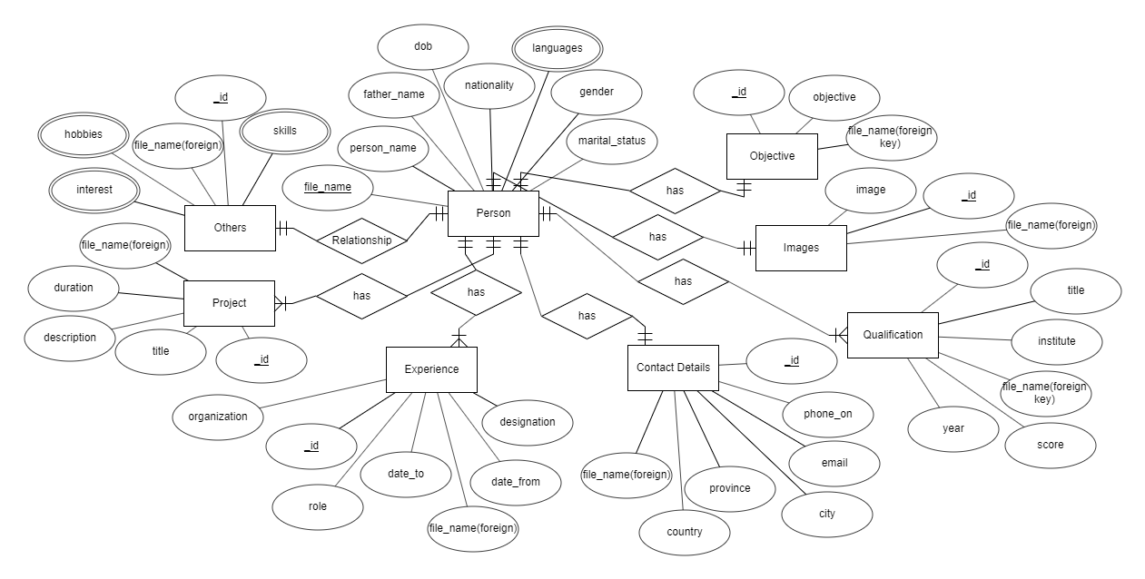

* 1. **Architectural Representation (Architectural Diagram)**

Here I will use one tier architecture because our system is based on simple single user interface and also file will be save in user’s device.

**One Tier Architecture**

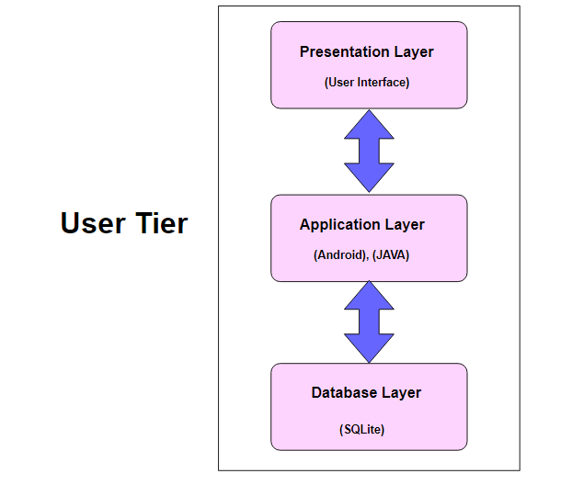

* 1. **Dynamic Model (Sequence Diagrams)**
     1. Create New CV

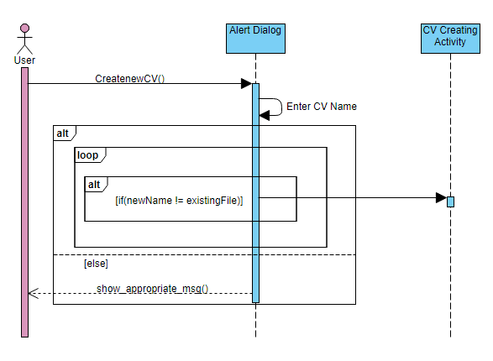

* + 1. Edit Existing CV

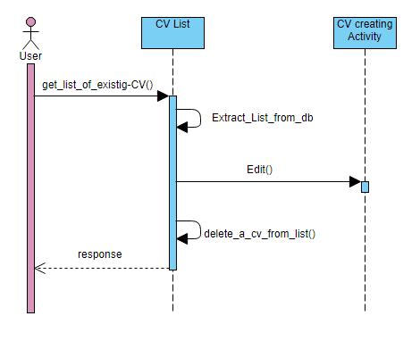

Edit from List

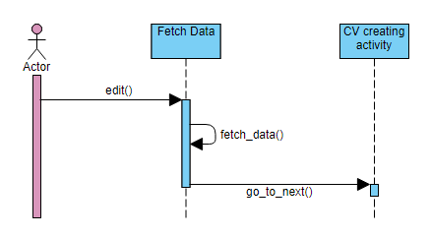

Delete CV

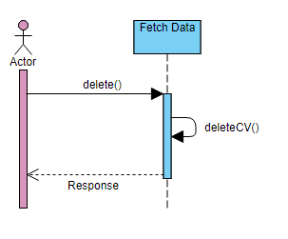

Resume Current editing

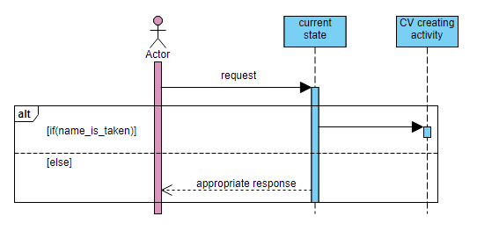

Save CV

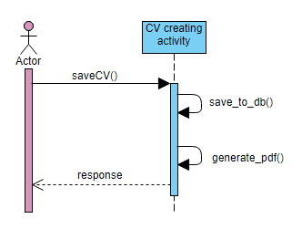

Preview

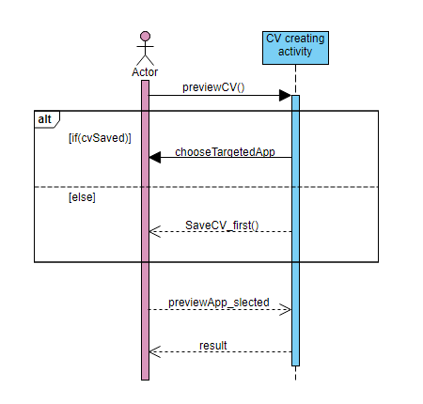

Export

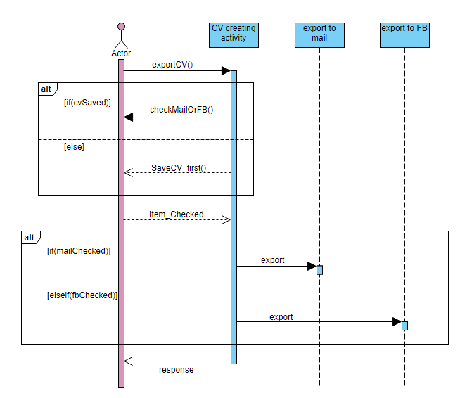

* 1. Object Model/Logical Model: Class Diagram

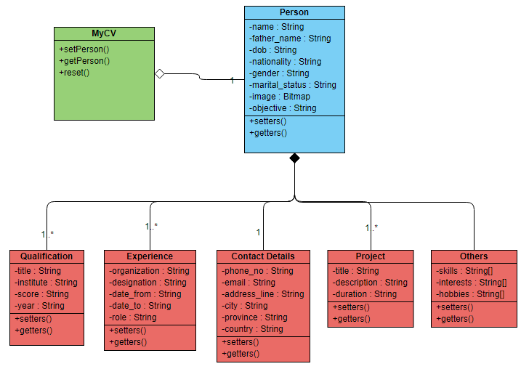

3.6 Database Model (Database Diagram)

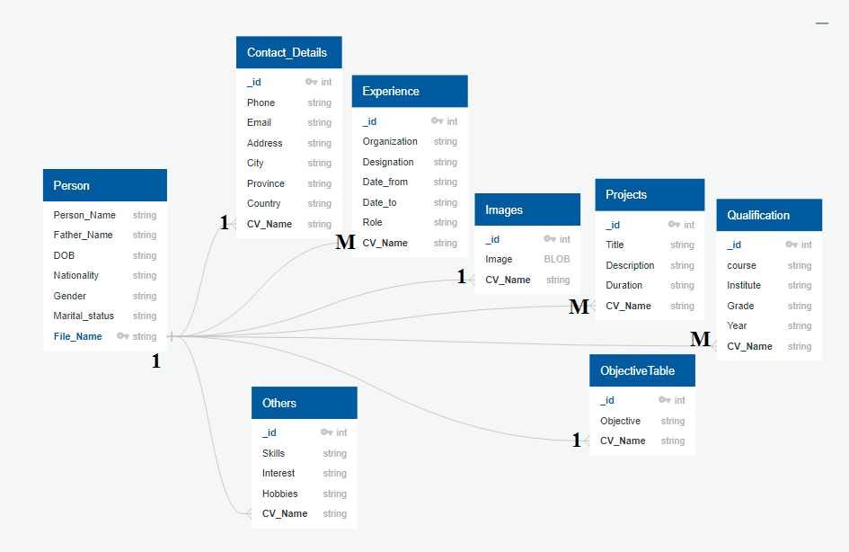

3.7 Graphical User Interfaces

Splash Activity

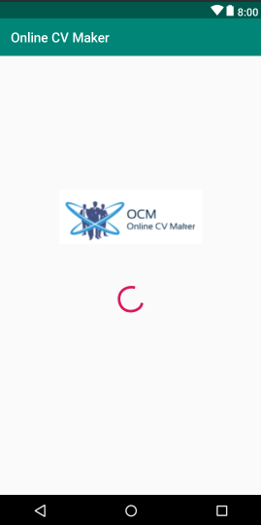

Main Activity

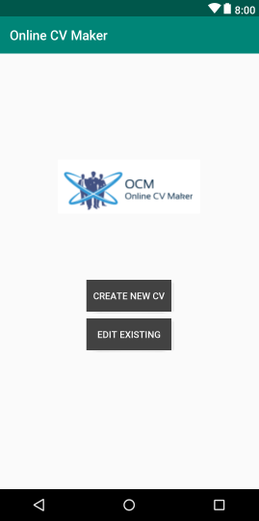

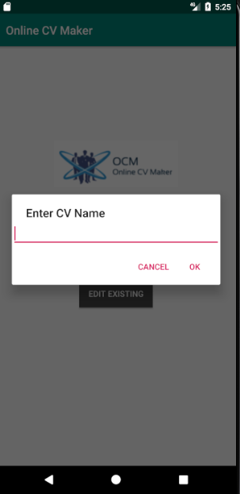

CV Creating Activity

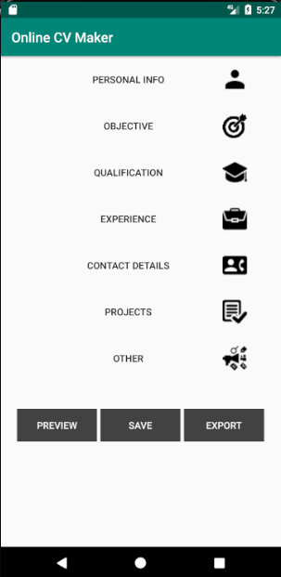

Personal Info Activity

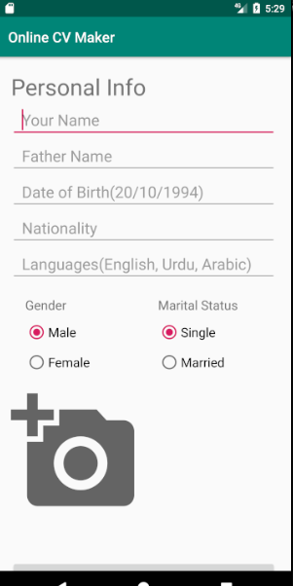

Export Activity

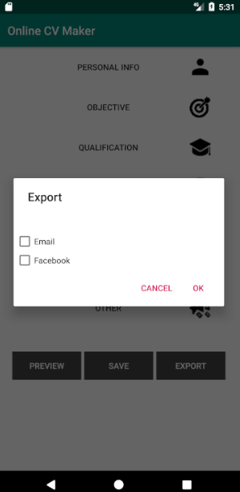

Edit Existing CV Activity

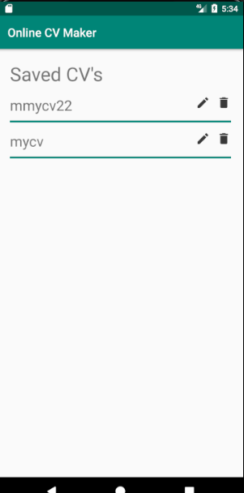

**CHAPTER 4**

Development

* 1. **Architectural Representation (Architectural Diagram)**

Here I will use one tier architecture because our system is based on simple single user interface and also file will be save in user’s device.

**One Tier Architecture**



**REFERENCES**

Web Links:

* www.google.com
* [www.tutorialpoints.com](http://www.tutorialpoints.com)
* [www.youtube.com](http://www.youtube.com)
* [www.developer.android.com](http://www.developer.android.com)
* [www.developer.facebook.com](http://www.developer.facebook.com)
* [www.itextpdf.com](http://www.itextpdf.com)
* [www.stackoverflow.com](http://www.stackoverflow.com)
* [www.github.com](http://www.github.com)
* [www.diagrams.visual-paradigm.com](http://www.diagrams.visual-paradigm.com)
* www.[online.visual-paradigm.com](https://online.visual-paradigm.com/)
* [www.erdplus.com](http://www.erdplus.com)
* [www.quickdatabasediagrams.com](http://www.quickdatabasediagrams.com)