**BCPhA Proposal**

Medication nonadherence rates averages around 25% and varies depending on the class of drugs in question. $290 billion problem in the US,

<https://www.bcpharmacy.ca/uploads/Medication_Adherence.pdf>

**Cochrane Review**

Successful adherence interventions are complex and composed of many approaches combined together. Even the most effective interventions did not lead to substantial improvements in adherence, which illustrates the difficulty of the problem we are trying to solve.

<http://www.sefap.it/servizi_letteraturacardio_200807/CD000011.pdf>

Chat Streams:

1. Initial assessment & demographics
2. Follow-up (continues patient engagement)
3. Pre-clinic surveys (prioritizes patient issues, helpful for MD)

Nonadherence Profiles:

* Forgetters, education on value, interventions to simplify drug taking
* Reactors, presentation of alternatives, education on self-management of side effects
* Fearful, education, emphasis on reassurance & evidence
* Unsure -> education, emphasis on value
* Skeptics -> education, emphasis on evidence

Survey Questions:

1. [splash screen] Hi! I’d like to ask you some questions about your general health!
2. Please select your gender: [Male, Female, Trans, Other]
3. How old are you?
4. Please enter the names of the medication(s) you are starting on:
   1. SSRIs: escitalopram, citalopram, fluoxetine, fluvoxamine, paroxetine, sertraline
   2. TCAs: nortriptyline, amitriptyline, doxepin
   3. SNRIs: venlafaxine, desvenlafaxine, duloxetine
   4. Serotonin Modulators: trazodone
   5. Other
5. When do you start therapy?
6. [screening for comorbidities] Do you worry about:
   1. Sleep?
   2. Drugs?
   3. Smoking?
   4. Anxiety?
   5. Apetite?
7. Which doctor do you see? [input name, address, phone number] - 3 questions
8. Which pharmacy do you normally use? [input name, address, phone number] - 3 questions

Chat bot conversations:

1. [self-care measures] Hi _NAME_, have you considered:
   1. …
2. [side effect monitoring] Hey! Let’s do a quick check for side effects:
   1. SSRIs: Nausea, dry mouth, sleep disturbance, somnolence, sweating, sexual dysfunction, increased risk of GI bleeding, SIADH, dose-dependent QTc prolongation.
   2. SNRIs: Nausea, dry mouth, constipation, hyperhidrosis, headache, dizziness, increased heart rate, tachycardia, insomnia, erectile dysfunction. Nausea, sleep disturbance, drowsiness, nervousness, dizziness, dry mouth.  
      Dose-related hypertension occurs rarely, particularly at doses ≥225 mg/day.
   3. Serotonin Modulators: Drowsiness, orthostatic hypotension, nausea, headache, dry mouth, priapism.
   4. Anticholinergic (dry mouth, blurred vision, constipation, urinary hesitancy, tachycardia, delirium), antihistaminergic (sedation, weight gain), orthostatic hypotension, lowered seizure threshold; sexual dysfunction.
3. [patient education] Random facts about your health...
4. [efficacy monitoring]
   1. Have you noticed an improvement in your mood lately?
   2. Did you do something fun this weekend?
      1. What did you do?
5. [adherence] Hi! I wanted to check if you had any issues taking your medications.
   1. Have you forgotten to take any doses within the past week?
      1. How many doses have you missed?
      2. Do any of the following options explain why you’ve been missing your medications?
         1. Too expensive
         2. Forgot
         3. Difficulty swallowing pill
         4. Side effects
         5. Other
   2. How much are you paying out-of-pocket for your medications? [personalize based on the medications they are taking]
      1. [small amount < $5 for 30 pills] Sounds like you have your meds covered!
      2. [medium amount >$5-10 for 30 pills] That sounds like a bit much, did you have insurance to cover some of the cost?
      3. [large amount >$10 for 30 pills] Yikes! That sounds like a lot! Do you have insurance in place?
         1. [yes] Did you want to see what other insurance plans are out there?
         2. [no] Did you want to explore some insurance companies out there?
   3. Are you able to swallow your medications? Are any of the pills too big?
      1. [yes] Which one? [show list of medications]
      2. That pill comes in smaller sizes, so instead of one big pill, we can split it up into two smaller ones. Would you like your pharmacy to do this for you?
      3. That pill can be converted into a liquid. Did you want to find out which pharmacies can do this for you?
6. [when receiving a follow-up appointment request] Hey! It looks like your doctor want to check up on you to see how you are doing. Let’s set an appointment now. [display phone number]
7. [random facts about depression] Hey _NAME_! Did you know that [name of famous figure] suffered from depression? [... extra content...]
8. [random facts about your medications] Hey _NAME_! Did you know that…
   1. [<2 weeks since start of using app] Your medications can take around 1-2 weeks until you start noticing an effect.
   2. [>2 weeks] Your medications can take about 6-8 weeks until it reaches its full effects!
   3. [if fluoxetine is selected as a medication] Fluoxetine can be a bit stimulating! So try taking it in the morning to get a bit more energy throughout the day! If you are taking other meds in the morning, check with the pharmacy first to make sure they don’t interact!
   4. [if sertraline is selected as a medication] Do you have trouble sleeping at night? Sertraline can be a bit more relaxing, so try taking it at night to help you get to sleep better. Be sure to check with a pharmacist first if you’re also taking other meds at the same time!

Potential Project Ideas:

* App that pairs up upper class/middle class patients
  + Mentor/Mentee
  + Social network
  + Help with tips to follow treatment plan
  + Adherence
    - Each partner has a button, 1 partner takes treatment and records it on the app.
    - The other partner would notice it and be reminded to take their medication.
    - Mood plant - signals how the partner is feeling.
* How about pairing adolescents with parents (not their own parents, but someone else). Parents can ask questions about the teen’s experiences with depression, so that they can better understand what their own child is going through. Teens can get advice about what their own parents might be worrying about. They can get advice from parents.
  + And combine with a chatbot? LOL
* Interactive app to help identify mental health problems
  + Ask questions in an indirect way
  + Scenario cases - scenario answers lead to a different diagnosis
* Reminder/ping app where loved ones can link to the patient and send them ‘pings’ to their phone to remind them to take medication
  + Patient can have a different type of response ping
  + Cartoon living something rather can grow/be happy every time the patient responds with a yes they took their medication
* Follow-up texts service:
  + As soon as a patient starts a treatment for a condition, subscribe them to our follow-up texting service
  + The service sends personalized texts that:

1. Give self-care tips for their condition
2. Asks questions to screen for other conditions
3. Checks to see if the patient has any side effects
4. Reminds patients to take their pills

* (this idea might be a bit too general though…)

**I like this one, but can be complicated - can we simplify this one? - JL**

* Some chat-bot related idea? (Ahsan: can use chat-bot framework by Microsoft)
  + Add a visual representation
  + Jarvis
  + LUIS
  + We can use the chatbot to present visualizations/feedback and survey questions. The chatbot can probe for other comorbidities.
  + There can be a fixed visualization on the header of the chat screen that is a representation of their progress (e.g. grass growing, birds flying)
  + Chatbot can provide content from social media
  + Overall the chatbot is a very flexible way to collect data, visualize it, and provide self-help options.
* Treatment recommender system (might need some data mining work) - this would be added as feature to our application
* Some feature that would help us avoid user-churning and invite users to respond to their respective treatments - basically like a rewarding system (gamification element of the app)
* Possibly get to depression through recognized risk factor (e.g. acne)
* Yes or no survey questions in a tinder style
* Dumb ways to die style game to remind patients to take medication.
* Pure text-message based screening for adolescents. For accessbility.
* GitHub-style chart that gets filled in based on different scores (treatment adherence, screening question scores). Color can be based on mood (green, red, yellow, orange). Doesn’t have to be filled in by patient - clinicians or caregivers can use this. Can also be used in the addictions field (DTES) where patients have to come in every day to get their medications witnessed by a nurse or pharmacist.

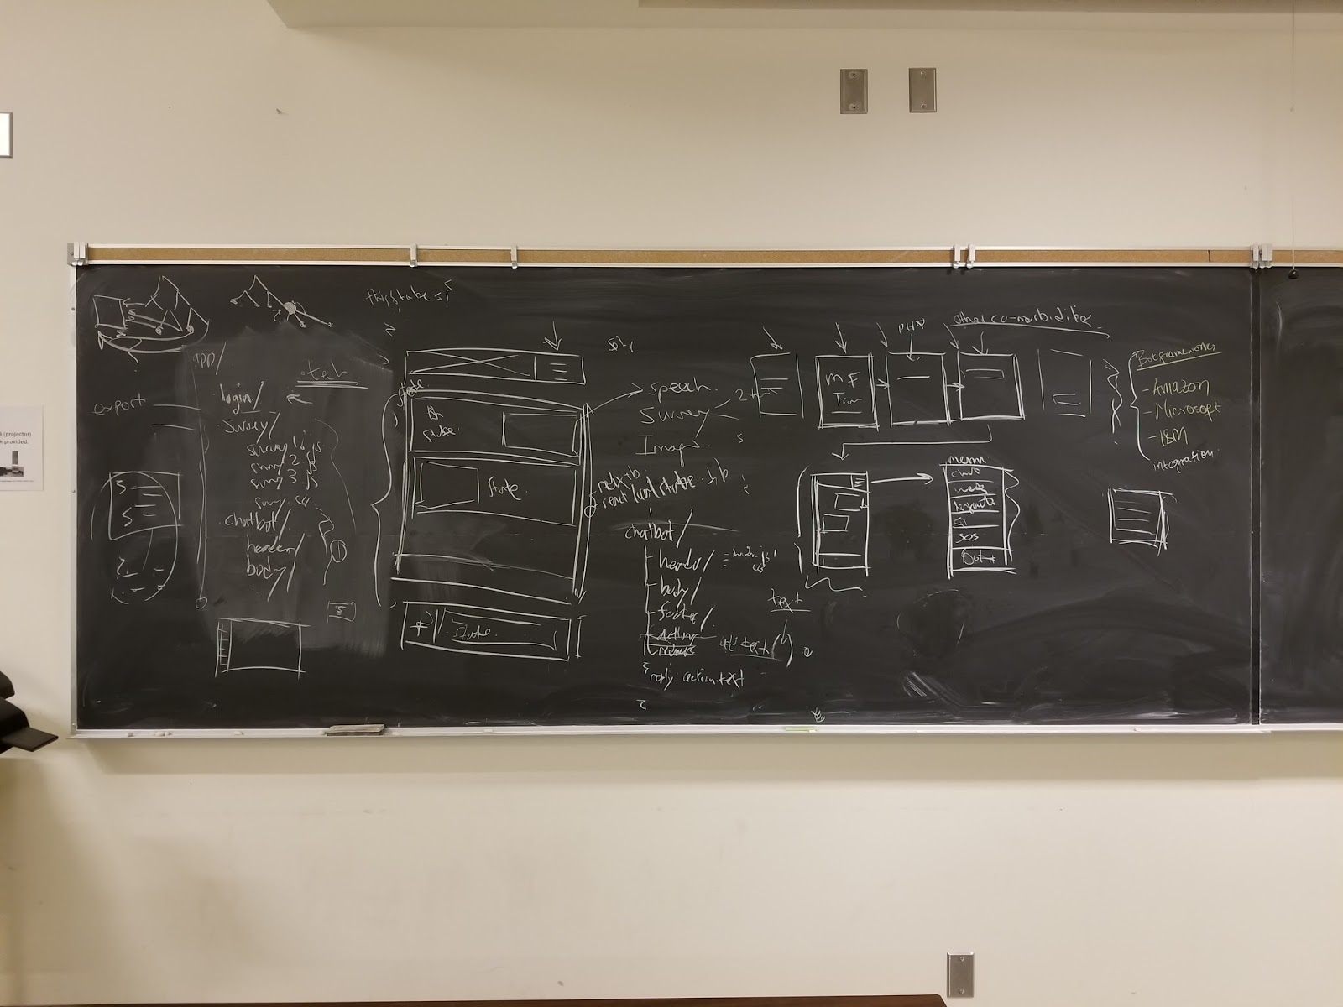

-------

**Risk factors For depression:**

Genetic susceptibility

Neurologic illness

Exposure to certain medications

Alcohol or drug misuse

Pain

Chronic illness  
Child physical abuse , including sexual abuse  
Family violence  
Early loss through parental separation, death, or trauma  
Psychosocial stress  
Biological factors, such as sexual maturation  
Environmental factors, such as increasing social and academic demands; contributory environmental factors may affect neurotransmitters and/or have an independent influence on depression  
Psychological factors, such as increased autonomy and abstract thinking  
Parental and/or family history of depression  
Female sex

**For suicide:**  
  
Previous suicide attempts  
History of depression or substance abuse  
Bullying or social ostracization  
Presence of guns

**Associated disorders**

In prepubertal children:

* Anxiety disorders
* Disruptive behavior disorders
* [Attention deficit hyperactivity disorder (ADHD)](https://www-clinicalkey-com.ezproxy.library.ubc.ca/#!/content/medical_topic/21-s2.0-1016272)
* Separation anxiety disorder (in younger children)
* Learning disorders

In adolescents:

* Substance abuse disorders
* Disruptive behavior disorders
* ADHD
* Learning disorders
* Eating disorders, such as [anorexia](https://www-clinicalkey-com.ezproxy.library.ubc.ca/#!/content/medical_topic/21-s2.0-1014406) and [bulimia](https://www-clinicalkey-com.ezproxy.library.ubc.ca/#!/content/medical_topic/21-s2.0-1014410)
* Anxiety disorders, such as [generalized anxiety disorder](https://www-clinicalkey-com.ezproxy.library.ubc.ca/#!/content/medical_topic/21-s2.0-1014407) , [obsessive compulsive disorder](https://www-clinicalkey-com.ezproxy.library.ubc.ca/#!/content/medical_topic/21-s2.0-1014425) , and [agoraphobia](https://www-clinicalkey-com.ezproxy.library.ubc.ca/#!/content/medical_topic/21-s2.0-1014405)

Physical disorders that may be associated with depressive symptomatology:

* Infections, such as [infectious mononucleosis](https://www-clinicalkey-com.ezproxy.library.ubc.ca/#!/content/medical_topic/21-s2.0-1014568) and [human immunodeficiency virus infection](https://www-clinicalkey-com.ezproxy.library.ubc.ca/#!/content/medical_topic/21-s2.0-5091501)
* Neurologic disorders, such as [epilepsy](https://www-clinicalkey-com.ezproxy.library.ubc.ca/#!/content/medical_topic/21-s2.0-1016546) and postconcussion syndrome
* Endocrine disorders, including [diabetes mellitus type 1](https://www-clinicalkey-com.ezproxy.library.ubc.ca/#!/content/medical_topic/21-s2.0-1016295) and [type 2](https://www-clinicalkey-com.ezproxy.library.ubc.ca/#!/content/medical_topic/21-s2.0-1011045) , [hyperthyroidism](https://www-clinicalkey-com.ezproxy.library.ubc.ca/#!/content/medical_topic/21-s2.0-1014734) , [hypothyroidism](https://www-clinicalkey-com.ezproxy.library.ubc.ca/#!/content/medical_topic/21-s2.0-1014742) , and [Addison disease](https://www-clinicalkey-com.ezproxy.library.ubc.ca/#!/content/medical_topic/21-s2.0-1014716)
* Hematologic disorders, such as anemia and cancer
* Autoimmune diseases, such as [multiple sclerosis](https://www-clinicalkey-com.ezproxy.library.ubc.ca/#!/content/medical_topic/21-s2.0-1014469) and [ulcerative colitis](https://www-clinicalkey-com.ezproxy.library.ubc.ca/#!/content/medical_topic/21-s2.0-1017692)