**Synopsis:**

We are going to implement a game in which the objective will be to destroy a tower. There will be multiple characters that the user can deploy, each with their own strengths, weaknesses and cost. The user’s elixir will increase over time, which the user can use to deploy different characters. The characters will move in a straight line towards the tower. The tower itself will have its own health and defense, like shooting arrows, cannons etc which will damage the characters deployed by the user. If the damage taken by characters is more than their health, the character will die. There will be a timer, and the goal of the game will be to destroy the tower before the time runs out. If the tower is destroyed within the timer, the player proceeds to next level. Each successive level will get tougher, as the health and damage done by tower to player will increase. Additionally, the player can also use spells to gain an advantage. Spells can include heal spell (that restores a character’s health) and rage spell (increases damage of characters).

**UML Diagram:**

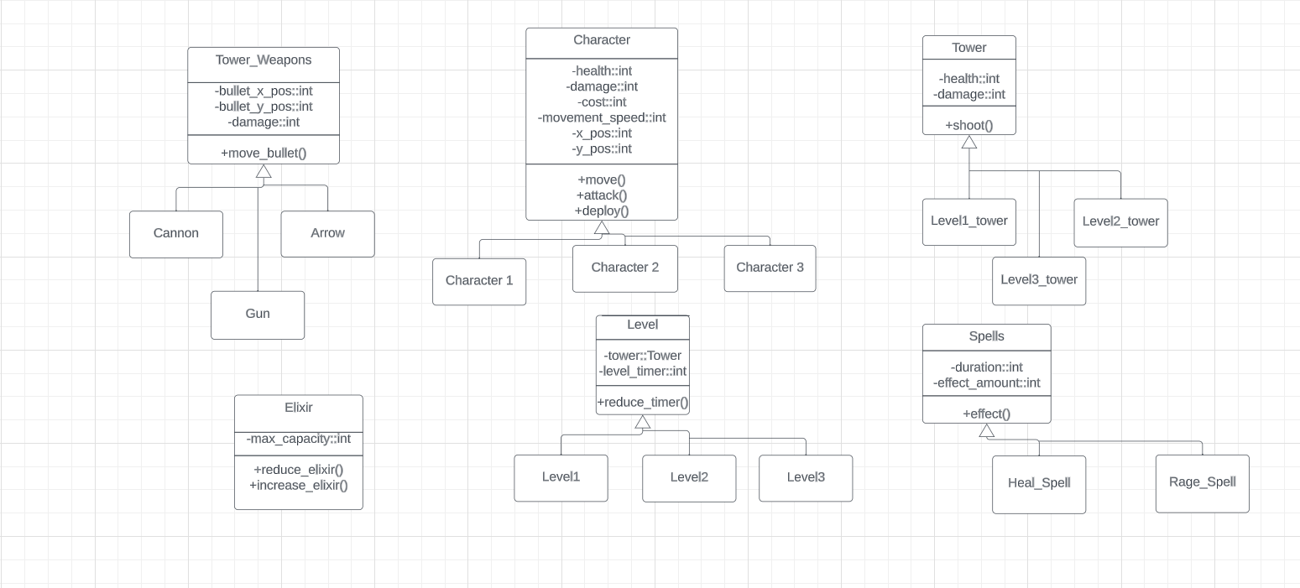

**Game Screens:**

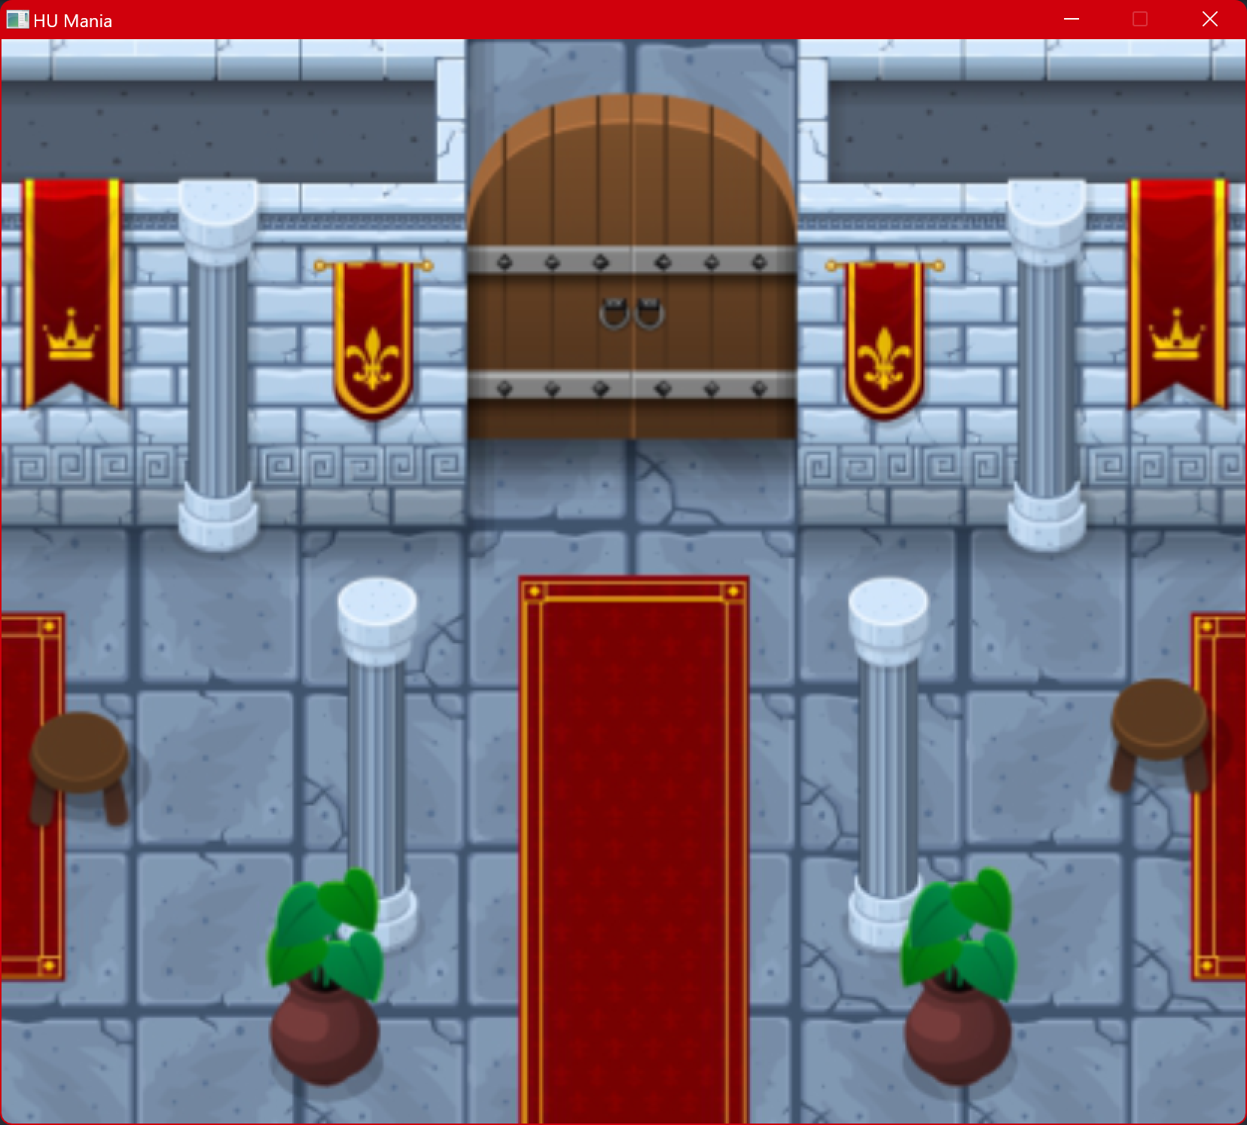

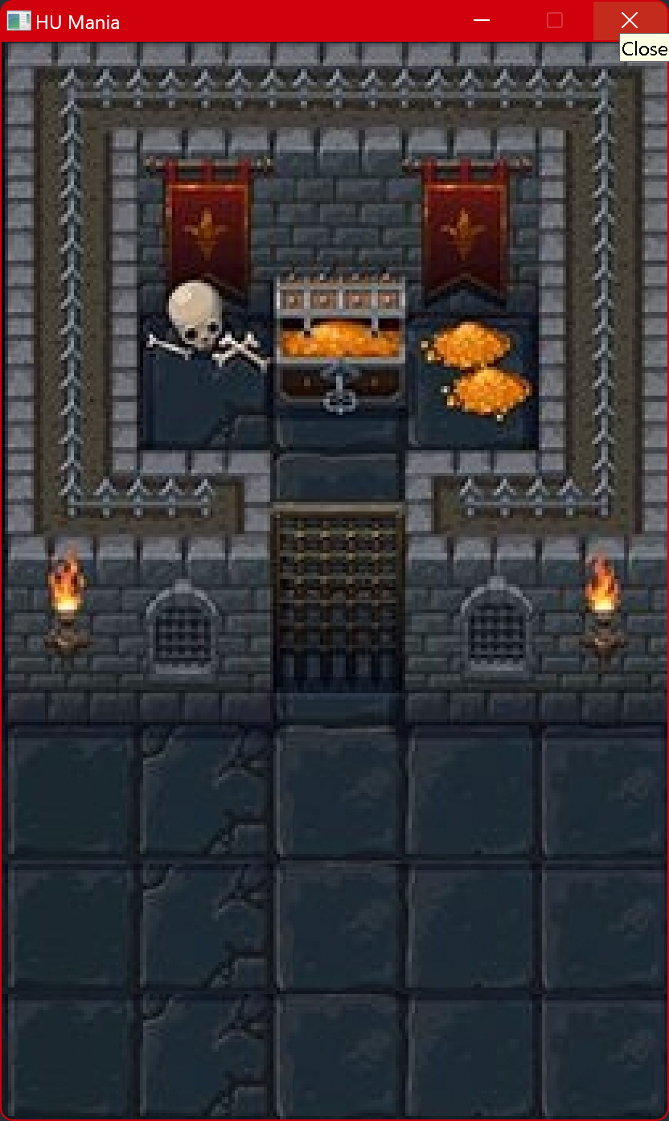

**Characters:**



