Subject: Mobile Computing  
Instructor: Prof. Haq Nawaz

Week No **1**

Lec 1 (February 23,2021)

Download Android Studio:

Step1: type **Android Studio**  on Google

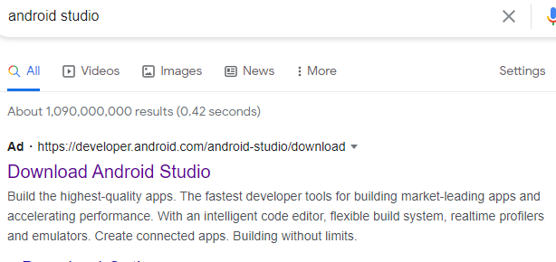

Step 2: Click on **Download Android Studio**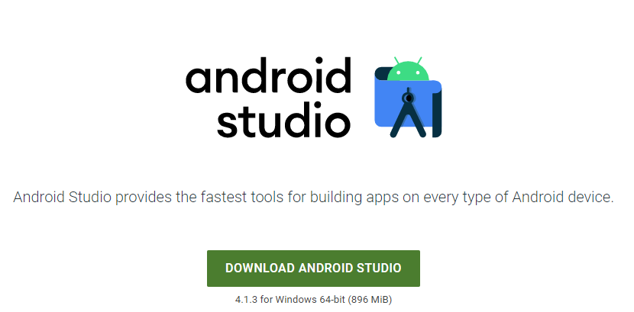

Step 3 : Click on **DOWNLOAD ANDROID STUDIO  
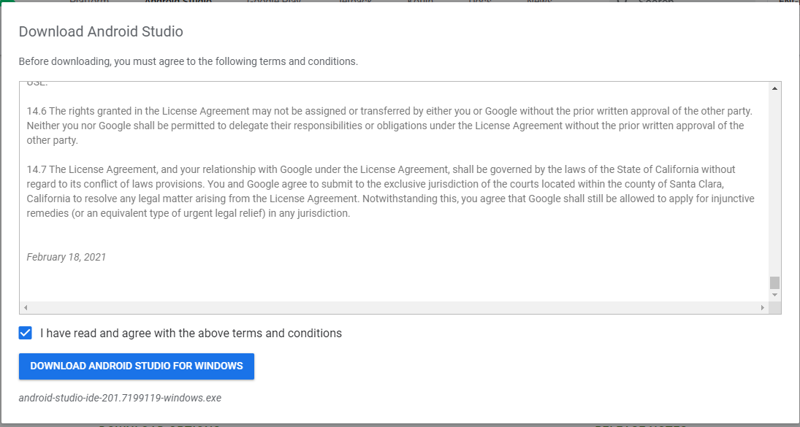**

Step 4 : Read all the terms and condition than click the check box and Click on **DOWNLOAD ANDRIOD STUDIO FOR WINDOWS  
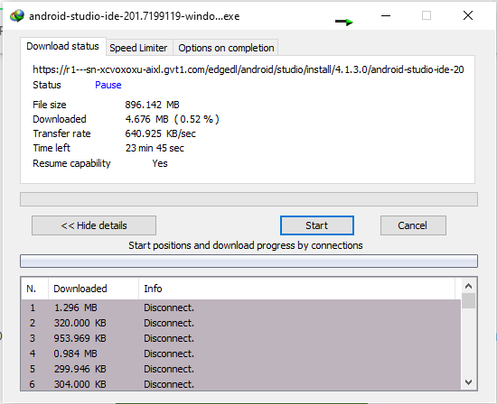**Step 5: Downloading will start wait until the downloading complete  
Step 6: After Downloading Install the **ANDRIOD STUDIO**

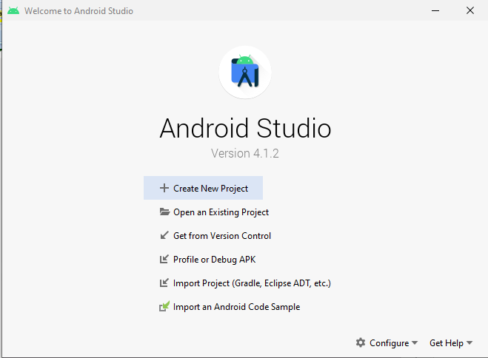

Lec 2 ( February 25,2021)

Create **Github** Account

To create Github Account first you have to download the git

* Step 1: To create github account first you have to download git  
   1.1: Simply open your browser and type **Download git** or click it

<https://git-scm.com/downloads>



1.2: Click on **Downloads – Git**   
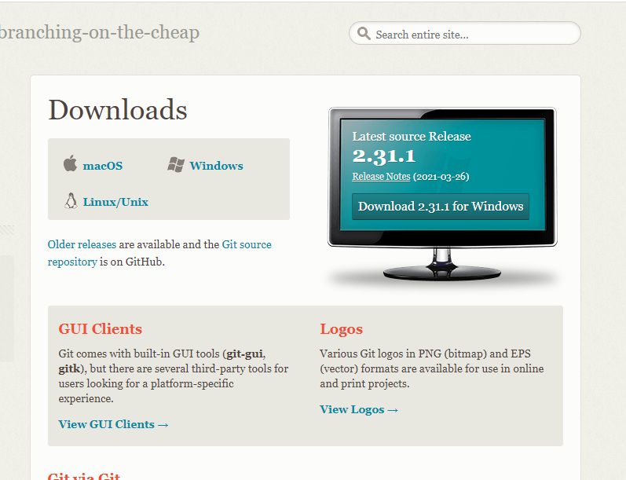1.3: this type of screen will show and than click on **Download 2.3.1 for Windows**  
 1.4: Now wait until the downloading will complete  
 1.5: After Downloading install it  
Now your git is install  
-> Step 2: Now you have to create your github account  
 2.1: Open your browser and type **github.com** or simply click on this link <https://github.com/> The following screen will appear and than click on **Sign up for GitHub**



2.2: Simple fill the form and after filling click on **Create Account** option

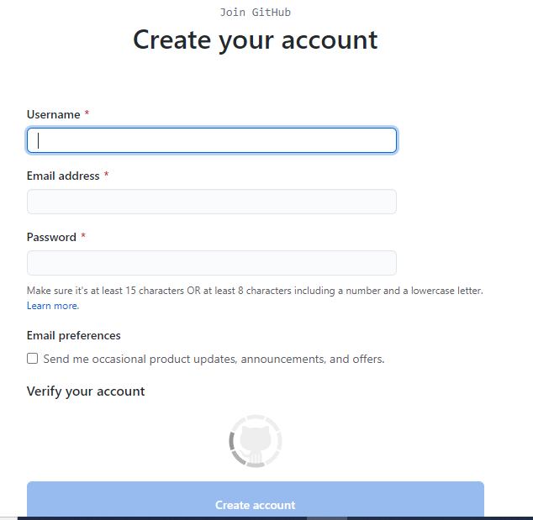

2.3: When your account is created successfully. The following screen will appear



Now your Github Account has been successfully created

-> Step 3: Creating a new Repository (repo) on github website

3.1 : Open your browser and type github.com/new or click this link <https://github.com/new>

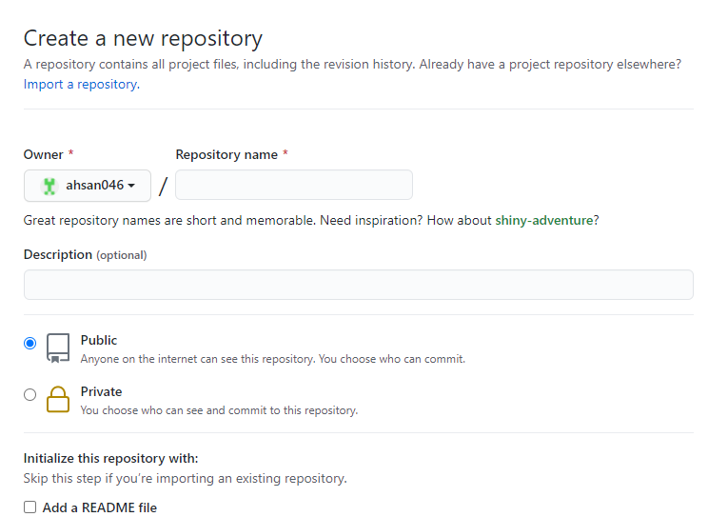

3.2: Enter your Repository name and make it public or private on your choice

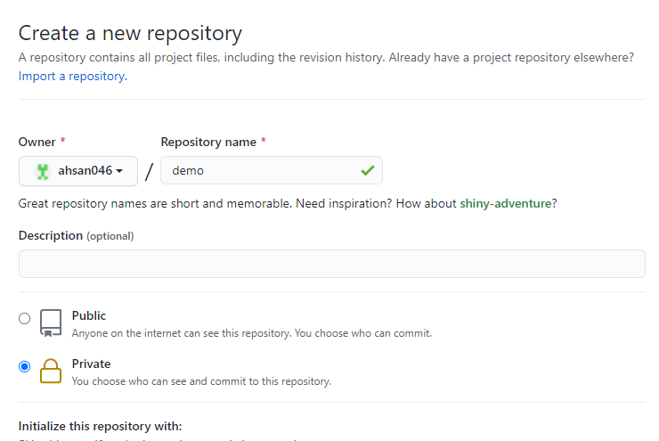

3.3: Scroll down and click on **Create repository**

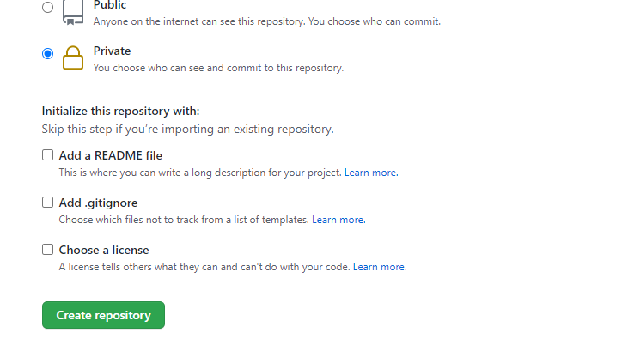

Now after repository creation the following screen will appear

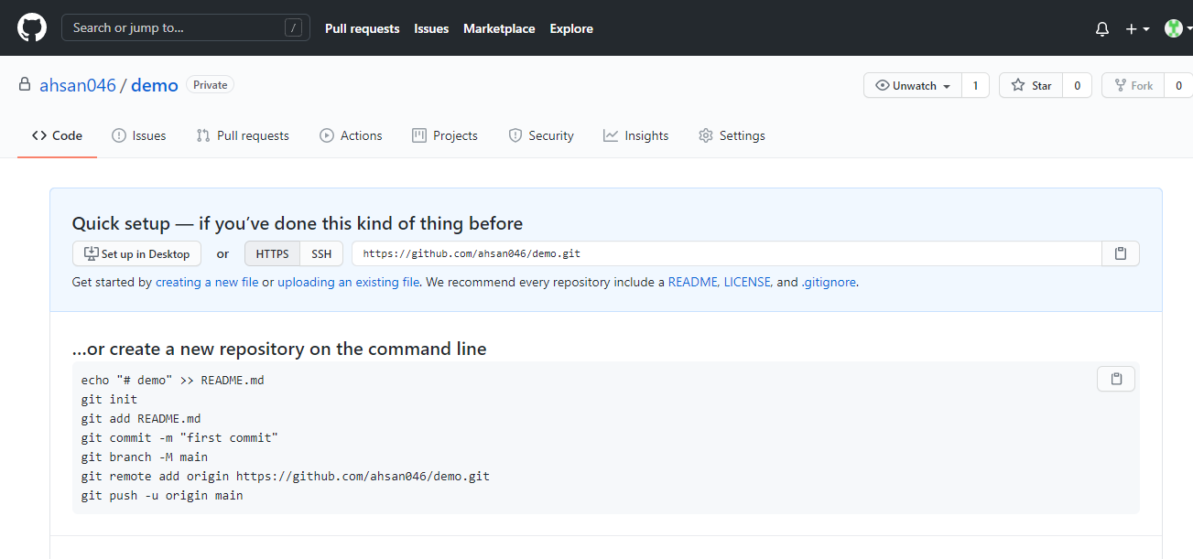

* Step 4: After creating a repository online. Let's try to clone it, so that it can be used on your PC.

4.1: Copy the repository URL or you can either copy **HTTPS** or **SSH**. I will copy

**HTTPS** URL.

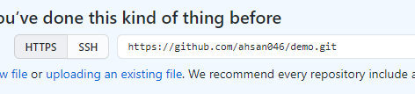

4.2: Go to your directory where you want to clone it and than open CMD

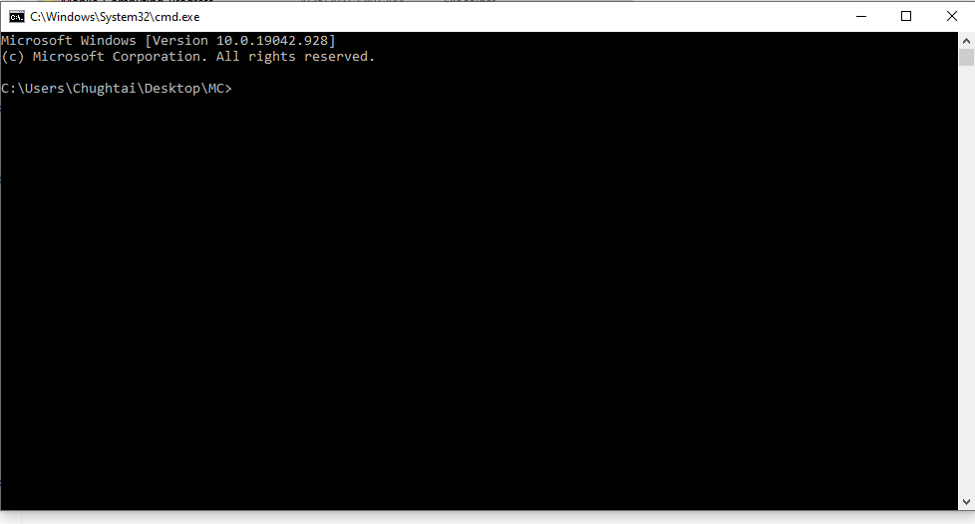

4.3: Now type **git clone** [**https://github.com/ahsan046/demo.git**](https://github.com/ahsan046/demo.git)

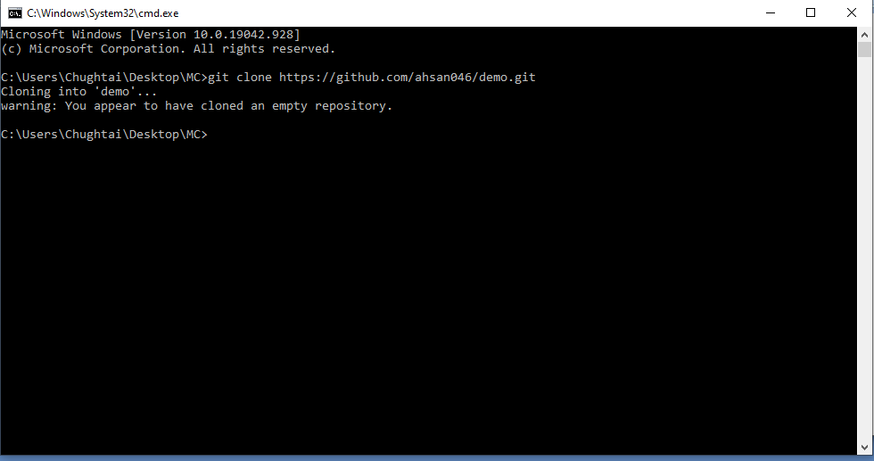

4.4: We have cloned the repository. Now add a new file and push it  
 First we have to go to that directory now type **cd directory_name** or  
 you can go to that directory and again open the CMD

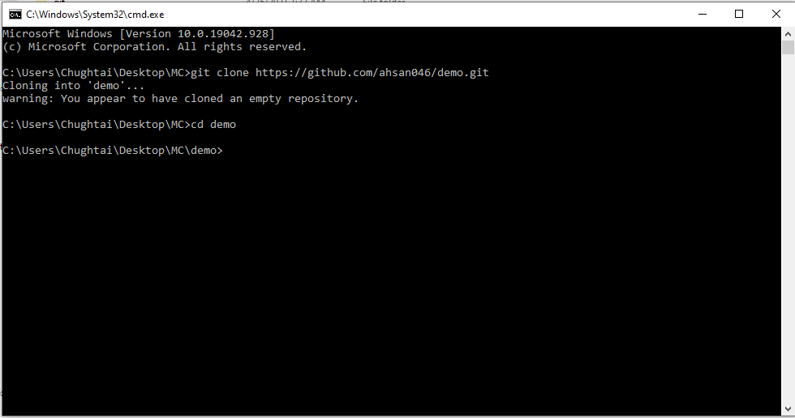

4.5: Create a new file which you want to push and something in it  
 Now use the **git add FileName** Command enter the file that you created   
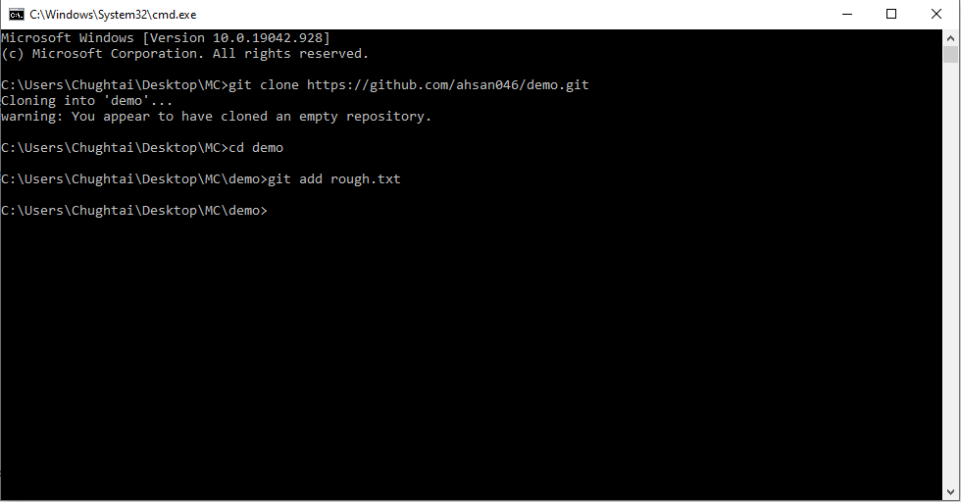

4.6: After adding we use git commit command with some message  
 Syntax -> git commit –m “Message”

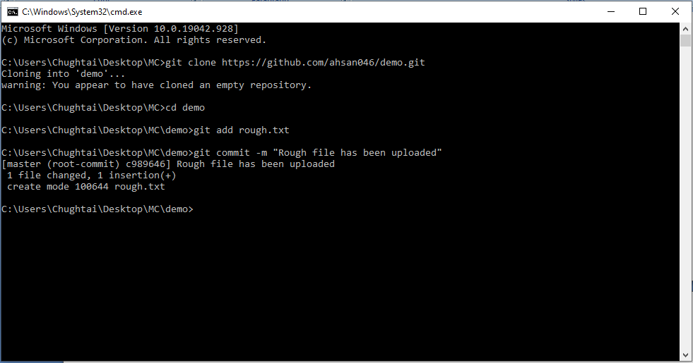

4.7: **git status** command is use to check the status of your repository

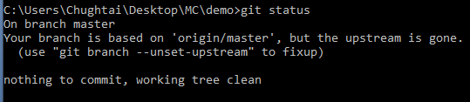

4.8:  Now we have committed the changes. But still these changes are not visible online. The reason is that we have to push the repo. So enter **git push** command. Now you can see changes on **Github repo** also.  
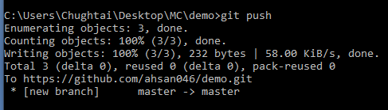

4.9: The **git pull** command is used to **fetch** and download content from a remote repository and immediately update the local repository to match that content.



End of First Week

Week No **2**

Lec 3 ( March 02,2021)