Connecteam

This is the document requirements based on discussion and reference (https://connecteam.com/) that to be done given time frame below. This is our work flow for Oversee execution with shift tasks website that to be developed by RPML Technologies Pvt Ltd. We are open to suggestions because all work flow is based on reference (https://connecteam.com/) Mainly. Please, let us know if anything does not match with your requirements. We can also add or change feature as per your requirements.

**Technologies:**

**Python (Django Framework)**

**Python version 3.8, Django version 3.1**

**Database: MySQL (also you can suggest)**

**Server:**

Linux Server or Cloud(recommended)

**Hosting:**

As per your Suggestion (recommended cloud hosting).

**Features:**

**UI Features:**

* 1. Website will have two view mode (like dark and white).
  2. UI will be similar to reference website.

**Database linking:**

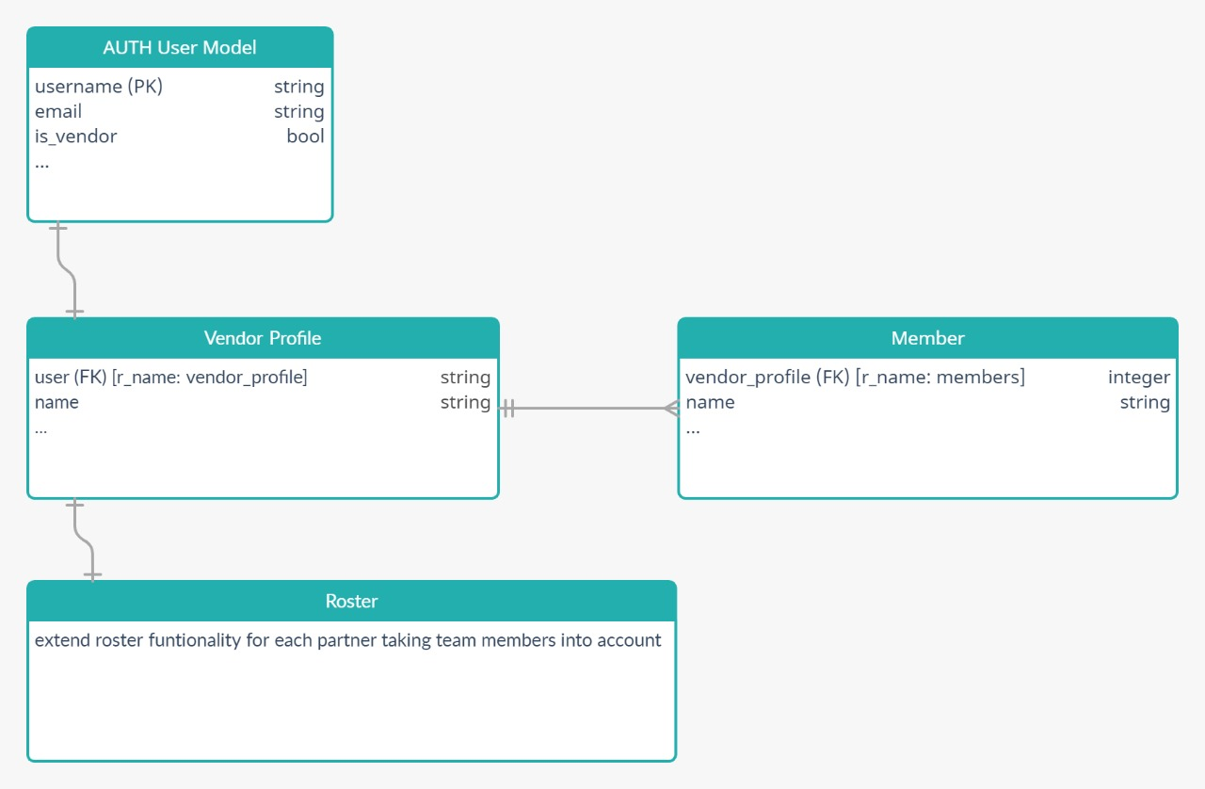

1. **User authentication in which we use Django inbuilt user model.**
2. **We use is_vendor Method to check user is vendor or not.**
3. **Vendor can multiple team.**
4. **Roasting feature will able to manage team members.**
5. **At time of login of user we will check whether user is vendor or not and if user is vendor then redirect it to theirdashboard.**

**Authentication:**

* 1. User will able to take trail on free signup with limited feature.
  2. User Detail user dashboard features:
  3. User can sign up with email and mobile number.
  4. At time of signup user will get an email to activate his account.
  5. After verification user will able to access his dashboard.
  6. User can login with username and password
  7. User can forget their password with help of email.
  8. User will able to change their profile info from his dashboard.

**User type:**

* 1. There will be multiple user type.
  2. User type will be decided by admin or super admin
  3. For e.g. staff, admin, super-admin, customer carer, executive etc.
  4. Every user type having separate dashboard with their unique feature.
  5. User can be added or removed by super admin.
  6. There will be two type of user in Normal User Dashboard.
  7. One is owner and second is owner.

**Owner dashboard features:**

* 1. They can add new team member.
  2. They can add new admin.
  3. They will be able to change work description or update it.
  4. They can create work flow with custom or designed template.
  5. They are able to see his activity and team member activity too.
  6. They are able to see list of user and also download in form of excel sheet.
  7. They are able to create new group based on their work (like technical team, marketing team etc.).
  8. They are also able to filter user of specific area.
  9. Update: admin can update their guidelines.
  10. Directory: it will help other user to contact detail of related user and managers.
  11. Admin will able to manage the other operations like time management, work flow, job scheduling etc.
  12. Admin can upgrade their plan anytime.
  13. Admin will able to add new operations and sections
  14. Admin will able to change basic information like company name, number of employees, billing system etc.
  15. Admin can also change permission of other users.
  16. Chat part:
      1. Admin are able to chat with other team member.
      2. Admin can chat with groups too.
      3. Admin are able to add member in group.
      4. Admin can remove any member from group.
      5. Media transfer will be supported in chat.
      6. Admin can deactivate the chat system anytime.
      7. Admin can send message according to member locations.

**Normal User Dashboard feature:**

* 1. Users are able to see company update
  2. User are able to see assigned group.
  3. User can only chat with assigned group.
  4. User are able to see assigned company scheduling.
  5. User are able to change his basic profile info.
  6. User can manage their work and salary part.
  7. User can request to join new group to admin.
  8. User are able to send leave request.
  9. User will able to report issues to related manager.
  10. User can see their over-time work in their dashboard.
  11. User can see the workflow given by admin
  12. User can also see quick assigned task.

**This document is created by reference of connect team website. So, it also contain some basic feature of above mention website.**

#Time required to complete this project is 25.

**M go daddy k sath call pr hokkkk wo bata rhe h kuch**