Department of Computer Science
Summative Coursework Set Front Page
Module Title | Imperative Programming
Module Code | CS1IP
Lecturers responsible | Martin Lester and Alan Guedes
Type of Assignment | Set exercise
Learning Outcomes Assessed | Write and execute a Java function that satisfies a simple input/output specification; Use version control.
Individual or Group Assignment | Individual
The weighting of the Assignment | 30%
Word count/page limit | N/A
Expected hrs spent for the assignment (set by lecturer) | 12 hours
Items to be submitted | 5 Java files inside a git repository
Work to be submitted on-line via Blackboard Learn by | November 10, 12:00 noon
Work will be marked and returned by | 15 working days
Artificial Intelligence Tools | May not be used
Note
By submitting this work, you are certifying that you have read the assessment guidelines (Assessment folder on Blackboard) and that you understand the associated policies and practices, including:
- Submitting your own work (not that of other people or systems, including AI) and penalties for Academic Misconduct
- Submitting by the specified deadline and penalties associated with late submission (if allowed)
- The exceptional circumstances system
- For students with relevant needs, attaching with a green sticker

1. Assessment classifications
This assignment requires you to submit your code for the problem described in Section 2.
Module Title | Imperative Programming
First Class/Distinction (>69%) | all problems are perfectly solved
Second/Pass (50-69%) | 4 problems are perfectly solved
Third (40-49%) | 3 problems are perfectly solved
Pass (35-39%) | 2 problems perfectly solved, and 1 problem partially solved
Fail (0-34%) | Only 1 problem perfectly solved

2. Assignment description
This coursework assesses CS1IP content for weeks 1-5, such as print out, capture user input, arrays, functions and loops.
Create a Git repository CS Gitlab repository with any name (the name does not need to be couresework1) and commit the programs to this repository INSIDE A SUBFODER CALLED coursework1.
Then click in the Submission Point at BlackBoard called Programming Exercise 1. It will redirect you to the GradeScope to select your repository like below.
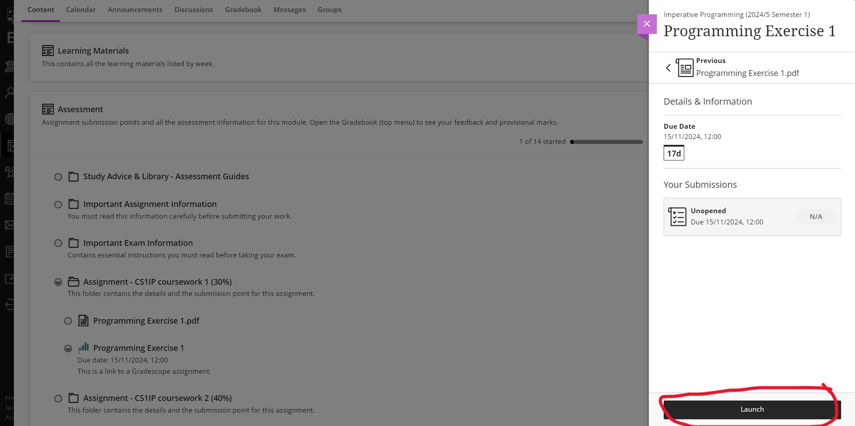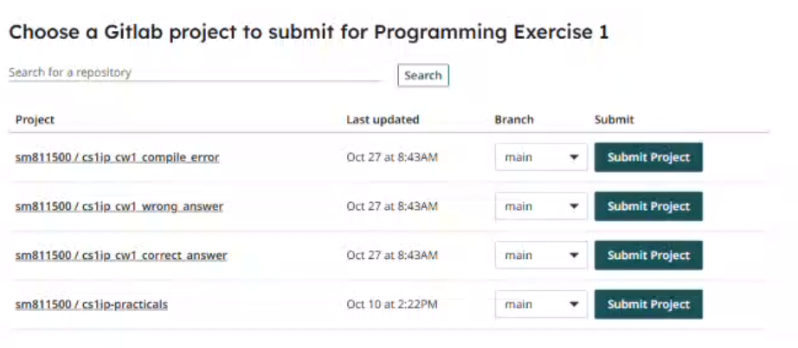
GradeScope will run some preliminary tests on the programs and inform you of any obvious errors, such as compilation errors. After the coursework deadline, GradeScope will run further tests. You will be allocated a percentage mark for each program based on which tests the program passed. The testing process will be entirely automated, so make sure your programs meet the specifications exactly.
Your mark for the coursework will be the sum of marks over all the programs. Note that this means the first program, which is very easy, has the same weight as the last program, which is considerably harder. You need only complete two programs successfully to get a passing mark of 40%, although obviously you should aim to complete them all.

Git repository (10%)
The Git repository should have the files in the structure below.
- coursework1/Hello.java
- coursework1/Volume.java
- coursework1/IceCream.java
- coursework1/SevenSegment.java
- coursework1/AverageGrades.java
Note: Make sure that the programs have the specified filenames. You SHOULD NOT use package coursework1; at your files.

coursework1/Hello.java (15%)
Write a program coursework1/Hello.java that when run greets you by your student number. For example, if your student number is 33123456, it should print:
Hello, student 33123456.

coursework1/Volume.java (15%)
In the file coursework1/Volume.java, write a method with the signature:
static double sphere(double d)
that computes the volume (in $cm^{3}$) of a sphere with diameter d.
Recall that the radius of a sphere r is defined by $r=1/2d$, and that its volume v is defined by $v=4/3πr^{3}$. You may assume that d is not negative.
For example, calling:
sphere(20.24);
it should return :
4341.403447756641

coursework1/IceCream.java (20%)
Write a program coursework1/IceCream.java for an ice cream shop that asks you for your choice of ice cream flavour and a number of scoops of ice cream, then prints out the total price of the ice cream in pounds and pence.
Each flavour of ice cream has a different price per scoop. In your program, set the prices (in pence) according to the last 6 digits of your student number. Looking at those 6 digits:
- Set the price of vanilla to be the last 2 digits.
- Set the price of chocolate to be the middle 2 digits.
- Set the price of strawberry to be the first 2 digits.
For example, if your student number is 33123456, then the last 6 digits are 123456. You should set vanilla to be 56 pence, chocolate to be 34 pence and strawberry to be 12 pence (If a flavour ends up costing 0 pence, that is fine; imagine there is a special promotion running for that flavour).
The total cost of the ice cream is 100 pence for a cone, plus the price per scoop (for the chosen flavour) multiplied by the number of scoops. For example:
Would you like (v)anilla, (c)hocolate or (s)trawberry?
v
How many scoops would you like?
3
That will be 2.68 please.
Give an error message if the user enters an invalid flavour or asks for anything other than 1, 2 or 3 scoops, as follows:
Would you like (v)anilla, (c)hocolate or (s)trawberry?
w
We don't have that flavour.
Or:
Would you like (v)anilla, (c)hocolate or (s)trawberry?
v
How many scoops would you like?
4
That's too many scoops to fit in a cone.
Or:
Would you like (v)anilla, (c)hocolate or (s)trawberry?
v
How many scoops would you like?
0
We don't sell just a cone.

coursework1/SevenSegment.java (20%)
In the file coursework1/SevenSegment.java, write a method with the signature:
static void display(int n)
that, given a number, displays ASCII art of that number in the style of an electronic “seven segment display”. For example:
display(28);
It will prints as output:
-- --
| | |
-- --
| | |
-- --
You may assume the number is a non-negative Java int.
Hints:
- Use n % 10 to get the right-most digit of a number. For example, 123456 % 10 == 6.
- Use n / 10 to chop off the right-most digit of a number. For example, 123456 / 10 == 12345.
To help your program draw the ASCII art, you should use the following method that, given a digit d and a line number n (from 1 to 5), returns a String representing line n of digit d.
String ssd(int d, int n) {
switch ((d*10)+n) {
case 1: case 5: case 21: case 23: case 25: case 31: case 33: case 35:
case 43: case 51: case 53: case 55: case 61: case 63: case 65: case 71:
case 81: case 83: case 85: case 91: case 93: case 95:
return " -- ";
case 24: case 52: case 62:
return "| ";
case 12: case 14: case 22: case 32: case 34: case 44: case 54: case 72:
case 74: case 94:
return " | ";
case 2: case 4: case 42: case 64: case 82: case 84: case 92:
return "| | ";
default: return " ";
}
}

coursework1/AverageGrades.java (20%)
In the file coursework1/AverageGrades.java, write a method with the signature:
static int[] average_grades(int grades[][], int weights[])
that, given an array of students’ percentage grades in each assessment component for a module, and an array of percentage weights for each component, calculates and returns a new array of their weighted average grades, rounded down to the nearest integer.
You may assume that:
- the weights[] are between 1 and 100 inclusive and sum to 100;
- the 2nd dimension of grades[][] is positive and equal to the dimension of weights[];
- all values in grades are between 0 and 100 inclusive.
To calculate a student’s weighted average grade, multiply each grade by its corresponding weight, then divide the total by 100.
For example, suppose two students were taking a module with assessments weighted at 30%, 40% and 30%, with grades as follows:
Name | Coursework 1 (30%) | Coursework 2 (40%) | Exam (30%)
Alice | 51 | 83 | 28
Bob | 0 | 38 | 95
Observe that Alice’s weighted average grade is ((51 * 30) + (83 * 40) + (28 * 30)) / 100 = (1530 + 3320 + 840)/100 = 5690 / 100 = 56.9, which rounds down to 56.
We could compute weighted averages for both students by using average_grades() as follows:
average_grades(new int[][]{{51, 83, 28}, {0, 38, 95}}, new int[]{30, 40, 30});
It will have as return:
int[2] { 56, 43 }

3. Marking scheme
The marking of each problem solution depends on whether it shows a compile error, a runtime error, or the expected output result.
Git repository | 0%: A git repository was NOT used in the submission  10%: A git repository was used in the submission
coursework1/Hello.java | 0%: The problem has a compile error, a runtime error, or has output which does not meet the specification  7.5%: The program has an output which meets the specification but does not follow the requested filename (e.g., wrong folder or misspelled filename)  15%: The program has an output which meets the specification
coursework1/Volume.java | 0%: The problem has a compile error, a runtime error, or has output which does not meet the specification  7.5%: The program has an output which meets the specification but does not follow the requested filename (e.g., wrong folder or misspelled filename)  15%: The program has an output which meets the specification
coursework1/IceCream.java | 0%: The problem has a compile error, a runtime error, or has output which does not meet the specification  10%: The program has an output which meets the specification but does not follow the requested filename (e.g., wrong folder or misspelled filename)  20%: The program has an output which meets the specification
coursework1/SevenSegment.java | 0%: The problem has a compile error, a runtime error, or has output which does not meet the specification  10%: The program has an output which meets the specification but does not follow the requested filename (e.g., wrong folder or misspelled filename)  20%: The program has an output which meets the specification
coursework1/AverageGrades.java | 0%: The problem has a compile error, a runtime error, or has output which does not meet the specification  10%: The program has an output which meets the specification but does not follow the requested filename (e.g., wrong folder or misspelled filename)  20%: The program has an output which meets the specification

