Department of Computer Science
Summative Coursework Set Front Page
Module Title | Imperative Programming
Module Code | CS1IP
Lecturers responsible | Martin Lester and Alan Guedes
Type of Assignment (e.g. technical report, portfolio exercise, in-class test) | Set exercise
Learning Outcomes Assessed | Implement and benchmark a simple algorithm that manipulates arrays; Use version control.
Individual or Group Assignment | Individual
The weighting of the Assignment | 40%
Word count/page limit | N/A
Expected hrs spent for the assignment (set by lecturer) | 16 hours
Items to be submitted | 1 Java file  1 PDF file
Work to be submitted on-line via Blackboard Learn by | December 12, 12:00 noon
Work will be marked and returned by | 15 working days
Artificial Intelligence Tools | May not be used
Note
By submitting this work, you are certifying that you have read the assessment guidelines (Assessment folder on Blackboard) and that you understand the associated policies and practices, including:
- Submitting your own work (not that of other people or systems, including AI) and penalties for Academic Misconduct
- Submitting by the specified deadline and penalties associated with late submission (if allowed)
- The exceptional circumstances system
- For students with relevant needs, attaching with a green sticker

1. Assessment classifications
This assignment requires you to submit your code for the problem described in Section 2.
Module Title | Imperative Programming
First Class/Distinction (>69%) | 5 all functions are working as expected, and 1 pdf as expected
Second/Pass (50-69%) | 4 all functions are working as expected and pdf incomplete (only plot image or only text)
Third (40-49%) | 3 all functions are working as expected
Pass (35-39%) | 2 all functions are working as expected
Fail (0-34%) | Only 1 function working as expected

2. Assignment description
This coursework assesses CS1IP content for weeks 6-11, such as File I/O, Collections, Top-down design, Big-O complexity, and sort algorithms.
Create a Git repository CS Gitlab repository with any name (the name does not need to be couresework2) and commit the programs to this repository INSIDE A SUBFODER CALLED coursework2.
Then click in the Submission Point at BlackBoard called Programming Exercise 2. It will redirect you to the GradeScope to select your repository like below.
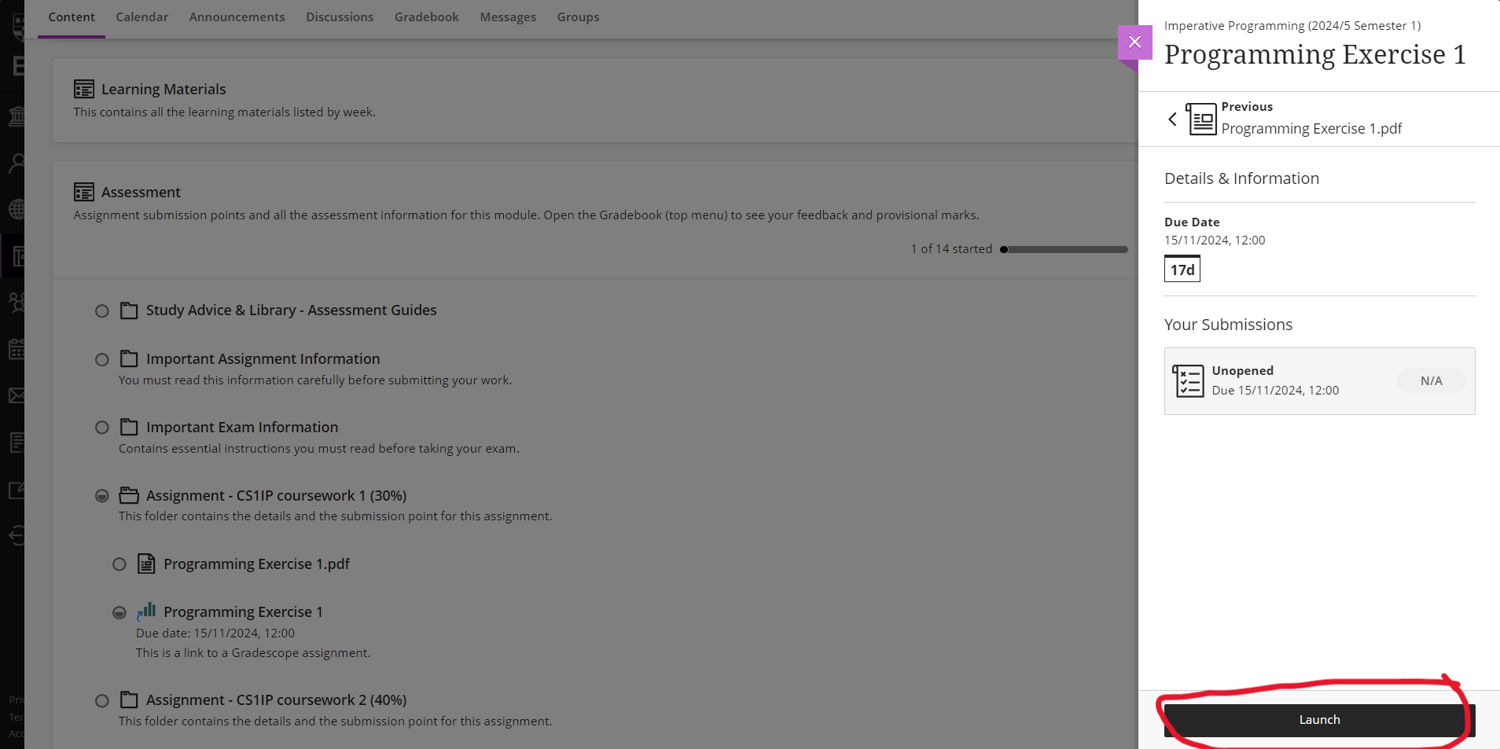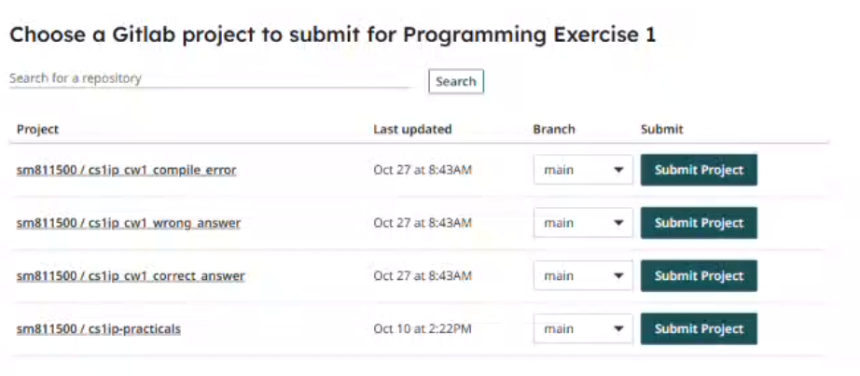
GradeScope will run some preliminary tests on the programs and inform you of any obvious errors, such as compilation errors. After the coursework deadline, GradeScope will run further tests. You will be allocated a percentage mark for each program based on which tests the program passed. The testing process will be entirely automated, so make sure your programs meet the specifications exactly.

Git repository (10%)
Commit the programs to a Git repository in a subdirectory called coursework2 and push a repository at CS Gitlab repository. Make sure that the files have precisely the filenames described below (avoid spaces).below.
- coursework2/SortComparison.java
- coursework2/SortComparison.pdf
Note: Make sure that the programs have the specified filenames. You SHOULD NOT use package coursework2; at your files.

coursework2/SortComparison.java file
The coursework2/sortComparison.java should have the following methods:
static int cardCompare(String card1, String card2){
// TODO
}
static ArrayList<String> bubbleSort(ArrayList<String> array){
// TODO
}
static ArrayList<String> mergeSort(ArrayList<String> array){
// TODO
}
static void sortComparison(String[] filenames) throws IOException{
// TODO
}
The following methods will assess your skills on File I/O, Collections, Sorting and Time Complexity:

cardCompare() (15%)
This method compares two cards. A card consists of a String in the format of:
- a card number represented from a number between 1 and 13, Ace as 1, 2 through 10, Jack as 11, Queen as 12, and King as 13. Its priority is 1 < 2 < 3 < … < 12 < 13.
- and a suit, represented by one the letter, ‘H’ for Hearts, ‘C’ for Clubs, ‘D’ for Diamonds, or ‘S’ for Spades. Its priority is H < C < D < S.
When comparing cards, the suit priority is checked first and then the number. So, 4H is less than 3S or 7S or 8C or 2D, but 4H is greater than 3H. The method returns -1 if the first card is less than the second one, 0 if both are equals, and 1 if the first is greater. See the execution example below:
cardCompare("4H", "4H"); // return 0
cardCompare("4H", "3S"); // return -1
cardCompare("4H", "7S"); // return -1
cardCompare("4H", "8C"); // return -1
cardCompare("4H", "2D"); // return -1
cardCompare("4H", "3S"); // return -1
cardCompare("7C", "7D") // return -1
cardCompare("1S","13S") // return -1
cardCompare("4H", "3H"); // return 1

bubbleSort() (20%)
This method executes a bubbleSort using the cardCompare. It receives an ArrayList<String> as param and returns the sorted list using BubbleSort Algorithm. See execution example below:
var list = new ArrayList<String>(List.of("4H", "3S", "7S", "8C", "2D", "3H"));
bubbleSort(list); // return [3H, 4H, 8C, 2D, 3S, 7S]

mergeSort() (20%)
This method executes a MergeSort using the cardCompare. It receives an ArrayList<String> as param and returns it sorted using MergeSort Algorithm. See execution example below:
var list = new ArrayList<String>(List.of("4H", "3S", "7S", "8C", "2D", "3H"));
mergeSort(list); // return [3H, 4H, 8C, 2D, 3S, 7S]

sortComparison() (20%)
This method receives multiple files as Strings. Each file contains a list of card elements, one per each line. Then, for each given file, sortComparison() measures the execution time (in milliseconds) using the sorting methods bubbleSort() and mergeSort(). The results are saved in a file called sortComparison.csv.
You can test this method using the files sort10.txt, sort100.txt, and sort10000.txt (download from Blackboard Assessment folder). See an execution example below:
sortComparison(new String[]{"sort10.txt", "sort100.txt", "sort10000.txt"})
The expected format of the sortComparison.csv file is as shown below (precise execution times will vary). The first line is the header with three integers indicating the number of cards in each file. The next lines display the execution times for bubbleSort() and mergeSort() for each file:
, 10, 100, 10000
bubbleSort, 0, 27, 1884
mergeSort , 0, 1, 8
Note: The execution times each sorting could not be exactly as above. But the format should be respected.

coursework2/SortComparison.pdf file (15%)
This PDF will include a written complexity discussion (2-3 paragraphs) regarding the performance of your sort methods. The document will have one section called “BubbleSort and MergeSort Complexity Reflection” with an image plot and related written text discussing results of your sortComparison for the files sort10.txt, sort10000.txt, and sort10000.txt (see example below). The discussion should relate the code complexity of each sorting method and the different input sizes.
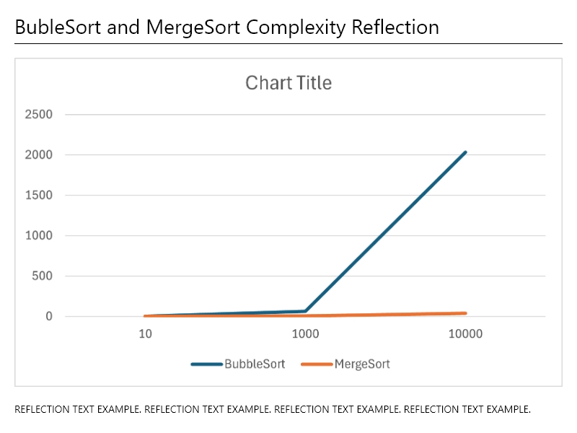
The image plot will have two lines indicating the performance of the bubbleSort and mergeSort routines. To generate the plot, you can open the sortComparison.csv file with Microsoft Excel, select all of the data, and insert a 2DLine plot (see steps below).
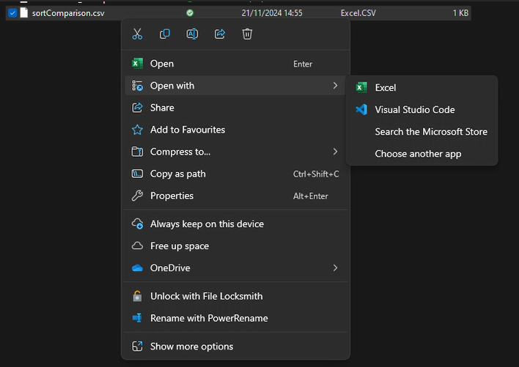
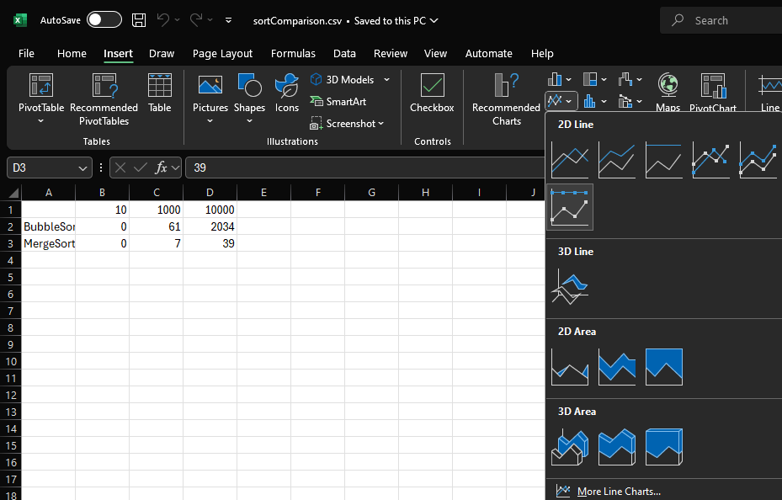

3. Marking scheme
The marking of each problem solution depends on whether it shows a compile error, a runtime error, or the expected output result.
Git repository | 0%: A git repository was NOT used in the submission  10%: A git repository was used in the submission
cardCompare function | 0%: The function call has a compile error, a runtime error, or has output which does not meet the specification  7.5%: The program has an output which meets the specification but does not follow the requested filename (e.g., wrong folder or misspelled filename)  15%: The program has an output which meets the specification
bubbleSort function | 0%: The function call has a compile error, a runtime error, or has output which does not meet the specification  10%: The program has an output which meets the specification but does not follow the requested filename (e.g., wrong folder or misspelled filename)  20%: The program has an output which meets the specification
mergeSort function | 0%: The function call has a compile error, a runtime error, or has output which does not meet the specification  10%: The program has an output which meets the specification but does not follow the requested filename (e.g., wrong folder or misspelled filename)  20%: The program has an output which meets the specification
sortComparison function | 0%: The function call has a compile error, a runtime error, or has output which does not meet the specification  10%: The program has an output which meets the specification but does not follow the requested filename (e.g., wrong folder or misspelled filename)  20%: The program has an output which meets the specification
SearchComparison.pdf file | 0%: File does not exist or file empty  10%: File include an image plot and correct  15%: File include image plot and paragraph, and they are correct

