***WormSpread*: an individual-based model of invasive earthworm population dispersal**

George Armstrong1, Ahsan Mahmood2, Andie Nugent2, Sonya Dexter2, Emily Hutto2, Timothy McCay2, Ahmet Ay1,2*

1Department of Mathematics, Colgate University

2Department of Biology, Colgate University

*Correspondence author. E-mail: [aay@colgate.edu](mailto:garmstrong@colgate.edu)

**Abstract**

1. European earthworm species such as *Lumbricus Rubellus* can reduce leaf litter on forest floors, which results in reduced tree populations and biodiversity. Individual Based Modeling (IBM) offers a way to predict the spread of such invasive species, and can provide insight for controlling their harmful effects.
2. We developed *WormSpread*, an individual-based, spatially explicit, population dynamics model. The user-interface is designed to be easy to learn and flexible enough to incorporate new data.
3. This program allows ecologists and conservationists to experiment with the effects of variations in landscape and parameters on predicted earthworm population levels. Such a model is helpful for determining where to concentrate conservation efforts and what strategies may or may not be helpful.
4. We have created a framework for population prediction, but more data is needed. A better understanding of worm behavior and more accurate parameters will increase the efficacy of this model.

**Introduction**

Invasive exotic earthworms have had significant impacts on many areas, especially forests, in the Northeastern United States. It has been shown that non-native earthworms alter soil characteristics and community composition, and can harm local biodiversity by competing with native species (Dempsey et al, 2013; Burtelow, Bohlen, and Groffman, 1998; Snyder, Callaham, and Hendrix, 2011; Snyder et al, 2013). Once an invasive population is established, eradication is often unfeasible (National Wildlife Federation). Therefore, preventing colonization into new areas may be the best strategy for protecting local ecosystems and communities from exotic earthworms. Models have become increasingly used in the fields of ecology and evolutionary biology (DeAngelis and Mooij, 2005). IBMs are also useful for conservation efforts, and have been developed for many species including the Large Blue Butterfly, the Red Cockated Woodpecker, and walleye and yellow perch in Zebra Mussel infested waters (Griebeler & Seitz, 2002; Letcher et al, 1998; Rutherford et al, 1999), indicating their utility for investigating the invasion of exotic species and conserving local biodiversity. Individual Based Models (IBM) can be utilized to predict which natural communities are most vulnerable to invasion by organisms such as earthworms and can be used to understand which environmental and intrinsic factors are most influential in the spread of invasive populations.

An IBM uses agents to represent individual organisms and simulate organisms’ histories and interactions amongst themselves and with their environment (DeAngelis and Mooij, 2005).  Previous earthworm IBMs have included parameters that take into account starting densities of adults and cocoons, developmental stages, survival probabilities in various environments, and fecundity in order to determine population growth and dynamics (Pelosi et al, 2008; Baveco & De Roos, 1996). Using state variables and attributes specific to the problem provides the model with a high level of specificity that makes predictions as accurate as possible. Unfortunately, this level of specificity often comes at a cost for researchers. West et al (2011) describes the challenges of adjusting parameters, running the program, and interpreting results for someone who is not experienced with computer modeling and programming. IBMs are very useful tools for conservation efforts, and our goal is to develop an intuitive graphic user interface that does not assume a high level of programming expertise. Our aim in designing *WormSpread* is to create a flexible platform for modeling the spread of invasive earthworms that is useable by any conservationist.

*WormSpread* was tested by simulating earthworm dispersal in a small portion of the Adirondacks State Park in New York. As a test species, *Lumbricus rubellus* was chosen due to the availability of research on that species, and *Lumbricus terrestris* data was used for parameters when *L. rubellus* data did not exist. Agents representing *L. rubellus* were placed into a simulated environment with temperature and pH, and went through their life cycles while moving through the environment and responding to various conditions. While the program was originally tested with *L. rubellus*, its flexibility will allow other species to be modelled. *Amynthas agrestis*, an Asian invasive earthworm, is one such species for which our program will be useful in modeling population survival and spread.

In this article, we offer an overview of the program, its design, and how it can be used to study earthworms for the purpose of conservation. We also further explain the features of the program that make it user-friendly and useful for testing a wide range of hypotheses given different conditions and variables.

**Components of *WormSpread***

**pH**

Soil pH was included in this model because areas of high and low soil pH can potentially limit the survival, and consequently the invasive potential, of earthworms. This information can be useful when mapping the invasion of lands with more acidic soils, such as the Adirondack State Park.

Earthworms absorb nutrients from the soil, and soil pH can have a direct effect on their chance of survival and cocoon production rate (Perämäki et al., 1992). Most earthworms can survive in a variety of soil pH, but will avoid soils with very acidic or basic pH levels (Ammer & Makeschin, 1994). However, previous studies have shown that the cocoon production rate decreases as the earthworms’ environment becomes more acidic (Spurgeon, 2006).

**Temperature**

Although soil can act as a buffer due to its high heat capacity (Zheng et al. 1993), and protects earthworms from harsher surface conditions, earthworms do exhibit temperature sensitivity. Earthworms can survive within a wide temperature range. *Lumbricus* species can survive up to a week in temperatures as low as -1C (Meshcheryakova, 2014) and survive for several days in temperatures as high as 25C (Daniel, 1990). However, the temperature may affect behaviors including movement, feeding activity, and growth (Neuhauser et al. 1988).

**Mortality**

In this model, mortality of an individual is dependent on three factors: temperature of the day, pH of the soil and age of the individual. Temperature and pH factors are calculated on a daily basis, using probabilities provided by the user. Survival probabilities dependent on pH are used to calculate a hazard rate, which is then plugged into a mortality function whereas those dependent on temperature are used without any modification. Mortality due to age follows a Type 1 survivorship curve following a survival function obtained from Baveco & de Roos (2016), which affects the worms independent of pH and temperature.

**Reproduction**

Worms start reproducing after reaching maturity. An individual’s maturation period is sampled from a Gaussian distribution. Each individual is assigned to one of four reproduction temperature ranges. A user provided cocoon rate is incremented to a counter whenever the global temperature falls within the individual's temperature range. When the counter hits one, a cocoon hatches and the counter resets. Since temperature and pH affect cocoon rates independently, the smaller of the two rates is selected at any given time.

**Burrowing**

An individual will burrow if the cumulative survival probability of a user-specified number of days is less than 0.7.

**Tolerance**

The software has the functionality to change the worms’ tolerance to pH and temperature. Doing so will translate the survival probability functions to the left or right according to the tolerance shift.

**Hatching**  
Several sources suggest that growing degree-days can be used as an accurate measure of the length of time required for a worm cocoon to hatch (Butt 1991).  The length of time required to hatch is consequently dependent upon the daily temperature.  It is assumed that *L. rubellus* inherits the number of degree days needed to hatch from its parent.  We observed a relationship between cocoon hatchability and temperature in the data collected by Butt (1991), and made the assumption that cocoon survivability is temperature dependent and that any cocoon surviving until its required number of degree-days will hatch. The two relevant parameters are the degree-day threshold, which we have hard-coded estimated based on available data (Butt 1991), and cocoon survivability dependent upon temperature, which is supplied by the user.

**GIS Integration**

A major goal of *WormSpread* is to incorporate the ability to make population projections in a simulated real world environment.  In order to accomplish this task, users can upload GIS shapefiles from the Web Soil Survey.  Temperature and pH data are available and dependence is currently in place, as described in the relevant sub-models. Users could also potentially prepare their own GIS files, as long as they provide a key corresponding to pH values in the proper format and location.  There are other attributes about soil that could be relevant to earthworm movement/behavior available on the soil survey (such as moisture) that could potentially be incorporated. However, currently there is not enough data to establish a dependence on other parameters, but if data were to become available, minimal coding experience would be required to add support for new features.

**User-Friendliness**

NetLogo features have allowed us to create a user-friendly interface for ecologists to set up and run simulations by saving files to the correct folders and manipulating them with a graphical user interface (GUI). **Figure 1** shows the GUI, which allows users to manipulate existing environments, import from GIS vector data, or create their own environment with the controls provided.

Users can also use their own functions for worm survival as a function of pH, cocoon production as a function of pH, worm survival as a function of temperature, and cocoon survival as a function of temperature in place of using the default functions we have provided by updating a .csv file.  This adds flexibility to the software so it can continue to be useful as more data regarding the parameters becomes available.

**Model Output**

*WormSpread* has the ability to record data within regions designated by the user. Currently the program will record the worm population within each monitor, the density of the worms (dependent upon the size of the region), and the genetic diversity, pH tolerance, and temperature tolerance of the worms in the region. These measurements are recorded for each week of the last year of the simulation, so users can choose a metric of population of the last year as they see fit. The program also currently outputs heat maps of the worm population every five years of the simulation.

Frequency of heat map output, or making slight changes to the code can modify what information is saved to the output .csv file. Instructions for modifying these sections of the code are available in the supplementary materials.

**Study Example**

The location of this model was selected to be representative of *L. rubellus* spread in the Adirondack State Park in New York. The Adirondacks were selected because their unusually acidic soil (Sullivan et al, 2005) and harsh winters. A central question was if the worms could overcome these factors, or if they would act as barriers to invasion. A one hundred square mile plot encompassing Raquette Lake and the surrounding forest area was selected. It was selected based on characteristics that may have an effect on the spread of *L. rubellus*. The area was chosen to be representative of a variety of land types that may include invasion factors such as aquatic, recreational, and undeveloped zones.

The soil pH data was downloaded for the area of interest from the USDA Web Soil Survey website. For our simulations, historical temperature data from PRISM for the past 30 years was used (links available in supplementary materials).

Simulations were run, each investigating the effects of a different environmental variable on worm dispersal. In each simulation (with the exception of the random introduction simulation where worms were introduced at points S1-S5) the worms were inserted at a single introduction point. Their density was then recorded in five regions located in the corners and center of the area of interest (Figure 2). The first series of simulations examined the worm’s ability to invade the area of interest with varying pH tolerances. The pH tolerance was chosen as a factor because of its apparent direct connection to worm survival (Perämäki et al., 1992). This is especially important in this case study because of the abnormally low pHs that can occur in the Adirondack State Park. Worms with a higher pH tolerance exhibited a larger spread across the area of interest, represented by higher densities in the five regions (Figure 3).

Temperature was also chosen as an environmental factor that affects the spread of *L. rubellus*. Soil acts as a temperature buffer due to its high heat capacity (Zheng et al. 1993), so earthworms are often able to survive in a wide range of temperatures. However, the temperature may still affect behaviors including movement, feeding activity, and growth (Neuhauser et al. 1988). The IBM simulated the potential spread of earthworms with varying temperature tolerances. In all but one region, worms with no shifted temperature tolerance were able to spread to the monitored regions more effectively (Figure 4).

The next parameter examined was the presence of roads. Using GIS data, current roads were incorporated into the IBM and the dispersal of worms was compared in two scenarios, one with current roads and one with possible future roads. Future possible road locations were selected based on popular tourist and residential areas within the area of interest. Because the regions are located in the four corners of the area of interest, the distribution is not easily understandable through the graph (Figure 5). Therefore the heat map may be a better way to understand distribution by showing the full spread of dispersion and not simply the density in the designated regions (Figure 6). Through the heat map, the current roads show a higher density of worms near the initial introduction point and although they did spread to other locations, they did so in smaller quantities. With the addition of new roads, a higher density of worms was shown to be spreading to new locations. Therefore, dispersal appears to be higher with the addition of roads.

Random insertions of worms were also incorporated into this model. Worms are often introduced to new regions by human activity, such as soil or plant transportation and fishing (Edwards; Tiunov et al, 2006). For this reason, our model introduced 25 *L. Rubellus* worms around Raquette Lake either 0, 5, or 10 times during the summer months in order to simulate random introductions due to fishing. They were introduced at a random site (S1-S5). In all monitored areas, worm population density was higher when random insertion was a factor (Figure 7).

Finally, density of worms was examined after primary introductions at these pre-selected sites (Figure 8). Twenty-five worms were introduced at a single point (S1-S5) and the simulation was run without further introductions. The worm density was then measured after thirty years in each of the five designated regions. This allowed us to investigate if the site of introduction played a significant role in the dispersion pattern of the worms.

**Conclusion**

*WormSpread* is a user-friendly tool that allows the user to take basic environmental conditions and worm tolerances and create population dispersal simulations. It is often difficult to understand how factors such as pH, temperature and urban development interact with each other within an ecosystem to influence a species. The IBM can assist in creating hypotheses about consequences of variations in large-scale ecological conditions (Patten 2013). These hypotheses can then be used to predict the spread of worms, helping researchers to inform strategies to manage the invasion. The information they receive from the program is multi-faceted and can be used to address invasion in different ways. Ecologists and conservationists can study the movement of the worms themselves and use this information to target the areas most vulnerable to invasion. It can supplement other environmental information when the locations of new roads, residential communities, and other anthropogenic additions to the environment to help stop the further spread of these invasive species.

These small-scale models can help pinpoint trends and patterns that can be applied on a larger scale. The limiting factors of this application are the lack of data available on the species and minimal knowledge regarding the mechanisms governing worm behavior. This project has pointed out that there is strikingly little data available on earthworm behavior, characteristics, and lifecycles. Through our literature search for the IBM, we found that data are sparse or non-existent for burrowing behaviors, rates of movement, and effects of pH and temperature on life cycle characteristics including cocoon survival, juvenile growth, and mortality. As our project continues, we hope to fill in some of these gaps in earthworm research.  With more data, this tool could become even more useful in predicting the worm’s spread across a variety of landscapes and how this changes based on genetic diversity and tolerances. The model can also be adapted to incorporate new or more specific parameters, which would most likely increase the accuracy of predictions.

**Figures**:

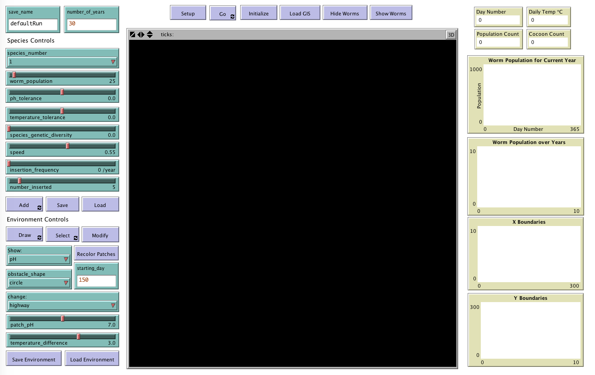

**Figure 1.** WormSpread GUI. a) Simulation parameters. b) Simulation controls. c) Species controls. d) Environment controls. e) NetLogo world.

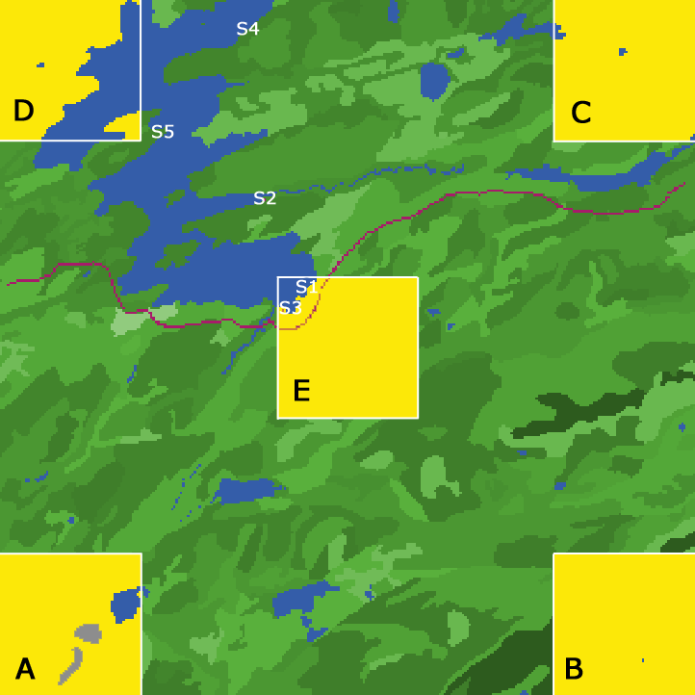

**Figure 2.** Locations of regions A-E and random introduction points. Plots in each corner and in the center of the area of interest are designated as a region A-E. Worm density is calculated in each region for each variation in environmental parameters and represented in the following figures. Points S1-S5 were chosen due to their location near popular fishing sites, areas believed to be possible introduction points for *L. rubellus*. Unless otherwise specified, S1 was used as the primary introduction point.

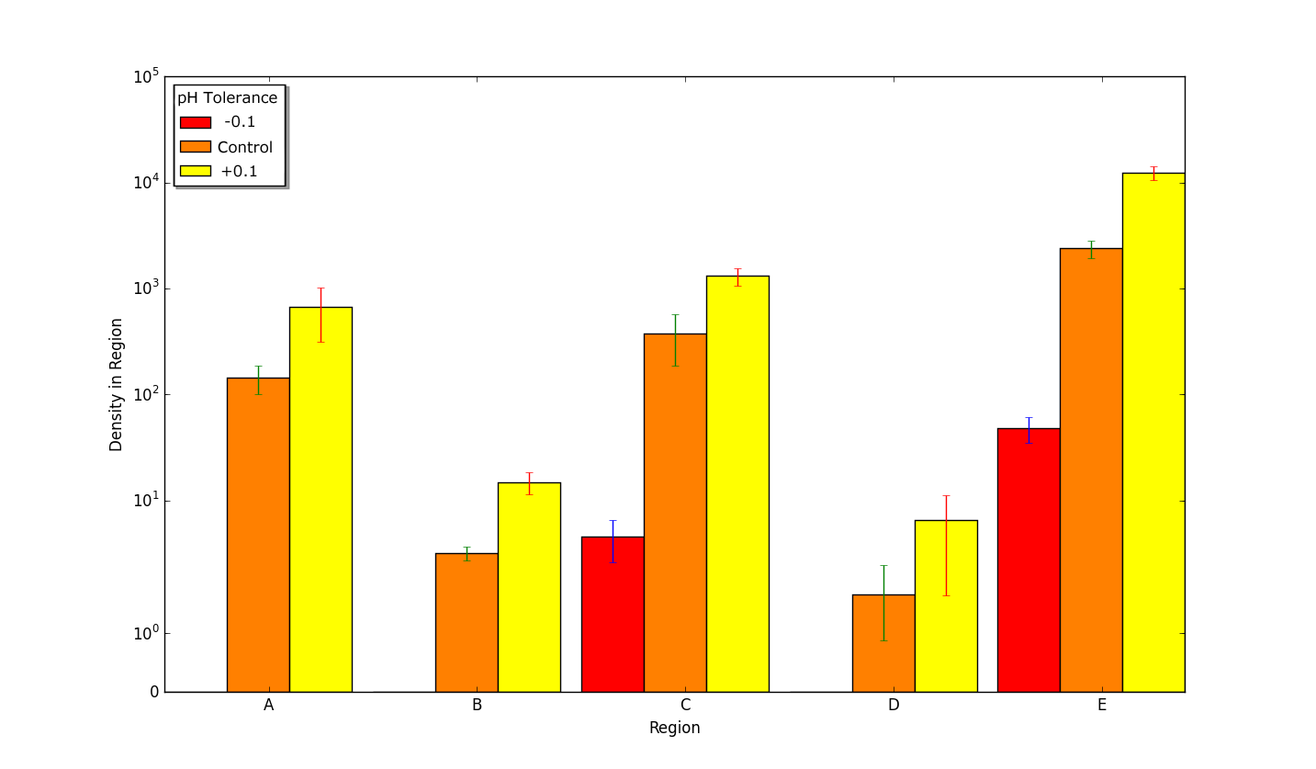

**Figure 3**. Density in regions A-E of populations with differing pH tolerance. Each individual worm’s survival in different pH values is dependent upon a curve that fits the values supplied by user. The mortality curve for these simulations was interpolated from results of Butt (1991). Worms with a pH tolerance of -0.1 have the curve shifted 0.1 pH unit to the right. Worms with a pH tolerance level of 0.0 are the control. A pH tolerance of 0.1 means the worms have a pH tolerance curve that is shifted 0.1 pH unit to the left. In all regions, density is significantly higher with each increased interval of pH tolerance. In regions A, B, and D, no earthworms of -0.1 tolerance successfully invaded.

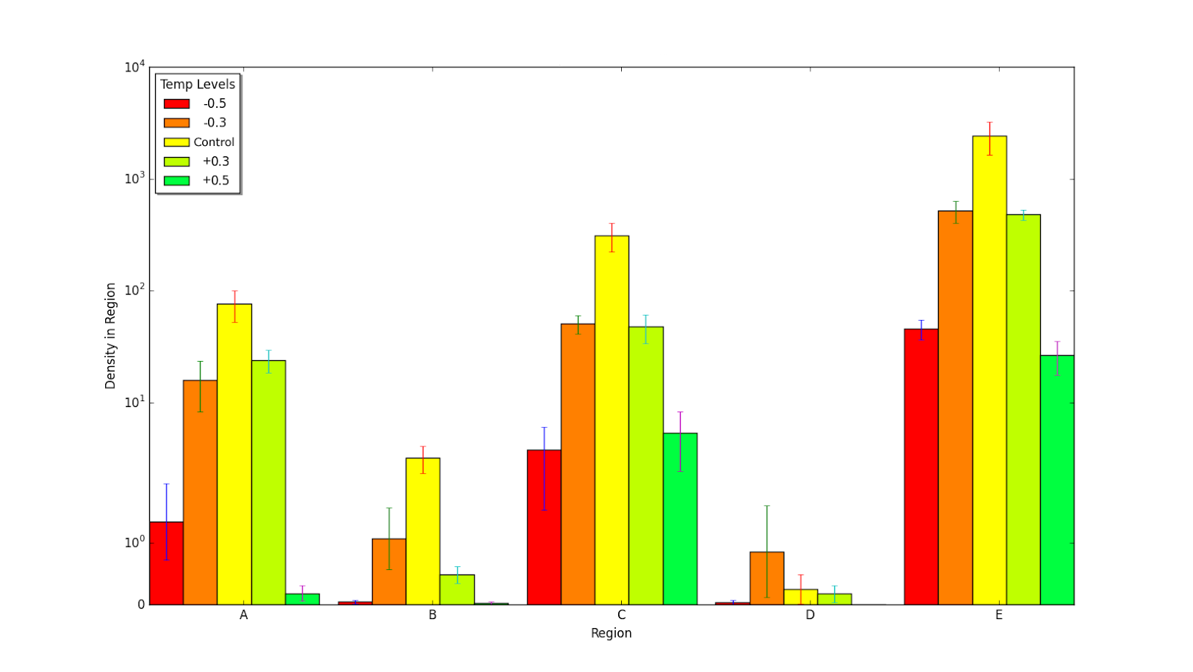

**Figure 4.** Density of worm populations in regions A-E with differing temperature tolerance, scaled logarithmically. Like the pH tolerance, the temperature tolerance of worms is determined by the user-determined relationship between temperature and mortality. A temperature tolerance of -0.3 means that the tolerance curve for the worms has been shifted down 0.3C, so the worms are able to survive in lower temperatures than the control worms. Worms with a temperature tolerance of 0.0 are the control. Worms with a tolerance of 0.3 have their tolerance curve shifted 0.3C up, so they are able to survive in higher temperatures than the control worms. In all but one region, density is higher with the control worms than with the worms whose tolerances have been altered.

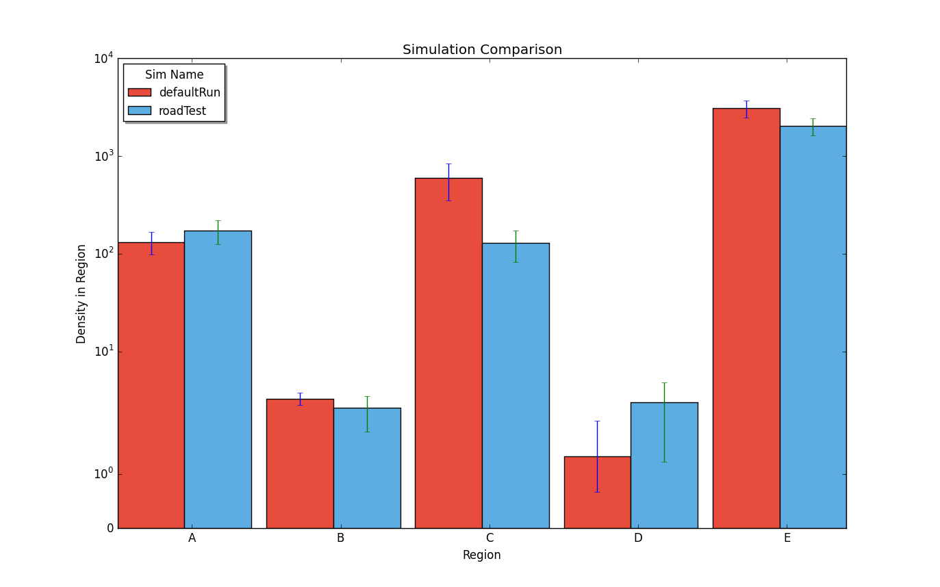

**Figure 5** Density of worm populations in regions A-E with current roads and with future possible roads. Road locations were imported from GIS data on Web Soil Survey. Future road locations were selected based on popular tourist and residential areas within the area of interest. Because the regions are located in the four corners of the area of interest, the distribution is not easily understandable through the graph. Therefore the heat map may be a better way to understand distribution.

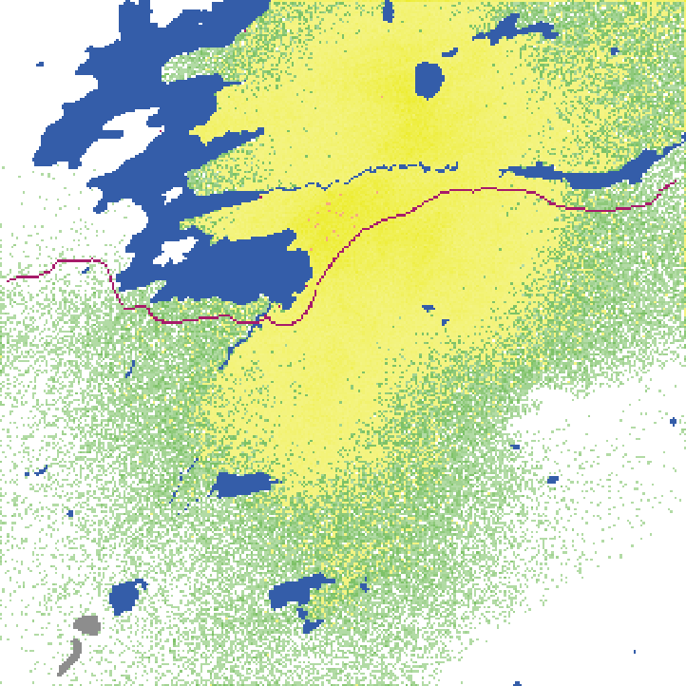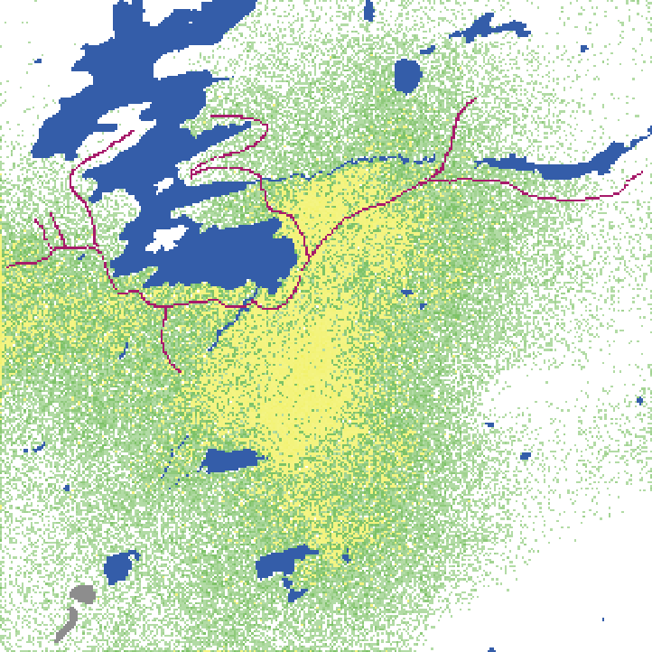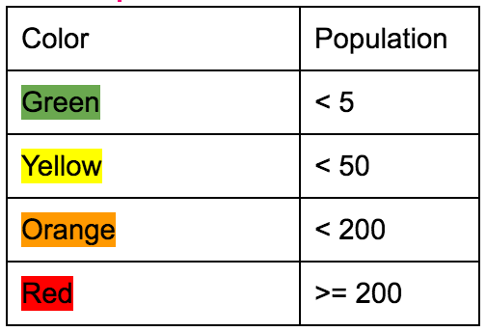

**Figure 6** Heat maps of worm density with current roads and with potential future roads. Cooler colors such as green indicate a lower worm density. Warmer colors such as yellow indicate a higher density. Worms exhibit a similar spread in both scenarios, however they indicate a higher density with the existence of fewer roads. Figure A shows a higher density of worms near the initial introduction point and although they did spread to other locations, they did so in smaller quantities. Figure B shows higher densities of the worms spreading to new locations.

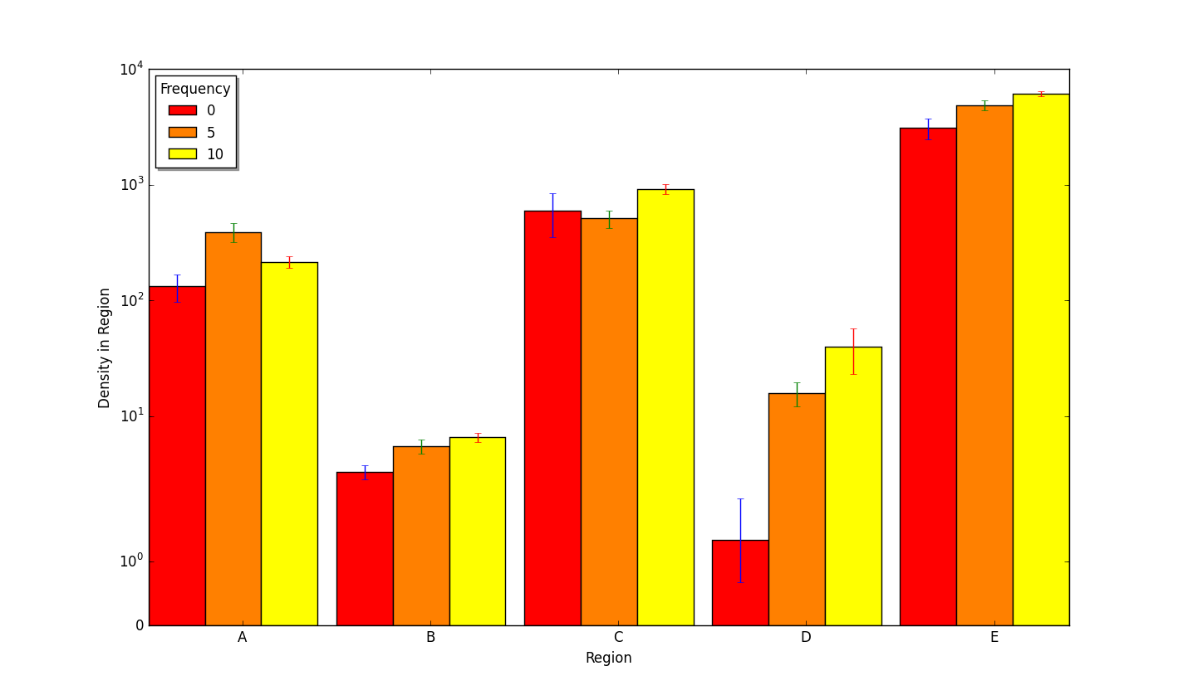

**Figure 7.** Frequency of random introductions each year compared with worm density at monitored regions in the area of interest. Introduction points S1-S5 were chosen at popular fishing sites near Raquette Lake due to the fact that *L. rubellus* are used as bait worms, and are often transported to new regions by fishermen. Random introductions only occurred during the summer months when fishing introductions were most likely, and each introduction consisted of 25 worms. Trials run at 0 random introductions each year served as the control. Trials with 5 and 10 introductions per year were run to determine if anthropogenic introductions of *L. rubellus* assisted in the spread of the species.

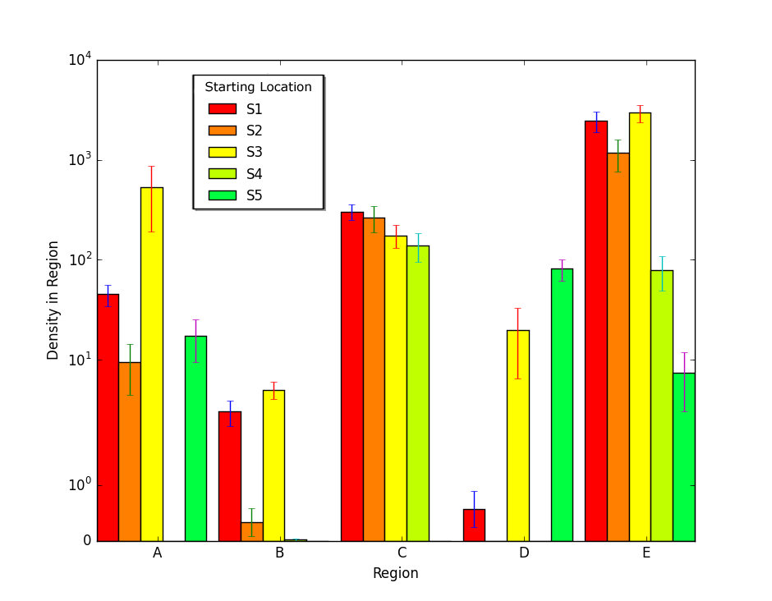

**Figure 8.** Density of worms in areas of interest after random introductions. Twenty-five worms were introduced at a single point (S1-S5) and the simulation was run without further introductions. The worm density was then measured after thirty years in each of the five designated regions.

**References:**

Ammer, V.S., &  Makeschin, F. 1994. Effects of simulated acid precipitation and liming on earthworm fauna (Lumbricidae, Oligochaeta) and humus type in a mature stand of Norway Spruce. *Forstwissenschaftliches Centralblatt, 113*, 70–85.

Baveco, J., & De Roos, A. (1996). Assessing the Impact of Pesticides on Lumbricid Populations: An Individual Based Modelling Approach. *Journal of Applied Ecology,* *33*(6), 1451-1468. doi:1. Retrieved from http://www.jstor.org/stable/2404784 doi:1

Berry, E.C., & Jordon, D. (2001). Temperature and soil moisture content effects on the growth of Lumbricus terrestris (Oligochaeta: Lumbricidae) under laboratory conditions. *Soil Biol. and Biochem., 33*, 133-136.

Burtelow, A.E., Bohlen, P.J., & Groffman, P.M. (1998). Influence of exotic earthworm invasion on soil organic matter microbial biomass and denitrification potential in forest soils of the northeastern United States. *Applied Soil Ecology, 9*(1-3), 197-202.

Butt, K.R. (1991). The effects of temperature on the intensive production of *Lumbricus terrestris. Pedobiologia, 35*, 257-264.

Daniel, O. (1990). LIFE CYCLE AND POPULATION DYNAMICS OF THE EARTHWORM LUMBRICUS TERRESTRIS L. Swiss Federal Institute of Technology.

DeAngelis, D., & Mooij, W. (2005). Individual-Based Modeling of Ecological and Evolutionary Processes. *Annual Review of Ecology, Evolution, and Systematics,* *36*, 147-168. Retrieved from <http://www.jstor.org/stable/30033800>.

Dempsey, M. A., Fisk, M. C., Yavitt, J. B., Fahey, T. J., & Balser, T. C. (2013). Exotic earthworms alter soil microbial community composition and function. *Soil Biology and Biochemistry, 67*, 263-270.

Edwards, C. A. (2004). *Earthworm Ecology* (2nd ed.). Boca Raton, FL: CRC PRESS.

Edwards, C.A & Bohlen, P.J. (1996). *Biology and Ecology of Earthworms*, Chapman & Hall, London.

Elvira, C., J. Domínguez, & Mato, S. (1997). The growth and reproduction of *Lumbricus rubellus* and *Dendrobaena rubida* in cow manure mixed cultures with *Eisenia andrei.* *Applied Soil Ecology, 5*(1), 97-103.

Evans, A.C., W.J.Mc.L. Guild. (1948). Some notes on reproduction in British Earthworms. *Annals and Magazine of Natural History,* 654-659.

Griebeler, E. M., & Seitz, A. (2002). An individual based model for the conservation of the endangered large blue butterfly, maculinea arion (lepidoptera: Lycaenidae). *Ecological Modelling, 156*(1), 43-60.

Letcher, B. H., Priddy, J. A., Walters, J. R., & Crowder, L. B. (1998). An individual-based, spatially-explicit simulation model of the population dynamics of the endangered red-cockaded woodpecker, picoides borealis. *Biological Conservation, 86*(1), 1-14. [doi:10.1016/S0006-3207(98)00019-6](http://dx.doi.org/10.1016/S0006-3207(98)00019-6)

Ma, Wei-chun. (1984). Sublethal Toxic Effects of Copper on Growth, Reproduction and Litter Breakdown Activity in the Earthworm Lumbricus RubelIus, with Observations on the Influence of Temperature and Soil pH. *Environmental Pollution, 33*, 207-219.

# [Meshcheryakova](https://www.researchgate.net/profile/Ekaterina_Meshcheryakova), E., &  Berman, D.I. (2014). Cold hardiness and geographic distribution of earthworms (Oligochaeta, Lumbricidae, Moniligastridae). *Entomological Review, 94*(4), 486-497.

Neuhauser, E.F., Loehr, R.C., & Malecki, M.R. (1988). The potential of earthworms for managing sewage sludge. *Earthworms in Waste and Environmental Management,* 9-20.

Patten, B.C. 2013. *Systems analysis and simulation in ecology* (ed.). Vol 3. Elsevier, 2013.

Pelosi, C., Bertrand, M., Makowski, D., & Roger-Estrade, J. (2008). WORMDYN: A Model of *Lumbricus terrestris* population dynamics in tilled and no tilled fields. *Ecological Modelling*, *218*, 219-234.

Perämäki, P.,  Itämies J., Karttunen, V., Lajunen, L.H.J., & Pulliainen, E. (1992). Influence of pH on the accumulation of cadmium and lead in earthworms (*Aporrectodea caliginosa*) under controlled conditions. *Ann. Zool. Fennici*, *29*, 105-111.

Roots, B. I. (1956). The water relations of earthworms. II. Resistance to dessication and immersion and behaviour when submerged and when allowed a choice of environment. *Journal of Experimental Biology,* *33*, 29–44

Rutherford, E.S., Rose, K.A., Mills, E.L., Forney, J.L., Mayer, C.M., & Rudstam, L.G. (1999). Individual-based model simulations of a zebra mussel (*Dreissena polymorpha*) induced energy shunt on walleye*(Stizostedion vitreum*) and yellow perch (*Perca flavescens*) populations in Oneida Lake, New York. *Canadian J. Fisheries and Aquatic Sci., 56,* 2148-2160.

Snyder, B.A., Callaham Jr., M.A., & Hendrix, P.F. (2011). Spatial variability of an invasive earthworm (*Amynthas* *agrestis*) population and potential impacts on soil characteristics and millipedes in the Great Smoky Mountains National Park, USA. *Biol. Invasions, 13,* 349-358.

Snyder, B.A., Callaham Jr., M.A., Lowe, C.N., & Hendrix, P.F. (2013). Earthworm invasion in North America: Food resource competition affects native millipede survival and invasive earthworm reproduction. *Soil Biology and Biochemistry, 57,* 212-216.

Spurgeon, D.J., Lofts, S., Hankard, P.K., Toal, M., McLellan, D., Fishwick, S., & Svendsen, C. (2006). Effect of pH on metal speciation and resulting metal uptake and toxicity for earthworms. *Environmental Toxicology and Chemistry, 25*(3), 788–796.

Tiunov, A.V., Hale, C.M. Holdsworth, A.R., & Vsevolodova-Perel, T.S. (2006). Invasion patterns of Lumbricidae into the previously earthworm-free areas of northeastern Europe and the western Great Lakes region of North America. *Biol. Invasions, 8*, 1223-1234.

West, A.D., Stillman, R.A., Drewitt, A., Frost, N.J., Mander, M., Miles, C., Langston, R., Sanderson, W.G., & Willis, J. (2011). WaderMORPH – a user-friendly individual-based model to advise shorebird policy and management. *Methods in Ecology and Evolution, 2,* 95-98.

*What We Do to Stop Invasive Species*. Retrieved from <<https://www.nwf.org/What-We-Do/Protect-Wildlife/Invasive-Species.aspx>>.

Zheng, D., Hunt Jr., E.R., & Running, S.W. (1993). A daily soil temperature model based on air temperature and precipitation for continental applications. *Climate Research, 2*, 183-191.