1. **Write a code in C++ that takes radius of a circle as input from user and outputs the circumference and area. The output should be clear and readable. Add proper comments to the code. You can set the value of π up to 3 decimal places?**

**Code:**

#include<iostream>

using namespace std;

#define PI 3.142

int main()

{

double rad, C, A;

//const double PI = 3.142;

cout << "Enter the radius of cirlcle: ";

cin >> rad;

C = 2 * PI * rad;

A = PI * rad * rad;

cout << "Circumference of circle is: " << C << endl;

cout << "Area of circle is: " << A;

cout << endl;

return 0;

}

**Output:**

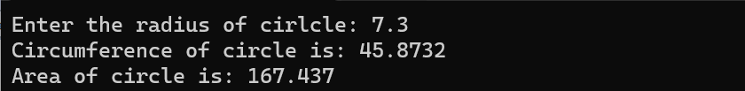

1. **Write a code in C++ that takes values of a and b from the user and displays result of polynomial $a^{2}+2ab+b^{2}$.**

**Code:**

#include<iostream>

using namespace std;

int main()

{

int a, b, c;

cout << "Enter the value of a: ";

cin >> a;

cout << "Enter the value of b: ";

cin >> b;

c = a * a + 2 * a * b + b * b;

cout << "Result: " << c;

cout << endl;

return 0;

}

**Output:**

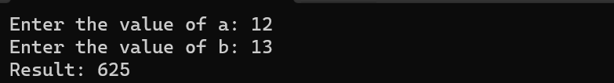

1. **Write a program that asks the user to enter a value for x and then displays the value of the following polynomial 2x^5+3x^4-x^3-2x^2+7x-6. To calculate x^5 you will have to use pow(x, 5). Note: include math.h library for pow.**

**Code:**

#include<iostream>

#include<math.h>

using namespace std;

int main()

{

int x, res;

cout << "Enter the value of x: ";

cin >> x;

res = 2 * pow(x,5) + 3 * pow(x,4) - pow(x,3) - 2 * pow(x,2)+ 7 *

x - 6;

cout << "Result: " << res;

cout << endl;

return 0;

}

**Output:**



1. **Take two complex number from user and add them. Print the resultant complex number.**

**Code:**

#include<iostream>

#include<math.h>

using namespace std;

int main()

{

int a, b, c, d, r_sum, i_sum;

cout << "Enter the real part of first number: ";

cin >> a;

cout << "Enter the imaginary part of first number: ";

cin >> b;

cout << "Enter the real part of second number: ";

cin >> c;

cout << "Enter the imaginary part of second number: ";

cin >> d;

r_sum = a + c;

i_sum = b + d;

cout << "Sum of two Complex Number: " << r_sum << " + i" << i_sum;

cout << endl;

return 0;

}

**Output:**

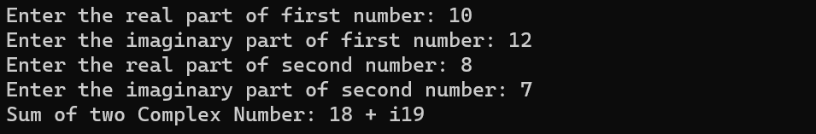

1. **Write a program to calculate the distance between two points using distance formula when coordinates of both the points are input by user.**

**Code:**

#include<iostream>

#include<math.h>

using namespace std;

int main()

{

float x1, x2, y1, y2, d;

cout << "Enter the x1: ";

cin >> x1;

cout << "Enter the y1: ";

cin >> y1;

cout << "Enter the x2: ";

cin >> x2;

cout << "Enter the y2: ";

cin >> y2;

d = sqrt(pow((x2 - x1),2) + pow((y2 - y1),2));

cout << "Distance is: " << d;

cout << endl;

return 0;

}

**Output:**

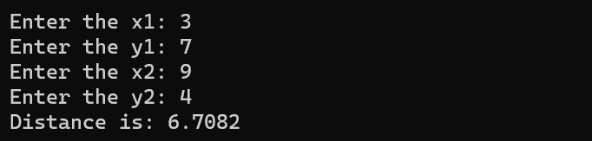

1. **Write a code in C++ to take length from user in centimeter and convert it into meter and kilometer.**

**Code:**

#include<iostream>

#include<math.h>

using namespace std;

int main()

{

float len_in_cm, len_in_m, len_in_km ;

cout << "Enter the length in centimeter: ";

cin >> len_in_cm;

len_in_m = len_in_cm / 100;

len_in_km = len_in_cm / 100000;

cout << "length in meter: " << len_in_m;

cout << "\nlength in kilometer: " << len_in_km;

cout << endl;

return 0;

}

**Output:**

1. **Write a code in C++ to enter P, T, R and calculate Simple Interest.**

**Code:**

#include<iostream>

#include<math.h>

using namespace std;

int main()

{

int P, T;

float R, I;

cout << "Enter the Principal Amount(in $): ";

cin >> P;

cout << "\nEnter the Interest Rate(in percentage): ";

cin >> R;

cout << "\nEnter the Time(in year): ";

cin >> T;

I = P * ( R / 100) * T;

cout << "\nSimple Interest Amount is: " << I;

cout << endl;

return 0;

}

**Output:**

1. **Write a program in C++ to convert temperature in Fahrenheit to Celsius.**

**Code:**

#include<iostream>

#include<math.h>

using namespace std;

int main()

{

float F, C;

cout << "Enter the Temperature(in Farenheit): ";

cin >> F;

C = (F - 32.0) * (5.0 / 9.0);

cout << "\nTemperature(in Celsius): " << C;

cout << endl;

return 0;

}

**Output:**

