**LAB:NO:07**

**Object: TO UNDERSTAND MULTITHREADING.**

* **Write the same code for matrix multiplication and divide the code into ten threads. Also note the timestamp at the start and end of the program. Give your conclusion.**

**Matrix Multiplication using Traditional Method:**

**import java.lang.*;**

**public class MatrixMultiplication{**

**public static void main(String args[]){**

**System.out.print("Current Time in milliseconds =");**

**System.out.println(System.currentTimeMillis());**

**double time1=System.currentTimeMillis();**

**int a[][]={{1,2,3},{4,6,7},{8,9,10}};**

**int b[][]={{1,2,3},{4,6,7},{8,9,10}};**

**int c[][]=new int[3][3];**

**for(int i=0;i<3;i++){**

**for(int j=0;j<3;j++){**

**c[i][j]=0;**

**for(int k=0;k<3;k++){**

**c[i][j]+=a[i][k]*b[k][j];**

**}**

**System.out.print(c[i][j]+" ");**

**}**

**System.out.println();**

**}**

**double time2=System.currentTimeMillis();**

**double totalTime=time2-time1;**

**System.out.println("totalTime"+totalTime);**

**}}**

**Output:**

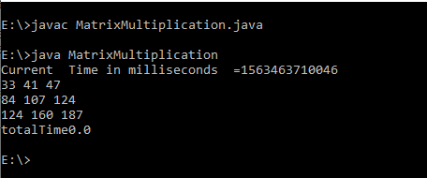

**Matrix Multiplication using Thread:**

**public class ParenThreadt{**

**public static final int NUM_OF_THREADS = 9;**

**public static void main(String args[]){**

**int row;**

**int col;**

**int A[][] = {{1,2,3},{5,5,6},{8,7,8}};**

**int B[][]= {{1,2,3},{5,5,6},{8,7,8}};**

**int C[][] = new int[3][3];**

**int threadcount = 0;**

**System.out.print("Current Time in milliseconds =");**

**System.out.println(System.currentTimeMillis());**

**double time1=System.currentTimeMillis();**

**Thread[] thrd = new Thread[NUM_OF_THREADS];**

**try{**

**for (row = 0 ; row < 3; row++){**

**for (col = 0 ; col < 3; col++ )**

**{**

**thrd[threadcount] = new Thread(new WorkerTh(row, col, A, B, C));**

**thrd[threadcount].start();**

**thrd[threadcount].join();**

**threadcount++;**

**}}}**

**catch (InterruptedException ie){}**

**System.out.println("A Matrix :");**

**for (row = 0 ; row < 3; row++){**

**for (col = 0 ; col < 2; col++ ){**

**System.out.print(" "+A[row][col]);**

**}**

**System.out.println();**

**}**

**System.out.println(" B Matrix :");**

**for (row = 0 ; row < 2; row++){**

**for (col = 0 ; col < 3; col++ ){**

**System. out . print ( " "+B [row] [col]) ;**

**}**

**System.out.println();**

**}**

**System.out.println(" Resulting C Matrix :");**

**for (row = 0 ; row < 3; row++){**

**for (col = 0 ; col < 3; col++){**

**System.out.print(" "+C[row][col]);**

**}**

**System.out.println();**

**}**

**double time2=System.currentTimeMillis();**

**double totalTime=time2-time1;**

**System.out.println("totalTimen+totalTime");**

**}**

**}**

**class WorkerTh implements Runnable**

**{**

**private int row;**

**private int col;**

**private int A[][];**

**private int B[][];**

**private int C[][];**

**public WorkerTh(int row, int col, int A[][], int B[][], int C[][] )**

**{**

**this.row = row;**

**this.col = col;**

**this.A = A;**

**this.B = B;**

**this.C = C;**

**}**

**@Override**

**public void run()**

**{**

**for(int k = 0; k < B.length; k++)**

**{**

**C[row][col] += A[row][k] * B[k][col];**

**}**

**}**

**}**

**Output:**

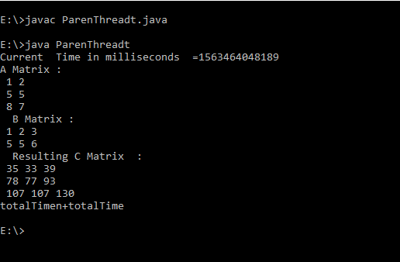

**Conclusion: time taken to calculate the matrix multiplication using threads is more than the traditional one.**