Software Requirements Specification (SRS)

**Project Title: SafeTails**

Course: CSE470 - Software Engineering (BRACU)

**Author: Ahsan Habib**

**Email: ahsan.habib1@g.bracu.ac.bd**

**ID: 22201027**

Date: 04 August, 2025

Semester: Summer 25

Section: 14

**Document Version: Sprint 1**

# 1. Introduction

## 1.1 Purpose

This Software Requirements Specification (SRS) outlines the complete functional and non-functional requirements for SafeTails — a full-stack web application designed to assist in pet welfare through lost pet recovery, adoption, fostering, and emergency services using geolocation and community-driven efforts.

## 1.2 Scope

SafeTails will allow users to:  
- Report and locate lost, abandoned, or injured pets.  
- Submit pet adoption and foster requests.  
- View and interact with location-based emergency vet contact directories.  
- Receive geo-alerts and filter posts by pet type, location, and need.  
- Access a moderation-enabled community space overseen by an admin panel.

## 1.3 Definitions, Acronyms, and Abbreviations

- MVC: Model View Controller  
- NGO: Non-Governmental Organization  
- Leaflet.js: JavaScript library for interactive maps  
- OSM: OpenStreetMap

- JWT: JSON Web Token.

- UI: User Interface.

- API: Application Programming Interface.

## 1.4 References

<https://petcolove.org/lost/>   
<https://www.pawboost.com/>   
<https://pet911.co.uk/>   
<https://findpet.com/>   
<https://leafletjs.com/>

<https://resend.com/>

## 1.5 Overview

This document outlines the product’s overall features, user roles, system architecture, development timeline, and success metrics. Sections 2–7 continue in the full version with all technical details, features, architecture, and development plan as previously written.

# 2. Overall Description

## 2.1 Product Perspective

SafeTails is a standalone system based on the MERN-like architecture using:  
- Frontend: Next.js, TypeScript,Tailwind CSS, Leaflet.js  
- Backend: Express.js, MongoDB, Axios, Node.js  
- Geolocation: Leaflet + OSM

- Email Service : Resend Api + Local server ( OTP Verification )

Optional integrations include Firebase for media hosting and push notifications.

## 2.2 Product Features

1. User Profile registration / Deletion (Creating a Profile, Deleting a profile)
2. UI dynamically changing based on Guest user or Logged in user or a Vet.
3. Profile management (Editing / Updating Profile)
4. Create and manage posts (lost, adoption, foster, etc.)
5. Upload Multiple photos for posts
6. Map integration for pet location pinning (Leaflet.js + OpenStreetMap)
7. Emergency vet contact directory in nearby areas (searchable and clickable)
8. Search & filtering (by type, location, pet category)
9. Geolocation-based alert system
10. Temporary foster request and response feature
11. Post reporting and moderation tools
12. Admin dashboard for reviewing and flagging inappropriate content
13. Sending Email to Registered user for OTP verification

## 2.3 User Classes and Characteristics

- Guest: Can browse public pet posts including pet’s last known location and picture  
- Registered User: Can create/manage posts, Find vets, request fosters, Request for veteran consultant and receive alerts  
- Veterinarian: Can provide emergency contact info and assist in verification, Can manage and respond to vet requests.  
- Admin: Manages reports, user (Pet owner, Vet ) accounts, and platform moderation

## 2.4 Operating Environment

Frontend: Modern browsers  
Backend: Node.js + Express on cloud  
Database: MongoDB  
Map Service: Leaflet + OpenStreetMap  
Mobile Compatibility: Android/iOS browsers -

## 2.5 Constraints

• Must be operational within 8–10 weeks  
• Use free APIs/services (Leaflet, OSM, Resend)  
• Open-source or educational licenses only  
• Limited cloud deployment resources

## 2.6 Assumptions and Dependencies

• Users allow location access  
• Emergency vet info is verified  
• Community posts are moderated  
• Image hosting may rely on Firebase

# 3. System Requirements

## 3.1 Functional Requirements

• FR-1: User registration, login  
• FR-2: Role-based dashboards  
• FR-3: Sending Email With OTP verification   
• FR-4: Post management with image uploads  
• FR-5: Location tagging  
• FR-6: Post search/filter  
• FR-7: Foster request features  
• FR-8: Emergency vet contact directory  
• FR-9: Admin DashBoard Moderation (Reporting and moderation tools)

• FR-10: Vet Dashboard Moderation ( Block user, List all users )

• FR-11: Send / Receive Notifications based on Geo-location

• FR-12: Profile management (Edit / Update) Own profile.

## 3.2 Non-Functional Requirements

• NFR-1: Login with OTP verification with JWT authentication

• NFR-1: Page load < 2s  
• NFR-2: Map render < 1.5s  
• NFR-3: HTTPS only  
• NFR-4: Token-based auth  
• NFR-5: ≥99.5% uptime  
• NFR-6: Daily backups  
• NFR-7: Modular MVC code  
• NFR-8: Search and filter optimization

## 3.3 External Interface Requirements

• UI-1: Responsive UI for all devices  
• UI-2: Role-specific dashboards  
• HI-1: Standard server/cloud  
• SI-1: OSM API  
• SI-2: Firebase (optional)  
• CI-1: RESTful API (Axios)  
• CI-2: Optional notifications

# 4. Technology Stack & Architectural Overview

## 4.1 Stack

Frontend: Next.js, Tailwind CSS, TypeScript  
Backend: Express.js, MongoDB  
Map: Leaflet.js + OSM

Email Service: Resend + Local server  
Media: Firebase (optional)

## 4.2 Architecture

• Presentation Layer: React components (Next.js)  
• Logic Layer: Express routes/controllers  
• Data Layer: Mongoose models  
• Map Layer: Leaflet integration

# 5. Tentative Agile Development Plan

Sprint 1 (Week 1–2):

1. Environment Setup, User account ( Pet Owner, Vet ) Registration,
2. Sending Users Email for Verification
3. Role based Dashboard ( Pet Owner , Vet dashboard only )
4. New Pet Post creation

Sprint 2 (Week 3–4):

1. Admin Creation, Dashboard Management
2. Profile management (Edit / Update ) - Own user profile.
3. Map pinning With Leaflet and OSM
4. Filter / Search Posts for 4 criteria

Sprint 3 (Week 5–6):

1. Emergency vet contacts
2. Image upload of Pets
3. Admin, Vet Dashboard Management

Sprint 4 (Week 7–8):

1. Geo-location based post alerts / Notifications
2. Final touchup / Debugging Entire Project
3. Build Project for deployment
4. Deploy Project (Optional)

# 6. Acceptance Criteria

• Posts with location and images function correctly  
• Foster requests are stored and processed  
• Admin can moderate content  
• System meets uptime and security standards

# 7. Conclusion

SafeTails is a scalable, secure, and community-centric platform for pet welfare. It combines geolocation, role-based features, and moderation tools to address critical needs around pet safety and rescue.

**Sprint - 1**

**Feature 1: Environment setup and Role based Dashboard (Pet Owner, Admin dashboard and Vet Dashboard)**

**1.1 (Using npm and npx - Used** [**Next.js**](http://next.js) **and TypeScript For Frontend, .env file to store database and API keys) Using .gitignore to stop them from pushing sensitive info to github, All the Dependencies that i will be using is mentioned here**

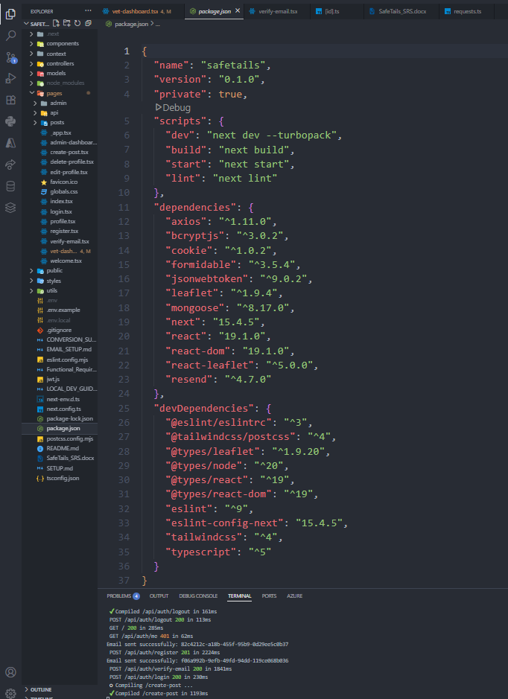

**1.2 User Account registration - PetOwner, Vet Registration:**

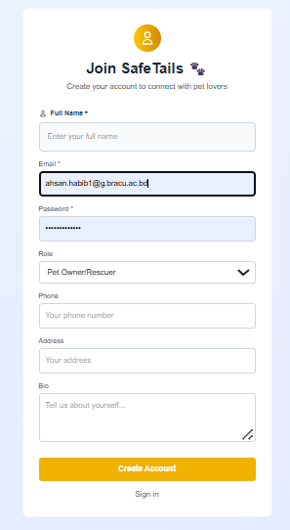

**Feature 2: OTP verification - With 10 minutes Expiry time**

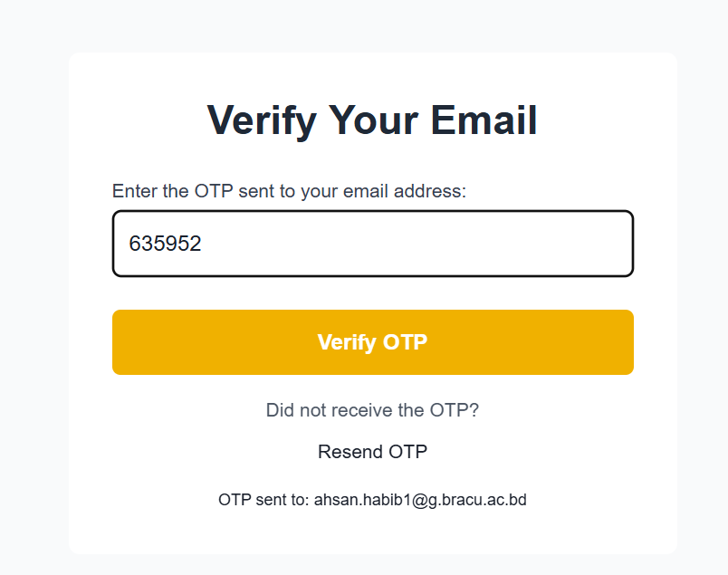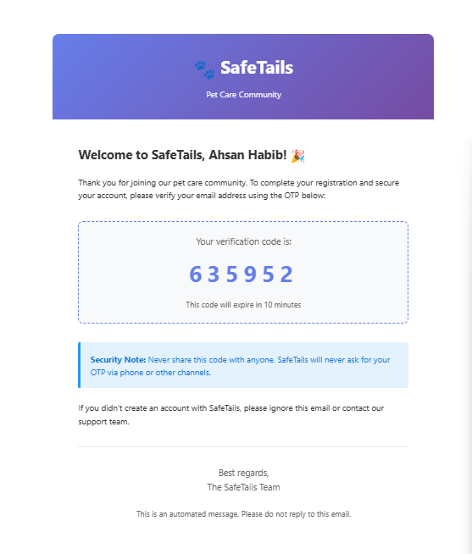

**Feature 03: Dashboard creation For Users ( Pet Owner, Vet Dashboard )**

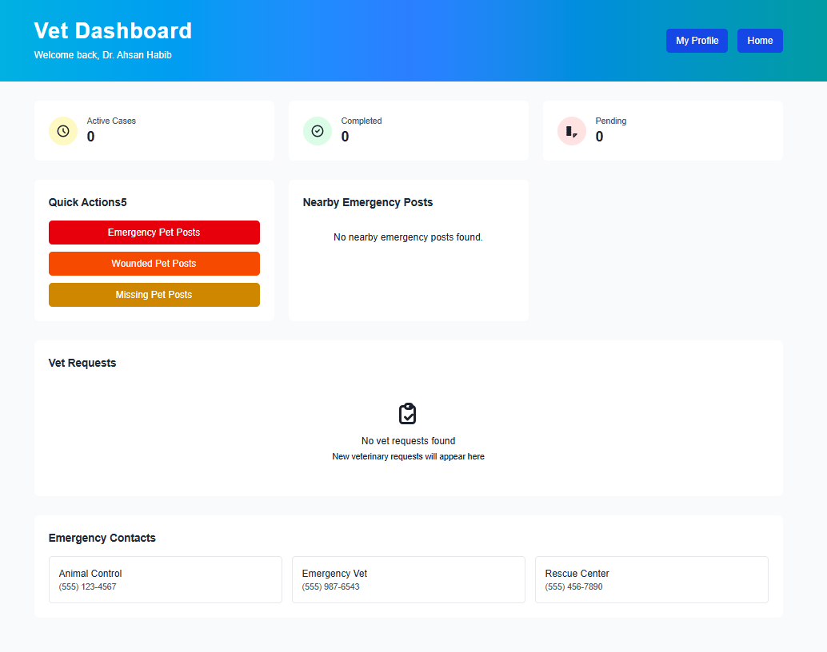

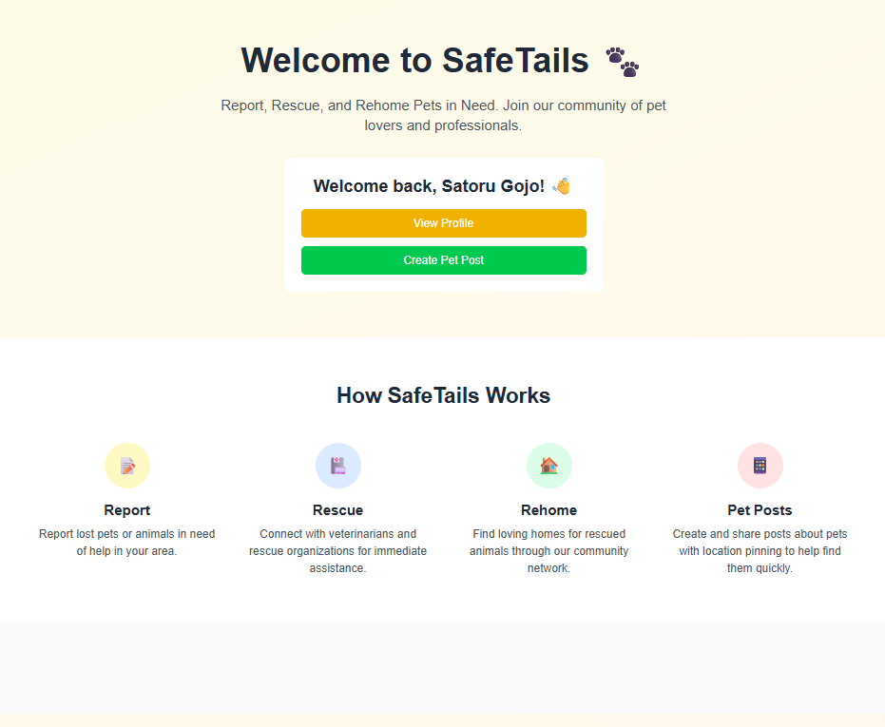

**Feature 04: New Post Creation**

