Network Security Scanner & Firewall Visualizer
Assignment 3 – Project Report
Student Name | Muhammad Ahsan Ashfaq
Roll No | 03-134231-036
GitHub | https://github.com/ahsanc413-rgb/Network-Security-Scanner

1. Introduction
This project is a web-based tool that scans a local network or a single IP address/hostname to find open ports, running services and possible vulnerabilities. It also includes a firewall rule simulator where users define allow/deny rules and see how those rules affect network traffic through a visual flow diagram.

2. Technology Stack
- Frontend: HTML, CSS, JavaScript (SVG for the flow diagram)
- Backend: Python 3 with Flask (REST API)
- Libraries: python-nmap, Scapy, socket (fallback engine), matplotlib (charts), ipaddress

3. System Architecture
Browser UI ⇄ Flask API (app.py) → Scanning Engine (scanner.py) / Firewall Engine (firewall.py)
Endpoint | Function
GET / | Serves the user interface
GET /api/status | Reports which scan engines are available
POST /api/scan | Runs a TCP Connect / TCP SYN / UDP scan and returns parsed results
POST /api/firewall/simulate | Evaluates packets against priority-ordered rules
POST /api/firewall/chart | Returns a matplotlib chart of allowed vs blocked traffic

4. Core Requirements Implementation

4.1 User Interface
- Input field for target IP, hostname or CIDR network (up to /24).
- Drop-down for scan type: TCP SYN, UDP, Full Connect; plus a port range selector (well-known, common, custom).
- Start Scan button and results table showing IP, Port, Protocol, Service, Status and a possible vulnerability note.
- Firewall rule creation section: priority, allow/deny, direction, source IP, destination IP, port(s), protocol.
- Visual flow diagram of traffic: Sources → Firewall rule chain → Destinations (green = allowed, red ✖ = blocked).

4.2 Scanning Engine
The engine first tries Nmap through the python-nmap wrapper (-sT, -sS or -sU with -sV for version detection). If Nmap is not installed, SYN scans use Scapy to send raw SYN packets and read SYN-ACK/RST replies. If raw packets are not possible (no Npcap or no admin rights), it falls back to a multi-threaded socket scanner (200 threads) and tells the user. UDP scanning sends a probe and treats an ICMP port-unreachable as closed, a reply as open, and no reply as open|filtered. Custom port ranges such as 22,80,8000-8100 are supported. Results are parsed into JSON, shown in a table and also as a readable text report. Known risky services (Telnet, FTP, SMB, RDP, Redis, MongoDB, etc.) get a short vulnerability note.

4.3 Firewall Simulation Logic
Each rule has a priority, action (allow/deny), direction, source and destination IP (single IP, CIDR or any), port (single, list, range or any) and protocol. For every packet, rules are sorted by priority (lowest number first) and checked one by one; the first matching rule decides the action (first-match rule chaining, like iptables). If nothing matches, the default policy (implicit deny or allow) is used. The result table shows the full chain checked for every packet, e.g. R1✗ → R2✗ → R3✓, and rules can be re-ordered with ▲/▼ buttons.

5. Screenshots
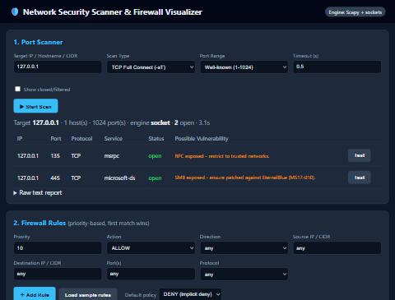
Figure 1: Port scanner with results and vulnerability hints
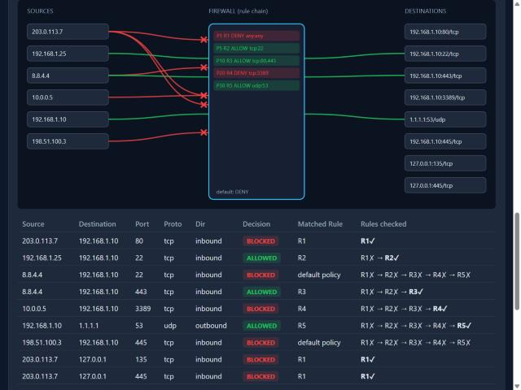
Figure 2: Firewall traffic-flow diagram and decision table
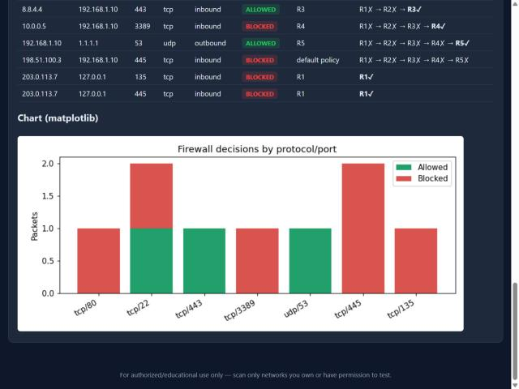
Figure 3: matplotlib chart of allowed vs blocked traffic

6. Sample Test Results
Scan of 127.0.0.1 (ports 1-1024, TCP Full Connect): port 135 (msrpc) and port 445 (microsoft-ds) open, finished in about 3 seconds.
Packet | Decision | Matched Rule | Reason
203.0.113.7 → :80/tcp | BLOCKED | R1 | Source subnet 203.0.113.0/24 denied (priority 1)
192.168.1.25 → :22/tcp | ALLOWED | R2 | SSH allowed from LAN
8.8.4.4 → :22/tcp | BLOCKED | Default | No rule matched, implicit deny
8.8.4.4 → :443/tcp | ALLOWED | R3 | Web ports 80,443 allowed
10.0.0.5 → :3389/tcp | BLOCKED | R4 | RDP denied
192.168.1.10 → 1.1.1.1:53/udp | ALLOWED | R5 | Outbound DNS allowed

7. How to Run
- pip install -r requirements.txt
- python app.py (or double-click run.bat)
- Open http://127.0.0.1:5000 in a browser
- Optional: install Nmap for the Nmap engine; Npcap + Administrator rights for real SYN scans.

8. Conclusion
The tool meets all core requirements: a usable interface for scanning and rule creation, a scanning engine that supports TCP, UDP and custom port ranges with readable output, and a priority-based firewall simulator with a clear visualization of blocked and allowed traffic. It is intended for educational use and for scanning only networks the user owns or is allowed to test.

