
COMSATS University Islamabad (CUI
Project Proposal
for
Sendox AI Multi-Channel Marketing Platform for E-commerce Brands
Version 1.0
By

Ahsan Ali CIIT/FA23-BCS-012/ISB
Amaima Salim CIIT/FA23-BCS-015/ISB

Supervisor
Ma’am Sajida Kalsoom

Bachelor of Science in Computer Science (2023-2027)
Table of Contents
Abstract 1
1. Introduction 1
2. Problem Statement 1
3. Problem Solution/Objectives 2
3.1 Objectives 2
4. Related System Analysis/Literature Review 3
5. Vision Statement 3
6. Scope 4
7. Modules 4
7.1 User Authentication & Workspace Management 4
7.2 Subscription Billing & Plan Management 5
7.3 Shopify Connection & Data Synchronization 5
7.4 Webhook Events Processing 6
7.5 Contact Database & Behavioral Event Store 6
7.6 Brand Onboarding & Context Extraction 6
7.7 Brand Knowledge Vectorization & Storage Engine (Vector Database) 7
7.8 RAG Retrieval & Prompt Assembly Pipeline 7
7.9 Strategy Agent (AI Campaign Planner) 8
7.10 Copywriting Agent (AI Email Content Generator) 8
7.11 Design Agent & MJML Email Renderer 8
7.12 AI Content Validation & Approval Layer 9
7.13 Campaign Engine (Email, SMS & WhatsApp) 9
7.14 Flow Engine (Multi-Channel) 10
7.15 Signup Forms & Subscriber Growth 10
7.16 Domain Authentication & Email Send Pipeline 10
7.17 Engagement & Performance Tracking Infrastructure 11
7.18 Bounce, Complaint & Unsubscribe Handling 11
7.19 Optimization Agent & Closed-Loop Learning 12
7.20 Predictive Customer Intelligence Engine 12
7.21 Conversational AI Marketing Copilot 12
7.22 Analytics & Performance Insights Dashboard 13
7.23 SMS Channel Infrastructure 13
7.24 WhatsApp Business Channel 13
7.25 Cross-Channel Orchestration & Consent 13
8. System Limitations/Constraints 13
9. Data Gathering Approach 14
10. Project Contribution 14
11. Relevance to Course Modules 14
12. Tools and Technologies 16
13. Project Stakeholders and Roles 19
14. Module based Work Division 19
15. WBS 23
16. Gantt Chart 24
17. Mockups 25
18. References 30
19. Plagiarism Report 31

Project Category:
- Web Application
- Problem Solving & AI
- Image Processing

Abstract
E-commerce brands spend thousands of dollars monthly on email marketing tools like Klaviyo and Mailchimp, yet still require expert human marketers to manually craft copy, design templates, build automation flows, and analyze performance. Current email marketing platforms were designed in the pre-AI era around the assumption that humans operate every feature, resulting in steep learning curves and high ongoing time commitments.Growing mid-sized ecommerce brands, in particular, struggle because they lack resources to hire dedicated email marketing professionals. No existing platform offers a truly AI-native solution where AI autonomously handles the entire email marketing lifecycle end-to-end. This project proposes an AI-First Email Marketing Platform that leverages multi-agent LLM architecture and Retrieval-Augmented Generation (RAG) to automatically generate brand-personalized email campaigns, build automation flows, segment audiences, and optimize performance ; all with minimal human intervention. The platform integrates with Shopify, uses Amazon SES for email delivery, and employs a RAG pipeline backed by ChromaDB for brand voice consistency. The system also features a closed-loop optimization cycle where real performance data continuously improves AI-generated content quality. By replacing manual effort with autonomous AI agents with minimal human intervention, the platform enables any e-commerce brand to deploy professional-grade email marketing at a fraction of the combined cost of traditional tools plus human marketers.

Introduction
This document presents the project proposal for an Sendox; a AI-First Email Marketing Platform; a full-stack SaaS application designed to automate and intelligently manage email marketing for e-commerce brands. Email marketing remains one of the highest-ROI digital marketing channels, generating an average of $42 for every $1 spent; however, its effectiveness depends heavily on continuous manual effort from skilled marketers. The dominant tools in this space Klaviyo (valued at $7.8B) and Mailchimp (acquired by Intuit for $12B), were built before the era of large language models and treat AI as a peripheral add-on rather than the core of the product. As a result, brands using these platforms must still manually write every email, design templates, configure automation flows, and interpret analytics reports. This creates a significant gap: the majority of the growing mid-sized merchants either give up on email marketing due to complexity, or cannot afford the $3,000–$8,000/month cost of a dedicated email marketing specialist. This proposed platform addresses that gap by building an AI-native alternative where multiple specialized AI agents i.e Strategy Agent, Copywriting Agent, Design Agent, and Optimization Agent that collaboratively handle the full email marketing workflow. The system integrates with Shopify via official APIs and webhooks, uses Amazon SES for scalable email delivery, and employs a RAG pipeline so each brand's AI understands its unique voice, products, and customer behavior. The platform is architected as a multi-tenant SaaS with a Next.js dashboard, FastAPI backend, PostgreSQL contact/event store, ChromaDB vector database, Celery task queue, and Stripe billing. The FYP will conclude with a functioning platform tested on 3–5 real Shopify brands, generating and sending AI-written emails with measurable engagement and revenue attribution metrics.

Problem Statement
E-commerce brands recognize that email marketing is one of the highest-RIO channels for driving repeat purchases,recovering abandoned carts, and building customer lifetime value; often delivering $36-$42 in revenue per $1 spent.Despite this, the majority of mid-sized brands either execute marketing inconsistently or fail to unlock its full potential, The root cause is the heavy manual effort required by current platforms; crafting on-brand copy, designing templates, building flows, segmenting audiences, and continuously optimizing performance. Effectively running Klaviyo or similar tools typically demands 10-20+ hours per week or hiring a dedicated specialist/agency at cos of $3000-$8000 per month; an expense many growing brands find unsustainable.

Existing platforms like Klaviyo and Mailchimp were built in the pre-AI era and treat AI as simple add-ons (e.g., subject line suggestions), which fail to meaningfully reduce the operational burden. As a result, thousands of Shopify merchants either under-invest in email or manage it poorly, leaving significant revenue on the table. There is currently no truly AI-native platform that lets a brand owner describe their business and have AI autonomously handle strategy, content, flows, segmentation, and optimization end-to-end.

This project aims to build the first AI-first email marketing platform; where AI is the core product, not a bolted-on feature.

Problem Solution/Objectives
The proposed platform is a complete AI-first email marketing system built specifically for e-commerce brands. Unlike existing tools that provide infrastructure and leave all thinking to the human, this system inverts the model: AI handles all strategy, copywriting, design, segmentation, and optimization while the brand owner simply reviews and approves. Upon connecting their Shopify store, the brand answers five onboarding questions about their tone, target audience, and brand values. The AI then autonomously scrapes their website and product catalog, builds a brand knowledge base in a vector database, and generates a complete email marketing strategy including automation flows and initial campaigns. The platform sends emails through Amazon SES, tracks engagement via custom pixel and click-tracking infrastructure, and feeds performance data back into the AI for continuous closed-loop optimization. The core AI engine consists of four specialized agents: a Strategy Agent that plans campaigns, a Copywriting Agent that generates brand-voice-consistent email copy using RAG, a Design Agent that renders HTML emails from pre-built responsive layouts, and an Optimization Agent that analyzes performance and refines future emails. Integration with Shopify's REST API and webhook system enables real-time event-driven automation, such as triggering an abandoned cart email within one hour of cart abandonment or a welcome email upon new signup. The technical stack, FastAPI, Next.js, PostgreSQL, ChromaDB, Celery, Redis, and Amazon SES, is selected for production-grade reliability, scalability, and cost efficiency suitable for a real SaaS product.

Objectives
BO-1: Enable any e-commerce brand to have professional email marketing automation running with minimal human intervention, with zero prior marketing expertise required.
BO-2: Reduce the combined cost of email marketing tools and human marketers by at least 60% compared to existing solutions.
BO-3: Achieve engagement at or above industry benchmarks on every channel: 15-25% email open rate, 95%+ SMS delivery rate, and 70%+ WhatsApp read rate, using AI-personalized content and send-time optimization.
BO-4: Automate at least 80% of all marketing decisions including channel selection, content creation, audience segmentation, and campaign scheduling.
BO-5: Demonstrate measurable revenue attribution from AI-generated messages across email, SMS and WhatsApp for 3–5 real Shopify brands during the beta phase.
BO-6: Coordinate messaging across email, SMS and WhatsApp so that the AI selects the channel per touchpoint and no contact exceeds an agreed cross-channel frequency cap.

Related System Analysis/Literature Review
Table 1 Related System Analysis with proposed project solution

Application Name | Weakness | Proposed Project Solution
Klaviyo | Despite strong AI features (Marketing Agent, Composer, generative content, Smart Send Time, and campaign suggestions), it still requires significant human oversight for strategy approval, flow customization, segmentation refinement, and quality control. The platform remains built on a manual-first architecture with a steep learning curve. Expensive as the list grows (~$350/month for 15K contacts). AI capabilities, while advanced, function as an assistive layer rather than a fully autonomous, AI-native system. | Truly AI-native architecture with specialized multi-agent system (Strategy, Copywriting, Design, Optimization) and deep RAG-based brand voice understanding. Delivers higher autonomy, end-to-end automation with minimal oversight, and continuous closed-loop optimization from day one.
Mailchimp | General-purpose email tool not deeply optimized for e-commerce. Shopify integration exists but lacks real-time webhook depth compared to specialized platforms. AI features (Creative Assistant, predictive segments) are helpful but remain assistive rather than autonomous. Complex for advanced automation. | Dedicated real-time Shopify integration with webhook-driven automation. E-commerce-specific flows built automatically by AI. Zero manual setup for core flows.
Omnisend | Strong e-commerce focus with good AI content tools, but still requires manual campaign building, template selection, and flow configuration. Channels are offered as separate add-on tools, each needing its own setup, audience and reporting; there is no single AI deciding which channel a given message should use. Brand voice personalization is limited. | Fully autonomous AI that generates complete campaigns, flows, and content with superior RAG-based brand voice consistency. Simpler email-only focus with deeper personalization.
ActiveCampaign | Powerful automation and CRM capabilities, but overly complex setup requiring marketing expertise. Not purpose-built for pure Shopify e-commerce. AI features (Active Intelligence) are advanced but layered on a traditional platform. | Purpose-built, simple Shopify-first platform with no unnecessary CRM complexity. Multi-agent AI handles strategy, content, segmentation, and optimization end-to-end with minimal expertise required.

Vision Statement

- For growing Shopify e-commerce brands who want professional-grade email marketing results but lack the time or budget to hire expensive specialists or spend hours managing campaigns manually,
Sendox is an AI-native SaaS platform that uses multi-agent AI to understand brand voice, autonomously create personalized campaigns and flows, send, track, and continuously optimize performance ;delivering high-quality results with minimal human input. Unlike traditional platforms like Klaviyo and Mailchimp, where AI is still an assistive layer on top of manual workflows, Our product is built AI-first from the ground up, handling strategy, content, segmentation, and optimization end-to-end while learning from results to improve over time.

Scope
The Sendox AI Multi-Channel Marketing Platform is a multi-tenant SaaS application for Shopify e-commerce brands with 500 to 15,000 contacts who need automated, AI-driven email marketing with minimal human oversight. The platform covers the complete email marketing lifecycle, including brand onboarding, data synchronization with Shopify, AI-driven campaign generation, controlled email delivery, engagement tracking, and continuous optimization. The AI architecture is a multi-agent system of five autonomous agents responsible for strategy, copywriting, design, optimization, and conversational marketing, supported by a predictive intelligence layer and an output validation system that reviews every AI-generated email before send. Email execution is divided into a Campaign Engine for one-time sends and a Flows Engine for behavior-triggered automated sequences such as abandoned cart, welcome series, and post-purchase follow-ups. Analytics, revenue attribution, and continuous A/B optimization close the loop by feeding real-world performance data back into the AI to improve future campaigns. Subscriber acquisition is handled through embeddable signup forms installed on the brand's storefront, and the dashboard provides onboarding, approval workflows, analytics, and a conversational AI copilot. Messaging is delivered across three coordinated channels — email, SMS and WhatsApp — with a cross-channel orchestration layer that holds per-channel consent, lets the AI select the channel for each touchpoint, and enforces a frequency cap across all channels. Out of scope are visual drag-and-drop builders, push notifications and in-app messaging, integrations beyond Shopify, dedicated sending IP management, and formal compliance certifications. The platform will be validated with 3 to 5 real Shopify brands during FYP duration and carried out by two BS Computer Science students, with measurable targets for delivery rate, engagement, revenue attribution, and AI safety.

Modules

User Authentication & Workspace Management
This module is the platform's front door and account control center combined. It handles how users sign up, log in, and secure their accounts, and manages the multi-tenant workspace layer where users can create isolated brand workspaces and invite team members with role-based permissions. Because Sendox supports users running multiple brands and teams collaborating on each, this module ensures every account is secure and every brand's data stays cleanly separated from every other brand's, even when sharing the same database.

FE-1: Secure user registration and email verification flow with password strength validation and time-limited activation tokens sent via Amazon SES.
FE-2: Authenticated login system with JWT-based session management (NextAuth.js, HTTP-only cookies), forgot-password and reset flows, and optional TOTP-based two-factor authentication.
FE-3: Account management interface for users to update their profile, notification preferences, and trigger GDPR-compliant account deletion with full data purge.
FE-4: Workspace creation and switcher allowing each user to create and operate one or more isolated brand workspaces from a single account.
FE-5: Team invitation system with role-based access control (Owner, Admin, Editor, Viewer) and permission enforcement applied at both the API and UI layers.
FE-6: Tenant data isolation enforced at the PostgreSQL row level using tenant_id foreign keys, ensuring no brand's data can be accessed from another workspace.
FE-7: Workspace settings panel for configuring brand name, logo, default sender identity, and timezone, with an audit log of team activity (logins, sends, edits) viewable by owners.

Subscription Billing & Plan Management
Sendox is a paid SaaS product, so it needs a system to charge customers monthly and track how much they are using. This module integrates with Stripe to handle subscription payments, offers tiered pricing plans (e.g., Starter, Growth, Scale), and meters usage in real time so customers can be billed fairly. It is essentially the business-revenue layer of the platform.

FE-1: Stripe Checkout integration for self-serve subscription signup across multiple plan tiers.
FE-2: Tiered pricing plans (Starter, Growth, Scale) based on contact count and monthly email volume.
FE-3: Real-time usage metering ; track contacts stored, emails sent, and AI generations consumed per billing cycle.
FE-4: Soft and hard usage limits with in-app warnings before sending limits cap account activity.
FE-5: Plan upgrade, downgrade, and cancellation flows with prorated billing handled by Stripe.
FE-6: Stripe webhook receiver for subscription events (payment success, payment failure, cancellation).
FE-7: Invoice and billing history page with PDF invoice download.

Shopify Connection & Data Synchronization
Sendox needs continuous access to each user's Shopify store data ; customers, orders, products, and collections ; to power its AI. This module establishes that connection securely using Shopify's official OAuth 2.0 protocol (the same way Google or Facebook ask permission before accessing your data), then runs the full data pipeline that pulls store data in and keeps it continuously updated. It performs the initial bulk import on the first connection (which can be tens of thousands of records) and then runs an automatic background continuous sync after a few intervals. Without this module, the AI would have nothing to work with.

FE-1: Shopify OAuth 2.0 connection wizard with scope management; the guided flow that installs the Sendox app on a Shopify store and requests only the minimum required permissions (read_customers, read_orders, read_products, read_checkouts).
FE-2: Encrypted token storage and lifecycle management using AES-256 with per-tenant keys, including automatic refresh, re-authorization handling, and a clean disconnection flow with optional data retention or full data wipe.
FE-3: Multi-store support allowing a single Sendox workspace to connect and operate across multiple Shopify stores simultaneously.
FE-4: Initial bulk data import of customers, orders, products, and collections from Shopify via REST API, with pagination and leaky-bucket rate-limit handling for stores with tens of thousands of records.
FE-5: Incremental background sync running every 15 minutes via Celery Beat, treating Shopify as the source of truth with conflict resolution that overwrites local data on mismatch.
FE-6: Sync reliability layer covering automatic retry with exponential backoff for transient failures, comprehensive error logging, and a manual full-resync trigger for recovery from sync drift.
FE-7: Connection health dashboard showing live API status, last successful sync timestamp, sync progress with records-processed indicators, and any authentication or sync errors requiring user attention.

Webhook Events Processing
Polling Shopify after continuous intervals is fine for general data updates, but for time-sensitive events like a customer abandoning their cart, we need to know immediately. This module receives real-time webhook notifications from Shopify the moment events happen and processes them in milliseconds. It is what makes flows like 'send abandoned-cart email within one hour' technically possible.

FE-1: Webhook receiver endpoints for Shopify events: orders/create, checkouts/create, customers/create, products/update.
FE-2: HMAC signature verification on every webhook request to prevent spoofing.
FE-3: Idempotency layer using Shopify's X-Shopify-Webhook-Id header to prevent duplicate event processing.
FE-4: Event queueing in Redis with Celery worker consumption for asynchronous processing.
FE-5: Behavioral event store in PostgreSQL ; every event (purchase, cart_abandon, signup) recorded with timestamp and metadata.
FE-6: Webhook retry handling and dead-letter queue for permanently failed events.
FE-7: Webhook health monitoring dashboard showing event throughput and failure rates.

Contact Database & Behavioral Event Store
This module is the heart of the platform's data layer, the central database that stores every customer (contact) and every action they have ever taken (events). Each contact has a complete timeline showing when they signed up, what they bought, which emails they opened, and what they clicked. This timeline is what the AI later uses to write personalized emails that actually feel relevant to each customer.

FE-1: PostgreSQL contact table with email, name, Shopify customer ID, opt-in status, and JSONB property field.
FE-2: Behavioral event timeline per contact ; chronological feed of every action taken (purchases, opens, clicks, page views).
FE-3: Contact tagging system ; manual and automatic tags (e.g., 'VIP', 'first_time_buyer') for segmentation.
FE-4: Manual contact import via CSV upload with field mapping and duplicate detection.
FE-5: Contact export to CSV for backups and migration.
FE-6: Contact list viewer in the dashboard with search, filter, and pagination.
FE-7: Individual contact detail page showing full event history and AI-generated engagement summary.
FE-8: Phone number capture with E.164 normalization, per-channel consent state (email, SMS, WhatsApp) and a preferred-channel field on every contact.

Brand Onboarding & Context Extraction
Before the AI can write emails that match a brand's voice, it needs to understand who the brand actually is; their tone, audience, values, visual identity, and full product story. This module combines two complementary approaches: a guided onboarding wizard where the brand owner answers a few targeted questions and uploads their visual assets, and an automated web crawler that visits the brand's storefront and reads every product page, blog post, and About page to capture the brand's voice in their own words. Together, they produce a rich, multi-source picture of the brand that the AI can later use to write emails that genuinely sound like the brand wrote them.

FE-1: Multi-step guided onboarding flow that activates immediately after Shopify connection, with progress tracking and skip-and-resume capability so users can complete it in stages.
FE-2: Five-question brand intake form covering tone, target audience, brand values, content style, and email goals, paired with brand asset upload for logo, primary colors (color picker), and font preferences.
FE-3: Sitemap.xml discovery and parsing combined with an asynchronous Playwright-based scraper that can handle modern JavaScript-rendered Shopify themes.
FE-4: Content extraction pipeline that parses product pages (title, description, price, metadata) and brand-voice content (About page, FAQ, blog posts) to capture both catalog data and storytelling material.
FE-5: Image and asset downloader that stores logos, hero images, and product imagery to AWS S3 for later use in AI-generated email designs.
FE-6: Polite crawling behavior with full robots.txt compliance and a 1-request-per-second rate limit to avoid disruption to the user's storefront.
FE-7: Brand profile review screen that surfaces the combined results of the wizard answers and the scraped content, letting the user confirm or refine the AI-extracted brand identity before activation, with a re-run option for monthly refreshes.

Brand Knowledge Vectorization & Storage Engine (Vector Database)
Raw scraped text is not useful to an AI on its own, it needs to be converted into a format the AI can search and retrieve from intelligently. This module breaks the scraped content into small chunks, transforms each chunk into a mathematical representation called an embedding, and stores those embeddings in a vector database (ChromaDB). Think of it as building a custom 'brain' for each brand that the AI can later consult when writing emails.

FE-1: Text chunking pipeline that splits scraped content into semantically meaningful chunks of ~500 tokens.
FE-2: Embedding generation using OpenAI text-embedding-3-small or open-source alternative for each chunk.
FE-3: ChromaDB vector store population with metadata (source URL, content type, last updated) per embedding.
FE-4: Brand profile JSON schema generation by AI ; structured fields for tone, voice, audience, USPs, and product themes.
FE-5: Knowledge base versioning so prior brand profiles can be restored if a refresh degrades quality.
FE-6: Knowledge base inspector UI letting users see what the AI has 'learned' about their brand.
FE-7: Manual override interface for users to add custom brand context (taglines, do/don't word lists, mission).

RAG Retrieval & Prompt Assembly Pipeline
RAG stands for Retrieval-Augmented Generation, and it is how Sendox makes AI emails sound like they were written by someone who genuinely knows the brand. Whenever the AI is about to write an email, this module first searches the brand's knowledge base for the most relevant pieces of brand context (e.g., past product descriptions, brand values, previous winning emails) and inserts them into the AI's prompt. The result is dramatically higher-quality output without needing to retrain the AI model.

FE-1: Query embedding generation using the same model as the knowledge base for semantic similarity.
FE-2: Top-K semantic search against ChromaDB with configurable K and similarity threshold.
FE-3: Context ranking and re-ranking using a cross-encoder model to surface the most relevant chunks.
FE-4: Prompt template library; modular prompt fragments for subject lines, body copy, and CTAs.
FE-5: Dynamic prompt assembly that inserts retrieved brand context, customer data, and product data into the prompt.
FE-6: Token budget management to ensure assembled prompts stay within Claude API context limits.
FE-7: Prompt logging for every AI generation to enable auditing and prompt iteration.

Strategy Agent (AI Campaign Planner)
Most email tools assume a human marketer will decide what to send and when. The Strategy Agent replaces that human decision-making with AI: it analyzes the brand's products, customers, and seasonality, then proposes a complete content calendar ; which campaigns to run, which audience segments to target, and on which days. The brand owner can approve, edit, or reject the AI's plan before anything is sent.

FE-1: Autonomous flow recommendation; analyzes brand and store data to recommend which automation flows to activate.
FE-2: Campaign calendar generator producing a 4-week content calendar based on brand seasonality and product launches.
FE-3: Audience segment recommendation; identifies high-value segments worth targeting (e.g., 'lapsed VIPs', 'cart abandoners').
FE-4: Send-time strategy planner determining optimal weekday and hour slots based on contact engagement patterns.
FE-5: Goal-based campaign planning; accepts natural-language goals like 'clear winter inventory' and produces a multi-email plan.
FE-6: Strategy approval UI where users review and edit AI-proposed strategies before execution.
FE-7: Strategy explanation panel; every AI decision includes a plain-English rationale citing the data behind it.
FE-8: Channel selection per touchpoint; the agent chooses email, SMS or WhatsApp based on consent, past engagement and message urgency, and explains the choice.

Copywriting Agent (AI Email Content Generator)
This is the module that actually writes the emails. Given a campaign plan from the Strategy Agent and brand context from the RAG pipeline, the Copywriting Agent produces subject lines, preheader text, body copy, and call-to-action buttons; all in the brand's distinct voice. It can produce multiple versions of each email so the user can pick their favorite or run automatic split tests.

FE-1: Subject line generator producing 3–5 brand-voice-consistent variants per campaign.
FE-2: Preview text (preheader) generator complementing the subject line and previewing the body content.
FE-3: Body copy generator producing structured email content: hook, value proposition, social proof, and CTA sections.
FE-4: CTA generator producing action-oriented button copy aligned with the campaign goal.
FE-5: Multi-tone variant output; same campaign generated in alternative tones (urgent, casual, premium) for testing.
FE-6: Personalization token insertion; automatic placement of {first_name}, {last_product_viewed}, etc. with fallbacks.
FE-7: Regenerate-with-feedback function; user provides natural-language feedback ('shorter, more playful') and AI rewrites.
FE-8: Channel-native copy generation: SMS copy within segment limits with shortened links, and WhatsApp template copy with variable placeholders.

Design Agent & MJML Email Renderer
Words alone do not make a beautiful email; the layout, colors, fonts, and product imagery matter just as much. The Design Agent picks the best email layout for the campaign type (announcement, abandoned cart, product showcase, etc.) from a library of pre-built responsive templates, applies the brand's colors and fonts, and inserts the AI-generated copy and Shopify product blocks. The output is mobile-friendly HTML that looks good in Gmail, Outlook, Apple Mail, and every other major email client.

FE-1: Library of 12–15 pre-built responsive MJML email layouts covering common e-commerce email types.
FE-2: AI-driven layout selection based on email purpose (announcement, abandoned cart, product showcase, etc.).
FE-3: Brand styling injection; pulls brand colors, fonts, and logo from the brand profile into the layout.
FE-4: Product block auto-population using Shopify product data (image, title, price, link).
FE-5: MJML-to-HTML compilation pipeline producing inboxes-tested cross-client compatible HTML.
FE-6: Plain-text version auto-generation for accessibility and spam-filter compliance.
FE-7: Live email preview pane in the dashboard with desktop and mobile viewport toggles.
FE-8: WhatsApp template composition (header, body, footer and quick-reply/CTA buttons) alongside MJML email rendering.

AI Content Validation & Approval Layer
AI is powerful but imperfect; it can occasionally make up facts, drift off-brand, or use language that gets flagged as spam. This module is the safety net that checks every piece of AI output before it goes out: it verifies factual claims against real product data, scores how well the content matches the brand voice, flags spam-trigger language, and routes anything questionable to a human approval queue. It is what makes the platform trustworthy enough to operate without constant human supervision.

FE-1: Hallucination detector that cross-references AI-generated product claims against real Shopify product data.
FE-2: Brand voice consistency scorer using semantic similarity against the brand knowledge base.
FE-3: Spam-trigger word and phrase detector flagging language likely to harm deliverability.
FE-4: Profanity, sensitive topic, and compliance filter blocking inappropriate AI output before send.
FE-5: Confidence scoring on every AI generation; low-confidence outputs routed to a human review queue.
FE-6: Approval workflow UI for users to review, edit, or regenerate AI-generated emails before they go out.
FE-7: Auto-approve toggle for trusted flows so users can let high-confidence AI emails send without manual review.
FE-8: Channel-specific compliance checks: SMS character and segment count with mandatory opt-out wording, and WhatsApp template-category policy validation before submission to Meta.

Campaign Engine (Email, SMS & WhatsApp)
While automated flows handle behavior-triggered sequences, brands also need to send one-time campaigns; newsletters, product launches, sale announcements, and seasonal blasts to a chosen audience at a chosen moment. This module is the engine that runs those one-off campaigns: it handles audience selection from the contact database, scheduling, the campaign lifecycle from draft to sent, and the controlled handoff to the email send pipeline. Together with the Email Flows Engine, it forms the platform's complete send orchestration layer ; users access both from a single send center, choosing "campaign" for a one-time blast or "flow" for an ongoing automation, with both paths sharing the same underlying audience, content, and delivery infrastructure.

FE-1: Audience builder with segment selection, dynamic filters (e.g., "VIPs who opened in the last 30 days"), and a live audience size preview before send.
FE-2: Campaign scheduler supporting immediate send, scheduled send at a specific date and time in the recipient's timezone, and recurring campaigns (weekly, monthly).
FE-3: Campaign lifecycle state machine (Draft → Scheduled → Sending → Sent → Analyzing) with safe state transitions and full audit logging of every change.
FE-4: Pre-send validation layer that checks audience size against plan limits, verifies all required content is present, runs the AI safety review, and confirms domain authentication is healthy before the send is allowed to start.
FE-5: Send orchestration that hands the campaign to the SES Send Pipeline in throttled batches, with mid-send progress tracking and pause/resume controls.
FE-6: Per-campaign analytics with the full KPI rollup (sent, delivered, opens, clicks, conversions, revenue) plus segment-level breakdown showing which audience segments responded best.
FE-7: Campaign duplication and template saving so brands can reuse successful campaign structures, pre-fill audiences, and accelerate setup of recurring promotional pushes.
FE-8: Channel selector per campaign with per-channel pre-send validation, audience filtering by channel consent and per-channel cost estimate before send.

Flow Engine (Multi-Channel)
Many of the highest-performing emails in e-commerce are not one-time campaigns but automated sequences that fire based on customer behavior; for example, a 3-email reminder series sent when someone abandons their cart, or a welcome sequence when a new customer signs up. This module is the engine that runs these multi-step automations: it tracks where each contact is in each flow, waits the correct time delays, evaluates conditions, and sends the right email at the right moment.

FE-1: Visual flow viewer showing trigger → delay → condition → send pipeline as a node-based diagram.
FE-2: Pre-built Abandoned Cart Flow; 3-email sequence triggered by checkout webhook (1hr, 24hr, 48hr delays).
FE-3: Pre-built Welcome Series Flow; 3-email sequence on new signup (immediate, 2-day, 4-day delays).
FE-4: Pre-built Post-Purchase Flow; 3-email sequence on order creation (2-day, 14-day, 30-day delays).
FE-5: Flow execution engine with stateful flow runs per contact, persisted in PostgreSQL.
FE-6: Conditional logic engine; branch on contact properties or behavior (e.g., 'opened previous email?').
FE-7: Flow management UI; pause, resume, edit, duplicate, and view per-flow analytics.
FE-8: Multi-channel flow steps with channel branching, wait-for-reply nodes and automatic fallback (for example, SMS follow-up when an email goes unopened for 24 hours).

Signup Forms & Subscriber Growth
Email marketing only works if the brand has people to email, so the platform needs to help brands grow their contact lists. This module provides drag-and-drop signup forms (popups, inline forms, exit-intent slide-ins) that brand owners can install on their Shopify storefront with one line of code. New signups flow directly into Sendox, with optional discount-code rewards to incentivize sign-up.

FE-1: Embeddable JavaScript signup form widget for Shopify storefronts with one-line install.
FE-2: Form designer UI with drag-and-drop fields, brand styling, and live preview.
FE-3: Multi-form-type support; inline, popup, slide-in, and exit-intent triggered.
FE-4: Discount code reward integration; auto-issue Shopify discount on signup completion.
FE-5: Form analytics; impressions, conversion rate, and revenue attributed to each form.
FE-6: A/B testing on form variants (copy, design, fields).
FE-7: GDPR-compliant double-opt-in flow with confirmation email.
FE-8: Phone number capture with separate, explicit consent checkboxes for SMS and WhatsApp, recorded independently from email consent.

Domain Authentication & Email Send Pipeline
This module is the entire email-sending infrastructure of the platform ; everything that happens between "campaign approved" and "email lands in the recipient's inbox." On one side, it handles the cryptographic trust setup that proves to Gmail, Yahoo, and other providers that emails are genuinely coming from the brand and not a scammer (SPF, DKIM, DMARC authentication on the brand's DNS). On the other side, it operates the throttled, queued pipeline that hands those emails to Amazon SES at a safe rate, retries failures, logs every send, and lets the user stop campaigns mid-flight if something goes wrong. Without proper authentication, emails get flagged as spam; without a controlled pipeline, the platform would trip rate limits and damage sender reputation. This module ensures both happen correctly.

FE-1: Domain authentication wizard that walks users through DNS setup with auto-generated SPF, DKIM, and DMARC records tailored to their sending domain, plus SES sender identity verification via Amazon's verification API.
FE-2: Live DNS record validator that checks propagation and confirms successful authentication, with automated re-verification reminders when records change or expire.
FE-3: Custom tracking domain setup (e.g., track.brand.com) for branded click-tracking links and improved deliverability signals.
FE-4: Domain reputation monitoring dashboard surfacing SES reputation metrics and Google Postmaster Tools data so brands can spot deliverability issues early.
FE-5: Celery + Redis send queue with per-tenant rate limiting and a batch orchestrator that splits large campaigns into throttled batches respecting SES sending quotas.
FE-6: Per-message send-time scheduling that dispatches each email at the optimal moment for that recipient, with sandbox-versus-production mode handling and automatic SES limit detection.
FE-7: Send reliability and control layer covering complete send-status logging (queued, sent, delivered, bounced, complained), automatic retry with exponential backoff for transient failures, and user-facing pause and emergency-stop controls to halt campaigns mid-send.

Engagement & Performance Tracking Infrastructure
This module is the platform's eyes and ears on every email that goes out. It captures the full spectrum of engagement signals ; opens, clicks, conversions, and downstream behavior ; that tell us whether emails are actually working. It does this by embedding an invisible 1×1 pixel in every email (which fires when the email is opened), rewriting every link to pass through a tracking redirect (which logs each click), and connecting that data back to revenue events from Shopify (which closes the loop on attribution). It also filters out artificial signals caused by Apple's Mail Privacy Protection and email-prefetch bots so the metrics stay honest. Every event captured here flows into the Optimization Agent and Predictive Intelligence Engine, making this module the foundation of every data-driven decision the platform makes.

FE-1: 1x1 transparent tracking pixel server endpoint logging every email open with IP, user agent, and timestamp.
FE-2: Link rewriting middleware; every URL in outbound emails replaced with a tracking redirect link.
FE-3: Click redirect handler logging the click event and forwarding the user to the original destination.
FE-4: Tracking event database with foreign keys to campaign, contact, and email message records.
FE-5: Cloudflare-fronted tracking domain to ensure low latency and geographic distribution.
FE-6: Bot/prefetch detection (e.g., Apple Mail Privacy Protection) to filter inflated open metrics.
FE-7: Engagement event stream feeding the Optimization Agent and Predictive Intelligence Engine.
FE-8: SMS click tracking through shortened links, and WhatsApp delivery and read receipts ingested from the Cloud API webhook into the same event store.

Bounce, Complaint & Unsubscribe Handling
Not every email reaches its destination; some addresses are invalid (bounces), some recipients mark emails as spam (complaints), and some choose to unsubscribe. Email providers like Gmail will severely punish senders who keep emailing these contacts. This module automatically detects these signals, removes affected contacts from future sends, and ensures legal compliance with anti-spam regulations like CAN-SPAM and GDPR.

FE-1: Amazon SNS webhook receivers for bounce and complaint notifications from SES.
FE-2: Hard-bounce auto-suppression; addresses permanently removed from sending after one hard bounce.
FE-3: Soft-bounce retry logic with progressive backoff before escalating to suppression.
FE-4: Spam complaint handler immediately suppressing any contact who marks an email as spam.
FE-5: One-click unsubscribe header support (RFC 8058) for Gmail and Yahoo deliverability requirements.
FE-6: Branded unsubscribe page with reason capture and resubscribe option.
FE-7: Suppression list viewer and CSV export for compliance audits.
FE-8: STOP, UNSUBSCRIBE and HELP keyword processing for SMS and WhatsApp opt-outs, with per-channel suppression lists and a unified suppression view.

Optimization Agent & Closed-Loop Learning
Most A/B testing in email marketing requires a human to set up two versions, wait a week, and pick a winner. This module replaces that with a continuous, autonomous optimization loop: the AI generates multiple variants of every campaign, sends them in calculated proportions using a statistical technique called Thompson Sampling, automatically routes more traffic to winning variants in real time, and feeds the lessons back into the brand knowledge base so the next campaigns start smarter. This is the closed feedback loop that makes the system genuinely improve over time.
FE-1: Performance metric ingestion; opens, clicks, conversions, and revenue continuously fed into the AI feedback layer.
FE-2: Auto A/B testing; every campaign automatically split-tested across subject line variants.
FE-3: Multi-armed bandit allocator (Thompson Sampling) routing more sends to winning variants in real time.
FE-4: Winning-pattern extractor that analyzes top-performing emails and updates the brand knowledge base with learnings.
FE-5: Per-segment optimization; the agent learns which content patterns work best per audience segment.
FE-6: Continuous prompt tuning; successful prompts are reinforced, underperforming prompts are deprioritized.
FE-7: Optimization insights dashboard showing what the AI has learned and the lift achieved over time.
FE-8: Channel treated as a bandit arm, so Thompson Sampling learns which channel performs best for each segment and message type.

Predictive Customer Intelligence Engine
Beyond writing emails, the AI can also predict customer behavior using machine learning models trained on each brand's order history. This module produces four key predictions per customer: their lifetime value (how much they will spend over time), their churn risk (how likely they are to stop buying), their next-best product (what they are most likely to buy next), and their personal optimal send time. These predictions then feed back into the Strategy and Copywriting Agents to make every campaign sharper.

FE-1: Customer Lifetime Value (CLV) prediction using gradient boosting trained on Shopify order history.
FE-2: Churn risk scoring; probability that a customer will not purchase again within their typical cycle.
FE-3: Next-Best-Product prediction using a hybrid collaborative-filtering and content-based model.
FE-4: Per-contact optimal send-time prediction learned from individual open-time history.
FE-5: Auto-generated predictive segments refreshed weekly (e.g., 'About to Churn', 'Rising VIPs', 'First-Time Buyers').
FE-6: Prediction confidence indicators surfaced in the UI so users understand model certainty.
FE-7: Predictive insights feed pushing high-impact opportunities to the dashboard daily.
FE-8: Best-channel prediction per contact, scoring the likelihood of engagement on email, SMS and WhatsApp.

Conversational AI Marketing Copilot
Rather than navigating menus and forms, the brand owner can simply chat with an AI assistant in plain English; like having a marketing strategist on call. They can ask questions ('why did last week underperform?'), describe goals ('I need to clear winter inventory in two weeks'), or request explanations ('what does this segment mean?'), and the copilot can read the data, draft emails, schedule sends, and modify flows on their behalf. This module turns the platform from a tool into a colleague.

FE-1: Natural-language chat interface where the user can talk to a brand strategist agent.
FE-2: Goal-to-execution translation; user types 'clear 200 winter jackets in 2 weeks' and the agent plans, drafts, and queues a campaign.
FE-3: Performance Q&A; ask 'why did last week's campaign underperform?' and get a data-grounded explanation.
FE-4: Daily AI-generated 'next moves' feed surfaced on the dashboard based on recent performance.
FE-5: Tool-use orchestration; the copilot can read, store data, draft emails, schedule sends, and modify flows on command.
FE-6: Conversation history with searchable past chats for ongoing strategy discussions.
FE-7: Voice-of-customer synthesis; optional Shopify reviews/support integration feeding emotional themes back into copywriting.

Analytics & Performance Insights Dashboard
Every brand owner ultimately wants to know one thing: did email marketing make me money, and how much? This module is the analytics and reporting layer ; real-time dashboards showing opens, clicks, and revenue per campaign, plus a sophisticated attribution model that uses Markov chains to fairly credit revenue across multiple email touchpoints. It also runs automatic holdout-group experiments to measure the true causal lift of email marketing (the revenue that would not have happened without the emails).

FE-1: Real-time campaign analytics; opens, clicks, conversions, and revenue updated live via WebSockets.
FE-2: Per-flow analytics dashboard showing stage-by-stage drop-off and revenue per flow.
FE-3: Multi-touch revenue attribution model assigning fractional credit across email touchpoints (Markov-chain based).
FE-4: Holdout-group causal lift testing; automatic 5–10% control group per campaign to measure true incremental revenue.
FE-5: Per-recipient revenue and engagement scoring viewable on the contact detail page.
FE-6: Weekly AI-generated executive summary in plain English (e.g., 'AI emails generated $12,400 last week, up 23% MoM').
FE-7: Exportable analytics reports (CSV, PDF) for stakeholder reporting.
FE-8: Per-channel performance and cost reporting, plus a cross-channel journey view showing every touchpoint a converting customer received.

SMS Channel Infrastructure
Email is not always the fastest way to reach a customer. A cart abandoned on a phone is often recovered better by a text message than by an email that sits unread. This module is the entire SMS sending layer: registering the brand as a legitimate sender with the mobile networks, storing phone numbers in a valid international format, counting characters so a message is not silently split and billed twice, respecting quiet hours so nobody is woken at 3 a.m., and honouring an opt-out the moment someone replies STOP.

FE-1: SMS provider integration with per-tenant sender configuration and credential isolation.
FE-2: Sender registration workflow (10DLC in the US, alphanumeric sender ID elsewhere) with status tracking inside the dashboard.
FE-3: Phone number validation and E.164 normalization on import, signup and Shopify sync, with per-country formatting rules.
FE-4: Character and segment counter with GSM-7 / UCS-2 detection, warning the sender before a message splits into multiple billable segments.
FE-5: Inbound keyword handler for STOP, START and HELP, writing opt-outs to the suppression list within seconds.
FE-6: Quiet-hours enforcement per contact time zone, holding messages until an allowed sending window.
FE-7: Delivery receipt ingestion and per-message cost metering, with a per-brand monthly SMS spend cap.

WhatsApp Business Channel
WhatsApp is the primary messaging app for customers in much of the world, but it is not an open channel: a business cannot simply message whoever it likes. Every business-initiated message must use a template that Meta has reviewed and approved in advance, and free-form replies are only allowed inside a 24-hour window after the customer writes first. This module handles that entire lifecycle, so the AI can draft a template, submit it for approval, track whether Meta accepted or rejected it, and then send only what the rules allow.

FE-1: WhatsApp Business Cloud API integration with per-tenant phone number registration and webhook verification.
FE-2: Template composer producing header, body, footer and button components from AI-generated copy, with variable placeholders.
FE-3: Template submission to Meta and approval-status tracking (pending, approved, rejected) surfaced in the dashboard with rejection reasons.
FE-4: Customer service window tracker that records the last inbound message per contact and keeps the 24-hour session state.
FE-5: Message router that sends an approved template outside the window and a free-form session message inside it, refusing anything non-compliant.
FE-6: Inbound message webhook capturing customer replies, media and button taps into the behavioural event store.
FE-7: Delivery, read and failure receipt ingestion with per-message cost metering by template category and destination country.

Cross-Channel Orchestration & Consent
Adding two channels creates a problem that neither channel has on its own: the same customer can now be contacted three different ways, and without coordination they get three copies of the same message. This module is the layer that prevents that and is where the real intelligence of a multi-channel system lives. It holds a separate consent record for every channel, lets the AI pick the right channel for each touchpoint, caps how often any one person is contacted across all channels combined, and falls back to a second channel only when the first one goes unanswered.

FE-1: Per-channel consent ledger storing opt-in source, timestamp and proof separately for email, SMS and WhatsApp.
FE-2: Channel preference resolution per contact, combining stated preference, consent state and observed engagement history.
FE-3: AI channel-selection service exposing the decision and its reasoning to the Strategy Agent and the approval queue.
FE-4: Cross-channel frequency capping with a configurable per-brand limit on total messages per contact per week.
FE-5: Fallback and escalation rules, for example an SMS follow-up only when an email has gone unopened for a defined period.
FE-6: Unified suppression so an opt-out, hard bounce or complaint on one channel can be applied across all channels by brand policy.
FE-7: Cross-channel deduplication preventing the same campaign reaching one contact on more than one channel within a defined window.

System Limitations/Constraints

LI-1: The platform integrates exclusively with Shopify during the FYP phase; WooCommerce, BigCommerce, and other e-commerce platforms are out of scope.
LI-2: Email sending relies on Amazon SES shared IP pool; dedicated IP warming and dedicated IP management are not included.
LI-3: Visual drag-and-drop email editor and visual flow builder are not included; all email design is AI-generated from pre-built HTML layouts.
LI-4: The platform supports email, SMS and WhatsApp. Push notifications, in-app messaging and other channels remain out of scope.
LI-5: AI agents depend on the Claude API; API rate limits may constrain concurrent email generation at very high volumes.
LI-6: Platform is validated with up to 50,000 emails per brand per month during beta; higher volumes require SES sending limit increases.
LI-7: WhatsApp business-initiated messages require templates pre-approved by Meta; approval is outside the team’s control, takes time and may be rejected, so new template copy cannot be sent on demand.
LI-8: SMS sender registration (10DLC in the United States, sender ID in other markets) takes several weeks and differs by country; SMS during beta is therefore limited to the markets registered in time.
LI-9: SMS and WhatsApp are billed per message rather than per thousand like email, so beta volume on these two channels is capped per brand and the unit economics differ from the email channel.

Data Gathering Approach
Requirements for this project were gathered through four complementary approaches. First, a competitive analysis of Klaviyo, Mailchimp, Omnisend, and ActiveCampaign was conducted by reviewing their feature sets, pricing, user reviews on G2 and Capterra, and official documentation to identify gaps for an AI-native alternative. Second, informal interviews were held with three Shopify store owners who currently use or have abandoned email marketing platforms, to understand their workflow pain points and desired level of automation. Third, Shopify App Store reviews of competing email marketing apps were analyzed at scale to surface the most recurring complaints and unmet feature requests. Finally, technical documentation for Amazon SES, the Shopify REST API, the Anthropic Claude API, and ChromaDB was reviewed to assess integration feasibility and identify constraints that shaped the system architecture.

Project Contribution
The Sendox Email Marketing Platform introduces the following technical and conceptual contributions that distinguish it from all existing commercial email marketing solutions:
AI-Native Architecture (Novel System Design): Unlike Klaviyo and Mailchimp where AI is bolted on top of a manual-first architecture, this platform is designed from the ground up around AI agents. Every workflow, strategy, copywriting, design, optimization, is AI-first. This represents a fundamental paradigm shift in how email marketing software is architected.
- Multi-Agent LLM Orchestration for Marketing Automation: The system implements a coordinated pipeline of four specialized AI agents (Strategy, Copywriting, Design, Optimization) that collaborate to manage the full email marketing lifecycle. This is a novel application of multi-agent AI architecture to autonomous digital marketing.
- RAG-Based Brand Personalization Without Fine-Tuning: The platform achieves fine-tuning-level brand voice consistency using Retrieval-Augmented Generation (RAG) with ChromaDB. Brand websites, product data, and writing samples are embedded and retrieved at generation time, enabling per-brand personalization at near-zero marginal cost compared to model fine-tuning.
- Closed-Loop Autonomous Optimization: The Optimization Agent creates a feedback loop where real email performance metrics (open rates, click rates, revenue attribution) are fed back into the AI context for subsequent generations, enabling continuous self-improvement without human intervention.
- Event-Driven E-commerce AI Automation: The system responds in real-time to Shopify webhook events (cart abandonment, purchases, new signups) to trigger AI-generated personalized emails at precisely the right moment, combining event-driven architecture with generative AI in a novel way for e-commerce marketing.
- Empirical AI vs. Human Content Evaluation: The project will produce a measurable comparison of AI-generated email marketing performance (open rates, click rates, revenue) against industry benchmarks, providing a research contribution to the emerging field of AI-generated marketing content evaluation.

Relevance to Course Modules
Software Engineering: Applied full SDLC phases; requirements analysis, architectural design (component diagrams, database schema), agile sprint planning, unit/integration testing, and technical documentation.
Artificial Intelligence / Machine Learning: Multi-agent LLM system design, prompt engineering, RAG pipeline implementation with ChromaDB, and quantitative evaluation of AI-generated marketing content.
- Database Systems: Relational database design (PostgreSQL) for multi-tenant contact/event storage with JSONB for flexible properties; vector database (ChromaDB) for semantic search and brand knowledge retrieval.
- Web Technologies: Full-stack web development; Next.js 14 + React for the frontend dashboard and FastAPI (Python) for the RESTful backend API including webhook endpoint handling.
- Computer Networks / Distributed Systems: Amazon SES email delivery infrastructure, distributed task queue (Celery + Redis), Shopify webhook integration, Cloudflare CDN, and DNS management (SPF/DKIM/DMARC).
- Cybersecurity: Multi-tenant data isolation, OAuth 2.0 authentication (Shopify OAuth, NextAuth.js), API key management, GDPR/CAN-SPAM legal compliance, and encryption of customer PII data.
- Artificial Intelligence / Machine Learning : After collecting the brand/business data, the AI agent will train to create the best strategy, text, design for the emails.

Tools and Technologies

Table 2: Tools and Technologies for Proposed Project

Tools And Technologies | Tools | Version | Rationale
Frontend | Next.js + React | 14.x | Dashboard UI, onboarding wizard, campaign approval screens
Frontend | Tailwind CSS + shadcn/ui | Latest | Responsive component library and styling
Frontend | Recharts | 2.x | Analytics charts and data visualization
Backend API | Python FastAPI | 0.110+ | REST API endpoints, Shopify webhook handlers
Background Jobs | Celery | 5.x | Async email send queue and AI processing jobs
Message Broker | Redis | 7.x | Celery broker, cron scheduler, caching
Primary DB | PostgreSQL | 16 | Contacts, campaigns, flows, events, analytics
Vector DB | ChromaDB (self-hosted) | 0.5+ | Brand voice embeddings, RAG retrieval pipeline
LLM / AI | Claude API (Anthropic) | claude-sonnet-4-6 | All AI agents: strategy, copywriting, optimization
Email Sending | Amazon SES | v2 | SMTP delivery, bounce/complaint SNS webhooks
SMS Sending | AWS End User Messaging SMS | Latest | SMS delivery, sender registration, delivery receipts
WhatsApp | WhatsApp Business Cloud API | v21.0+ | Template messages, session replies, delivery and read receipts
Phone Numbers | libphonenumber | Latest | E.164 validation and normalization, per-country formatting
Link Shortening | Self-hosted shortener on tracking domain | Latest | Short trackable links for SMS where characters are billed
File Storage | AWS S3 | Latest | Email image assets, brand logos
Authentication | NextAuth.js | 4.x | User auth, Shopify OAuth 2.0 integration
Payments | Stripe | Latest | SaaS subscription billing and plan management
Hosting | Railway / AWS EC2+RDS | Latest | Application server and managed database hosting
CDN / DNS | Cloudflare | Latest | Tracking domain, click/open pixel CDN
Containers | Docker + Docker Compose | 25.x | Dev/production environment consistency
CI/CD | GitHub Actions | Latest | Automated testing and deployment pipeline
Monitoring | Sentry | Latest | Error tracking and performance monitoring
E-commerce API | Shopify REST API + Webhooks | 2024-01 | Product, order, customer data sync and event triggers
Email Framework | MJML | 4.x | Responsive HTML email template authoring

Project Stakeholders and Roles

Table 3 Project Stakeholders for Proposed Project

Project Sponsor | COMSATS University Islamabad ; Department of Computer Science. The project is developed as a Final Year Project under academic supervision. Real ecommerce brand owners who participate in the beta phase serve as client-side sponsors.
Stakeholder | Students (Ahsan Ali, Amaima Salim): Developers and primary project owners responsible for full system design, implementation, testing, and deployment.  FYP Supervisor (Ma’m Sajida Kalsoom): Academic guide responsible for reviewing progress, providing technical and research guidance, and evaluating deliverables.  Shopify Brand Owners (Beta Users): E-commerce merchants who test the platform, provide real-world validation, and give feedback on AI-generated email quality.  Email Recipients (End Customers): Customers of Shopify brands who receive AI-generated marketing emails; their engagement metrics (opens, clicks, purchases) are the ultimate measure of success.  COMSATS University: Institutional stakeholder evaluating academic output, originality, and technical depth of the FYP.

Module based Work Division
Table 4 Team Member Work Division for Proposed Project

Student Name | Student Registration Number | Responsibility/Module/ Feature
Ahsan Ali | CIIT/FA23-BCS-012/ISB | Module 1 : User Authentication & Account Management: NextAuth.js implementation, registration, login, 2FA, password reset, profile management, multi-Tenant Workspace & Team Management: Workspace isolation, team invitations, role-based access control, audit logs.  Module 2 : Subscription Billing & Plan Management: Stripe integration, plan tiers, usage metering, webhook handling, invoicing.  Module 3 : Shopify OAuth & Store Connection: OAuth 2.0 flow, scope management, encrypted token storage, multi-store support, Shopify Data Sync Pipeline: Initial bulk import, incremental Celery sync scheduler, rate-limit handling, conflict resolution.  Module 4 : Real-Time Webhook Event Processing: Webhook receivers, HMAC verification, idempotency, Redis event queue, retry logic.Module 5 : Contact Database & Behavioral Event Store: PostgreSQL schema design.Module 8 : RAG Retrieval & Prompt Assembly Pipeline: Query embedding generation, semantic search against ChromaDB, cross-encoder re-ranking, prompt template library, dynamic prompt assembly, token budget management.Module 11 : Design Agent & MJML Email Renderer: 12–15 responsive MJML layouts, AI-driven layout selection, brand styling injection, product block auto-population, plain-text generation, cross-client preview pane.  Module 16 : Domain Verification & Email Authentication: SPF/DKIM/DMARC wizard, DNS validator, SES verification, custom tracking domains, Amazon SES Send Pipeline & Queue Management: Celery + Redis send queue, batch orchestration, retry logic, send controls.  Module 17 : Engagement & Performance Tracking Infrastructure: Tracking pixel server, link rewriting, click redirect handler, Cloudflare CDN, bot/MPP filtering, KPI computation layer.  Module 19 : Optimization Agent & Closed-Loop Learning: Performance metric ingestion, auto A/B testing  Module 20: Optimal send-time prediction, predictive segments  Module 21: Prompt Engineering: Prompt design, output validation, quality evaluation framework for AI-generated emails  Module 22 : Analytics & Performance Insights Dashboard: Real-time analytics,,, per-flow funnel analysis, executive summary generator.Frontend Dashboard: All Next.js UI screens, onboarding wizard, flow manager, campaign approval, contact viewer, analytics, billing pages.Infrastructure: Docker, GitHub Actions CI/CD, Railway/AWS deployment, monitoring (Sentry), production hardening.  Module 23 : SMS Channel Infrastructure: Provider integration, sender/10DLC registration workflow, E.164 normalization, segment counting, STOP/START/HELP keyword handling, quiet hours, delivery receipts and cost metering.  Module 25 : Cross-Channel Orchestration & Consent (shared): Frequency capping, fallback and escalation rules, unified suppression, cross-channel deduplication.
Amaima Salim | CIIT/FA23-BCS-015/ISB | Module 5: event timeline, tagging system, CSV import/export. Module 6: Brand Onboarding & Context Extraction: Multi-step intake form, brand asset upload, website detection, progress tracker, sitemap discovery, Playwright scraper, product/blog parsers, S3 asset storage.  Module 7: Brand Knowledge Vectorization & Storage Engine (Vector Database): Text chunking, embedding generation, ChromaDB population, brand profile JSON schema, knowledge base versioning.  Module 9: Strategy Agent (AI Campaign Planner): Flow recommendation, campaign calendar generator, segment recommendation, send-time strategy, goal-based planning, strategy explanation panel.  Module 10: Copywriting Agent (AI Email Content Generator): Subject line, preview text, body copy, and CTA generation, multi-tone variants, personalization tokens, regenerate-with-feedback.  Module 12 : AI Content Validation & Approval Layer: Hallucination detector, brand voice scorer, spam detector, confidence scoring, approval workflow, auto-approve toggle.  Module 13 : Email Campaigns Engine: Audience builder with segment selection, campaign scheduler, lifecycle state machine, pre-send validation, send orchestration, per-campaign analytics, template duplication.  Module 14 : Email Flows Engine: Stateful flow execution engine, pre-built flows (abandoned cart, welcome series, post-purchase), conditional logic, time-delay scheduling, flow management UI.  Module 15 : Embeddable Signup Forms & List Growth: JS widget for Shopify storefronts, drag-and-drop form designer, multi-form-type support (popup, inline, exit-intent), discount integration, A/B testing, double opt-in flow.  Module 18 : Bounce, Complaint & Unsubscribe Handling: SNS webhook receivers, hard-bounce auto-suppression, RFC 8058 one-click unsubscribe, branded unsubscribe page, GDPR compliance.  Module 19 : Multi-armed bandit (Thompson Sampling), winning-pattern extractor, continuous prompt tuning.  Module 20 : Predictive Customer Intelligence Engine: CLV prediction (XGBoost), churn risk scoring, next-best-product  Module 21 : Conversational AI Marketing Copilot: Chat interface, goal-to-execution agent, performance Q&A, daily insights feed, tool-use orchestration.  Module 22: multi-touch Markov-chain attribution, holdout-group causal lift testing.  Module 24 : WhatsApp Business Channel: Cloud API integration, template composer, Meta approval tracking, 24-hour customer service window logic, message routing, inbound webhook, receipt ingestion.  Module 25 : Cross-Channel Orchestration & Consent (shared): Per-channel consent ledger, channel preference resolution, AI channel-selection service.  Research & Documentation: Academic literature review, FYP report writing, research paper drafting on multi-agent LLM systems and RAG-based personalization.  Backend Support: FastAPI endpoint implementation for AI routes, PostgreSQL schema for AI data models, ML model training pipelines.

WBS
ID | Task | Duration | Resources
1 | Project Initiation & Requirements | 15 d | Ahsan; Amaima
2 | Competitive analysis (Klaviyo, Mailchimp, Omnisend) | 4 d | Ahsan; Amaima
3 | Stakeholder interviews with Shopify brand owners | 3 d | Amaima
4 | Functional & non-functional requirements documentation | 4 d | Ahsan; Amaima
5 | Technical feasibility & API research | 3 d | Ahsan
6 | Requirements Phase Finished | 1 d
7 | System Design & Architecture | 12 d | Ahsan; Amaima
8 | High-level system architecture design | 3 d | Ahsan
9 | PostgreSQL database schema design | 3 d | Ahsan
10 | AI agent architecture & prompt design | 4 d | Amaima
11 | UI wireframes & dashboard mockups | 4 d | Ahsan
12 | Infrastructure & deployment design | 2 d | Ahsan
13 | Design Phase Finished | 1 d
14 | Foundation & Data Layer | 91 d | Ahsan, Amaima
15 | M1 — User Auth, Account & Workspace Management | 20 d | Ahsan
16 | M2 — Subscription Billing & Plan Management | 15 d | Ahsan
17 | M3 — Shopify OAuth, Connection & Data Sync | 25 d | Ahsan
18 | M4 — Real-Time Webhook Event Processing | 15 d | Ahsan
19 | M5 — Contact & Behavioral Event Database | 15 d | Ahsan, Amaima
20 | Foundation Layer Finished | 1 d
21 | Brand Intelligence Layer | 61 d | Amaima
22 | M6 — Brand Onboarding & Website Content Extraction | 20 d | Amaima
23 | M7 — Brand Knowledge Vectorization & Storage | 20 d | Amaima
24 | M8 — RAG Retrieval & Prompt Assembly Pipeline | 20 d | Ahsan
25 | Brand Intelligence Layer Finished | 1 d
26 | AI Generation Layer | 86 d | Amaima; Ahsan
27 | M9 — Strategy Agent (AI Campaign Planner) | 20 d | Amaima
28 | M10 — Copywriting Agent (Email Content Generator) | 25 d | Amaima
29 | M11 — Design Agent & MJML Email Renderer | 20 d | Ahsan
30 | M12 — AI Content Validation & Approval Layer | 20 d | Amaima
31 | AI Generation Layer Finished | 1 d
32 | Email Delivery Infrastructure | 56 d | Ahsan; Amaima
33 | M16 — Domain Authentication & SES Send Pipeline | 20 d | Ahsan
34 | M17 — Email Engagement & Performance Tracking | 20 d | Ahsan
35 | M18 — Bounce, Complaint & Unsubscribe Handling | 15 d | Amaima
36 | Delivery Infrastructure Finished | 1 d
37 | Send Orchestration & Growth | 56 d | Amaima; Ahsan
38 | M13 — Email Campaigns Engine | 20 d | Amaima
39 | M14 — Email Flows Engine | 20 d | Amaima
40 | M15 — Embeddable Signup Forms & List Growth | 15 d | Ahsan
41 | Send Orchestration Finished | 1 d
42 | Intelligence & Optimization Layer | 91 d | Amaima; Ahsan
43 | M19 — Optimization Agent & Closed-Loop Learning | 25 d | Amaima, Ahsan
44 | M20 — Predictive Customer Intelligence Engine | 20 d | Amaima, Ahsan
45 | M21 — Conversational Marketing Copilot | 20 d | Amaima, Ahsan
46 | M22 — Analytics & Performance Insights Dashboard | 25 d | Ahsan, Ahsan
47 | Intelligence Layer Finished | 1 d
48 | Testing & Quality Assurance | 21 d | Ahsan; Amaima
49 | Unit testing across all modules | 7 d | Ahsan; Amaima
50 | Integration testing | 6 d | Ahsan
51 | AI output evaluation framework | 4 d | Amaima
52 | End-to-end testing | 3 d | Ahsan; Amaima
53 | Testing Finished | 1 d
54 | Beta Validation | 26 d | Ahsan; Amaima
55 | Beta brand recruitment (3–5 Shopify stores) | 5 d | Ahsan
56 | Beta onboarding & deployment | 8 d | Ahsan; Amaima
57 | Performance measurement & feedback collection | 6 d | Amaima
58 | Iteration & bug fixes | 6 d | Ahsan; Amaima
59 | Beta Phase Finished | 1 d
60 | Deployment & Documentation | 16 d | Ahsan; Amaima
61 | Production deployment (Railway/AWS) | 3 d | Ahsan
62 | Monitoring & alerting setup (Sentry) | 2 d | Ahsan
63 | Technical documentation | 4 d | Ahsan; Amaima
64 | User & API documentation | 3 d | Amaima
65 | User acceptance testing with beta brands | 3 d | Ahsan; Amaima
66 | Deployment Finished | 1 d
67 | Buffer & Contingency | 11 d | Ahsan; Amaima
68 | Critical bug fix reserve | 5 d | Ahsan; Amaima
69 | Schedule buffer for delayed dependencies | 5 d | Ahsan; Amaima
70 | Contingency Reserve Finished | 1 d
71 | Final Defense Preparation | 16 d | Ahsan; Amaima
72 | FYP report finalization | 5 d | Amaima, Ahsan
73 | Demo preparation & rehearsal | 4 d | Ahsan; Amaima
74 | Research paper draft | 4 d | Ahsan; Amaima
75 | Defense rehearsal with supervisor | 2 d | Ahsan; Amaima
76 | Defense Finished | 1 d

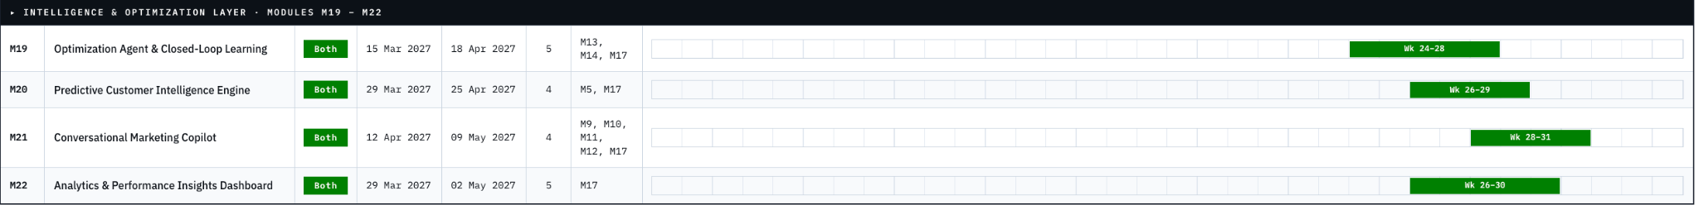
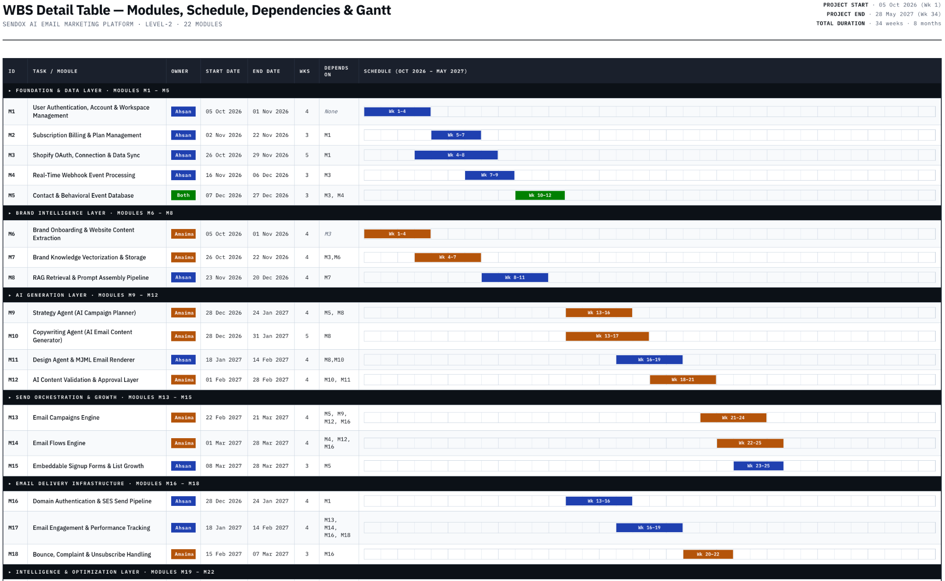
Gantt Chart

Mockups

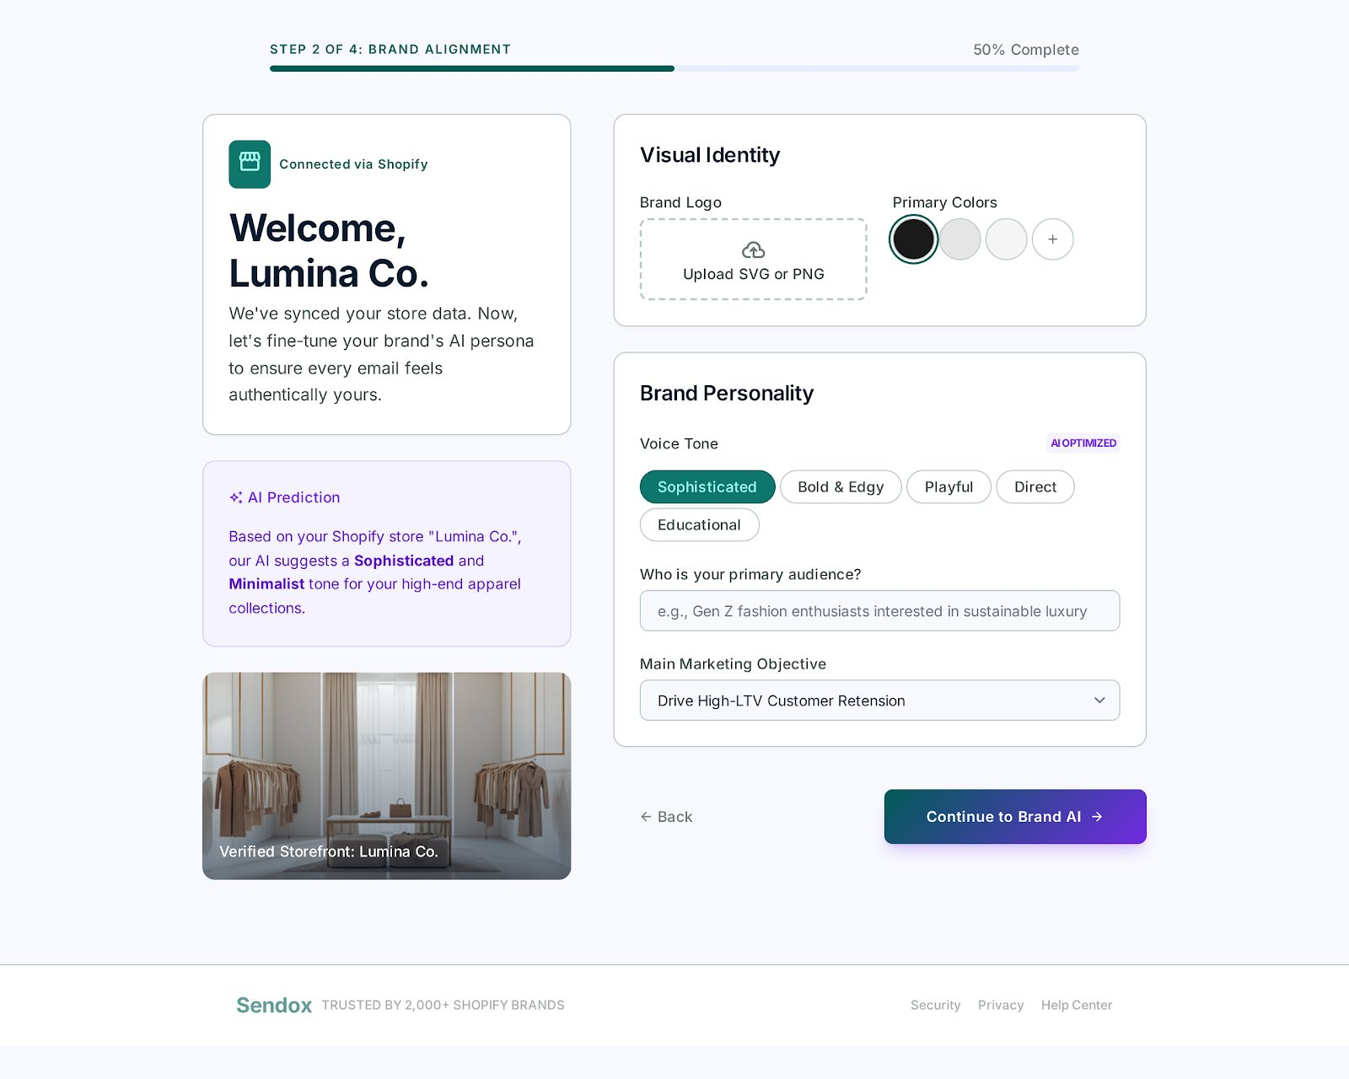

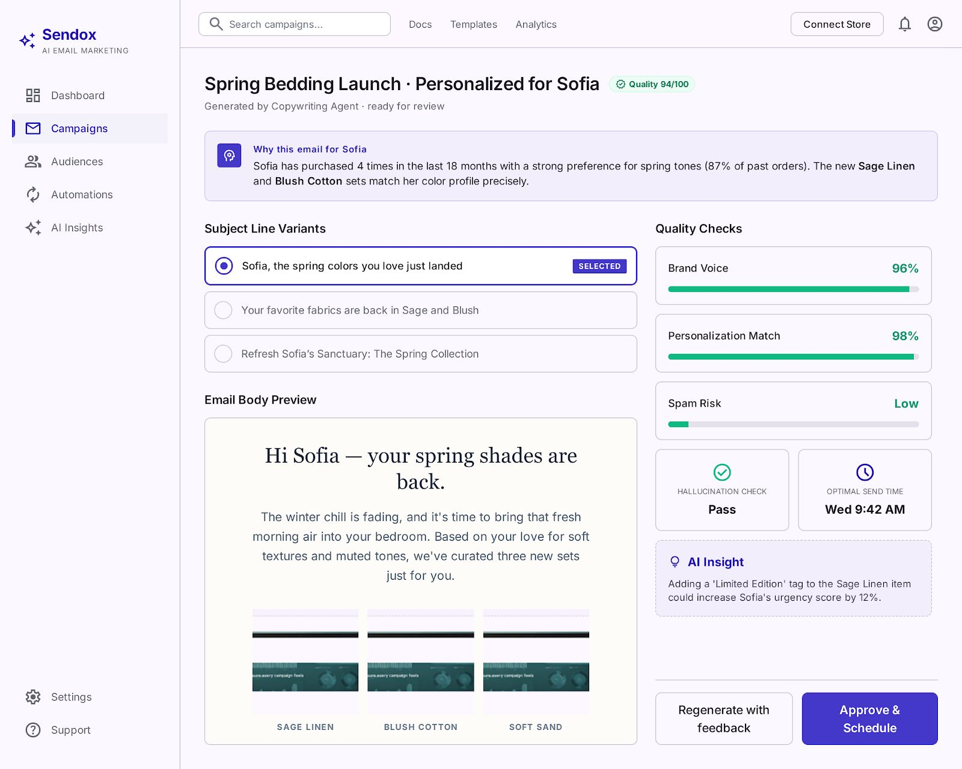

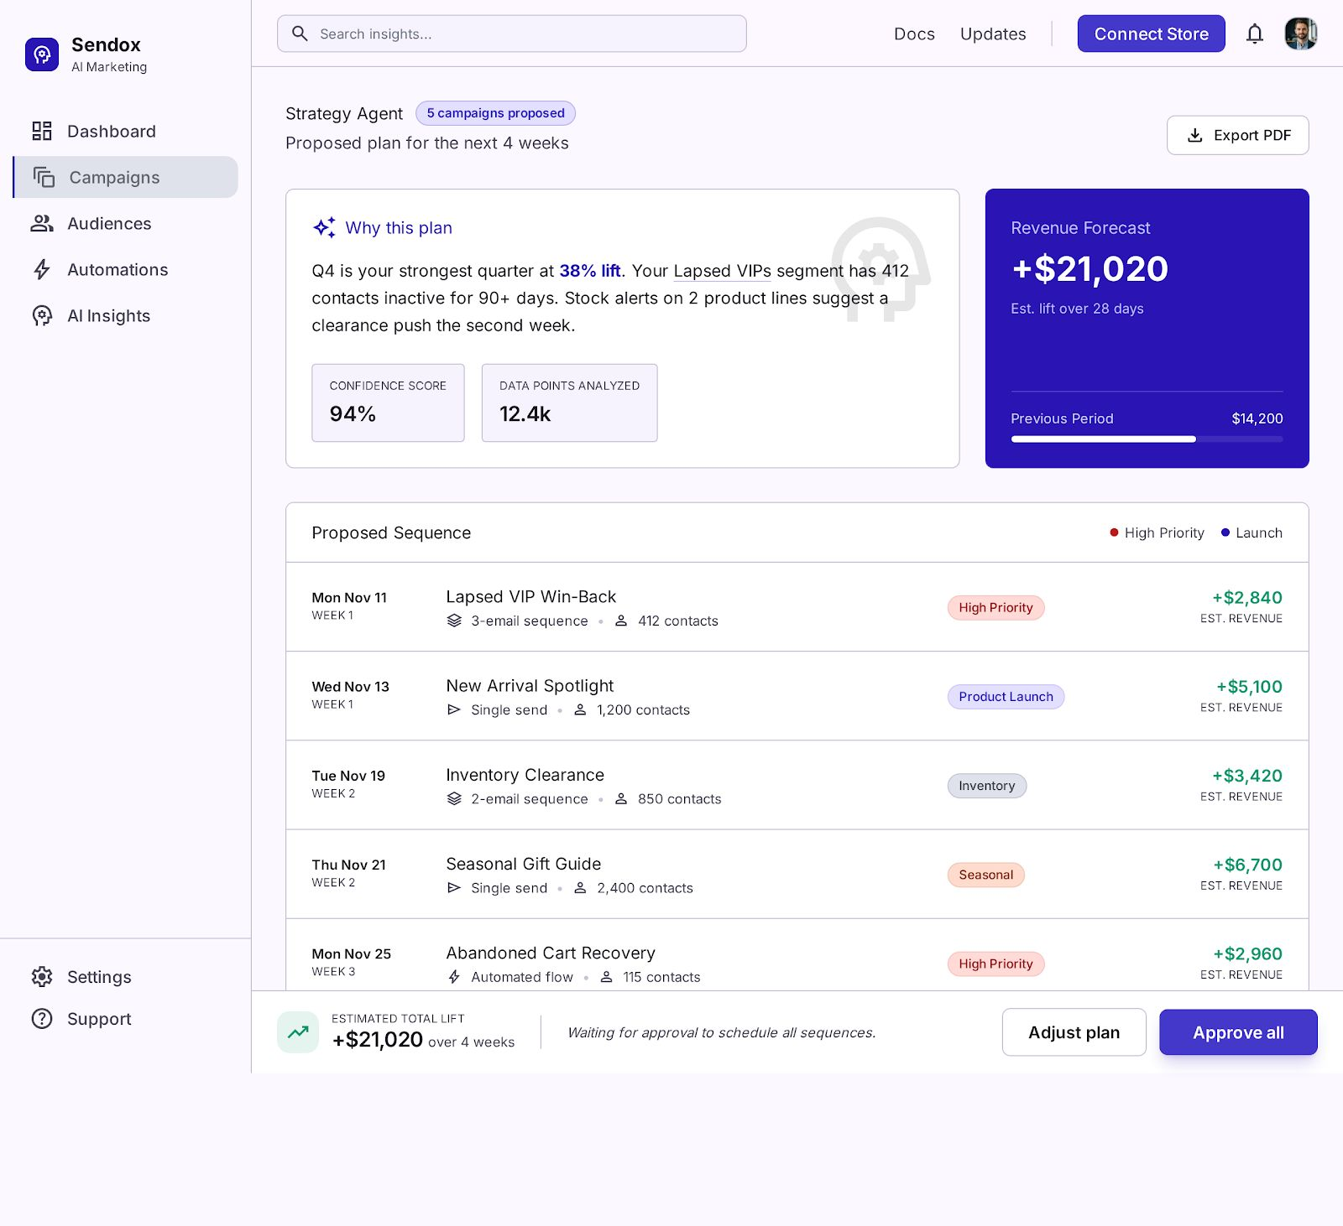

References

Amazon Web Services. "Amazon Simple Email Service Developer Guide." Internet: https://docs.aws.amazon.com/ses/latest/dg/Welcome.html, 2024 [Apr. 2026].

Shopify Inc. "Shopify Admin REST API Documentation." Internet: https://shopify.dev/docs/api/admin-rest, 2024 [Apr. 2026].

Anthropic. "Claude API Documentation." Internet: https://docs.anthropic.com/en/docs/welcome, 2024 [Apr. 2026].

Chroma. "ChromaDB: The AI-Native Open-Source Embedding Database." Internet: https://docs.trychroma.com/, 2024 [Apr. 2026].

MJML. "MJML — The Only Framework That Makes Responsive Email Easy." Internet: https://mjml.io/, 2024 [Apr. 2026].

Microsoft. "Playwright: Reliable End-to-End Testing for Modern Web Apps." Internet: https://playwright.dev/, 2024 [Apr. 2026].

Klaviyo Inc. "Klaviyo Platform Documentation and Developer API." Internet: https://developers.klaviyo.com/en, 2024 [Apr. 2026].

P. Lewis, E. Perez, A. Piktus et al. "Retrieval-Augmented Generation for Knowledge-Intensive NLP Tasks." Advances in Neural Information Processing Systems, vol. 33, pp. 9459–9474, 2020.

T. B. Brown, B. Mann, N. Ryder et al. "Language Models are Few-Shot Learners." Advances in Neural Information Processing Systems, vol. 33, pp. 1877–1901, 2020.

N. Reimers and I. Gurevych. "Sentence-BERT: Sentence Embeddings Using Siamese BERT-Networks." in Proc. Conference on Empirical Methods in Natural Language Processing (EMNLP), Hong Kong, 2019, pp. 3982–3992.

S. Russell and P. Norvig. Artificial Intelligence: A Modern Approach, 4th ed. Hoboken, NJ: Pearson, 2020.

D. Russo, B. Van Roy, A. Kazerouni et al. "A Tutorial on Thompson Sampling." Foundations and Trends in Machine Learning, vol. 11, no. 1, pp. 1–96, 2018.

T. Chen and C. Guestrin. "XGBoost: A Scalable Tree Boosting System." in Proc. 22nd ACM SIGKDD International Conference on Knowledge Discovery and Data Mining (KDD), San Francisco, CA, 2016, pp. 785–794.

E. Anderl, I. Becker, F. von Wangenheim, and J. H. Schumann. "Mapping the Customer Journey: Lessons Learned from Graph-Based Online Attribution Modeling." International Journal of Research in Marketing, vol. 33, no. 3, pp. 457–474, 2016.

R. Kohavi, D. Tang, and Y. Xu. Trustworthy Online Controlled Experiments: A Practical Guide to A/B Testing. Cambridge, UK: Cambridge University Press, 2020.

Litmus. "The 2024 State of Email Trends Report." Internet: https://www.litmus.com/state-of-email-reports, 2024 [Apr. 2026]. (Source for the $36 ROI per $1 spent on email marketing statistic.)

HubSpot. "State of Marketing Report 2024." Internet: https://www.hubspot.com/state-of-marketing, 2024 [Apr. 2026]. (Source for email automation revenue and engagement statistics.)

Statista. "E-commerce Email Marketing Statistics — Global Industry Overview." Internet: https://www.statista.com/topics/1446/e-mail-marketing/, 2024 [Apr. 2026]. (Source for global email marketing market size and B2C engagement data.)

Federal Trade Commission. "CAN-SPAM Act: A Compliance Guide for Business." Internet: https://www.ftc.gov/business-guidance/resources/can-spam-act-compliance-guide-business, 2023 [Apr. 2026].

European Union. "GDPR and Email Marketing." Internet: https://gdpr.eu/email-marketing/, 2023 [Apr. 2026].

Plagiarism Report

