**Objectives :**

**Equipment :**

**Theory :**

**Arduino** is an open-source platform used for building electronics projects. Arduino consists of both a physical programmable circuit board (often referred to as a microcontroller) and a piece of software, or IDE (Integrated Development Environment) that runs on your computer, used to write and upload computer code to the physical board.

The Arduino platform has become quite popular with people just starting out with electronics, and for good reason. Unlike most previous programmable circuit boards, the Arduino does not need a separate piece of hardware (called a programmer) in order to load new code onto the board – you can simply use a USB cable. Additionally, the Arduino IDE uses a simplified version of C++, making it easier to learn to program. Finally, Arduino provides a standard form factor that breaks out the functions of the micro-controller into a more accessible package.

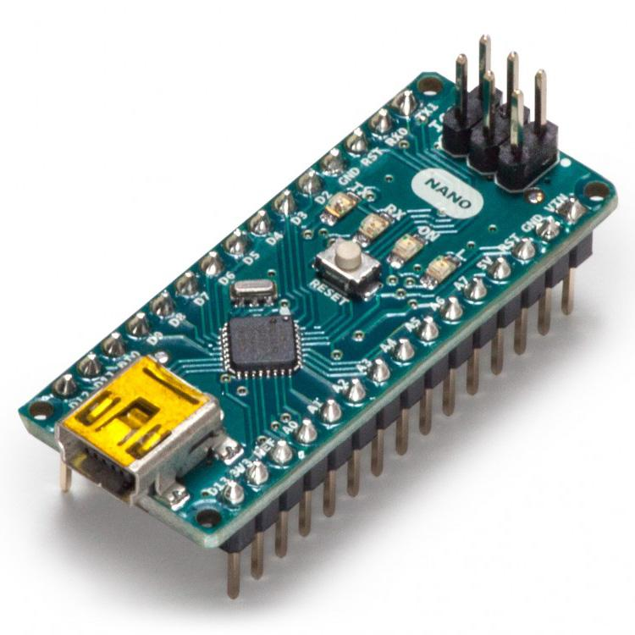

Fig-0 :

A **mobile robot** is a robot that is capable of locomotion, Mobile robotics is usually considered to be a subfield of robotics and information engineering. Mobile robots have the capability to move around in their environment and are not fixed to one physical location. Mobile robots can be "autonomous" (AMR - autonomous mobile robot) which means they are capable of navigating an uncontrolled environment without the need for physical or electro-mechanical guidance devices. Alternatively, mobile robots can rely on guidance devices that allow them to travel a pre-defined navigation route in relatively controlled space (AGV - autonomous guided vehicle). What we used in the project is controlled mobile robot via Bluetooth control.

Amader bot er pic dis

**Bluetooth** is a wireless technology standard for exchanging data over short distances (using short-wavelength UHF radio waves in the ISM band from 2.400 to 2.485 GHz) from fixed and mobile devices, and building personal area networks (PANs). Invented by Dutch electrical engineer Jaap Haartsen, working for telecom vendor Ericsson in 1994, it was originally conceived as a wireless alternative to RS-232 data cable.

The **HC-05 Bluetooth Module** can be used in a Master or Slave configuration, making it a great solution for wireless communication. Anyone can use it simply for a serial port replacement to establish connection between MCU and GPS, PC to embedded project, etc. The HC-05 Bluetooth Module has 6 pins- Vcc, GND, TX, RX, Key, and LED. It comes pre-programmed as a slave, so there is no need to connect the Key pin, unless you need it change it to Master Mode. The major difference between Master and Slave modes is that, in Slave mode the Bluetooth module cannot initiate a connection, it can however accept incoming connections. After the connection is established the Bluetooth module can transmit and receive data regardless of the mode it is running in. If you are using a phone to connect to the Bluetooth module, you can simply use it in the Slave mode. The default data transmission rate is 9600kbps. The range for Bluetooth communication is usually 30m or less. The module has a factory set pin of “1234” which is used while pairing the module to a phone. It’s Features are -

* Protocol: Bluetooth Specification v2.0+EDR
* Frequency: 2.4GHz ISM band
* Modulation: GFSK
* Emission power: ≤4dBm, Class 2
* Sensitivity: ≤-84dBm at 0.1% BER
* Speed: Asynchronous: 2.1Mbps(Max) / 160 kbps, Synchronous: 1Mbps/1Mbps
* Security: Authentication and encryption
* Profiles: Bluetooth serial port
* Power supply: +3.3VDC 50mA
* Working temperature: -20 ~ +75 Centigrade

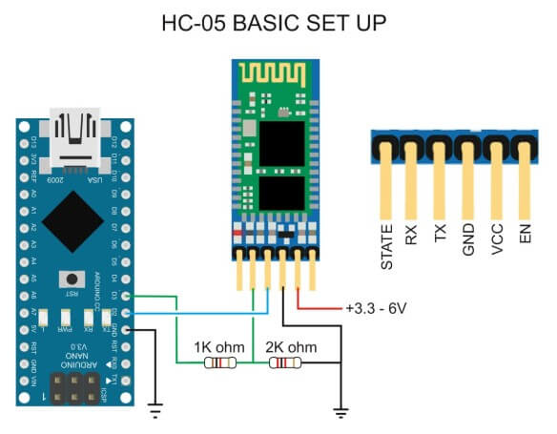

Fig-0 :

The **MPU6050** has an embedded 3-axis MEMS gyroscope, a 3-axis MEMS accelerometer. It is very useful for some motion detecting. This small module integrate the logic level converter circuit (makes it compatible with 3.3V-5V voltage level) together with the MPU6050 sensor, you can integrate it to project conveniently. This is capable of processing complex 9-axis algorithms, captures the x, y, & z channel at the same time, and is very accurate due to the 16-bits analog to digital conversion hardware for each channel. The MPU-6050 also removes the cross-axis alignment problems that can occur on discrete parts. The MPU-6050 acts as a slave to the Arduino with the SDA and SCL pins connected to the I2C-bus. Beside the normal I2C-bus, it has it’s own I2C controller, to be a master on a second (sub) I2C-bus. It uses the pins AUX_DA (XDA) and AUX_CL (XCL) for that second (sub)-I2C-bus which allows it to control, for example, a magnetometer. It’s features are-

* Standard I2C communications protocol
* Built-in 16bit ADC
* 16-bit data output
* Tri-Axis Gyro with a sensitivity up to 131 LSBs/ dps and a full-scale range of ± 250, 500, 1000, 2000°/s (dps)
* Tri-Axis Accelerometer with a programmable full scale range of ± 2, ± 4, ± 8, ± 16g
* Digital-output temperature sensor
* Pin pitch: 0.1 inch

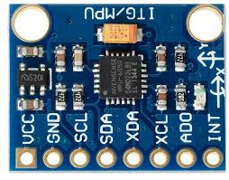

Fig-0 :