BS(CS/SE/DS/AI) FINAL PROJECT
Agile Software Design Specification

DESK-POSTURE & EYE STRAIN



Product Owner

Engr. Sajid Saleem

Presented by:
Group ID: S26CS034

Student Reg# Student Name
L1S23BSCS0329 M. UMAIR KHUSHNOOD
L1F22BSCS1031 AHSAN RASOOL
L1S23BSCS0363 SAIM RAFAQAT

Faculty of Information Technology & Computer Science

University of Central Punjab

Agile Software Design Specification

SDS Phase III

Version 3.0

Product Owner

Engr. Sajid Saleem

Scrum Master

M. Umair Khushnood

Group S26CS034

Team
Member Name | Roles
M. Umair Khushnood | Frontend Developer & Scrum Master
M. Ahsan Rasool | AI & Computer Vision Developer
Saim Rafaqat | Backend & Database Developer

Table of Contents
Table of Contents i
Revision History & Sprint Log ii
Previous Phases Feedback ii
Abstract iii
1. Introduction and Background 1
1.1 Product Vision & Problem Context 1
1.2 Stakeholders Identification 2
2. Sprint Breakdown and History 2
2.1 Completed Work: Sprints 1 – 8 2
2.2 Sprints 1 – 8 Retrospective Key Takeaways 3
2.3 Sprint-wise Design Evolution 4
3. UML Diagrams (Updated) 4
3.1 Use Case Diagram 5
3.2 Class Diagram 5
3.3 Entity-Relationship Diagram (Database Design) 7
4. Active Execution: Sprint 9 & 10 8
4.1 Planned Sprint Overview 8
4.2 User Stories and Product Backlog for Planned Sprints 8
4.3 Kanban Board / Task Tracking 9
5. Unit and Integration Testing 10
5.1 Overview 10
5.2 Version Control 14
6. Revised Project Plan 14
7. References 15
Appendix A: Glossary 16
Appendix B: Sprint and Phase Retrospective Report 17
Retrospective Overview 17
Retrospective Header 17
Sprint Summary: Planned, Achieved, and Carried Forward 17
Follow-up on Previous Action Items 18
Discussion: Start, Stop, Continue 18
New Action Items 19
Metrics Snapshot (optional but recommended) 19

Revision History & Sprint Log
Version | Sprint | Date | Changes | Owner
1.0 | Sprints 1 – 2 | Apr 2026 | SRS (Phase 1): vision, stakeholders, epics, product backlog, user stories, NFRs, risks | M. Umair Khushnood
2.0 | Sprints 3 – 4 | 20 Jun 2026 | SDS (Phase 2): architecture, UML diagrams, ERD, API design, UI prototypes, test design | M. Umair Khushnood
3.0 | Sprints 5 – 9 | 10 Nov 2026 | SDS (Phase 3): sprint history 1 – 8, updated use case / class / ER diagrams, Sprint 9 – 10 plan, unit & integration testing, version control, revised plan, retrospective | M. Umair Khushnood

Previous Phases Feedback

Idea Defence Feedback (Screenshot)
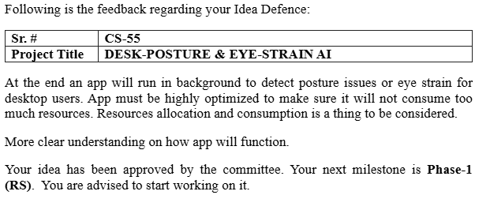

Phase 2 (SDS) Feedback (Screenshot)
[Paste the Phase 2 (SDS) feedback screenshot here]

Abstract
Prolonged sitting and screen use among students and office workers lead to poor sitting posture and Computer Vision Syndrome (CVS). Desk-Health-AI is a privacy-first desktop application that uses only a standard webcam to detect slouching and unsafe screen distance in real time, without any wearable hardware. Slouching is modelled as the combination of Forward Head Posture, Thoracic Kyphosis (rounded and dropped shoulders) and Posterior Pelvic Tilt. Because a front-facing webcam cannot measure side-view angles directly, the system first records the user's own upright posture (calibration) and then measures changes from it using MediaPipe pose and face landmarks: the shoulders going down or moving forward is the primary signal, the neck is a secondary signal, and pelvic tilt is inferred from the trunk sinking. Face-to-screen distance is estimated from the size of the iris with a pinhole camera model, and the user is asked to move back when closer than 50 cm. The system combines a Python engine (OpenCV, MediaPipe), an Electron.js desktop shell with system-tray operation and native notifications, a React.js dashboard and a local SQLite database; video frames stay in memory and only numeric results are stored. By the Phase 3 submission, Sprints 1 – 8 (47 of 60 planned story points, 78%) are complete, including posture and distance detection, smart timed alerts, frame-rate throttling and automatic camera release during video calls, and Sprint 9 (SQLite integration and native alerts) is under testing.

Introduction and Background

Product Vision & Problem Context
Real-Time Problem Description:
- Today, people spend many continuous hours sitting in front of computer screens for work and study.
- This prolonged sitting often leads to bad habits, such as slouching or leaning too close to the screen, which users usually do not notice until they feel pain.
- These bad habits cause serious health issues, including chronic back pain, neck strain, and Computer Vision Syndrome (eye strain and dryness).
- While there are solutions available (like posture-correcting chairs or wearable sensors), they are highly expensive and require users to buy extra physical hardware, making them out of reach for students and average professionals.
Target Users:
- Students and Digital Learners: Individuals who spend hours attending online lectures or coding for university projects.
- Office Employees and Freelancers: Professionals who work at a desk for 4 or more hours a day and are at high risk of developing physical strain.
Objectives of the System:
- To continuously monitor the user's upper-body posture (slouching: shoulders dropping or moving forward, together with forward head movement) using only a standard built-in webcam.
- To calculate the distance between the user's face and the screen to prevent eye strain, and to ask the user to move back when they are too close.
- To provide smart, non-annoying desktop alerts only when the user stays in a bad posture for too long.
- To run completely in the background without slowing down the computer or distracting the user from their main work.
- To show users a graphical "Health Dashboard" so they can track their posture improvements over weeks and months.
User Research Conducted:
- Method Used: We conducted an online survey and one-on-one interviews to understand user pain points.
- Number of Participants: 15 participants for the survey and 5 participants for the interviews.
- Participant Types: The group included university computer science students, software developers, and operational office staff.
- Key Findings:
  - Over 80% of the participants reported feeling back or neck pain after long computer sessions.
  - During interviews, users strongly stated they would prefer a free or cheap software application over wearing a physical posture belt.
  - Users requested that the software must be "smart", meaning it should not send annoying alerts when they are simply relaxing or in a video meeting.
Expected Benefits and Potential Beneficiaries:
- Expected Benefits: The system will help users build long-lasting, healthy sitting habits. It will reduce daily muscle fatigue, prevent long-term spinal damage, and protect eyesight without requiring any financial investment in hardware.
- Potential Beneficiaries: The main beneficiaries are IT professionals, remote workers, students, and any individual whose daily life requires extensive computer usage.

Stakeholders Identification
1. General User (Students and Office Professionals)
- Role: The primary end-users who install and run the application on their personal computers or laptops.
- Expectations:
  - Expects the software to be completely free of lag so it does not slow down their games or work.
  - Expects the application to respect their privacy by never saving or sharing video recordings.
  - Expects the alerts to be accurate and not annoying when they are just trying to relax.
  - Expects a simple dashboard to see their posture improvement over time.
2. Corporate IT / HR Managers
- Role: Decision-makers who might deploy this software across an office or university lab to protect employee/student health.
- Expectations:
  - Expects the software to be highly secure and safe to install on company networks.
  - Expects that the application will automatically pause and not interfere with important software like Zoom or Microsoft Teams.
3. Project Supervisor and Evaluators (Academic Stakeholders)
- Role: The university faculty (Engr. Sajid Saleem) responsible for grading and validating the BSCS final year project.
- Expectations:
  - Expects the software to fully meet all the functional and technical requirements mentioned in the SRS document.
  - Expects the AI and computer vision models (MediaPipe/OpenCV) to detect posture accurately in real-time.
  - Expects the code to be clean, modular, and well-documented.
4. Physiotherapists and Ergonomic Experts (Indirect Users)
- Role: Health professionals who might view the application's data when treating a patient with back pain.
- Expectations:
  - Expects the Health Dashboard to clearly show the frequency and duration of poor posture.
  - Expects the data to be easy to read so they can use it to give better medical advice to the user.

Sprint Breakdown and History

Completed Work: Sprints 1 – 8
Sprint goals and dates follow the plan in the Phase 1 SRS (Section 2.5) and the Phase 2 SDS (Section 8). Sprints 1 – 8 were completed before the Phase 3 submission on 10 November 2026. SP = story points.
Sprint | Objective / Focus Area | Key Features Delivered | Status | Planned Velocity | Delivered Velocity
Sprint 1 (1 – 28 Mar 2026) | Project initiation & requirements | Project setup, initial SRS draft, project repository set-up, Electron + React + Python technology stack selected | Completed | 4 SP | 4 SP
Sprint 2 (29 Mar – 25 Apr 2026) | Requirements & UI/UX design | Final SRS (Phase 1); digital wireframes for the Dashboard, Analytics, Alerts and Settings pages | Completed | 5 SP | 5 SP
Sprint 3 (26 Apr – 23 May 2026) | Frontend foundation | Base React.js template, modular component architecture, sidebar navigation | Completed | 5 SP | 5 SP
Sprint 4 (24 May – 20 Jun 2026) | Dashboard & settings | Main Health Dashboard layout, camera selection menu, eye-strain tracking toggle (Phase 2 SDS submitted) | Completed | 6 SP | 6 SP
Sprint 5 (1 – 28 Jul 2026) | Charts & notification UI | Weekly posture bar chart, today's split donut chart and hourly trend chart (Recharts); in-app alert pop-up with Snooze and "too close" banner designs | Completed | 6 SP | 6 SP
Sprint 6 (29 Jul – 25 Aug 2026) | AI vision engine | OpenCV webcam capture; MediaPipe Pose Landmarker (nose, ears, shoulders, hips) and Face Landmarker (478 points incl. iris); live preview with skeleton overlay kept in memory only | Completed | 8 SP | 8 SP
Sprint 7 (26 Aug – 22 Sep 2026) | Slouch algorithm & screen distance | Slouch index = 0.5 × Kyphosis + 0.3 × Forward Head + 0.2 × Pelvic Tilt (shoulders primary); posture calibration; posture score 0 – 100; resting-state detection; iris-based screen distance and too-close detection | Completed | 7 SP | 7 SP
Sprint 8 (23 Sep – 20 Oct 2026) | Performance & background behaviour | Frame-rate throttling (1 – 3 FPS); automatic camera release during Zoom/Teams calls; system-tray operation; first test of the Windows build on a team laptop and fixes (camera re-open after Resume, shoulder-drop sensitivity, slump-back classification, close/quit behaviour) | Completed | 6 SP | 6 SP
Total delivered: 47 of 60 planned story points (78%). Sprint 9 (8 SP) is in progress and Sprint 10 (5 SP) is planned (Section 4).

Sprints 1 – 8 Retrospective Key Takeaways
• What went well: Building the React interface against a mock data bridge (Sprints 3 – 5) let frontend work continue before the AI engine existed; the same screens were later connected to live data without redesign.
• What went well: The posture logic was covered by automated unit tests (pytest) with a simulated 3-D seated body before laptop testing, so later threshold changes could be made safely.
• Improvement area: Testing on a real laptop webcam started late (Sprint 8) and found four defects that photos and simulated data had not shown. Hardware testing must happen in every sprint.
• Improvement area: The Phase 2 database schema had to be extended during implementation (alert duration, resting and too-close time, calibration data); the schema should be checked against the UI screens earlier.

Sprint-wise Design Evolution
The design changed as the team built and tested each part. The table below records what was designed in each sprint and what was improved compared with the earlier design.

Sprint | Features Designed | Improvements
Sprint 1 | System scope and technology stack | Desktop-only, offline design chosen for privacy; Electron + React + Python stack selected.
Sprint 2 | UI/UX wireframes | Paper sketches turned into digital wireframes; bar and pie charts chosen for posture data.
Sprint 3 | React architecture and routing | Single script replaced by modular React components with a sidebar navigation flow.
Sprint 4 | Settings and camera selection | Toggle switches and camera dropdown validated with mock UI state.
Sprint 5 | Charts and notification UI | Recharts components (stacked weekly bars, donut, hourly trend); in-app alert pop-up with a Snooze button and a red "too close" banner.
Sprint 6 | AI vision engine | MediaPipe Tasks API (Pose Landmarker and Face Landmarker) used instead of the older "Solutions" API, which is not available in current MediaPipe releases; frames processed in RAM only.
Sprint 7 | Slouch and distance algorithms | Slouching defined by the formula FHP + Thoracic Kyphosis + PPT, with the shoulders as the main signal so that bending only the neck is not slouching. A calibration step was added (new US-09) because a front webcam can only measure change from the user's own upright posture; the "Posture Threshold 35°" setting became a slouch threshold in %. Screen distance estimated from iris diameter and eye spacing; default too-close limit 50 cm. The Python engine became the only process that opens the SQLite file; Electron requests data through IPC.
Sprint 8 | Background behaviour and robustness | Frame-rate throttling and automatic camera release (Windows camera-usage registry and Zoom meeting process). After laptop testing: camera re-open with warm-up and backend fallback; shoulder drop measured independent of the distance to the screen; Resting only with upright shoulders (slumping back is slouching); close-window choice, Quit button and clean shutdown of the AI engine; light theme as default with a dark option.
Sprint 9 (in progress) | Database and native alerts | ALERT_HISTORY stores duration and the user's response (Opened / Dismissed / Snoozed); DAILY_SUMMARY stores resting and too-close time and a daily health score, unique per profile and date.

UML Diagrams (Updated)
The diagrams below update the Phase 2 design to match the system as implemented. They were drawn with PlantUML following UML 2.5 notation (use case and class diagrams) and crow's-foot notation (ERD).

Use Case Diagram
The Desktop User is the only human actor. The OS notification service and video-call applications (Zoom / Teams) are external systems, shown as secondary actors. Use cases added since Phase 2: Calibrate Upright Posture, Pause / Resume Monitoring, Snooze Alerts, View Analytics, View Alert History, Export Posture Data (CSV) and Quit Application. The "Admin" actor that appeared in the Phase 2 sequence diagram was removed, because the application has a single local user.
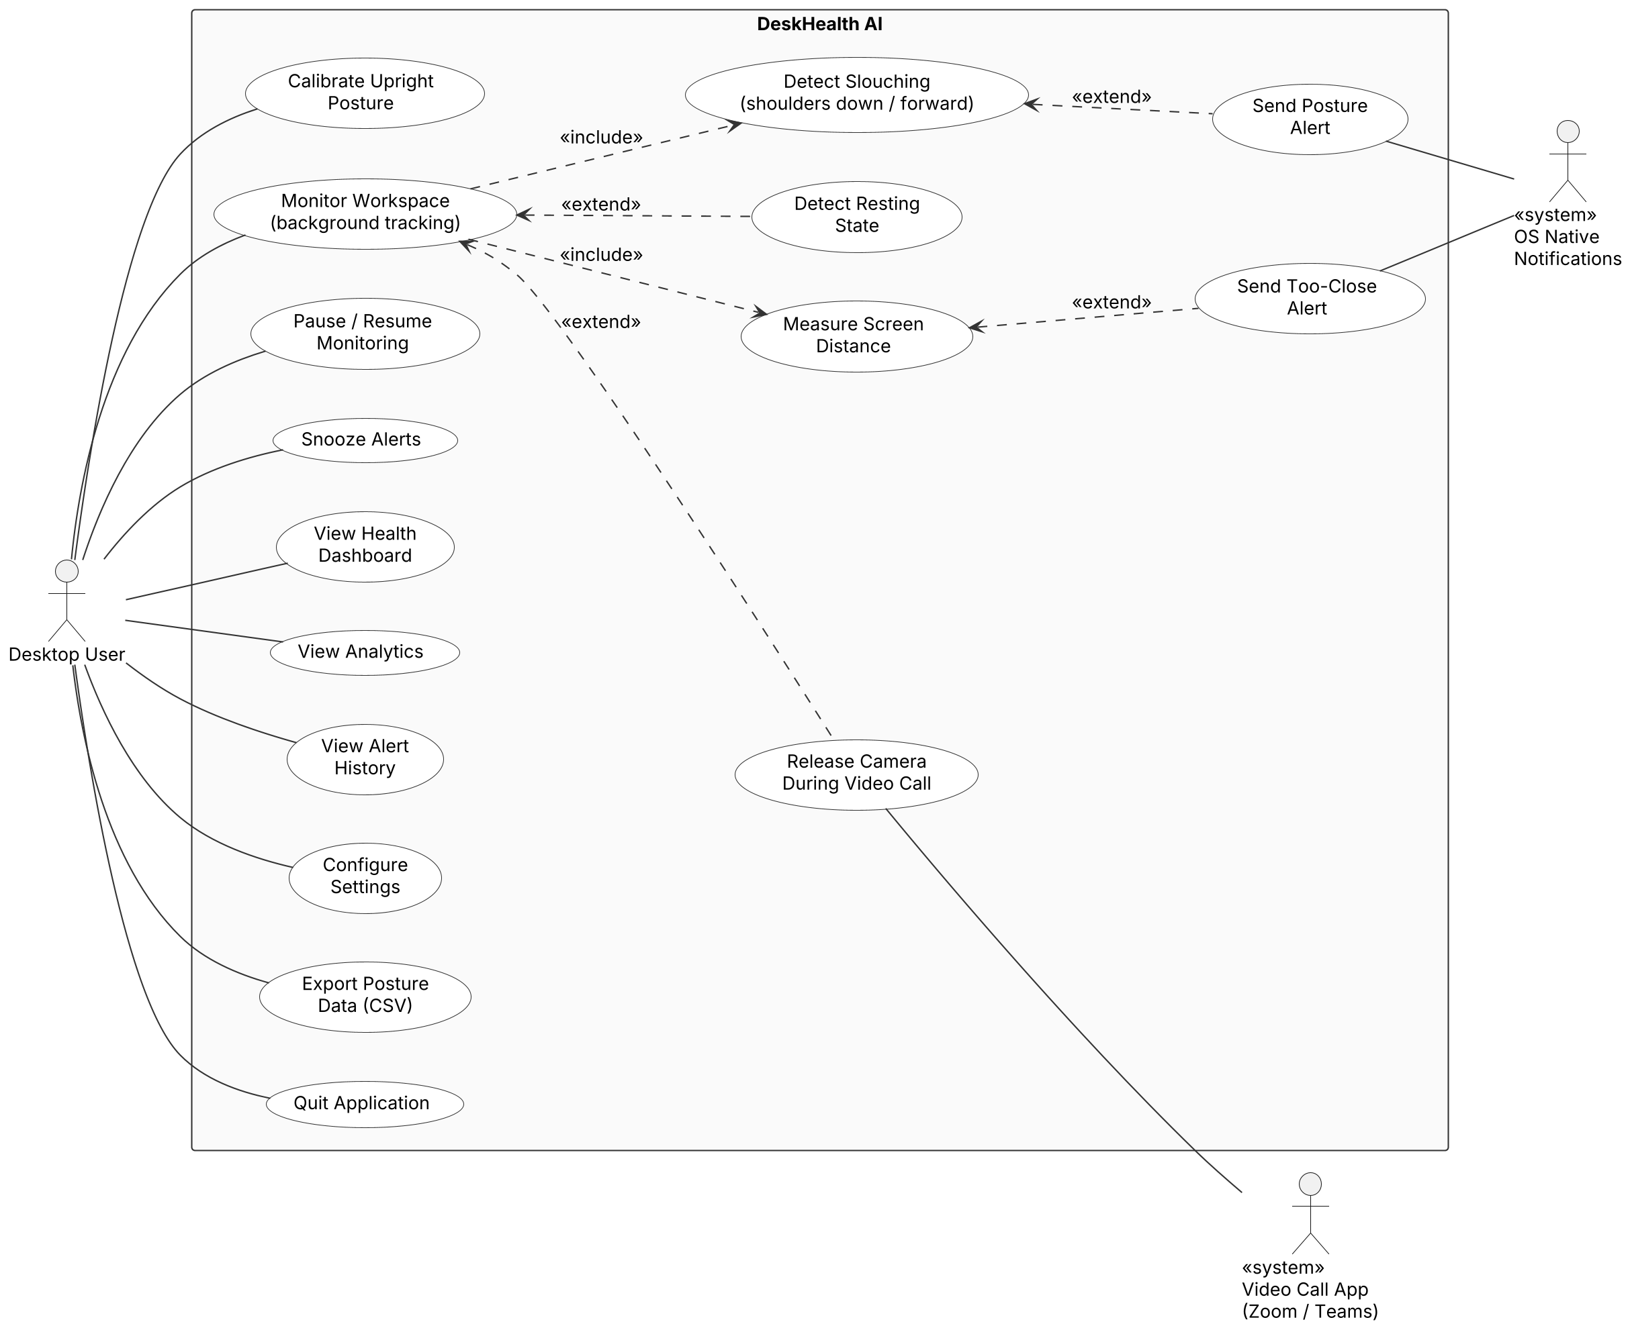
Figure 1: Use Case Diagram (updated)
Notation used:
- Actors stand outside the system boundary; a plain line (no arrowhead) joins an actor to a use case it takes part in.
- «include» is a dashed arrow from the base use case to the included one: monitoring the workspace always detects slouching and measures the screen distance.
- «extend» is a dashed arrow from the extending use case to the base one, and happens only under a condition: a posture alert after slouching longer than the alert timer, a too-close alert after 5 s closer than the minimum distance, resting detection when the user leans back upright, camera release when a video call starts.
- A use case diagram shows what the system does for its actors, not the order of steps; the order is shown by the sequence diagrams of Phase 2.

Class Diagram
Figure 2 shows the classes as implemented. The Python engine classes and the JavaScript classes EngineBridge and CallDetector are real classes in the code. ReactDashboard and ElectronMain are JavaScript modules; they are shown with the «module» stereotype so they can be traced to the Phase 2 ReactDashboard and ElectronWrapper classes. Classes marked «dataclass» only hold measurements or results.
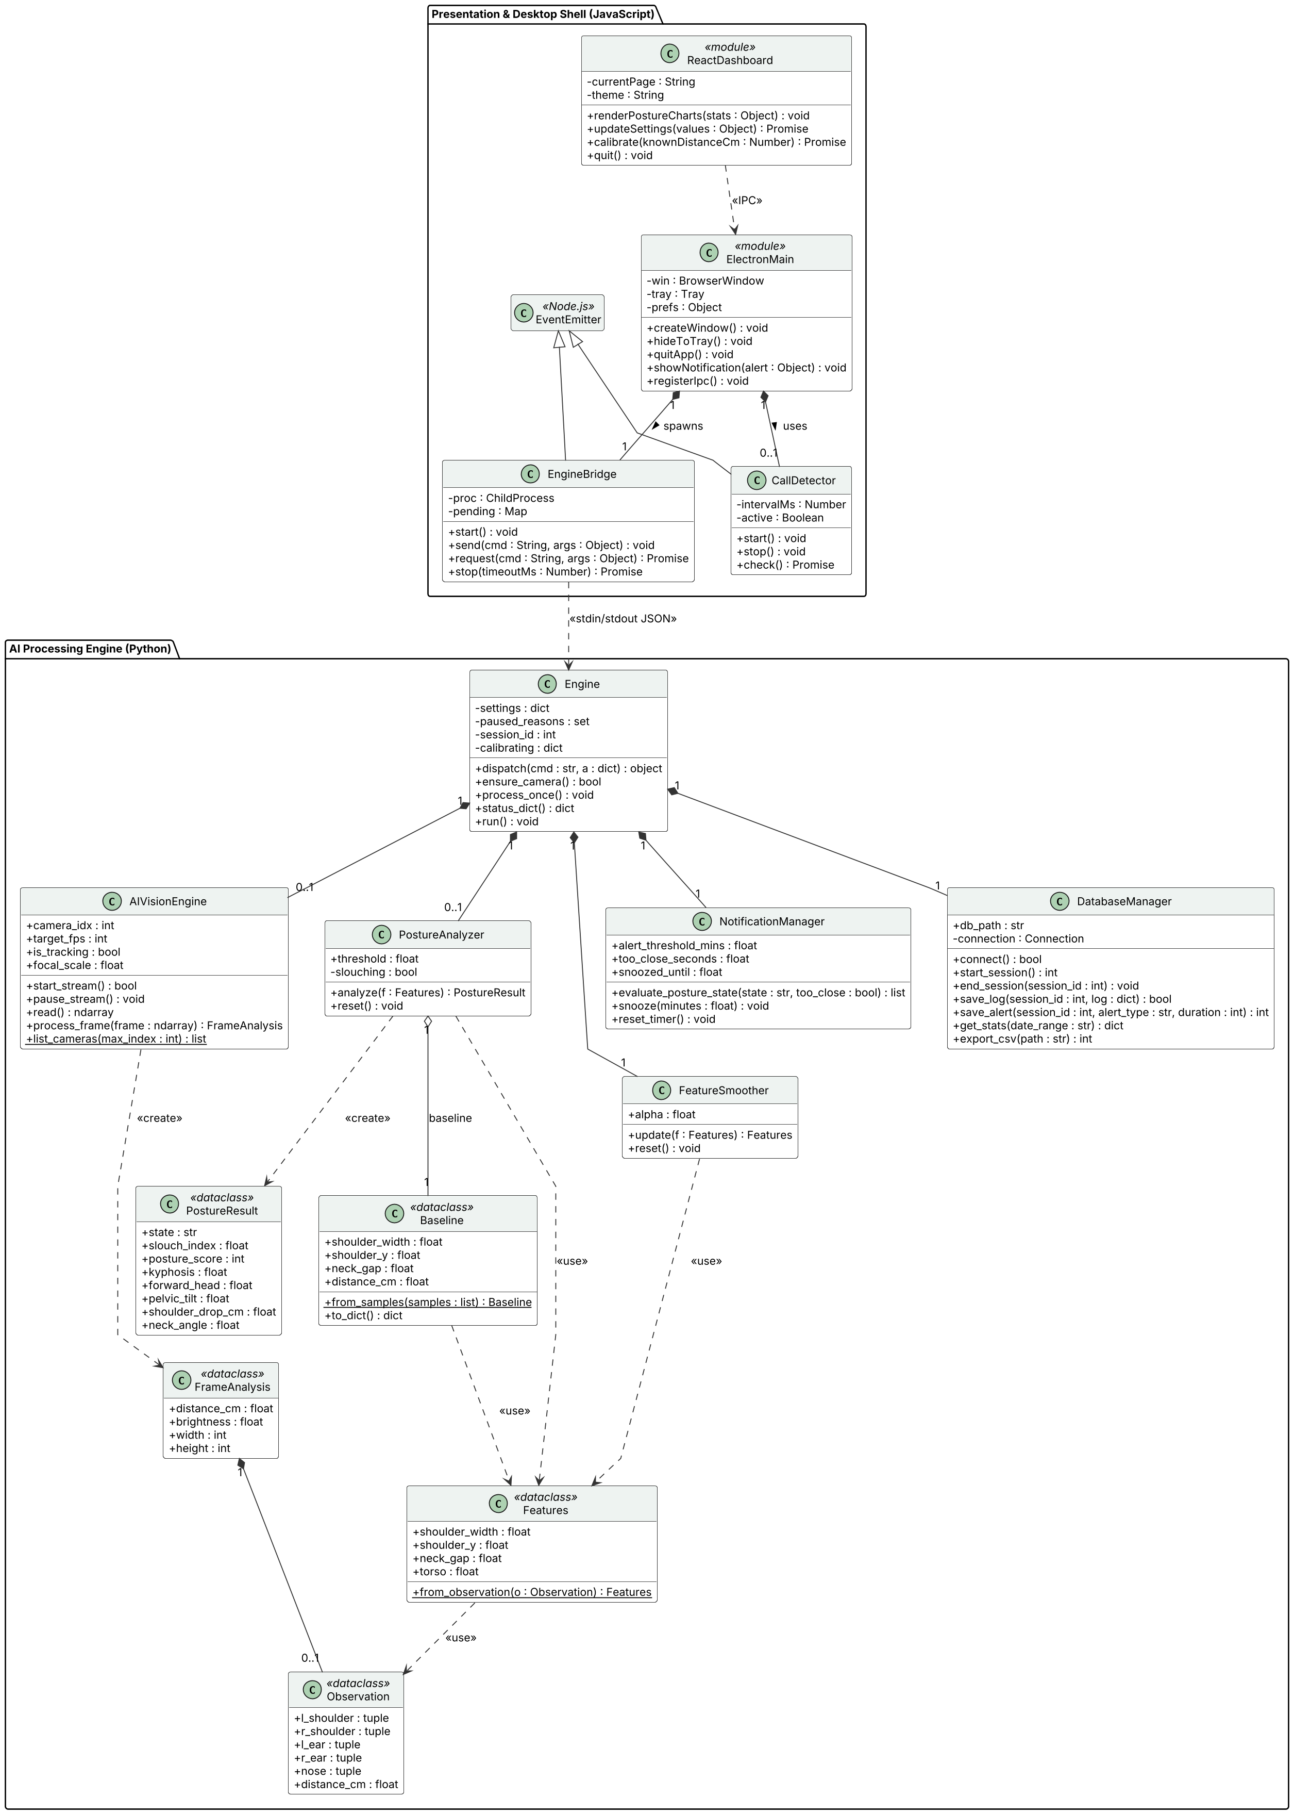
Figure 2: Class Diagram (updated)
Changes since Phase 2 and notation:
- The posture calculations moved from AIVisionEngine into PostureAnalyzer, which compares Features (from each frame, smoothed by FeatureSmoother) with the calibrated Baseline and returns a PostureResult. Engine coordinates all modules.
- Filled diamond = composition (the part only exists inside the whole, e.g. Engine owns its DatabaseManager). Hollow diamond = aggregation (PostureAnalyzer uses a Baseline created separately from the saved calibration). Hollow triangle = inheritance (EngineBridge and CallDetector extend Node.js EventEmitter). Dashed arrow = dependency («create», «use», «IPC»).
- Multiplicity 0..1 means the object is created only when needed: the vision engine starts on first camera use and the analyzer exists only after calibration.
- Visibility: + public, - private. Only the main attributes and operations are shown; private helper methods are left out for readability.

Entity-Relationship Diagram (Database Design)
Figure 3 is the updated SQLite database design in crow's-foot notation. PK = primary key (underlined), FK = foreign key, ● = NOT NULL column. Only numbers and timestamps are stored, never images (NFR-09, NFR-10).
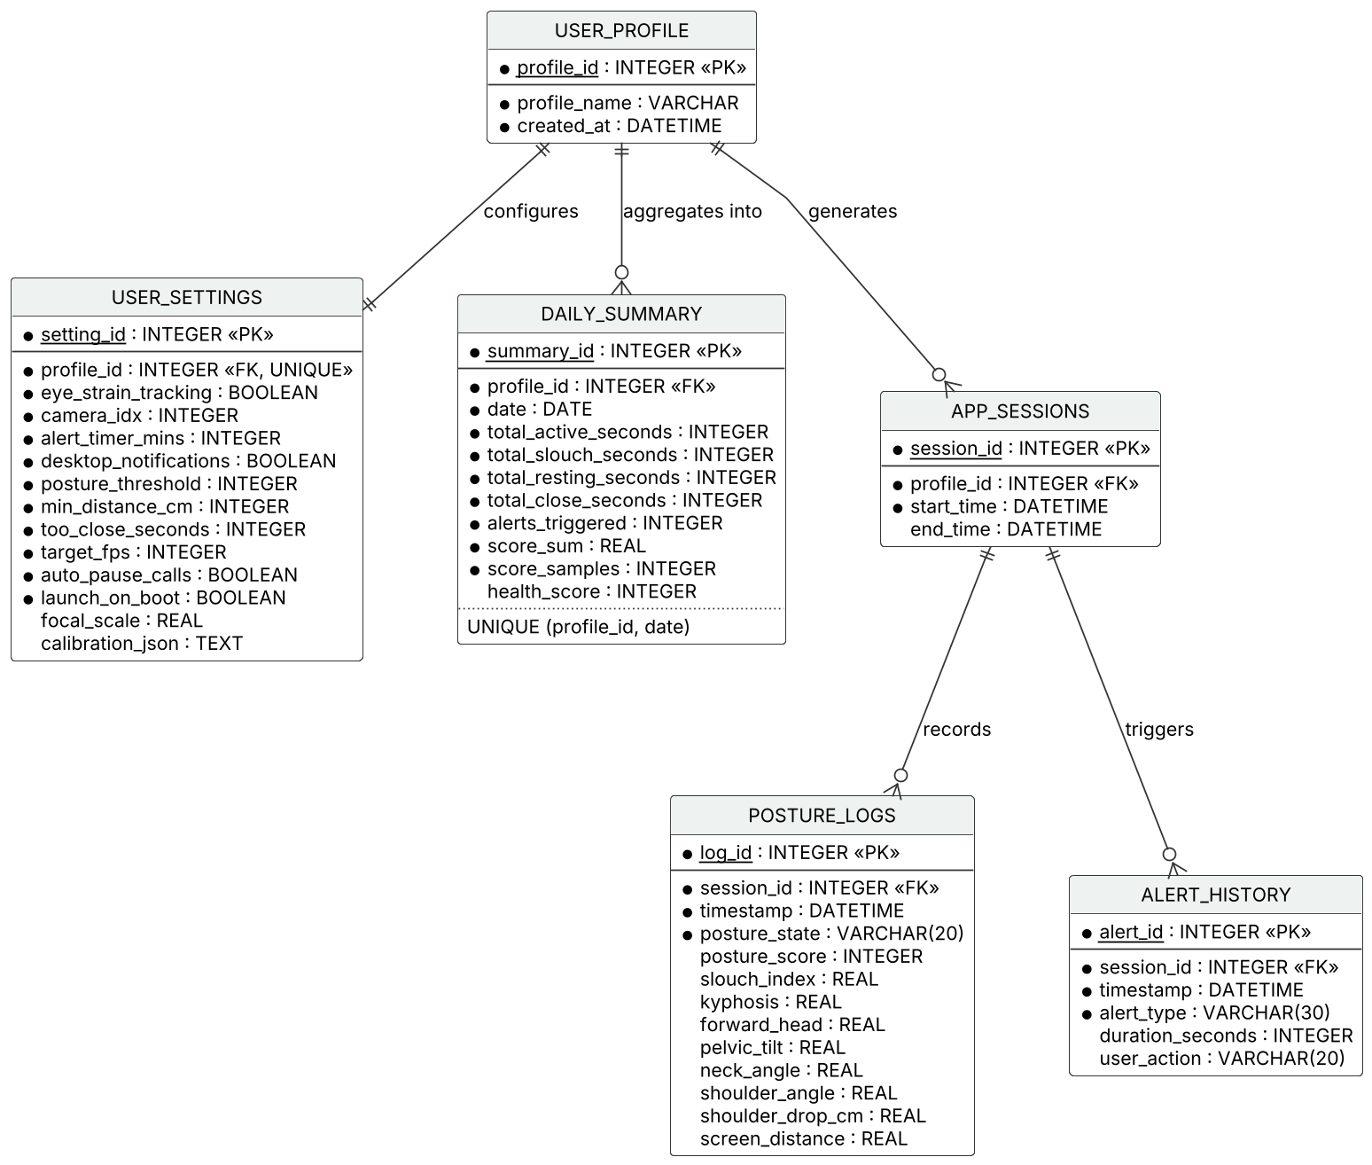
Figure 3: Entity-Relationship Diagram (updated)
Changes since Phase 2:
- USER_SETTINGS: new columns posture_threshold, min_distance_cm, too_close_seconds, target_fps, auto_pause_calls, launch_on_boot, focal_scale and calibration_json (the calibrated upright posture).
- DAILY_SUMMARY: total_resting_seconds, total_close_seconds, score_sum, score_samples and health_score; a day is now unique per profile (UNIQUE(profile_id, date)) instead of the date alone.
- POSTURE_LOGS: stores the slouch formula components (kyphosis, forward_head, pelvic_tilt), slouch_index, posture_score and shoulder_drop_cm; angle columns are nullable because no angle exists while the user is away.
- ALERT_HISTORY: duration_seconds added, as shown on the Alerts page.
- Relationships: USER_PROFILE 1 – 1 USER_SETTINGS; USER_PROFILE 1 – 0..* DAILY_SUMMARY and APP_SESSIONS; APP_SESSIONS 1 – 0..* POSTURE_LOGS and ALERT_HISTORY. The ERD shows data structure only; it does not show behaviour or which process uses the database (only the Python engine opens the file).

Active Execution: Sprint 9 & 10

Planned Sprint Overview
- Sprint 9 goal: Integrate the local SQLite database and OS native desktop alerts end-to-end (Phase 1 plan, Sprint 9).
- Duration: Sprint 9: 21 October – 17 November 2026; Sprint 10: 18 November – 15 December 2026.
- Estimated story points: 8 SP (Sprint 9) and 5 SP (Sprint 10).
- Status at the Phase 3 submission (10 November 2026): Sprint 9 is in progress; its features are implemented and under testing. Sprint 10 (connect the UI to live data and final end-to-end testing) is planned.

Sprint | Focus Area/objective | Feature Description | Duration | Estimated Story Points
Sprint 09 | SQLite database integration & OS native alerts | Save sessions, posture logs, daily summaries and alert history in the local SQLite database.  Native Windows notifications for posture and too-close alerts; the user's response (Opened / Dismissed / Snoozed) is logged.  Export posture data to CSV. | 21 Oct – 17 Nov 2026 | 8
Sprint 10 | Live data & final testing | Check all dashboard views with live data collected over several days of real use.  Final end-to-end testing on testers' laptops and bug fixing.  Windows installer release for evaluation. | 18 Nov – 15 Dec 2026 | 5

User Stories and Product Backlog for Planned Sprints
Backlog ID | Epic | Feature Description | User Story ID | User Story | Priority | Estimated Story Points | Status
PB-09 | Health Analytics Dashboard | Set up the local SQLite database to securely save daily posture events | US-06 | As a user, I want to view a visual chart of my daily and weekly posture habits so that I can see if my back health is actually improving. | High | 5 | In progress (Sprint 9) – under testing
PB-07 | Smart Notification System | Connect the app to Windows native notification systems to display alerts | US-04 | As a user, I want to receive a desktop alert only if I slouch for several minutes so that I am not annoyed by instant, constant warnings. | High | 3 | In progress (Sprint 9) – under testing
PB-12, PB-13 | Health Analytics Dashboard | Main UI and charts showing live data (time in good vs. bad posture over the week) | US-06 | As a user, I want to view a visual chart of my daily and weekly posture habits so that I can see if my back health is actually improving. | Medium | 3 | Planned (Sprint 10)
— | All epics | Final end-to-end testing, bug fixing and installer release (task, no user story) | — | — | High | 2 | Planned (Sprint 10)
Backlog items added since Phase 2 (already completed): these stories came from design work and laptop testing and were finished inside Sprints 7 – 8 without moving later sprints.
Backlog ID | Epic | Feature Description | User Story ID | User Story | Priority | Estimated Story Points | Status
PB-17 | AI Vision & Tracking Engine | Calibrate the user's upright posture | US-09 | As a user, I want to calibrate my upright posture once so that slouch detection fits my body, chair and camera position. | High | 3 | Done (Sprint 7)
PB-18 | Smart Notification System | Notify the user to move back when too close to the screen | US-10 | As a user, I want to be told to move back when I sit too close to the screen so that I can avoid eye strain. | High | 2 | Done (Sprint 7)
PB-19 | Background App Management | Close-window choice and a Quit button that stops the app and AI engine completely | US-11 | As a user, I want to quit the app completely so that it does not keep running hidden or block uninstalling. | Medium | 1 | Done (Sprint 8)
Note: PB-17 – PB-19 were absorbed into the existing sprint capacity, so the sprint story-point totals of the Phase 1 plan are unchanged.

Kanban Board / Task Tracking
Tasks move through four states: To Do → In Progress → Testing → Done. The Scrum Master keeps the board up to date on the task-tracking tool chosen in Phase 1 (Kanban board) and the team reviews it in the twice-weekly stand-ups. A task moves to Done only after its tests pass. The board below shows the Sprint 9 – 10 tasks at the time of the Phase 3 submission.
Kanban board – Sprints 9 & 10
To Do | In Progress | Testing | Done
Final end-to-end test on testers' laptops (S10)  Check dashboards with several days of real data (S10)  Windows installer release for evaluators (S10)  Phase 4 documentation (S10) | Verify camera release during a live Zoom / Teams call (carried from S8)  Re-test of the Sprint 8 fixes on all team laptops (S9) | SQLite logging of sessions, posture logs and daily summaries (PB-09)  Windows notifications with Opened / Dismissed / Snoozed logging (PB-07)  CSV export of posture data | SQLite schema and DatabaseManager  Alert timers: 3 min posture, 5 s too close, snooze  Automatic Windows installer build on GitHub Actions

Unit and Integration Testing

Overview
Since Phase 2 the system was tested at two levels. Unit tests check each Python module on its own with pytest. Integration tests connect the modules step by step, from the camera and AI models up to the full desktop app, and finally the Windows build on a team laptop.
- Unit level: 22 pytest test cases for the posture analyzer, the notification manager and camera handling; all 22 pass on the development machine and on a Windows machine (GitHub Actions, 16 October 2026). The React and Electron code was tested through the integration tests; it has no automated unit tests yet.
- Integration sequence: vision engine + MediaPipe (Sprint 6) → posture and distance analysis with calibration (Sprint 7) → engine with alerts, SQLite and the IPC protocol (Sprints 7 – 9) → Electron + React desktop app (Sprint 8) → packaged Windows build on GitHub Actions and on a team laptop (Sprint 8).
- Integration result: all scripted integration scenarios pass. The first test of the Windows build on a team laptop found four defects (the camera did not re-open after Resume; a pure shoulder drop was not marked as slouching; slumping back was shown as Resting; the app could not be closed, which blocked uninstalling). All four were fixed in Sprint 8 and covered by new automated tests; the re-test on the laptops is part of Sprint 9.
Unit test results
Module / Unit | Framework | Test Cases Run | Pass / Fail | Notes
Posture analysis – posture.py (PostureAnalyzer, Baseline, Features, FeatureSmoother) | pytest | 15 | 15 / 0 | Simulated 3-D seated body seen through a pinhole camera: upright, small fidget, classic slouch, shoulders down only, shoulders forward only, neck-only bend (must stay Healthy), lean back (Resting), slump back (Slouching), moving back, pelvic proxy, score order.
Alerts – notifier.py (NotificationManager) | pytest | 4 | 4 / 0 | Alert only after 3 min of slouching; short corrections (< 8 s) keep the timer; too-close alert after 5 s with a 60 s cooldown; snooze blocks alerts.
Camera & engine control – vision.py, main.py (AIVisionEngine, Engine) | pytest with a simulated webcam | 3 | 3 / 0 | Camera warm-up frames, re-open after Pause / Resume, single dropped frames not treated as a disconnect. Regression tests for a laptop defect: they fail on the earlier code and pass on the fix.
All engine tests on Windows (GitHub Actions, windows-latest) | pytest | 22 | 22 / 0 | Run 38888453258 on 16 Oct 2026, same run that built the installer.

Integration test results
Modules Integrated | Sprint | Test Scenario | Expected Result | Actual Result | Status
AIVisionEngine + MediaPipe Pose / Face Landmarker | S6 | Frontal photos of a seated person used as camera input | Shoulders, ears, nose and iris detected; skeleton overlay drawn | As expected | Pass
AIVisionEngine + PostureAnalyzer + distance | S7 – S8 | Calibrate on an upright photo, then feed copies with the shoulders lower, leaning in, slumped back and leaning back | Slouching, Slouching, Slouching, Resting | First runs: leaning back shown as Healthy and slumping back as Resting; thresholds fixed; now as expected | Pass (after fix)
Distance estimation + NotificationManager | S7 | Face enlarged 1.6× (moved close) for more than 5 s | Distance below 50 cm; too-close banner and Eye_Strain alert | Distance 49 → 31 cm; banner and alert shown | Pass
Engine + DatabaseManager (SQLite) + NotificationManager | S7 – S9 | Alert raised during tracking; settings updated; CSV export | Rows added to ALERT_HISTORY and DAILY_SUMMARY; unknown setting keys ignored; CSV written | As expected | Pass
Engine IPC protocol (stdin/stdout JSON) | S8 | Pause for a video call, Resume, unknown command | Camera released and state Paused; tracking resumes; error reply without a crash | As expected | Pass
Electron + EngineBridge + Engine + React UI | S8 | Full desktop app with a demo video (upright → slouch → too close) | Live state, score and distance in the UI; alert listed on the Alerts page | Healthy → Slouching within about 2 s; too-close banner; alert listed | Pass
Packaged engine (PyInstaller) on Windows | S8 | GitHub Actions: build the engine, calibrate on a test photo | Engine starts and classifies the posture | As expected; installer DeskHealth-AI-Setup-0.5.1.exe built | Pass
Windows build on a team laptop: Pause → Resume | S8 | Pause tracking, then Resume | Camera tracking continues | "Camera not accessible" shown | Fail → fixed (camera warm-up and backend fallback); laptop re-test in S9
Windows build on a team laptop: shoulders down | S8 | Drop the shoulders from the calibrated position | Slouching | Healthy | Fail → fixed (shoulder drop alone counts); laptop re-test in S9
Windows build on a team laptop: slump back | S8 | Slump back in the chair, away from the screen | Slouching | Resting | Fail → fixed (distance-corrected drop, upright-only Resting); laptop re-test in S9
Windows build on a team laptop: close & uninstall | S8 | Close the app, then uninstall | App and AI engine stop; uninstall works | App kept running hidden; uninstall blocked | Fail → fixed (close dialog, Quit button, engine shutdown; all processes end in 1.6 s in test); laptop re-test in S9

Version Control
The code is managed with Git and hosted on GitHub in the public repository ahsanjutt5844-bit/desk-health-ai (https://github.com/ahsanjutt5844-bit/desk-health-ai). Every push to the main branch starts a GitHub Actions workflow on a Windows machine that runs the unit tests, builds the AI engine, runs a smoke test and publishes the Windows installer as a GitHub Release (build-1: DeskHealth-AI-Setup-0.5.1.exe, 16 October 2026).
Workflow used so far: US-01 Detect slouching → commit on main → GitHub Actions (tests + Windows build) → Release build-1.

Sprint 08
User Story ID | US-01 | Backlog ID |  | PB-03
Assignee | M. Ahsan Rasool | Priority |  | High
Activity | What Students Should Do |  | Desk-Health-AI (actual)
Repository | Create one shared project repository |  | ahsanjutt5844-bit/desk-health-ai (public)
Branch | Create a branch for each user story/feature |  | main (no feature branches yet)
Commit | Commit small, meaningful changes |  | af41ccc – "Shoulder drop/forward = slouching; slumping back no longer 'Resting'; app quits cleanly"
Pull Request | Submit completed feature for review |  | Not used yet – committed directly to main
Review & Test | Team member reviews and tests the feature |  | 22 unit tests passed locally and on GitHub Actions (Windows), run 38888453258
Merge | Merge approved code into main |  | main → GitHub Actions build → Release build-1
Contribution | Maintain visible work from each member |  | 3 commits so far, all pushed from M. Ahsan Rasool's account

Revised Project Plan
Figure 4 shows the plan from the Phase 1 SRS with the status at the Phase 3 submission. Sprint goals and dates are unchanged; Sprint 3 and 4 dates follow the Phase 2 SDS.
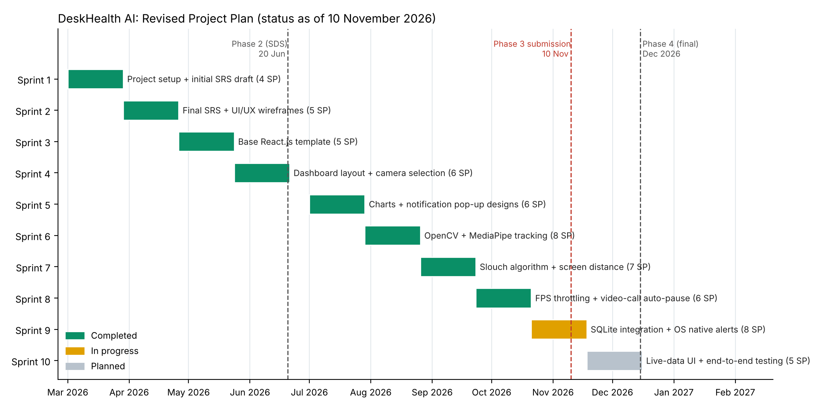
Figure 4: Gantt chart – revised project plan (status on 10 November 2026)
- Completed: Sprints 1 – 8, 47 of 60 story points (78%).
- In progress: Sprint 9 (8 SP): SQLite integration and native alerts, ends 17 November 2026.
- Planned: Sprint 10 (5 SP): live data on all dashboard views, final end-to-end testing, bug fixing and installer release, 18 November – 15 December 2026, followed by the Phase 4 final submission in December 2026.
- Changes to the plan: none to the sprint goals or dates. The calibration step (US-09), the too-close notification (US-10) and the quit behaviour (US-11) were added inside Sprints 7 – 8 without moving later sprints. Live-call verification of camera release and the laptop re-test of the Sprint 8 fixes were carried into Sprint 9.

References
[1] World Health Organization, "Physical activity," Fact Sheet, WHO, 2024. [Online]. Available: https://www.who.int/news-room/fact-sheets/detail/physical-activity
[2] A. K. Singh, V. A. Kumbhare, and K. Arthi, "Real-time human pose detection and recognition using MediaPipe," in Soft Computing and Signal Processing (ICSCSP 2021), Advances in Intelligent Systems and Computing, vol. 1413, pp. 145-154, Springer, Singapore, 2022.
[3] L. V. Kallings, O. Ekblom, and M. Hemmingsson, "Workplace sitting is associated with self-reported general health and back/neck pain: A cross-sectional analysis in 44,978 employees," BMC Public Health, vol. 21, no. 875, 2021, doi: 10.1186/s12889-021-10893-8.
[4] C. Blehm, S. Vishnu, A. Khattak, S. Mitra, and R. W. Yee, "Computer vision syndrome: A review," Survey of Ophthalmology, vol. 50, no. 3, pp. 253-262, 2005.
[5] F. P. Kendall, E. K. McCreary, P. G. Provance, M. M. Rodgers, and W. A. Romani, Muscles: Testing and Function, with Posture and Pain, 5th ed. Baltimore, MD, USA: Lippincott Williams & Wilkins, 2005.
[6] Google, "Pose landmark detection guide," MediaPipe Solutions, Google AI for Developers, 2024. [Online]. Available: https://ai.google.dev/edge/mediapipe/solutions/vision/pose_landmarker
[7] Google, "Face landmark detection guide," MediaPipe Solutions, Google AI for Developers, 2024. [Online]. Available: https://ai.google.dev/edge/mediapipe/solutions/vision/face_landmarker
[8] A. Vakunov and D. Lagun, "MediaPipe Iris: Real-time iris tracking & depth estimation," Google AI Blog, Aug. 2020. [Online]. Available: https://ai.googleblog.com/2020/08/mediapipe-iris-real-time-iris-tracking.html
[9] Occupational Safety and Health Administration, "Computer Workstations eTool: Monitors," U.S. Department of Labor. [Online]. Available: https://www.osha.gov/etools/computer-workstations/components/monitors
[10] OpenCV Team, "OpenCV Documentation," OpenCV, 2024. [Online]. Available: https://docs.opencv.org
[11] Electron.js Contributors, "Electron Documentation," Electron, 2024. [Online]. Available: https://www.electronjs.org/docs/latest
[12] Meta Open Source, "React Documentation," 2024. [Online]. Available: https://react.dev
[13] SQLite Consortium, "SQLite Documentation," 2024. [Online]. Available: https://www.sqlite.org/docs.html
[14] pytest-dev, "pytest Documentation," 2024. [Online]. Available: https://docs.pytest.org
[15] PyInstaller Development Team, "PyInstaller Manual," 2024. [Online]. Available: https://pyinstaller.org/en/stable/
[16] Object Management Group, "Unified Modeling Language (UML), Version 2.5.1," OMG, Dec. 2017. [Online]. Available: https://www.omg.org/spec/UML/2.5.1

Appendix A: Glossary
- Baseline (Calibration): The user's upright posture recorded during calibration; all posture changes are measured against it.
- CVS (Computer Vision Syndrome): Eye-related problems (dry eyes, blurred vision, eye strain) caused by long screen use or sitting too close to the screen.
- Electron.js: Framework used to build the desktop application (window, system tray, notifications) with web technologies.
- ERD (Entity-Relationship Diagram): Diagram of the database tables (entities), their columns and the relationships between them.
- Forward Head Posture (FHP): The head moving forward and down in front of the shoulders; the secondary component of the slouch formula.
- FPS (Frames Per Second): How many camera images are analysed per second; limited to 1 – 3 FPS to save CPU and battery.
- GitHub Actions: GitHub's automation service; used to run the tests and build the Windows installer on every push.
- IPC (Inter-Process Communication): Messages exchanged between the React interface, the Electron main process and the Python engine.
- Kanban Board: Board that shows tasks moving through To Do, In Progress, Testing and Done.
- Landmark: A tracked body or face point (e.g. shoulder, ear, nose, iris) returned by MediaPipe.
- MediaPipe: Google's on-device machine-learning library; its Pose Landmarker and Face Landmarker models track the user.
- OpenCV: Library used to open the webcam and process video frames.
- Pinhole Camera Model: Distance = focal length × real size ÷ size in pixels; used with the iris size to estimate the screen distance.
- Posterior Pelvic Tilt (PPT): The tailbone tucking under, often by sliding down in the chair; inferred from the trunk sinking because the pelvis is usually hidden by the desk.
- Posture Score: 100 × (1 − slouch index); 100 means the calibrated upright posture.
- PyInstaller: Tool that bundles the Python engine so the installed app does not need Python on the user's computer.
- React.js: Library used to build the Health Dashboard interface.
- Resting State: The user leaning back in the chair with upright shoulders; alerts are paused.
- Slouch Index: 0.5 × Thoracic Kyphosis + 0.3 × Forward Head Posture + 0.2 × Posterior Pelvic Tilt, each from 0 to 1.
- Sprint: A fixed four-week period in which the team completes a planned set of backlog items.
- SQLite: Local database file that stores settings and posture data on the user's own computer.
- Story Point (SP): Relative estimate of the effort for a backlog item.
- System Tray: Notification area of the Windows taskbar where the app keeps running in the background.
- Thoracic Kyphosis: Rounding of the upper back that makes the shoulders drop and move forward; the primary (50%) component of the slouch formula.
- Unit / Integration Test: A unit test checks one module on its own; an integration test checks modules working together.

Appendix B: Sprint and Phase Retrospective Report

Advisor Name Signature

Retrospective Overview

Retrospective Header
Team Name / Project Name | S26CS034 – Desk-Health-AI (Desk-Posture & Eye Strain)
Phase | Phase 3
Sprint / Cycle Number | Sprint 8 (23 Sep – 20 Oct 2026)
Date | [dd/mm/yyyy – to be filled by the team]
Facilitator | [Name of the member who facilitated this retrospective]
Attendees | M. Umair Khushnood, M. Ahsan Rasool, Saim Rafaqat
Supervisor Present | [Yes / No]

Sprint Summary: Planned, Achieved, and Carried Forward

Type | Item / Artefact ID | Description | Status | If Not Achieved, Why
Epic | EP-02 | Background App Management: run silently, throttle the frame rate, release the camera for video calls | Achieved
User Story | US-05 / PB-06 | Release the webcam automatically when Zoom / Teams starts a call | Partially Achieved | Detection implemented (Windows camera-usage registry and Zoom meeting process) and tested with simulated input; not yet verified during a live Zoom / Teams call on a team laptop.
User Story | US-03 / PB-05 | Run silently in the system tray | Achieved
Backlog item | PB-10 | Throttle analysis to 1 – 3 FPS to limit CPU use | Achieved
Architecture / Design | — | Camera re-open with warm-up and backend fallback; distance-corrected shoulder drop; Resting only with upright shoulders; clean shutdown of the AI engine | Achieved
UML Diagram | — | Updated use case diagram, class diagram and ERD (Section 3) | Achieved
Other | — | First test of the Windows build on a team laptop; four defects found and fixed | Achieved
Other | — | Re-test of the four fixes on the team laptops | Not Achieved | The fixes were finished at the end of the sprint; re-test moved to Sprint 9.

Carried Forward to Next Sprint

Item / Artefact ID | Description | New Target Sprint | Notes
US-05 / PB-06 | Verify camera release during a live Zoom and a Teams call on a team laptop | Sprint 9 | Needs a real call on Windows; cannot be fully checked with simulated input.
— | Re-test the four Sprint 8 defect fixes (Resume, shoulder drop, slump back, close & uninstall) on all team laptops | Sprint 9 | Already covered by automated tests.

Follow-up on Previous Action Items

# | Action Item (from last retrospective) | Owner | Status | Notes
– | No action items were recorded in the Phase 1 and Phase 2 retrospectives | – | – | This report starts the team's action-item log.

Discussion: Start, Stop, Continue
Category | Notes
Start doing | Test each sprint's build on a real laptop webcam, not only on photos and simulated data; the four Sprint 8 defects only appeared on real hardware.  Develop each user story on its own branch and merge it through a pull request reviewed by another member.
Stop doing | Leaving hardware-dependent checks (video-call release, camera re-open) to the end of a sprint.  Pushing all work from one GitHub account; each member should commit their own work.
Continue doing | Writing an automated test for every defect before fixing it (the camera tests failed on the old code and pass on the fix).  Developing the UI against the mock data bridge so frontend work does not wait for the engine.  Building the Windows installer automatically on every push.

New Action Items
# | Action | Owner | Due Date | Linked To | Status
1 | Verify camera release in a live Zoom call and a live Teams call | M. Ahsan Rasool | 17/11/2026 | US-05 / PB-06 | Open
2 | Re-test the Sprint 8 fixes on all three team laptops | Saim Rafaqat | 17/11/2026 | Sprint 8 defects | Open
3 | Use a feature branch and pull request per user story; each member commits from their own account | M. Umair Khushnood | 17/11/2026 | Version control (5.2) | Open

Metrics Snapshot (optional but recommended)
Planned Points | Completed Points | Carried Over | Blockers Logged | Notes
6 | 6 (implementation) | 0 (2 verification tasks) | 5 | All planned features were implemented. Blockers: four defects from laptop testing (all fixed) and no live video call available for testing US-05.

 |  |  | University of Central Punjab  (Incorporated by Ordinance No. XXIV of 2002 promulgated by Government of the Punjab)  Faculty of Information Technology and Computer Science
 |  | Semester wise SDP Meeting Report
 |  | Group ID |  | Student Roll Number |  |  |  |  | Student Name and Signatures |  | Advisor
 |  | S26CS034 |  | L1S23BSCS0329 |  |  |  |  | M. Umair Khushnood
 |  |  |  | L1F22BSCS1031 |  |  |  |  | M. Ahsan Rasool
 |  |  |  | L1S23BSCS0363 |  |  |  |  | Saim Rafaqat
 | Sr. | Date |  | Status (P/A/L) |  |  |  |  | Agenda Items | Notes
 |  |  |  | Student 1 | Student 2 |  | Student 3
 | 1
 | 2
 | 3
 | 4
 | 5
 | 6
 | 7
 | 8
 | 9
 | 10
 | 11
 | 12
 | 13
 |  | Date: |  |  | Advisor's Signatures: |  |  |  | ________________________________

