BS(CS/SE/DS/AI) FINAL PROJECT

DESK-POSTURE & EYE STRAIN



Product Owner

Engr. Sajid Saleem

Presented by:
Group ID: S26CS034

Student Reg# Student Name
L1S23BSCS0329 M. UMAIR KHUSHNOOD
L1F22BSCS1031 AHSAN RASOOL
L1S23BSCS0363 SAIM RAFAQAT
Faculty of Information Technology & Computer Science

University of Central Punjab
Complete System
SDP Phase IV

Desk-Posture & Eye Strain (Desk-Health-AI)
Version 4.0

Product Owner
Engr. Sajid Saleem

Scrum Master
M. Umair Khushnood

Group S26CS034

Team
Member Name | Roles
M. Umair Khushnood | Frontend Developer & Scrum Master
M. Ahsan Rasool | AI & Computer Vision Developer
Saim Rafaqat | Backend & Database Developer

Table of Contents
Table of Contents i
Revision History iii
Previous Phases Feedback iii
Abstract iv
1. Introduction and Background 1
1.1 Product Vision & Problem Context 1
1.2 Stakeholders Identification 2
1.3 Miscellaneous 3
2. Sprint Breakdown and History 3
2.1 Completed Work: Sprints 1 – 10 3
2.2 Sprints 1 – 10 Retrospective Key Takeaways 4
2.3 Sprint-wise Design Evolution 4
3. Screenshots/Prototype 5
3.1 Workflow 5
3.2 Screens 6
3.3 Additional Information 12
4. Active Execution: Sprint 9 & 10 12
4.1 Planned Sprint Overview 12
4.2 User Stories and Product Backlog for Planned Sprints 13
4.3 Kanban Board / Task Tracking 14
5. Unit and Integration Testing 15
5.1 Overview 15
5.2 Version Control 18
6. Other Design Details 19
6.1 Slouch Detection Method 19
6.2 Posture States 19
6.3 Screen Distance Estimation 20
6.4 Alert Timer 20
6.5 Data Protection 20
7. Test Specification and Results 21
7.1 Test Case Specification 21
7.2 Summary of Test Results 28
8. Project Completion Status 28
9. Deployment/Installation Guide 30
10. User Manual 30
11. References 31
12. Project Summary Form 32
Appendix A: Glossary 34
Appendix B: Sprint and Phase Retrospective Report 36
Retrospective Overview 36
Retrospective Header – Sprint 9 36
Sprint Summary: Planned, Achieved, and Carried Forward – Sprint 9 36
Follow-up on Previous Action Items – Sprint 9 37
Discussion: Start, Stop, Continue – Sprint 9 37
New Action Items – Sprint 9 37
Metrics Snapshot (optional but recommended) – Sprint 9 37
Retrospective Header – Sprint 10 37
Sprint Summary: Planned, Achieved, and Carried Forward – Sprint 10 38
Follow-up on Previous Action Items – Sprint 10 38
Discussion: Start, Stop, Continue – Sprint 10 38
New Action Items – Sprint 10 38
Metrics Snapshot (optional but recommended) – Sprint 10 39

Revision History
Name | Date | Reason For Changes | Version
M. Umair Khushnood | Apr 2026 | Phase 1 (SRS): vision, stakeholders, product backlog, user stories, requirements and sprint plan | 1.0
M. Umair Khushnood | 20 Jun 2026 | Phase 2 (SDS): architecture, UML diagrams, database design, API design and UI prototypes | 2.0
M. Umair Khushnood | 10 Nov 2026 | Phase 3 (SDS): Sprints 1 to 8, updated diagrams, unit and integration testing, revised plan | 3.0
M. Umair Khushnood | Dec 2026 | Phase 4 (final): complete system after Sprint 10, screens, test cases and results, installation guide and user manual | 4.0

Previous Phases Feedback

Idea Defence Feedback (Screenshot)
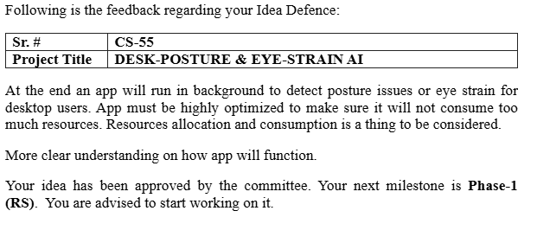
Phase 2 (SDS) Feedback (Screenshot)
[Paste the Phase 2 (SDS) feedback screenshot here]

Phase 3 (SDS) Feedback (Screenshot)
[Paste the Phase 3 (SDS) feedback screenshot here]

Abstract
Sitting for long hours in front of a computer causes poor posture and Computer Vision Syndrome (CVS) in students and office workers. Desk-Health-AI is a desktop application that uses only a normal webcam to detect slouching and sitting too close to the screen, without any wearable device. In our project, slouching is the combination of Forward Head Posture, Thoracic Kyphosis (rounded and dropped shoulders) and Posterior Pelvic Tilt. The user first records their upright posture (calibration) and the system then checks how much the posture changes from it, with the shoulders going down or moving forward as the main sign of slouching. The screen distance is calculated from the size of the iris, and the user is told to move back when closer than 50 cm. Alerts come only after continuous slouching for the time chosen by the user, and leaning back to rest pauses them. The system is built with Python (OpenCV, MediaPipe), Electron.js, React.js and a local SQLite database, works fully offline and never saves video. The data is protected by a local profile password. All 10 sprints (60 story points) are complete, and the final Windows installer was tested by our team on our own laptops with several days of real use.

Introduction and Background

Product Vision & Problem Context
Real-Time Problem Description:
- Today, people spend many continuous hours sitting in front of computer screens for work and study.
- This prolonged sitting often leads to bad habits, such as slouching or leaning too close to the screen, which users usually do not notice until they feel pain.
- These bad habits cause serious health issues, including chronic back pain, neck strain, and Computer Vision Syndrome (eye strain and dryness).
- While there are solutions available (like posture-correcting chairs or wearable sensors), they are highly expensive and require users to buy extra physical hardware, making them out of reach for students and average professionals.
Target Users:
- Students and Digital Learners: Individuals who spend hours attending online lectures or coding for university projects.
- Office Employees and Freelancers: Professionals who work at a desk for 4 or more hours a day and are at high risk of developing physical strain.
Objectives of the System:
- To continuously monitor the user's upper-body posture (slouching: shoulders dropping or moving forward, together with forward head movement) using only a standard built-in webcam.
- To calculate the distance between the user's face and the screen to prevent eye strain, and to ask the user to move back when they are too close.
- To provide smart, non-annoying desktop alerts only when the user stays in a bad posture for too long.
- To run completely in the background without slowing down the computer or distracting the user from their main work.
- To show users a graphical "Health Dashboard" so they can track their posture improvements over weeks and months.
User Research Conducted:
- Method Used: We conducted an online survey and one-on-one interviews to understand user pain points.
- Number of Participants: 15 participants for the survey and 5 participants for the interviews.
- Participant Types: The group included university computer science students, software developers, and operational office staff.
- Key Findings:
  - Over 80% of the participants reported feeling back or neck pain after long computer sessions.
  - During interviews, users strongly stated they would prefer a free or cheap software application over wearing a physical posture belt.
  - Users requested that the software must be "smart", meaning it should not send annoying alerts when they are simply relaxing or in a video meeting.
Expected Benefits and Potential Beneficiaries:
- Expected Benefits: The system will help users build long-lasting, healthy sitting habits. It will reduce daily muscle fatigue, prevent long-term spinal damage, and protect eyesight without requiring any financial investment in hardware.
- Potential Beneficiaries: The main beneficiaries are IT professionals, remote workers, students, and any individual whose daily life requires extensive computer usage.

Stakeholders Identification
1. General User (Students and Office Professionals)
- Role: The primary end-users who install and run the application on their personal computers or laptops.
- Expectations:
  - Expects the software to be completely free of lag so it does not slow down their games or work.
  - Expects the application to respect their privacy by never saving or sharing video recordings.
  - Expects the alerts to be accurate and not annoying when they are just trying to relax.
  - Expects a simple dashboard to see their posture improvement over time.
2. Corporate IT / HR Managers
- Role: Decision-makers who might deploy this software across an office or university lab to protect employee/student health.
- Expectations:
  - Expects the software to be highly secure and safe to install on company networks.
  - Expects that the application will automatically pause and not interfere with important software like Zoom or Microsoft Teams.
3. Project Supervisor and Evaluators (Academic Stakeholders)
- Role: The university faculty (Engr. Sajid Saleem) responsible for grading and validating the BSCS final year project.
- Expectations:
  - Expects the software to fully meet all the functional and technical requirements mentioned in the SRS document.
  - Expects the AI and computer vision models (MediaPipe/OpenCV) to detect posture accurately in real-time.
  - Expects the code to be clean, modular, and well-documented.
4. Physiotherapists and Ergonomic Experts (Indirect Users)
- Role: Health professionals who might view the application's data when treating a patient with back pain.
- Expectations:
  - Expects the Health Dashboard to clearly show the frequency and duration of poor posture.
  - Expects the data to be easy to read so they can use it to give better medical advice to the user.

Miscellaneous
Tools used: Visual Studio Code for development, Git and GitHub for version control, GitHub Actions for building the Windows setup automatically, pytest for unit testing and PyInstaller and electron-builder for packaging.
Meetings: short stand-up meetings three times a week (on campus or on WhatsApp calls) and a demo to our supervisor at the end of each sprint, as planned in Phase 1.
System requirements: a Windows 10 or 11 (64-bit) laptop or desktop with a webcam. No internet connection is needed after installation.

Sprint Breakdown and History

Completed Work: Sprints 1 – 10
Sprint goals and dates follow the plan in the Phase 1 SRS and the Phase 2 SDS. All ten sprints are complete. SP = story points.
Sprint | Objective / Focus Area | Key Features Delivered | Status | Planned Velocity | Delivered Velocity
Sprint 1 (1 – 28 Mar 2026) | Project initiation & requirements | Project setup, initial SRS draft, project repository set-up, Electron + React + Python technology stack selected | Completed | 4 SP | 4 SP
Sprint 2 (29 Mar – 25 Apr 2026) | Requirements & UI/UX design | Final SRS (Phase 1); digital wireframes for the Dashboard, Analytics, Alerts and Settings pages | Completed | 5 SP | 5 SP
Sprint 3 (26 Apr – 23 May 2026) | Frontend foundation | Base React.js template, modular component architecture, sidebar navigation | Completed | 5 SP | 5 SP
Sprint 4 (24 May – 20 Jun 2026) | Dashboard & settings | Main Health Dashboard layout, camera selection menu, eye-strain tracking toggle (Phase 2 SDS submitted) | Completed | 6 SP | 6 SP
Sprint 5 (1 – 28 Jul 2026) | Charts & notification UI | Weekly posture bar chart, today's split donut chart and hourly trend chart; in-app alert pop-up with Snooze and "too close" banner | Completed | 6 SP | 6 SP
Sprint 6 (29 Jul – 25 Aug 2026) | AI vision engine | OpenCV webcam capture; MediaPipe Pose Landmarker and Face Landmarker (including iris); live preview kept in memory only | Completed | 8 SP | 8 SP
Sprint 7 (26 Aug – 22 Sep 2026) | Slouch algorithm & screen distance | Slouch formula with the shoulders as the main part; posture calibration; posture score; resting state; iris-based screen distance and too-close detection | Completed | 7 SP | 7 SP
Sprint 8 (23 Sep – 20 Oct 2026) | Performance & background behaviour | Frame rate control (1 – 3 FPS); camera release during Zoom/Teams calls; system tray; first laptop test of the Windows setup and fixes | Completed | 6 SP | 6 SP
Sprint 9 (21 Oct – 17 Nov 2026) | SQLite database & native alerts | Sessions, posture logs, daily summaries and alert history saved in SQLite; Windows notifications; CSV export; profile password; resting state fixed after laptop testing (Phase 3 submitted) | Completed | 8 SP | 8 SP
Sprint 10 (18 Nov – 15 Dec 2026) | Live data & final testing | All dashboard views checked with several days of real data; final testing on our laptops; Windows installer for evaluation | Completed | 5 SP | 5 SP
Total delivered: 60 of 60 planned story points (100%).

Sprints 1 – 10 Retrospective Key Takeaways
- What went well: We built the React screens with sample data first (Sprints 3 to 5), so frontend work did not wait for the AI engine. Later the same screens were connected to the real data without changing the design.
- What went well: We wrote automated tests (pytest) for the posture logic, so we could change the limits safely after every laptop test.
- What went well: Testing the Windows setup on our own laptops in Sprints 8 to 10 found real problems (camera restart, shoulder drop, slumping and leaning back) that photos did not show, and all of them were fixed.
- Improvement area: We started real hardware testing late (Sprint 8). It should start as soon as the camera works.
- Improvement area: All code was pushed to one main branch from one account. Feature branches and pull requests would have shown each member's work more clearly.

Sprint-wise Design Evolution
The design changed as we built and tested each part. The table below shows what we designed in each sprint and what we improved.

Sprint | Features Designed | Improvements
Sprint 1 | System scope and technology stack | Desktop-only, offline design chosen for privacy; Electron + React + Python stack selected.
Sprint 2 | UI/UX wireframes | Paper sketches turned into digital wireframes; bar and pie charts chosen for posture data.
Sprint 3 | React architecture and routing | Single script replaced by modular React components with a sidebar navigation flow.
Sprint 4 | Settings and camera selection | Toggle switches and camera dropdown checked with sample data.
Sprint 5 | Charts and notification UI | Stacked weekly bars, donut and hourly trend charts; in-app alert pop-up with a Snooze button and a red "too close" banner.
Sprint 6 | AI vision engine | MediaPipe Pose Landmarker and Face Landmarker used (the older MediaPipe "Solutions" API is not available in current releases); frames processed in RAM only.
Sprint 7 | Slouch and distance algorithms | Slouching calculated with the formula FHP + Thoracic Kyphosis + PPT, with the shoulders as the main part. Calibration added (US-09) because a front webcam can only measure the change from the user's own upright posture. Screen distance from iris size, default limit 50 cm. Only the Python engine opens the database.
Sprint 8 | Background behaviour and robustness | Frame rate control and camera release during Zoom and Teams calls. After laptop testing: camera restart after Resume, shoulder drop detected even when moving away from the screen, slumping back shown as Slouching, Quit button added.
Sprint 9 | Database, native alerts and data protection | Alert history saves the alert duration and the user's action; daily summary saves resting and too-close time and a health score. Profile password added (saved only as a hash) with lock and auto-lock. Leaning back to rest is now Resting while slumping stays Slouching. The alert needs continuous slouching, and the dashboard shows both the current and the total slouching time.
Sprint 10 | Final testing with real data | No new design. The dashboards were checked with several days of real data on our laptops, and a small display fix was made in the slouching timer.

Screenshots/Prototype
This section shows the complete workflow of the system and the screens of the final application.

Workflow
Figure 1 shows the complete workflow of Desk-Health-AI in four lanes: the user, the desktop app (Electron and React), the AI engine (Python) and the SQLite database. After login and calibration, the AI engine repeats the tracking loop in the background until the app is paused or closed.
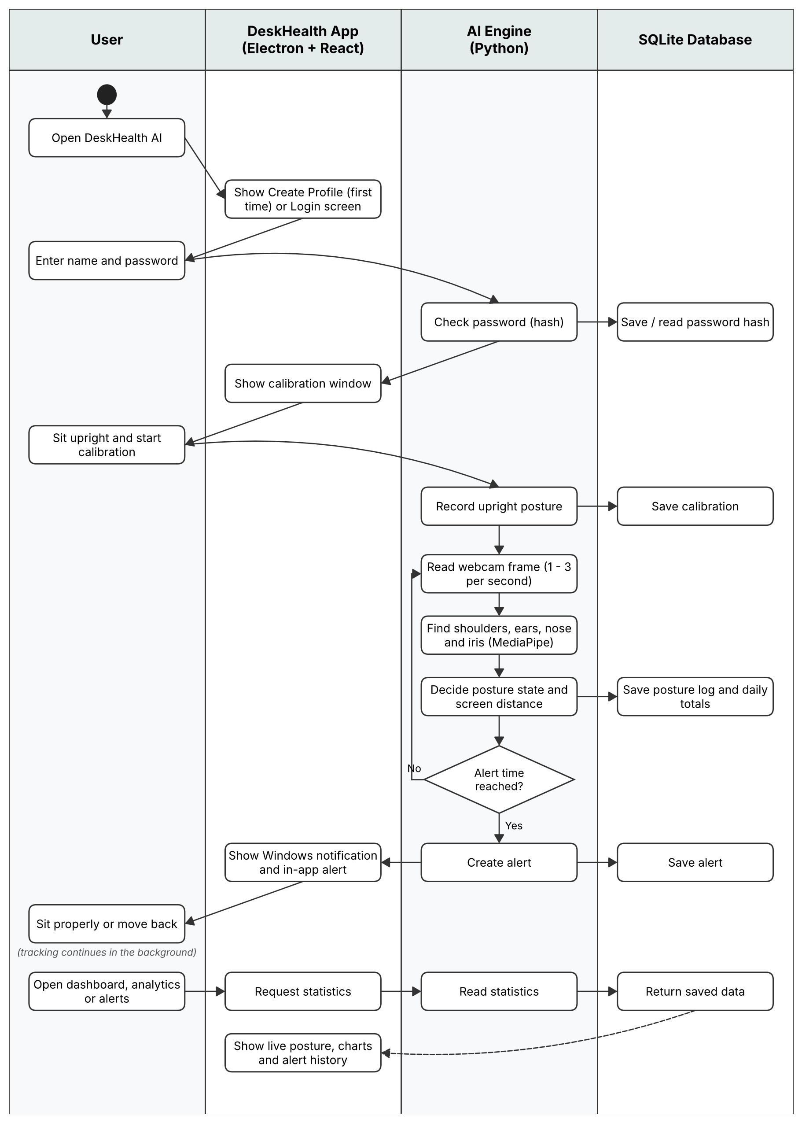
Figure 1: System workflow (swim-lane diagram)

Screens
On the first start the user creates a local profile with a name and a password.
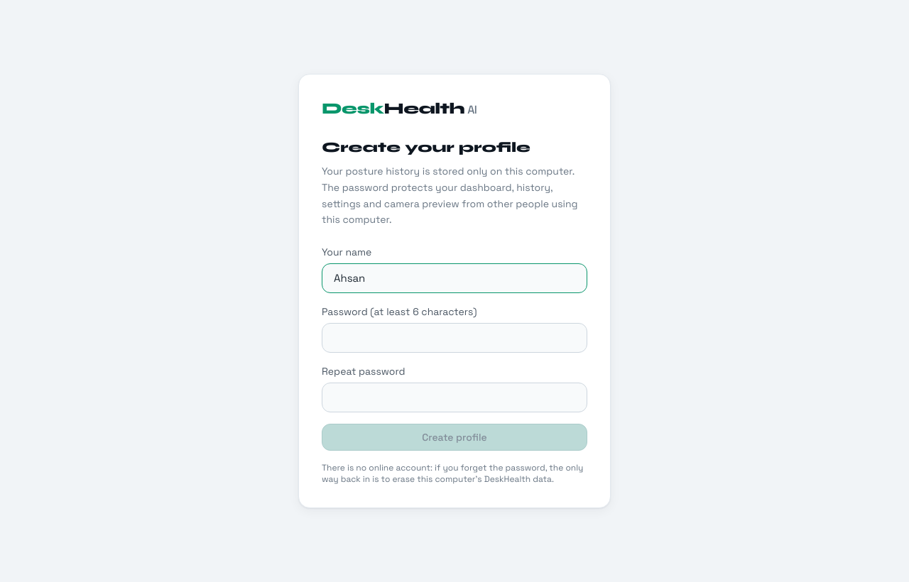
Figure 2: Create profile screen (first start)
On every later start, or after the app is locked, the password is asked. Tracking continues while the app is locked.
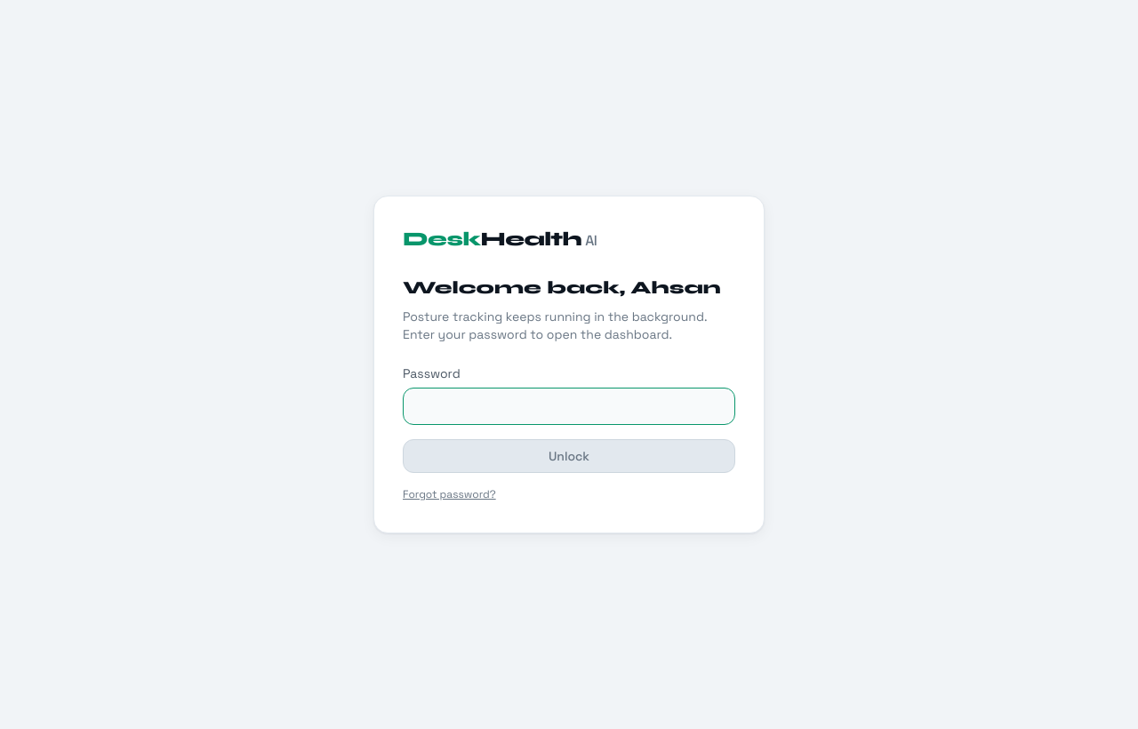
Figure 3: Login screen
The user sits upright and starts the calibration. It takes about 3 seconds.
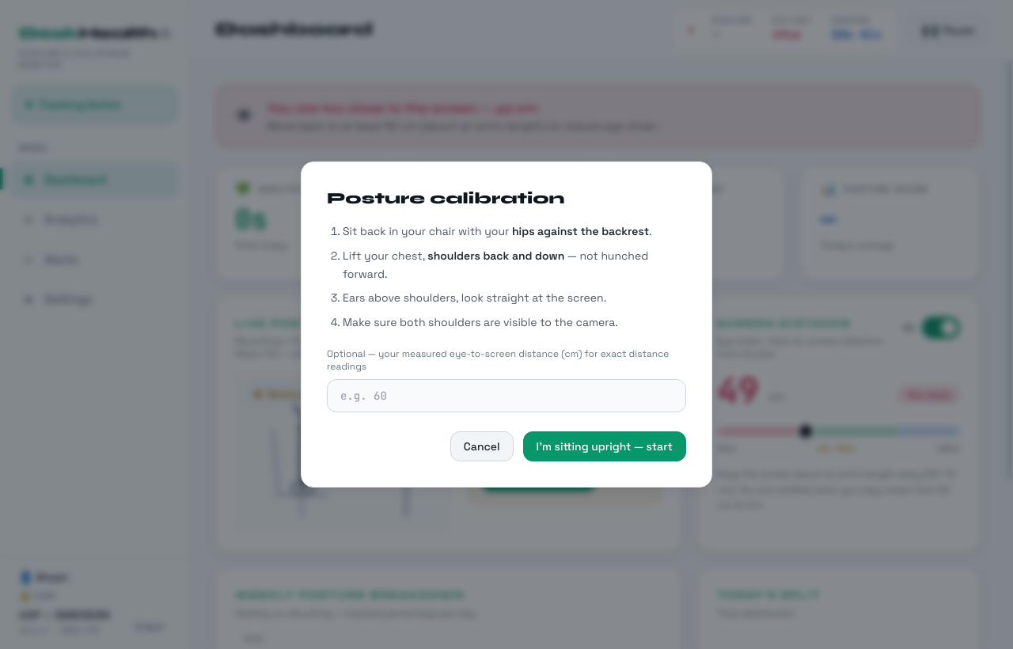
Figure 4: Posture calibration
The dashboard shows today's totals, the live posture with the score and the three parts of the slouch formula, the continuous slouching timer and the screen distance with its on/off switch.
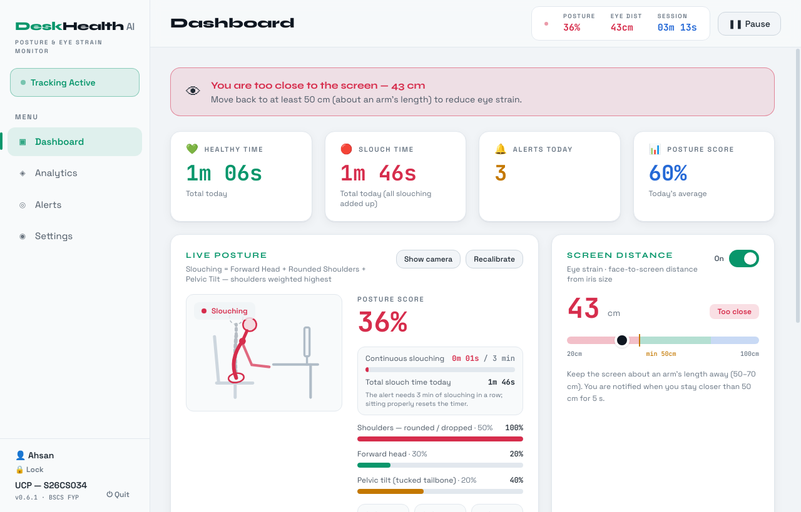
Figure 5: Dashboard with live posture and screen distance
Lower part of the dashboard with the weekly posture breakdown and today's split.
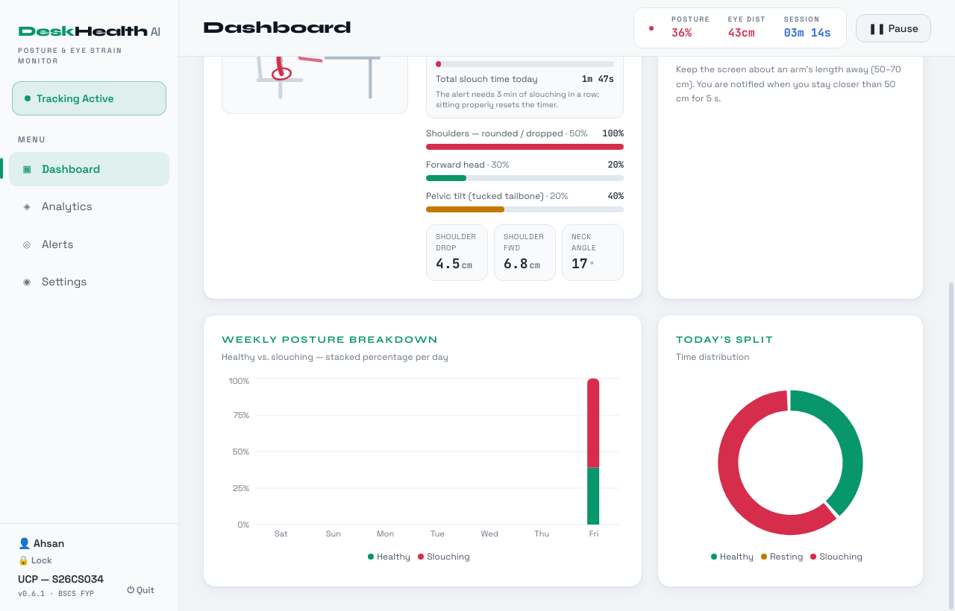
Figure 6: Dashboard charts
When the user stays too close to the screen, a red banner and an alert appear. The same alert is also shown as a Windows notification.
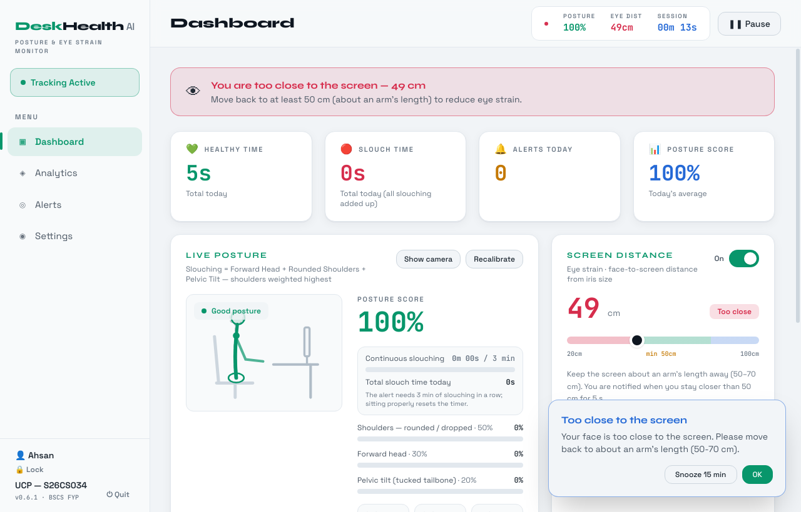
Figure 7: Too-close banner and alert pop-up
Weekly score, total alerts, best day, hourly trend and a daily log.
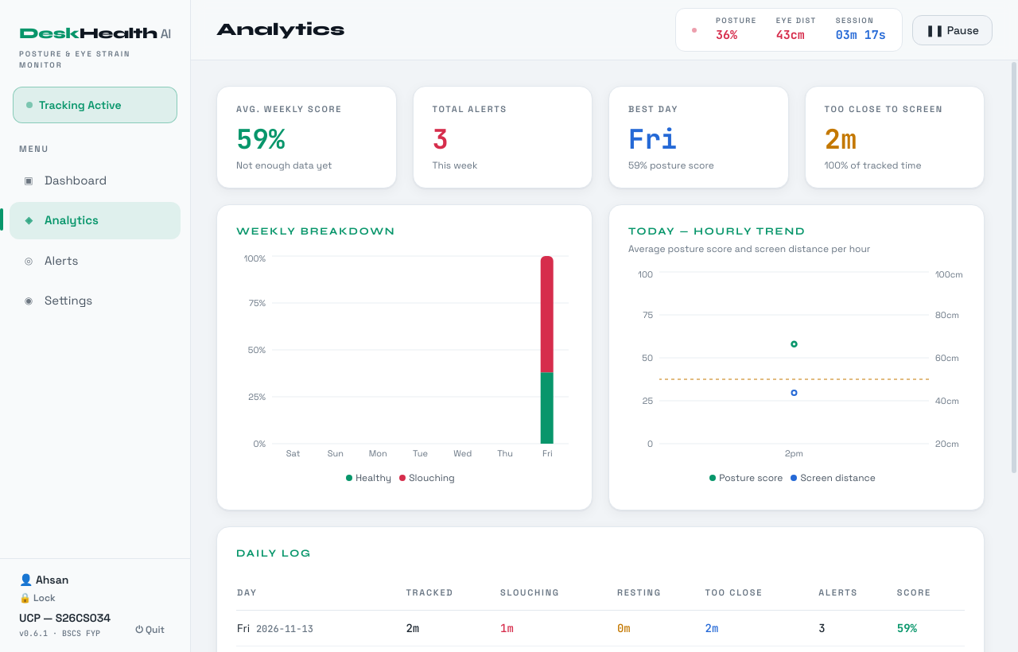
Figure 8: Analytics page
All alerts of the day with time, type and duration.
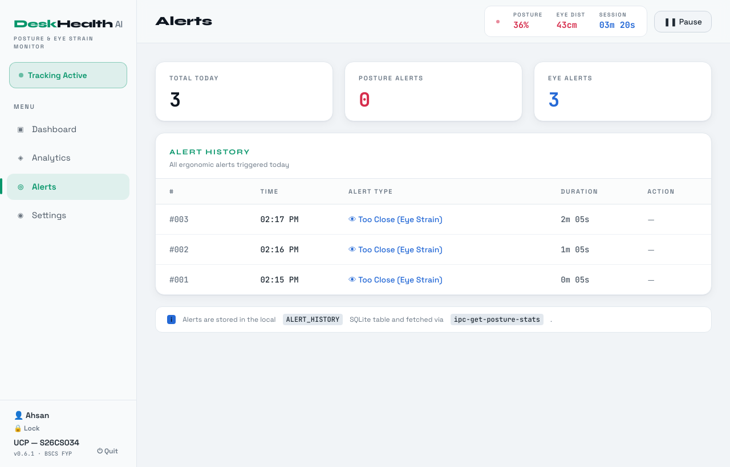
Figure 9: Alerts page
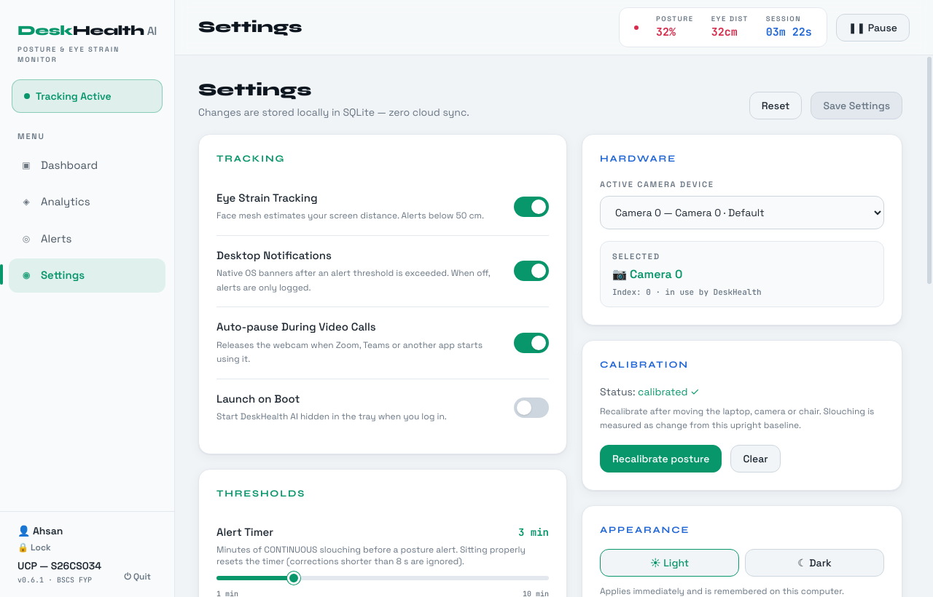
Figure 10: Settings page (tracking, hardware and calibration)
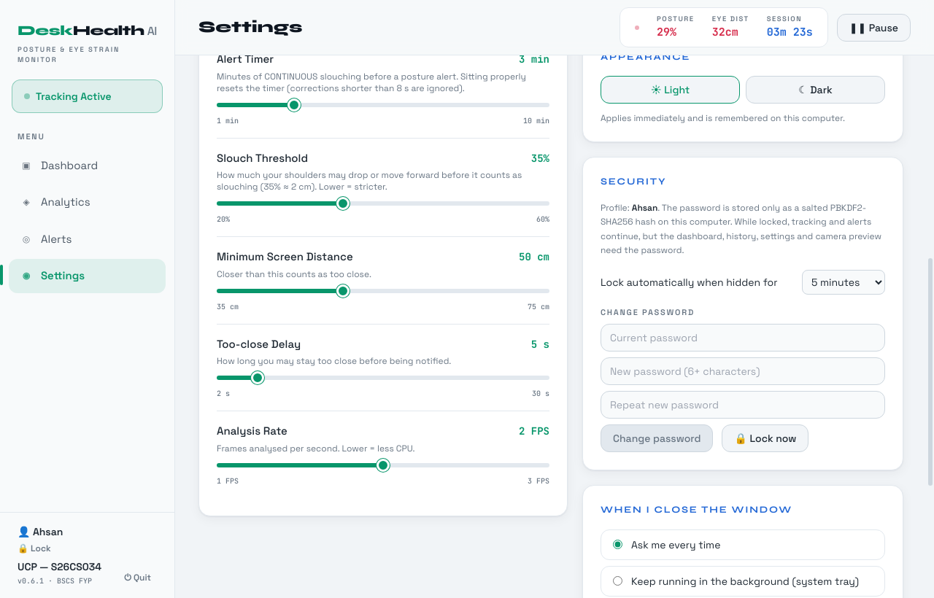
Figure 11: Settings page (thresholds and security)
Settings include eye-strain tracking, notifications, auto-pause for video calls, camera, alert timer, slouch threshold, minimum distance, frame rate, theme, auto-lock, password change, CSV export and clearing the history.
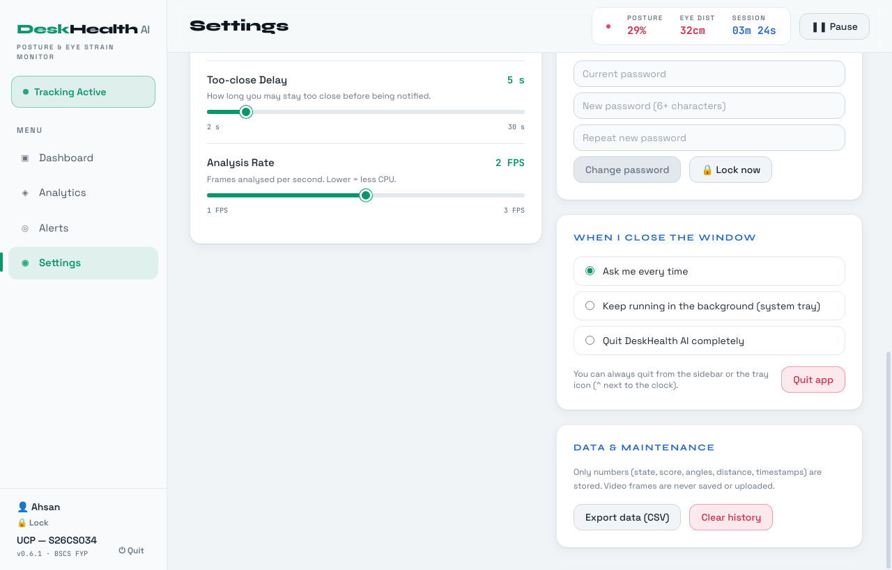
Figure 12: Settings page (close behaviour and data)

Additional Information
- System tray: when the window is closed the user can keep the app running in the system tray. The tray menu has Open Dashboard, Pause / Resume Tracking, Snooze alerts, Recalibrate posture, Lock and Quit.
- Windows notifications: posture and too-close alerts are shown as Windows notifications, even when the window is hidden.
- Themes: the app has a light theme (default) and a dark theme.
- Privacy: the camera preview is shown only when the user clicks Show camera. Video frames are never saved.

Active Execution: Sprint 9 & 10

Planned Sprint Overview
- Sprint 9 goal: integrate the local SQLite database and Windows desktop alerts (Phase 1 plan, Sprint 9).
- Sprint 10 goal: connect the UI to live data, final end-to-end testing and bug fixing (Phase 1 plan, Sprint 10).
- Duration: Sprint 9: 21 October – 17 November 2026; Sprint 10: 18 November – 15 December 2026.
- Estimated story points: 8 SP (Sprint 9) and 5 SP (Sprint 10).
- Status: both sprints are completed. Sprint 9 also included two items found during laptop testing: the profile password (PB-21) and the resting state fix (US-07).
Sprint | Focus Area/objective | Feature Description | Duration | Estimated Story Points
Sprint 09 | SQLite database integration & OS native alerts | Save sessions, posture logs, daily summaries and alert history in the local SQLite database.  Windows notifications for posture and too-close alerts; the user's action (Opened / Dismissed / Snoozed) is saved.  Export posture data to CSV.  Profile password with lock and auto-lock (PB-21); resting state fixed (US-07). | 21 Oct – 17 Nov 2026 | 8
Sprint 10 | Live data & final testing | Check all dashboard views with live data from several days of real use.  Final end-to-end testing on our laptops and bug fixing.  Windows installer for evaluation. | 18 Nov – 15 Dec 2026 | 5

User Stories and Product Backlog for Planned Sprints

Backlog ID | Epic | Feature Description | User Story ID | User Story | Priority | Estimated Story Points | Status
PB-09 | Health Analytics Dashboard | Set up the local SQLite database to securely save daily posture events | US-06 | As a user, I want to view a visual chart of my daily and weekly posture habits so that I can see if my back health is actually improving. | High | 5 | Done (Sprint 9)
PB-07 | Smart Notification System | Connect the app to Windows native notification systems to display alerts | US-04 | As a user, I want to receive a desktop alert only if I slouch for several minutes so that I am not annoyed by instant, constant warnings. | High | 3 | Done (Sprint 9)
PB-21 | Health Analytics Dashboard | Local profile password: hashed storage, lock / auto-lock, lock after wrong passwords, reset if forgotten | US-12 | As a user, I want my posture history and settings protected by a password so that other people using my computer cannot see or change them. | Medium | 2 | Done (Sprint 9)
PB-12, PB-13 | Health Analytics Dashboard | Main UI and charts showing live data (time in good vs. bad posture over the week) | US-06 | As a user, I want to view a visual chart of my daily and weekly posture habits so that I can see if my back health is actually improving. | Medium | 3 | Done (Sprint 10)
- | All epics | Final end-to-end testing, bug fixing and installer for evaluation (task, no user story) | - | - | High | 2 | Done (Sprint 10)
PB-21 was completed within Sprint 9, so the sprint plan of Phase 1 did not change.

Kanban Board / Task Tracking
Our tasks move through four columns: To Do, In Progress, Testing and Done. The Scrum Master updates the Kanban board and the team checks it in the stand-up meetings. A task is moved to Done only after it is tested. The board below shows the final state of the Sprint 9 and 10 tasks.
Kanban board – Sprints 9 & 10 (final)
To Do | In Progress | Testing | Done
- | - | Verify camera release during a live Zoom / Teams call (US-05) [update after the test] | SQLite logging of sessions, posture logs and daily summaries (PB-09)  Windows notifications with Opened / Dismissed / Snoozed logging (PB-07)  CSV export  Profile password, lock and auto-lock (PB-21)  Resting state fix (US-07)  Re-test of the Sprint 8 fixes on our laptops  Dashboards checked with several days of real data (PB-12, PB-13)  Final testing on our laptops  Windows installer for evaluation

Unit and Integration Testing

Overview
We tested the system at two levels. In unit testing we tested each Python module separately with pytest. In integration testing we joined the modules step by step, from the camera and AI models to the full desktop app, and then tested the Windows setup on our own laptops.
- Unit testing: 40 test cases for posture analysis, alerts, camera handling and the password. All 40 pass on our computer and on Windows (GitHub Actions). The React and Electron parts were tested in integration testing.
- Integration order: camera and MediaPipe (Sprint 6), then posture and distance with calibration (Sprint 7), then alerts, database and IPC (Sprints 7 to 9), then the full Electron and React app (Sprint 8), then the Windows setup on our laptops (Sprints 8 to 10).
- Integration result: the first laptop test (Sprint 8) found four problems: the camera did not start again after Resume, dropping the shoulders was not detected, slumping back was shown as Resting and the app could not be closed. In Sprint 9 we found that leaning back to rest was shown as Slouching. All five were fixed and passed the re-test on our laptops.
Unit test results
Feature / Unit | Framework | Test Cases Run | Pass / Fail | Notes
Posture analysis – posture.py (PostureAnalyzer, Baseline, Features, FeatureSmoother) | pytest | 19 | 19 / 0 | Tested with a simulated sitting person: sitting upright, small movements, slouching, shoulders only down, shoulders only forward, bending only the neck (should stay Healthy), leaning back to rest (Resting), slumping (Slouching), moving away from the screen and the posture score.
Alerts – notifier.py (NotificationManager) | pytest | 7 | 7 / 0 | Alert comes only after 3 minutes of continuous slouching, separate slouches are not added together, short breaks under 8 seconds do not reset the timer, too-close alert after 5 seconds, and snooze stops alerts.
Profile password – auth.py, database.py (AuthManager, DatabaseManager) | pytest | 11 | 11 / 0 | Password is saved as a hash, wrong and right password, lock after 5 wrong tries, password rules, change password, no data shown while locked, settings limits, reset profile and database upgrade.
Camera & engine control – vision.py, main.py (AIVisionEngine, Engine) | pytest with a simulated webcam | 3 | 3 / 0 | Camera starting time, camera opens again after Pause and Resume, and one missing frame is not treated as a disconnected camera.
All engine tests on Windows (GitHub Actions) | pytest | 40 | 40 / 0 | Run together with every Windows setup build.

Integration test results
Features Integrated | Sprint | Test Scenario | Expected Result | Actual Result | Status
AIVisionEngine + MediaPipe Pose / Face Landmarker | S6 | Front photos of a sitting person used as camera input | Shoulders, ears, nose and iris detected and drawn | As expected | Pass
AIVisionEngine + PostureAnalyzer + distance | S7 – S8 | Calibrate on an upright photo, then use copies with the shoulders lower, leaning in, slumped back and leaning back | Slouching, Slouching, Slouching, Resting | At first leaning back was Healthy and slumping back was Resting, fixed after changing the limits | Pass (after fix)
Distance estimation + NotificationManager | S7 | Face moved close for more than 5 s | Distance below 50 cm; too-close banner and Eye_Strain alert | Distance went from 49 to 31 cm, banner and alert shown | Pass
Engine + DatabaseManager (SQLite) + NotificationManager | S7 – S9 | Alert raised during tracking; settings updated; CSV export | Rows saved in ALERT_HISTORY and DAILY_SUMMARY, wrong settings ignored, CSV file saved | As expected | Pass
Electron + EngineBridge + Engine + React UI | S8 | Full desktop app with a demo video (upright, then slouching, then too close) | Live posture, score and distance shown, alert shown on the Alerts page | Healthy to Slouching in about 2 seconds, banner and alert shown | Pass
Windows setup on a laptop: Pause and Resume | S8, S10 | Pause tracking, then Resume | Camera tracking continues | S8: "Camera not accessible". Re-test: tracking continues | Fixed, re-test passed
Windows setup on a laptop: shoulders down | S8, S10 | Drop the shoulders from the calibrated position | Slouching | S8: Healthy. Re-test: Slouching | Fixed, re-test passed
Windows setup on a laptop: slump back | S8, S10 | Slump back in the chair, away from the screen | Slouching | S8: Resting. Re-test: Slouching | Fixed, re-test passed
Windows setup on a laptop: close & uninstall | S8, S10 | Close the app, then uninstall | App closes fully; uninstall works | S8: app kept running hidden. Re-test: closes and uninstalls | Fixed, re-test passed
Windows setup on a laptop: lean back to rest | S9, S10 | Recline in the chair with hands behind the head | Resting (alerts paused) | S9: Slouching. Re-test: Resting | Fixed, re-test passed
Electron + React + Engine: profile password | S9 | Create profile, calibrate, lock, enter wrong and right password, auto-lock, change password, quit | Data hidden until unlocked, wrong password rejected, password not saved as plain text, app closes fully | As expected | Pass
Complete system on our laptops: several days of use | S10 | Use the app for several days during normal work | Daily data saved; dashboard, analytics and alerts pages show the real data | As expected | Pass

Version Control
The code is managed with Git and hosted on GitHub in the repository ahsanjutt5844-bit/desk-health-ai. Every push to the main branch starts a GitHub Actions workflow on a Windows machine that runs the unit tests, builds the AI engine and publishes the Windows setup as a GitHub Release.
Workflow used (example: US-12 profile password): commit on the main branch, then GitHub Actions runs the tests and builds the Windows setup, then it is published as a release.

Sprint 09
User Story ID | US-12 | Backlog ID |  | PB-21
Assignee | M. Ahsan Rasool | Priority |  | Medium
Activity | What Students Should Do |  | Desk-Health-AI (actual)
Repository | Create one shared project repository |  | ahsanjutt5844-bit/desk-health-ai
Branch | Create a branch for each user story/feature |  | main (no feature branches)
Commit | Commit small, meaningful changes |  | adbc675 – "Recline = Resting, eye-strain switch, live slouch totals, security layer (v0.6.0)"
Pull Request | Submit completed feature for review |  | Not used – committed directly to main
Review & Test | Team member reviews and tests the feature |  | Unit tests passed locally and on GitHub Actions (Windows)
Merge | Merge approved code into main |  | main, then GitHub Actions build, then Release build-3
Contribution | Maintain visible work from each member |  | All commits pushed from M. Ahsan Rasool's account

Other Design Details
This section explains the main logic of the AI engine, which was not fully covered in the earlier documents.

Slouch Detection Method
A front webcam cannot see the body from the side, so the system first records the user's upright posture (calibration, 15 samples) and then compares every frame with it. Each part of the slouch formula gets a value from 0 to 1:
- Thoracic Kyphosis (50%): the shoulders going down, moving forward (the shoulders look wider) or rolling inward. This is the main part.
- Forward Head Posture (30%): the ears coming down towards the shoulders, converted to a neck angle.
- Posterior Pelvic Tilt (20%): the body getting shorter between shoulders and hips, or the whole upper body sinking when the hips are hidden by the desk.
Slouch index = 0.5 × Kyphosis + 0.3 × Forward Head + 0.2 × Pelvic Tilt, and Posture score = 100 × (1 − slouch index). The user is slouching when the shoulder part alone reaches the slouch threshold (default 35%, about 2 cm of shoulder movement), so bending only the neck, for example to look at a phone, is not slouching. Because moving towards or away from the camera changes the size of the body in the image, the shoulder drop is compared with where the shoulders should appear at the new distance.

Posture States
Figure 13 shows the states of the tracking engine. Resting is checked first: the user is resting when the shoulders move at least 12 cm back from the calibrated position and do not drop more than the recline explains. Slumping into the chair is still slouching. Once resting, the state stays until the user clearly sits up or slumps, so it does not switch on and off at the limit.
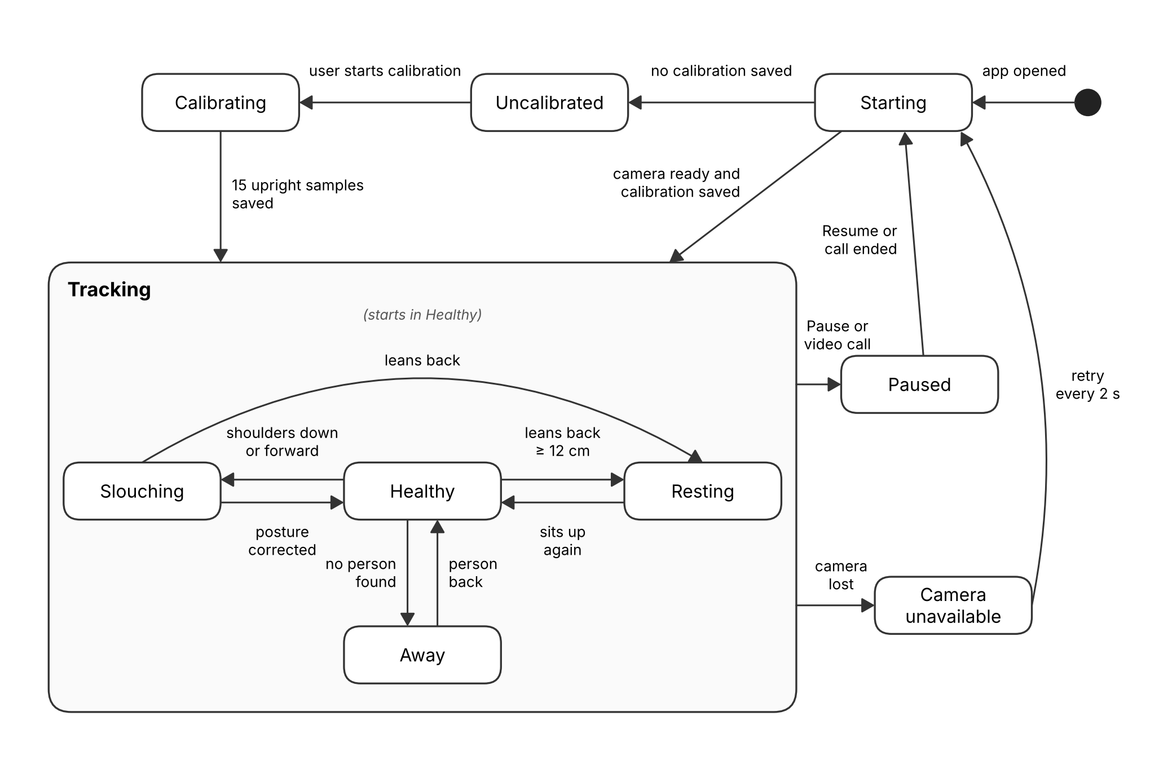
Figure 13: State diagram of posture tracking

Screen Distance Estimation
The distance between the face and the screen is calculated with the pinhole camera model: distance = focal length × real size ÷ size in pixels. Two face sizes from MediaPipe are used and averaged: the iris diameter (about 1.17 cm) and the distance between the pupils (about 6.3 cm). The user can enter the measured distance once during calibration to make it exact. If the user stays closer than the minimum distance (default 50 cm) for 5 seconds, a too-close alert is shown, at most once every 60 seconds.

Alert Timer
A posture alert comes only after the user has slouched continuously for the alert time set in Settings (1 to 10 minutes, default 3). Separate slouches are not added together. A break shorter than 8 seconds, for example a quick correction or a camera frame without a person, does not restart the timer. Sitting properly, resting or leaving the desk for longer resets it. Snooze stops all alerts for 15 minutes to 1 hour.

Data Protection
- The password is never saved. Only a PBKDF2-HMAC-SHA256 hash with a random salt and 600,000 rounds is saved in USER_PROFILE.
- After 5 wrong passwords the login waits 30 seconds, and the wait doubles up to 5 minutes.
- The AI engine does not send any data (history, settings, camera preview, export) while the app is locked. The app locks itself after it has been hidden or minimised for 5 minutes (can be changed).
- Video frames are processed in memory and never saved, and the app works fully offline (NFR-09, NFR-10).

Test Specification and Results

Test Case Specification
The test cases below cover the user stories of the SRS and the items added later. The actual results come from our tests on our own laptops and from the automated tests.
Table 7.1: TC-1
Identifier | TC-1
Related requirements(s) | US-12 / PB-21
Short description | Create a profile and log in
Pre-condition(s) | App installed and opened for the first time
Input data | Name: Ahsan, password: secret123
Detailed steps | 1. Open the app  2. Enter name and password twice and click Create profile  3. Close and open the app again  4. Enter the password and click Unlock
Expected result(s) | Profile is created; on the next start the login screen asks for the password and opens the dashboard
Post-condition(s) | Dashboard is open
Actual result(s) | As expected
Test Case Result | Pass

Table 7.2: TC-2
Identifier | TC-2
Related requirements(s) | US-12 / PB-21
Short description | Wrong password and lock-out
Pre-condition(s) | Profile exists, app is locked
Input data | Wrong password entered 5 times
Detailed steps | 1. Enter a wrong password  2. Repeat 5 times  3. Enter the right password after the wait
Expected result(s) | Each wrong password is rejected with the attempts left; after 5 tries login waits 30 seconds; the right password then works
Post-condition(s) | Dashboard is open
Actual result(s) | As expected
Test Case Result | Pass

Table 7.3: TC-3
Identifier | TC-3
Related requirements(s) | US-09 / PB-18
Short description | Posture calibration
Pre-condition(s) | Profile unlocked, user sitting upright in front of the webcam
Input data | Upright posture
Detailed steps | 1. Click Recalibrate  2. Sit upright and click start  3. Wait about 3 seconds
Expected result(s) | Progress bar fills and "Calibration saved" is shown; status changes to calibrated
Post-condition(s) | Calibration saved in USER_SETTINGS
Actual result(s) | As expected
Test Case Result | Pass

Table 7.4: TC-4
Identifier | TC-4
Related requirements(s) | US-01 / UC-01
Short description | Shoulders going down is slouching
Pre-condition(s) | Calibrated, tracking active
Input data | User drops the shoulders about 3 cm
Detailed steps | 1. Sit upright for a few seconds  2. Drop the shoulders and stay
Expected result(s) | State changes from Good posture to Slouching within a few seconds; shoulder part rises
Post-condition(s) | Slouching time increases
Actual result(s) | As expected on our laptops
Test Case Result | Pass

Table 7.5: TC-5
Identifier | TC-5
Related requirements(s) | US-01 / UC-01
Short description | Slumping back in the chair is slouching
Pre-condition(s) | Calibrated, tracking active
Input data | User slides down and slumps back
Detailed steps | 1. Slump back in the chair, away from the screen
Expected result(s) | State is Slouching (not Resting)
Post-condition(s) | Slouching time increases
Actual result(s) | As expected on our laptops
Test Case Result | Pass

Table 7.6: TC-6
Identifier | TC-6
Related requirements(s) | US-07 / UC-05
Short description | Leaning back to rest
Pre-condition(s) | Calibrated, tracking active
Input data | User reclines with hands behind the head
Detailed steps | 1. Lean far back in the chair to rest
Expected result(s) | State is Resting, no posture score, alerts paused
Post-condition(s) | Resting time increases
Actual result(s) | As expected on our laptops
Test Case Result | Pass

Table 7.7: TC-7
Identifier | TC-7
Related requirements(s) | US-01
Short description | Bending only the neck is not slouching
Pre-condition(s) | Calibrated, tracking active
Input data | User looks down at a phone, shoulders stay
Detailed steps | 1. Bend only the neck forward
Expected result(s) | State stays Good posture; forward head part rises
Post-condition(s) | No slouching time added
Actual result(s) | As expected (automated test)
Test Case Result | Pass

Table 7.8: TC-8
Identifier | TC-8
Related requirements(s) | US-02 / UC-02, PB-19
Short description | Too close to the screen
Pre-condition(s) | Calibrated, eye-strain tracking on
Input data | Face closer than 50 cm
Detailed steps | 1. Move the face close to the screen  2. Stay for more than 5 seconds
Expected result(s) | Red banner on the dashboard and a too-close alert after 5 seconds
Post-condition(s) | Alert saved in ALERT_HISTORY
Actual result(s) | As expected
Test Case Result | Pass

Table 7.9: TC-9
Identifier | TC-9
Related requirements(s) | US-04 / UC-03
Short description | Posture alert only after continuous slouching
Pre-condition(s) | Alert timer 3 minutes
Input data | Slouching for 3 minutes; and 2 min + break + 2 min
Detailed steps | 1. Slouch continuously for 3 minutes  2. Then slouch 2 minutes, sit properly 30 seconds, slouch 2 minutes
Expected result(s) | Alert after 3 continuous minutes; no alert for the separate slouches
Post-condition(s) | Alert saved in ALERT_HISTORY
Actual result(s) | As expected (automated test)
Test Case Result | Pass

Table 7.10: TC-10
Identifier | TC-10
Related requirements(s) | US-08 / UC-07
Short description | Change the alert timer
Pre-condition(s) | Profile unlocked
Input data | Alert timer changed in Settings
Detailed steps | 1. Open Settings  2. Move the Alert Timer slider  3. Click Save Settings
Expected result(s) | Setting is saved and the dashboard timer shows the new limit
Post-condition(s) | New value in USER_SETTINGS
Actual result(s) | As expected (tested with 1 and 3 minutes)
Test Case Result | Pass

Table 7.11: TC-11
Identifier | TC-11
Related requirements(s) | PB-16
Short description | Turn eye-strain tracking off
Pre-condition(s) | Tracking active
Input data | Switch on the Screen distance panel
Detailed steps | 1. Click the On/Off switch
Expected result(s) | Distance is no longer measured and no too-close alerts are shown
Post-condition(s) | Setting saved
Actual result(s) | As expected
Test Case Result | Pass

Table 7.12: TC-12
Identifier | TC-12
Related requirements(s) | US-03 / UC-04
Short description | Run in the system tray
Pre-condition(s) | App open
Input data | Close button (X)
Detailed steps | 1. Click X and choose Keep running in background  2. Open the tray menu
Expected result(s) | Window hides, tray icon stays, tracking continues
Post-condition(s) | App running in the tray
Actual result(s) | As expected on our laptops
Test Case Result | Pass

Table 7.13: TC-13
Identifier | TC-13
Related requirements(s) | UC-04
Short description | Pause and Resume the camera
Pre-condition(s) | Tracking active
Input data | Pause, then Resume
Detailed steps | 1. Click Pause  2. Click Resume
Expected result(s) | Camera is released on Pause and tracking starts again on Resume
Post-condition(s) | Tracking active
Actual result(s) | As expected on our laptops (after the Sprint 8 fix)
Test Case Result | Pass

Table 7.14: TC-14
Identifier | TC-14
Related requirements(s) | US-05 / UC-04
Short description | Release the camera during a video call
Pre-condition(s) | Tracking active, auto-pause on
Input data | Zoom or Teams video call
Detailed steps | 1. Start a Zoom or Teams call with the camera on  2. End the call
Expected result(s) | App pauses and Zoom/Teams can use the camera; tracking starts again after the call
Post-condition(s) | Tracking active
Actual result(s) | [Fill after the live call test]
Test Case Result | [Pass / Fail]

Table 7.15: TC-15
Identifier | TC-15
Related requirements(s) | US-06 / UC-06
Short description | Dashboard and analytics with real data
Pre-condition(s) | App used for several days
Input data | Several days of real use
Detailed steps | 1. Open the Dashboard  2. Open Analytics and Alerts
Expected result(s) | Charts and tables show the saved data of each day
Post-condition(s) | -
Actual result(s) | As expected on our laptops
Test Case Result | Pass

Table 7.16: TC-16
Identifier | TC-16
Related requirements(s) | TD-07
Short description | Export posture data
Pre-condition(s) | Profile unlocked
Input data | Export data (CSV) in Settings
Detailed steps | 1. Click Export data (CSV)  2. Choose a folder and save
Expected result(s) | A CSV file with the posture logs is saved
Post-condition(s) | CSV file on the computer
Actual result(s) | As expected
Test Case Result | Pass

Table 7.17: TC-17
Identifier | TC-17
Related requirements(s) | PB-20
Short description | Quit and uninstall
Pre-condition(s) | App running
Input data | Quit, then uninstall from Windows Settings
Detailed steps | 1. Click Quit in the sidebar or tray  2. Uninstall from Windows Settings, Apps
Expected result(s) | App and AI engine close fully and uninstall works
Post-condition(s) | App removed
Actual result(s) | As expected on our laptops (after the Sprint 8 fix)
Test Case Result | Pass

Summary of Test Results
The table below shows the problems (defects) found in each part of the software and how many of them were fixed.
Table 7.18: Summary of All Test Results
Feature Name | Test cases run | Number of defects found | Number of defects corrected so far | Number of defects still need to be corrected
Profile password | TC-1, TC-2 | 2 | 2 | 0
Posture detection (calibration, slouching, resting) | TC-3 to TC-7 | 4 | 4 | 0
Screen distance | TC-8, TC-11 | 0 | 0 | 0
Alerts and alert timer | TC-9, TC-10 | 1 | 1 | 0
Background, camera and tray | TC-12, TC-13, TC-14, TC-17 | 2 | 2 | 0
Dashboard, analytics and data | TC-15, TC-16 | 0 | 0 | 0
Complete System | 17 test cases | 9 | 9 | 0
Defects found: the app did not lock when minimised and a second copy of the app could start (profile password); shoulder drop not detected, slumping back shown as Resting, leaning back shown as Slouching and Resting switching on and off at the limit (posture detection); one lost camera frame restarted the alert timer (alerts); camera did not restart after Resume and the app could not be closed (background). TC-14 (live video call) is still to be tested.

Project Completion Status
All features planned in the Phase 1 SRS are complete for Windows. The table also lists the features we added that were not part of the original requirements.
Table 8.1: Project Completion Status
Feature Name | Status  (Complete, Partially Implemented, Not Implemented)
Slouch detection with the shoulders as the main part (US-01) | Complete
Screen distance and too-close detection (US-02) | Complete
Run in the system tray (US-03) | Complete
Smart timed alerts and Windows notifications (US-04) | Complete
Release the camera during video calls (US-05) | Complete (live Zoom / Teams test: [to be confirmed])
Health dashboard and charts (US-06) | Complete
Resting state detection and Snooze (US-07) | Complete
Custom alert timer and settings (US-08) | Complete
Local SQLite database | Complete
Windows installer | Complete
macOS version (NFR-11) | Not Implemented (only the Windows version was built and tested)
Additional: posture calibration (US-09) | Complete
Additional: too-close notification (US-10) | Complete
Additional: Quit option and close-window choice (US-11) | Complete
Additional: profile password, lock and auto-lock (US-12) | Complete
Additional: CSV export, light and dark theme | Complete
Complete System | Complete for Windows
The table below shows how many of the objectives in Section 1.1 have been met.
Table 8.2: Objective(s)/Target(s) Status
Target/Objective | Status  (Completed,  Partially Completed,  Not Completed) | Reason(s)
Monitor the user's posture (slouching) with a normal webcam | Completed
Calculate the screen distance and ask the user to move back | Completed
Smart, non-annoying alerts only after bad posture for too long | Completed
Run in the background without slowing down the computer | Completed | Analysis is limited to 1 – 3 frames per second. [CPU use measured on our laptop: __ %]
Health dashboard to track improvement over weeks and months | Partially Completed | Daily and weekly charts are available, but there is no monthly view. All data can be exported to CSV.
Number of Targets Completed | 4
Number of Targets Partially Completed | 1
Number of Targets Not Completed | 0

Deployment/Installation Guide
Installing the application (users):
- Use a Windows 10 or 11 (64-bit) computer with a webcam.
- Download DeskHealth-AI-Setup-0.6.1.exe from the Releases page of our GitHub repository (github.com/ahsanjutt5844-bit/desk-health-ai/releases).
- Double-click the file. Windows may show "Windows protected your PC" because the setup is not signed: click More info, then Run anyway.
- The setup installs the app in one step, creates a desktop shortcut and starts DeskHealth AI. Python or any other software is not needed.
- If Windows blocks the camera, open Settings, Privacy & security, Camera, and turn on Camera access and Let desktop apps access your camera.
Uninstalling:
- Click Quit in the app (sidebar or tray menu), then open Windows Settings, Apps, Installed apps, find DeskHealth AI and click Uninstall.
- The user's data is kept in %APPDATA%\DeskHealth AI\deskhealth.db and can be deleted by hand.
Running from the source code (developers):
- Install Node.js 20 or newer and Python 3.10 to 3.12 (64-bit).
- Clone the repository: git clone https://github.com/ahsanjutt5844-bit/desk-health-ai.git
- Create the Python environment: python -m venv engine\.venv, then engine\.venv\Scripts\pip install -r engine\requirements.txt
- Install the app packages: npm install
- Start the app: npm run dev (with live reload) or npm start.
- Run the unit tests: engine\.venv\Scripts\python -m pytest engine\tests -q
- Build the Windows setup: npm run dist (the setup file is saved in the release folder).

User Manual
1. First start
- Enter your name and a password (at least 6 characters) and click Create profile.
- The calibration window opens. Sit back in your chair, lift your chest, keep your shoulders back and down and make sure both shoulders are visible to the camera. Click "I'm sitting upright – start" and hold still for about 3 seconds.
- Optional: enter your measured eye-to-screen distance in cm before starting, for exact distance readings.
2. Dashboard
- The top cards show healthy time, slouch time, alerts and the average posture score of today.
- Live posture shows your current state (Good posture, Slouching, Resting or Away), the posture score and the three parts of the slouch formula.
- Continuous slouching shows how long you have been slouching without a break, compared with the alert time. Total slouch time today adds up all slouching.
- Screen distance shows how far your face is from the screen. Use the On/Off switch to turn eye-strain tracking off.
- Click Show camera to see the camera preview, and Recalibrate after moving your chair, laptop or camera.
3. Alerts
- A Windows notification appears when you slouch continuously for the alert time (default 3 minutes) or stay too close to the screen for 5 seconds.
- Click Snooze 15 min on the pop-up, or use Snooze alerts in the tray menu, to stop alerts for a while.
- Leaning back in your chair to rest pauses posture alerts.
- The Alerts page shows all alerts of today.
4. Analytics
- Shows the average weekly score, total alerts, best day, the weekly breakdown, today's hourly trend and a daily log.
5. Settings
- Tracking: eye-strain tracking, desktop notifications, auto-pause during video calls, launch on boot.
- Thresholds: alert timer (1 – 10 minutes), slouch threshold, minimum screen distance, too-close delay and analysis rate.
- Hardware: choose the camera. Appearance: light or dark theme.
- Security: auto-lock time, change password and Lock now.
- Data: export the data to CSV or clear the history. Click Save Settings after changing a value.
6. Pause, lock and quit
- Click Pause at the top to stop tracking and release the camera; click Resume to continue.
- Click Lock in the sidebar to lock the dashboard. Tracking continues while it is locked.
- Closing the window asks whether to keep running in the background or quit. Click Quit in the sidebar or tray menu to close the app completely.
- Forgot your password? Click "Forgot password?" on the login screen and type RESET. This deletes all DeskHealth data on this computer so you can create a new profile.

References
[1] World Health Organization, "Physical activity," Fact Sheet, WHO, 2024. [Online]. Available: https://www.who.int/news-room/fact-sheets/detail/physical-activity
[2] A. K. Singh, V. A. Kumbhare, and K. Arthi, "Real-time human pose detection and recognition using MediaPipe," in Soft Computing and Signal Processing (ICSCSP 2021), Advances in Intelligent Systems and Computing, vol. 1413, pp. 145-154, Springer, Singapore, 2022.
[3] L. V. Kallings, O. Ekblom, and M. Hemmingsson, "Workplace sitting is associated with self-reported general health and back/neck pain: A cross-sectional analysis in 44,978 employees," BMC Public Health, vol. 21, no. 875, 2021, doi: 10.1186/s12889-021-10893-8.
[4] C. Blehm, S. Vishnu, A. Khattak, S. Mitra, and R. W. Yee, "Computer vision syndrome: A review," Survey of Ophthalmology, vol. 50, no. 3, pp. 253-262, 2005.
[5] F. P. Kendall, E. K. McCreary, P. G. Provance, M. M. Rodgers, and W. A. Romani, Muscles: Testing and Function, with Posture and Pain, 5th ed. Baltimore, MD, USA: Lippincott Williams & Wilkins, 2005.
[6] Google, "Pose landmark detection guide," MediaPipe Solutions, Google AI for Developers, 2024. [Online]. Available: https://ai.google.dev/edge/mediapipe/solutions/vision/pose_landmarker
[7] Google, "Face landmark detection guide," MediaPipe Solutions, Google AI for Developers, 2024. [Online]. Available: https://ai.google.dev/edge/mediapipe/solutions/vision/face_landmarker
[8] A. Vakunov and D. Lagun, "MediaPipe Iris: Real-time iris tracking & depth estimation," Google AI Blog, Aug. 2020. [Online]. Available: https://ai.googleblog.com/2020/08/mediapipe-iris-real-time-iris-tracking.html
[9] Occupational Safety and Health Administration, "Computer Workstations eTool: Monitors," U.S. Department of Labor. [Online]. Available: https://www.osha.gov/etools/computer-workstations/components/monitors
[10] OWASP Foundation, "Password Storage Cheat Sheet," OWASP Cheat Sheet Series, 2024. [Online]. Available: https://cheatsheetseries.owasp.org/cheatsheets/Password_Storage_Cheat_Sheet.html
[11] OpenCV Team, "OpenCV Documentation," OpenCV, 2024. [Online]. Available: https://docs.opencv.org
[12] Electron.js Contributors, "Electron Documentation," Electron, 2024. [Online]. Available: https://www.electronjs.org/docs/latest
[13] Meta Open Source, "React Documentation," 2024. [Online]. Available: https://react.dev
[14] SQLite Consortium, "SQLite Documentation," 2024. [Online]. Available: https://www.sqlite.org/docs.html
[15] pytest-dev, "pytest Documentation," 2024. [Online]. Available: https://docs.pytest.org
[16] PyInstaller Development Team, "PyInstaller Manual," 2024. [Online]. Available: https://pyinstaller.org/en/stable/
[17] Object Management Group, "Unified Modeling Language (UML), Version 2.5.1," OMG, Dec. 2017. [Online]. Available: https://www.omg.org/spec/UML/2.5.1

Project Summary Form
Name of Project | Desk-Posture & Eye Strain (Desk-Health-AI)
Project Type | Software Development (Desktop Application)
Department | Computer Science
Start Date | 01/03/2026
Completion Date | 15/12/2026
Supervisor / Team Leader | Engr. Sajid Saleem (Supervisor); M. Umair Khushnood (Scrum Master)
Team Members (if any) | M. Umair Khushnood (L1S23BSCS0329), M. Ahsan Rasool (L1F22BSCS1031), Saim Rafaqat (L1S23BSCS0363)
Funding Agency (if any) | None
Amount of Funding (if any) | None
Assign SDGs to Project | SDG 3: Good Health and Well-being
Motivation of Project | Students and office workers sit for many hours at a computer and develop back pain, neck strain and eye strain. Existing solutions need expensive hardware, so we wanted a free software solution that only needs a webcam.
Practical / Potential Application | Personal use by students, programmers and office workers; computer labs in universities and offices; a tool for physiotherapists to see how often a patient slouches.
Abstract | A Windows desktop app that uses a normal webcam and AI (MediaPipe) to detect slouching, with the shoulders as the main sign, and sitting too close to the screen. It gives smart alerts only after continuous bad posture, pauses during rest and video calls, and shows daily and weekly charts. It works fully offline and never saves video.
Key Technical Features | Webcam posture analysis with MediaPipe Pose and Face Landmarker; slouch formula (Forward Head + Thoracic Kyphosis + Pelvic Tilt) with personal calibration; iris-based distance estimation; continuous-slouch alert timer; resting detection; automatic camera release for Zoom/Teams; system tray app built with Electron and React; local SQLite database with a password-protected profile.
Projects Images / Screenshots

Appendix A: Glossary
- Baseline (Calibration): The user's upright posture recorded during calibration; all posture changes are measured against it.
- CVS (Computer Vision Syndrome): Eye problems (dry eyes, blurred vision, eye strain) caused by long screen use or sitting too close to the screen.
- Electron.js: Framework used to build the desktop application (window, system tray, notifications) with web technologies.
- ERD (Entity-Relationship Diagram): Diagram of the database tables, their columns and the relationships between them.
- Forward Head Posture (FHP): The head moving forward and down in front of the shoulders; the second part of the slouch formula.
- FPS (Frames Per Second): How many camera images are analysed per second; limited to 1 – 3 FPS to save CPU and battery.
- GitHub Actions: GitHub's automation service; used to run the tests and build the Windows setup on every push.
- IPC (Inter-Process Communication): Messages exchanged between the React interface, the Electron main process and the Python engine.
- Kanban Board: Board that shows tasks moving through To Do, In Progress, Testing and Done.
- Landmark: A tracked body or face point (e.g. shoulder, ear, nose, iris) returned by MediaPipe.
- MediaPipe: Google's on-device machine-learning library; its Pose Landmarker and Face Landmarker models track the user.
- OpenCV: Library used to open the webcam and process video frames.
- PBKDF2 (Password Hashing): Method that turns a password and a random salt into a hash by repeating a hash function many times; the app saves only this hash.
- Pinhole Camera Model: Distance = focal length × real size ÷ size in pixels; used with the iris size to estimate the screen distance.
- Posterior Pelvic Tilt (PPT): The tailbone tucking under, often by sliding down in the chair; the third part of the slouch formula.
- Posture Score: 100 × (1 − slouch index); 100 means the calibrated upright posture.
- PyInstaller: Tool that bundles the Python engine so the installed app does not need Python on the user's computer.
- React.js: Library used to build the Health Dashboard interface.
- Resting State: The user leaning back in the chair to rest (shoulders at least 12 cm behind the calibrated position); posture alerts are paused.
- Slouch Index: 0.5 × Thoracic Kyphosis + 0.3 × Forward Head Posture + 0.2 × Posterior Pelvic Tilt, each from 0 to 1.
- Sprint: A fixed four-week period in which the team completes a planned set of backlog items.
- SQLite: Local database file that stores settings and posture data on the user's own computer.
- Story Point (SP): Relative estimate of the effort for a backlog item.
- Swim-lane Diagram: Workflow diagram in which each column (lane) shows the steps done by one part of the system.
- System Tray: Notification area of the Windows taskbar where the app keeps running in the background.
- Thoracic Kyphosis: Rounding of the upper back that makes the shoulders drop and move forward; the main (50%) part of the slouch formula.

Appendix B: Sprint and Phase Retrospective Report

Advisor Name Signature

Retrospective Overview
This appendix contains the retrospectives of Sprint 9 and Sprint 10.

Retrospective Header – Sprint 9
Team Name / Project Name | S26CS034 – Desk-Health-AI (Desk-Posture & Eye Strain)
Phase | Phase 4
Sprint / Cycle Number | Sprint 9 (21 Oct – 17 Nov 2026)
Date | [dd/mm/yyyy – to be filled by the team]
Facilitator | [Name of the member who facilitated this retrospective]
Attendees | M. Umair Khushnood, M. Ahsan Rasool, Saim Rafaqat
Supervisor Present | [Yes / No]

Sprint Summary: Planned, Achieved, and Carried Forward – Sprint 9
Type | Item / Artefact ID | Description | Status | If Not Achieved, Why
Epic | EP-04 | Health Analytics Dashboard: save the posture data in the local SQLite database | Achieved
User Story | US-06 / PB-09 | Save sessions, posture logs, daily summaries and alert history | Achieved
User Story | US-04 / PB-07 | Windows notifications for posture and too-close alerts, with the user's action saved | Achieved
User Story | US-12 / PB-21 | Profile password with lock and auto-lock (added in this sprint) | Achieved
User Story | US-07 | Resting state fixed: leaning back to rest is Resting | Achieved
Other | - | CSV export of posture data | Achieved
Other | - | Re-test of the Sprint 8 fixes on our laptops | Achieved
Other | US-05 | Verify camera release in a live Zoom / Teams call | Not Achieved | No live call test was done in this sprint.
UML Diagram | - | Updated use case, class and ER diagrams (Phase 3) | Achieved

Carried Forward to Next Sprint
Item / Artefact ID | Description | New Target Sprint | Notes
US-05 | Verify camera release in a live Zoom / Teams call | Sprint 10 | Needs a real call on Windows.

Follow-up on Previous Action Items – Sprint 9
# | Action Item (from last retrospective) | Owner | Status | Notes
1 | Verify camera release in a live Zoom call and a live Teams call | M. Ahsan Rasool | Open | Carried to Sprint 10.
2 | Re-test the Sprint 8 fixes on all team laptops | Saim Rafaqat | Done | All four fixes passed.
3 | Use a feature branch and pull request per user story; each member commits from their own account | M. Umair Khushnood | Not done | All work is still pushed to the main branch from one account.

Discussion: Start, Stop, Continue – Sprint 9
Category | Notes
Start doing | Test every change on a laptop with the real webcam before marking it Done.
Stop doing | Leaving the video-call test for the end of the sprint.
Continue doing | Writing an automated test for every problem we fix.  Building the Windows setup automatically on every push.

New Action Items – Sprint 9
# | Action | Owner | Due Date | Linked To | Status
1 | Test camera release in a live Zoom and Teams call | M. Ahsan Rasool | 15/12/2026 | US-05 | Open
2 | Use the app for several days on our laptops and check the dashboards | Saim Rafaqat | 15/12/2026 | US-06 | Open

Metrics Snapshot (optional but recommended) – Sprint 9
Planned Points | Completed Points | Carried Over | Blockers Logged | Notes
8 | 8 | 0 | 1 | PB-21 (2 SP) was added and finished inside the sprint. Blocker: no live video call for testing US-05.

Retrospective Header – Sprint 10
Team Name / Project Name | S26CS034 – Desk-Health-AI (Desk-Posture & Eye Strain)
Phase | Phase 4
Sprint / Cycle Number | Sprint 10 (18 Nov – 15 Dec 2026)
Date | [dd/mm/yyyy – to be filled by the team]
Facilitator | [Name of the member who facilitated this retrospective]
Attendees | M. Umair Khushnood, M. Ahsan Rasool, Saim Rafaqat
Supervisor Present | [Yes / No]

Sprint Summary: Planned, Achieved, and Carried Forward – Sprint 10
Type | Item / Artefact ID | Description | Status | If Not Achieved, Why
User Story | US-06 / PB-12, PB-13 | Check all dashboard views with live data from several days of real use | Achieved
Other | - | Final end-to-end testing on our laptops and bug fixing | Achieved
Other | - | Windows installer for evaluation | Achieved
Other | - | Phase 4 documentation | Achieved
Other | US-05 | Verify camera release in a live Zoom / Teams call | [Achieved / Not Achieved] | [Fill after the test]

Carried Forward to Next Sprint
Item / Artefact ID | Description | New Target Sprint | Notes
- | Last sprint of the project; nothing is carried forward. | - | -

Follow-up on Previous Action Items – Sprint 10
# | Action Item (from last retrospective) | Owner | Status | Notes
1 | Test camera release in a live Zoom and Teams call | M. Ahsan Rasool | [Done / Open] | [Result of the test]
2 | Use the app for several days on our laptops and check the dashboards | Saim Rafaqat | Done | Charts showed the data of each day.

Discussion: Start, Stop, Continue – Sprint 10
Category | Notes
Start doing | Keeping a short written test log for every laptop test, with the date and the result.
Stop doing | Waiting until the end of a phase to update the documents.
Continue doing | Real use on our own laptops; it found the problems that matter most to users.

New Action Items – Sprint 10
# | Action | Owner | Due Date | Linked To | Status
1 | Add a monthly view to the analytics page (future work) | M. Umair Khushnood | - | Objective 5 | Open
2 | Build and test a macOS version (future work) | M. Ahsan Rasool | - | NFR-11 | Open

Metrics Snapshot (optional but recommended) – Sprint 10
Planned Points | Completed Points | Carried Over | Blockers Logged | Notes
5 | 5 | 0 | 0 | All planned items finished.

 |  | University of Central Punjab  (Incorporated by Ordinance No. XXIV of 2002 promulgated by Government of the Punjab)  Faculty of Information Technology and Computer Science
 | Semester wise SDP Meeting Report
 | Group ID |  | Student Roll Number |  |  |  |  | Student Name and Signatures |  | Advisor
 | S26CS034 |  | L1S23BSCS0329 |  |  |  |  | M. Umair Khushnood
 |  |  | L1F22BSCS1031 |  |  |  |  | M. Ahsan Rasool
 |  |  | L1S23BSCS0363 |  |  |  |  | Saim Rafaqat
Sr. | Date |  | Status (P/A/L) |  |  |  |  | Agenda Items | Notes
 |  |  | Student 1 | Student 2 |  | Student 3
1
2
3
4
5
6
7
8
9
10
11
12
13
 | Date: |  |  | Advisor's Signatures: |  |  |  | ________________________________

