Bengaluru Citizen Complaint Analytics Report
An Analysis of Bangalore City’s Complaint Data, 2019 to 2022
Examining acceptance, resolution, and engagement patterns across wards, agencies, categories, and subcategories

Table of Contents
Table of Contents 2
1. Introduction and Scope 3
2. Temporal Trends 4
3. Ward Level Analysis 4
4. Agency Level Analysis 6
5. Category Level Analysis 8
6. Subcategory Level Analysis 10
7. Complaint Tone and Resolution Outcomes 12
8. Summary of Findings 13

1. Introduction and Scope
This report examines complaint records filed through Bangalore's civic grievance redressal system (the BBMP / Naam Bangaluru platform) between 2019 and 2022. The dataset spans roughly 16,000 individual complaints raised across 198 wards, handled by 11 civic agencies, and classified into 43 categories, with a larger number of subcategories beneath them.
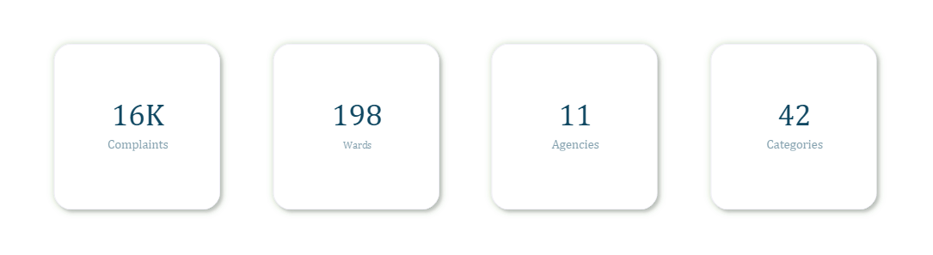
Figure 1. Dataset overview.
Before analysis, the raw dataset was cleaned to address duplicate entries (consistent with a system level glitch rather than genuine duplicate filings by citizens), missing civic agency assignments (filled as “Not Assigned” after cross filling from category title where present, since a small number of these complaints were resolved through local contact rather than formal agency routing), and missing ward, category, and subcategory titles, which were recovered by cross filling from their corresponding numeric identifiers elsewhere in the dataset. Identifiers referring to the same agency, category, or subcategory under different titles (for example, abbreviated versus full agency names) were standardized to a single consistent label.
Six metrics anchor the analysis throughout this report:
- Acceptance rate: the share of complaints that received any form of resolution attempt (Resolved, On the Job, Rejected, Closed, or Re opened), as opposed to remaining entirely untouched (Open).
- Resolution rate: the share of all complaints that were marked Resolved.
- Effective resolution rate: Resolved divided by (Total minus Open), measuring resolution success among all accepted complaints, including those still actively being worked (On the Job).
- Ignorance rate: The share of complaints marked Rejected or Closed, treated in this analysis as ignored. This is a simplifying assumption, as complaints may also be closed or rejected for legitimate reasons, such as insufficient information, triviality, or infeasibility of the requested action.
- Re opening rate: the share of complaints that were subsequently reopened.
- Comments per complaint (CPC): the average number of follow up comments logged against a complaint, used as a rough proxy for citizen engagement.
Complaints with a status of Open are treated as registered system entries and are retained in aggregate denominators throughout this report. Because the dataset has no per complaint extraction cutoff recorded there is no way to verify if the complaints are in process or being deliberately left unresolved to avoid a worse-looking status like Closed or Ignored

2. Temporal Trends
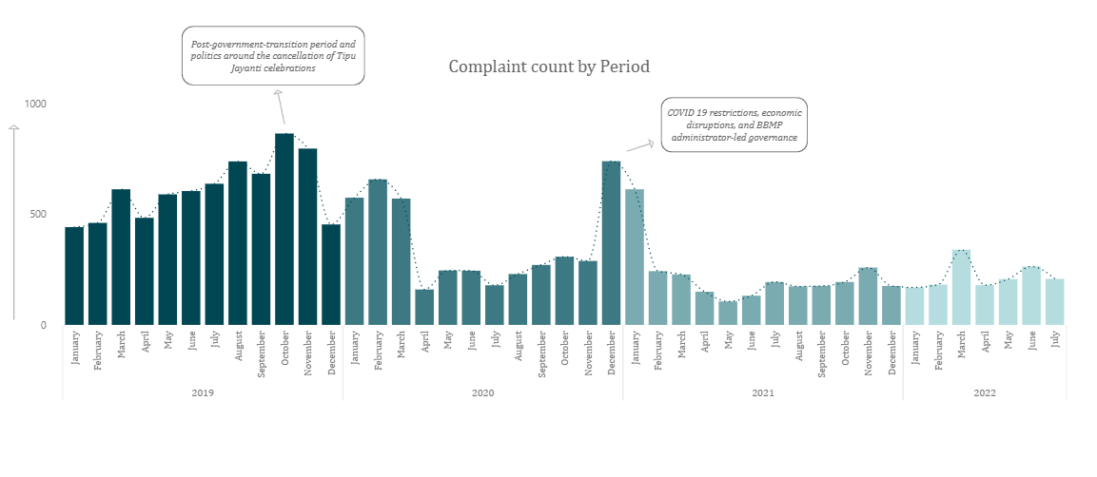
Figure 2. Complaint volume by year and month, 2019 to 2022.
2019 recorded the highest complaint volume in the dataset (7,371 complaints, 45.96% of all records), while 2022 recorded the lowest (1,550 complaints, 9.66%), though 2022's lower share is partly attributable to the dataset ending in July of that year rather than running a full calendar year.
Elevated complaint levels from January 2019 through March 2020 coincide with a cluster of civic and political events: the 2019 Lok Sabha elections, Karnataka's political crisis and government transition, anti CAA/NRC protests, and the early emergence of COVID 19, all of which plausibly increased public gatherings, traffic disruption, and citizen interaction with civic authorities. The peaks in October 2019 (865 complaints) and November 2019 (797 complaints) align with the post transition period and the public controversy surrounding the cancellation of state sponsored Tipu Jayanti celebrations. The December 2020 spike (740 complaints) coincides with ongoing COVID 19 restrictions, economic disruption, and a period of BBMP administrator led governance in the absence of an elected council.
These are observed temporal coincidences, not demonstrated causes. No claim is made that any single event directly drove complaint volume; the alignment is presented as plausible contributing context rather than an established mechanism. Similarly, the 2020 decline may partly reflect reduced citizen willingness to engage with authorities during COVID 19 restrictions, rather than a genuine drop in underlying civic issues.

3. Ward Level Analysis
An initial threshold of 100 or more registered complaints was proposed to exclude wards too small for reliable comparison, on the reasoning that wards with larger areas or populations naturally receive more complaints regardless of underlying service quality. Comparing four complaint volume cohorts (under 50, 50 to 100, 100 to 300, and over 300) showed only marginal differences in average metrics across cohorts, which did not support this cutoff at the cohort level. Individual wards, however, told a different story: Gurappanpalya showed an 82% resolution rate from only 29 complaints, and Padarayanapura showed a 50% resolution rate from only 2 complaints, both consistent with small sample instability rather than genuine performance. The “100 complaint” threshold was therefore retained for individual ward comparisons, even though cohort level averages did not show the same sensitivity. Hereafter, these are referred to as the qualified wards.
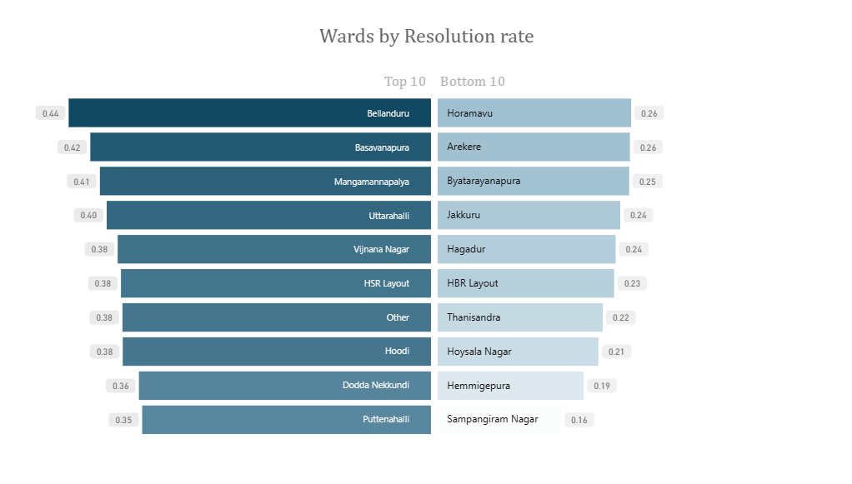
Figure 3. Wards by resolution rate, top 10 and bottom 10 (100 or more complaints).
Bellanduru with the highest complaint resolution rate (44.43%), second highest complaint acceptance rate (57.5%) and the most no. of complaints received (727) has displayed elite efficiency in grievance redressal and civic engagement. Hagadur has an acceptance of 43.88% and yet has an ignorance rate of 2.95% which is two times the median value, and also below average in other metrics (resolution rate: 23.63% and effective resolution: 53.85%) indicates a consistent and clear underperformance.

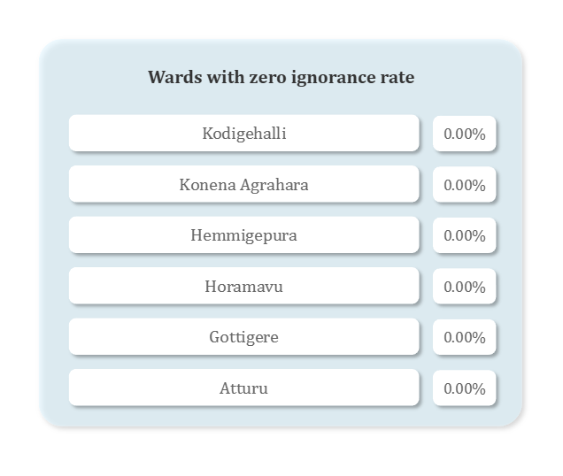
Figure 4. Wards with zero ignorance rate (100 or more complaints).
Kodigehalli, Konena Agrahara, Hemmigepura, Horamavu, Gottigere, and Atturu each recorded a 0% ignorance rate despite receiving over 100 complaints. Horamavu stands out in particular, handling 506 complaints without a single Rejected or Closed outcome.
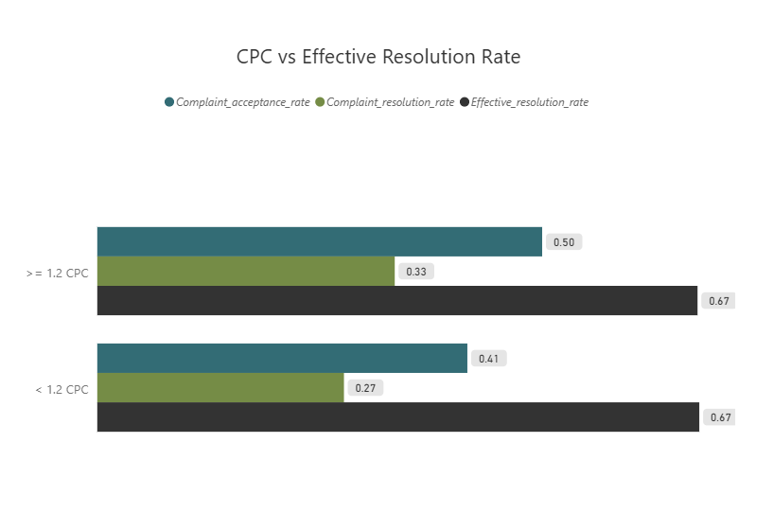
Figure 5. Comments per complaint (CPC) against acceptance, resolution, and effective resolution rate.
Wards with a CPC of 1.2 or higher show a higher acceptance rate (49.53% versus 41.21%) and resolution rate (33.12% versus 27.47%) than wards below that threshold, but a nearly identical effective resolution rate (~67% in both cohorts). This pattern suggests that comment activity is associated with whether a complaint gets acknowledged and worked on, rather than with the quality of the outcome once a decision is reached.
A few additional ward level patterns are worth noting. BBMP accounted for more than 70% of complaints in every qualified ward examined except two (Uttarahalli and Shantala Nagar), consistent with its role as Bangalore's primary municipal body; no other agency crossed this threshold in any ward. Other noteable concentrations are, Uttarahalli with 30.31% of complaints registered with BTC, Vidyaranyapura with 14.42% of their complaints registered with BWSSB, Basavanapura with 8.23% of their complaints registered with KSPCB and Vijnana Nagar with about 6.78% of their complaints registered with BESCOM.
Re opened complaints clustered notably in February, March, and June of 2019, though no clear citywide explanation was found for this pattern overall. Within Sir C V Raman Nagar (highest re opening rate with 7.48%) specifically, 82% of the ward’s reopened complaints in June 2019 plausibly coincides with a World Environment Day awareness event held in the ward that month.
Separately, six wards showed unusually high complaint concentration within a single month (over 13% of their total volume, the 90th percentile of this measure): Bilekahalli, Sampangiram Nagar, and Hoysala Nagar in December 2020 (consistent with the citywide COVID era spike), Vasanth Nagar in October 2019 (the post transition period), Kodegahalli in March 2020 (a period of political instability), and Sir C V Raman Nagar in June 2019 (World Environment Day).

4. Agency Level Analysis
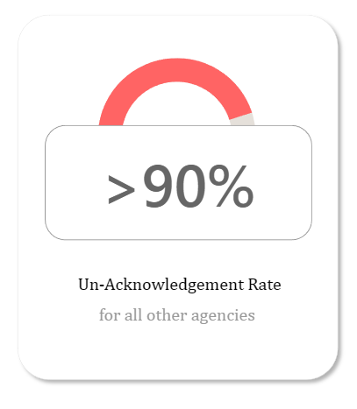
Figure 6. Un acknowledgement rate across all agencies other than BBMP and BTC.
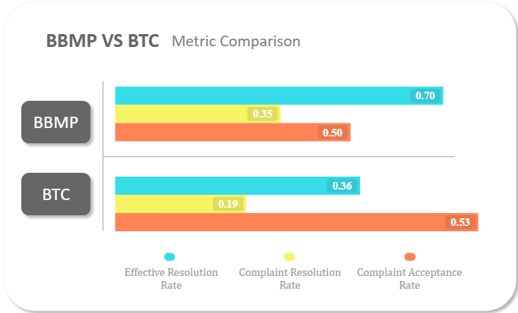
Figure 7. BBMP versus BTC, metric comparison.
Among agencies receiving more than 100 complaints, only BBMP and BTC reached acceptance rates worth comparing; every other agency left over 90% of assigned complaints unacknowledged. BBMP recorded a 50.40% acceptance rate, a 35.41% resolution rate, and a 70.25% effective resolution rate. BTC recorded a similar 53.45% acceptance rate, but only a 19.27% resolution rate, a 36.05% effective resolution rate and a massive 33.38% ignorance rate.
BBMP's scale and category breadth are expected given its role as Bangalore's primary municipal body, yet it maintains a 70.25% effective resolution rate despite operating at a far larger scale than any other agency in the dataset. BTC's similar acceptance rate alongside a much lower effective resolution rate points toward a difference in what happens after a complaint is accepted, rather than a difference in willingness to accept complaints in the first place, However, subsequent sub category analysis indicates that BTC’s (whose complaints fall entirely under Traffic and Road Safety category) lower resolution rate is largely driven by parking-related subcategories whose evidence verification requirements and time sensitive nature may plausibly explain the observed contrast, they are detailed in the sub category analysis.

5. Category Level Analysis
Only categories with 100 or more registered complaints, 17 of the 43 total categories in the cleaned dataset, were carried forward for comparison, following the same small sample reasoning applied at the ward and agency levels.
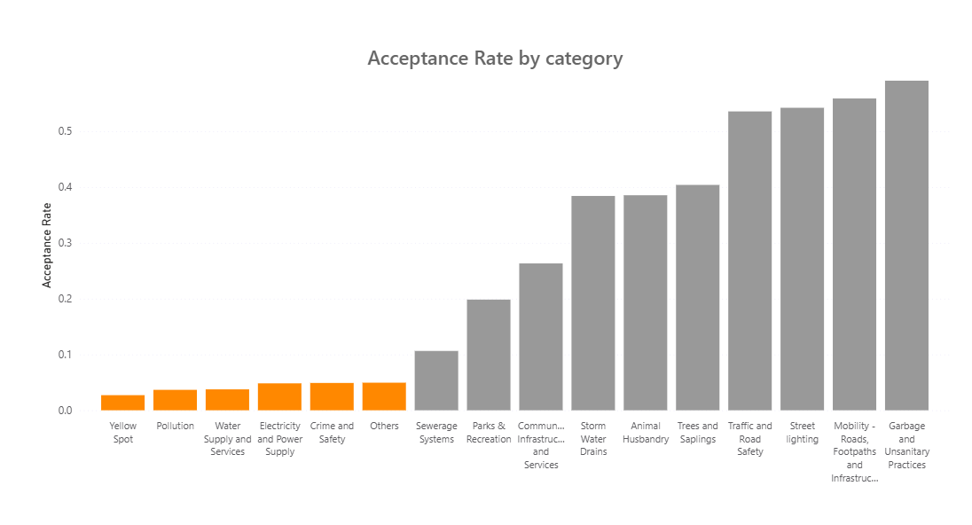–
Figure 8. Acceptance rate by category, ascending (100 or more complaints).
Six of the sixteen compared categories recorded an acceptance rate at or below roughly 5%: Yellow Spot (about 3%), Pollution (about 4%), Water Supply and Services (about 4%), Electricity and Power Supply (about 5%), Crime and Safety (about 5%), and Others (about 5%). For all seven, well over 95% of complaints in the category were not acknowledged at the dataset cut off date. Because the dataset has a fixed cutoff date, the 'Open' status is inherently ambiguous. It may indicate complaints that were genuinely still under processing at the time of data extraction, or, in some cases, complaints that remained unresolved and continued to be reported as 'Open' rather than being updated to a less favourable status. Therefore, before proposing any interventions, this analysis requires a complaint age at cutoff to differentiate genuine processing delays from potentially prolonged unresolved cases.

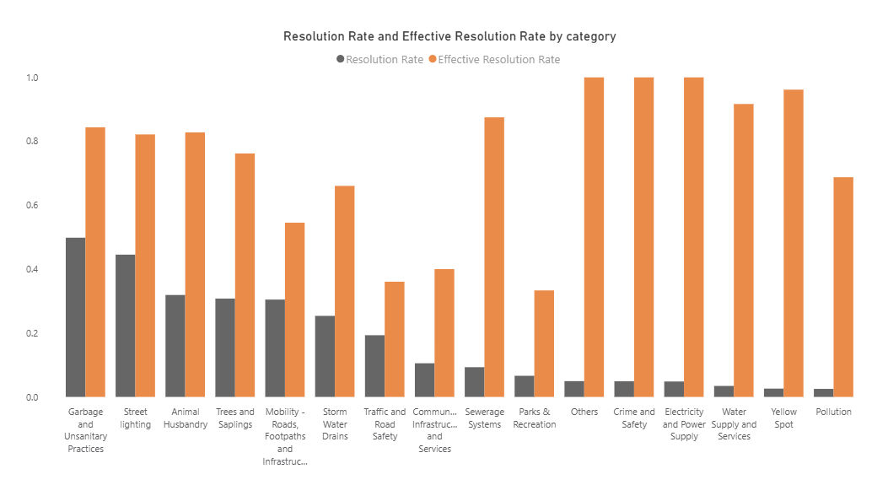
Figure 9. Resolution rate and effective resolution rate by category.
Garbage and Unsanitary Practices recorded the highest resolution rate (about 49.83%) among compared categories, alongside an 84.37% effective resolution rate, the strongest combination of volume (3,933 complaints) and outcome quality in the dataset. Street lighting follows closely, with a 44.52% resolution rate, an 82.14% effective resolution rate, and a 0% ignorance rate across 1,498 complaints. Traffic and Road Safety shows the weakest handling among high volume categories: more than half of its complaints were accepted (53.55%), but only 19.31% were ultimately resolved, a 36.05% effective resolution rate, while 33.44% fell into the ignored category.
Several of the low acceptance categories identified above (Others, Crime and Safety, Electricity and Power Supply, Water Supply and Services, Yellow Spot, Pollution) show effective resolution rates near or at 90 to 100% in the chart above. This reflects how few complaints in these categories were ever decided, not strong performance; with so few accepted complaints in the denominator, a small number of resolved cases produces a high rate. The same caution recurs in the subcategory section below.
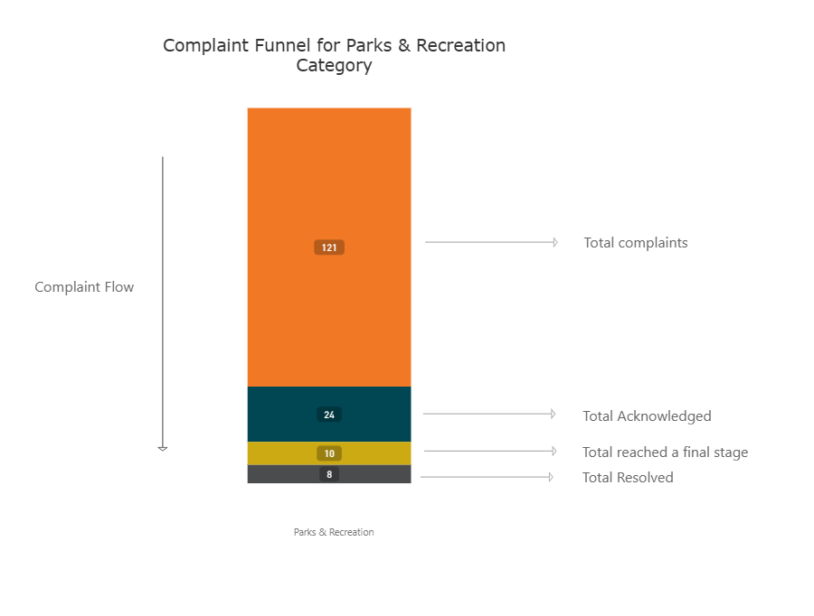
Figure 10. Complaint funnel for Parks & Recreation.
Of 121 total complaints in the Parks & Recreation category, only 24 (about 20%) were acknowledged at the cut off date, 14 of which remained On the Job at the time of data extraction. Of the 10 that reached a final outcome, 8 were resolved and 2 were re opened. The category's low resolution rate (6.6% of all complaints) is therefore driven almost entirely by the 97 complaints that were not acknowledged at the cut off date, not by complaints that were worked on and failed. Aggregate resolution rate alone does not distinguish between a complaint that was never picked up and one that was picked up and not resolved; for categories with low acceptance, this means resolution rate understates how much of the apparent underperformance is upstream acceptance, rather than downstream resolution capability. Effective resolution rate here is 8 divided by 24 (Resolved over Accepted), about 33%, roughly five times the 6.6% headline figure. As a separate spot check, restricting the denominator further to only the 10 complaints that had already reached a final Resolved, Rejected, or Closed outcome (excluding the 14 still On the Job) gives a decided outcome rate of 80%. This is a narrower, secondary check on how the cases that have actually concluded look, not a substitute for the standard effective resolution rate used elsewhere in this report, and the gap between the two figures here reflects how many cases in this category are still open ended rather than finished.
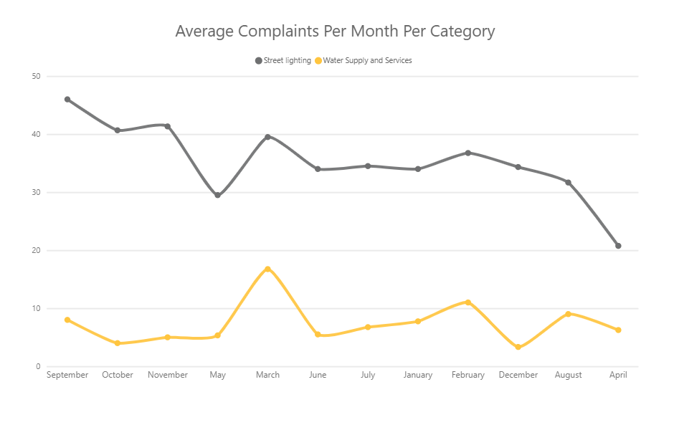
Figure 11. Average complaints per month, Street lighting and Water Supply and Services.
Because the dataset runs from January 2019 through July 2022, January through July each have one additional year of data (four years) compared to August through December (three years). The monthly figures above are computed as average complaints per month across however many years actually contributed to that month, rather than raw summed counts, to avoid months with more contributing years appearing artificially elevated.
Street lighting shows a clear monsoon season pattern, peaking in September (about 46 complaints per month on average) and falling to its lowest point in the post monsoon month of April (about 21), while maintaining an 82.14% effective resolution rate and a 0% ignorance rate year round, suggesting consistent handling regardless of seasonal demand. Water Supply and Services shows a separate seasonal pattern, peaking in March (about 17) and February (about 11), consistent with Bangalore's pre monsoon period when groundwater levels decline and demand rises with rising temperatures.
Electricity and Power Supply shows a complaint spike in May (10%), consistent with Bangalore's 2019 thunderstorm season and typical pre monsoon weather disruptions; however, a separate spike in November has no identifiable seasonal or external cause and is noted as unexplained. Parks and Recreation also exhibits elevated complaint volumes in February (9.5%) and March (11%), likely driven by a combination of factors — increased civilian park usage during favourable weather, civic agencies accelerating maintenance ahead of fiscal year-end, and possible overlap with the same pre formonsoon conditions affecting other categories. Sewerage Systems shows a comparable March spike (12.25%), but unlike Water Supply and Parks & Recreation, this does not align with a clear seasonal driver and is similarly flagged as unexplained.

6. Subcategory Level Analysis
Subcategories were examined within categories that had at least 100 total complaints and a non negligible acceptance rate, using a lower complaint count threshold of 30 rather than the 100 used at the category and ward level, since subcategory volumes are unevenly distributed within a category and a 100 complaint cutoff would exclude nearly all subcategories from comparison. Even at this threshold, individual rates were still checked against their underlying accepted count before being reported, since the 30 complaint floor governs total volume, not the number of decided cases a rate is actually calculated from.
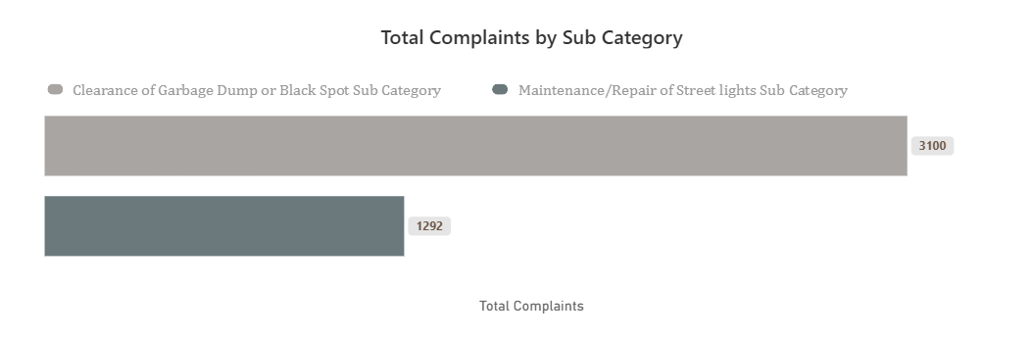
Figure 12. Total complaints by subcategory, Garbage and Street lighting.
Garbage and Unsanitary Practices is dominated by a single subcategory, Clearance of Garbage Dump or Black Spot, which accounts for 3,100 of the category's 3,933 complaints. Street lighting is similarly concentrated, with Maintenance/Repair of Streetlights accounting for 1,292 of 1,498 complaints and an 84.05% effective resolution rate within that subcategory.
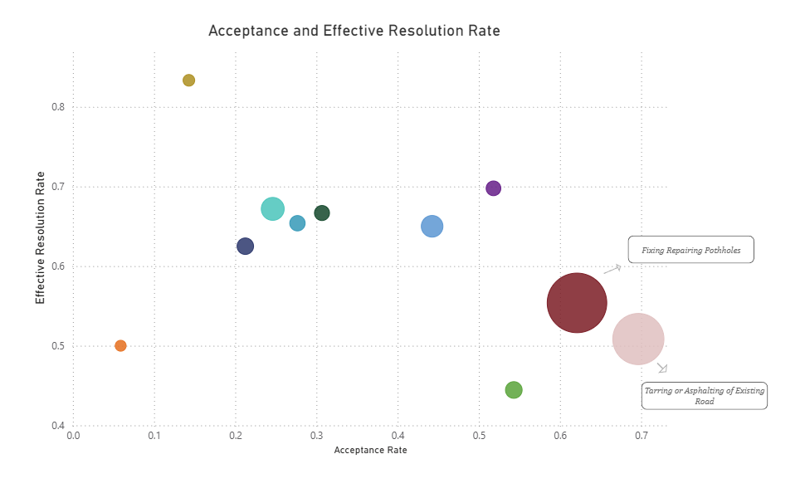
Figure 13. Acceptance rate against effective resolution rate by eligible subcategories of, “Mobility - Roads, Footpaths and Infrastructure” Category.
Across the eleven subcategories in Mobility - Roads, Footpaths and Infrastructure category, acceptance rate shows a moderate negative association with effective resolution rate (the two measures move in roughly opposite directions, though not strictly). The two highest acceptance subcategories, Tarring or Asphalting of Existing Road and Fixing/Repairing Potholes, also carry two of the lower effective resolution rates (50.84% and 55.83%). This pattern is not explained by complaint volume; the category's smallest subcategories span both the highest and one of the lowest effective resolution rates observed. What drives the relationship between acceptance and outcome quality here remains unclear from the available data.
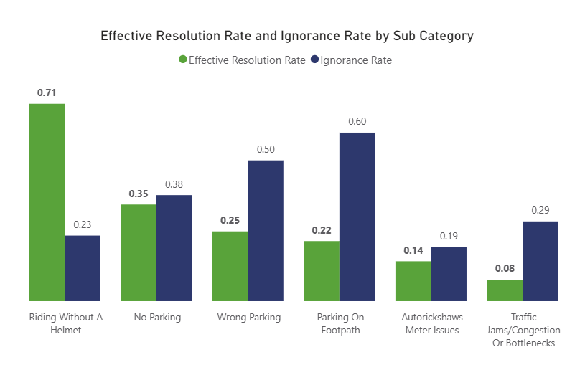
Figure 14. Effective resolution rate and ignorance rate by subcategory, Traffic and Road Safety.
Riding Without a Helmet stands out within Traffic and Road Safety which is the only category under BTC with a 71% effective resolution rate against an 83% acceptance rate, well above the category average. By contrast, Wrong Parking and Parking on Footpath show ignorance rates of 50.44% and 60.40% respectively, despite comparable acceptance rates (70.8% and 78.22%), and these two subcategories primarily account for the category's overall 33.44% ignorance rate. But complaints related to wrong parking and parking on footpaths often rely on sufficient evidence, such as clear photographs, timestamps, or identifiable vehicle details, for enforcement action. Where evidence is incomplete or inconclusive, authorities may be unable to verify the violation, particularly if the vehicle is no longer present for physical verification. This reliance on verifiable evidence, combined with the time sensitive nature of these violations, may contribute to comparatively higher ignorance rates or lower resolution rates in these categories. This could partially explain BTC’s lower resolution rate (19.27%)
Two further patterns are worth noting without separate charts. Within Animal Husbandry, one subcategory accounts for 770 of 801 complaints, meaning the category's overall metrics are effectively defined by a single subcategory's performance. Community Infrastructure and Services has two meaningful subcategories with a fairly even split: one carries 44% of complaints with a 72.72% effective resolution rate, the other carries the remainder with a 15% effective resolution rate, and together they produce the category's blended 40% effective resolution rate.

7. Complaint Tone and Resolution Outcomes
Complaints were flagged as Urgent or Frustrated based on the presence of predefined keywords in their title or description; a complaint could carry both flags, or neither. This is a coarse proxy for tone, not a validated sentiment classification, and does not account for context, sarcasm, or phrasing outside the keyword list.
Considered as two way comparisons, complaints flagged Frustrated showed a resolution rate of 33.10% (versus 30.23% for non Frustrated complaints) and an effective resolution rate of 70.5% (versus 67.5%). Complaints flagged Urgent showed the opposite direction: a resolution rate of 28.96% (versus 31.31% for non Urgent complaints) and an effective resolution rate of 63.8% (versus 69.4%).
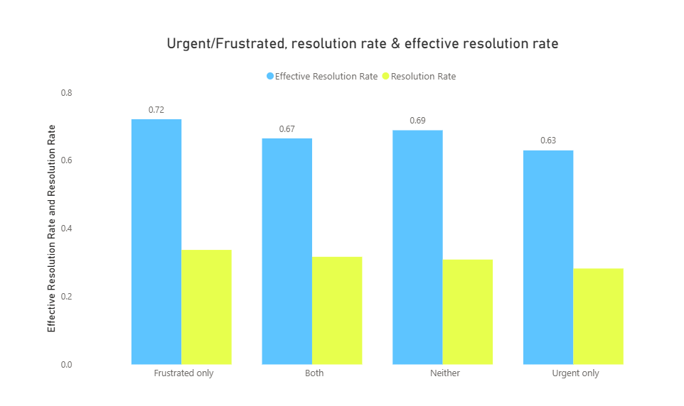
Figure 15. Resolution rate and effective resolution rate by tone combination.
Breaking the two tags into all four combinations (Neither, n = 10,140; Urgent only, n = 3,157; Frustrated only, n = 1,905; Both, n = 840) shows the same direction holding consistently: Frustrated only complaints show the highest effective resolution rate (about 72%) and resolution rate (about 34%) of the four groups, while Urgent only complaints show the lowest of both (about 63% and 28%). Neither and Both sit in between (about 69%/30% and 67%/31% respectively). Because this direction holds even when both tags are present together, the pattern does not appear to be an artifact of one tag riding along with the other.
No causal claim is made here. It is unclear whether frustration coded language reflects complaints that were already further along in the resolution process, and so more likely to express dissatisfaction with delay, or whether such language itself influences how a complaint is handled. All four group sizes are large enough that small sample concerns, of the kind raised elsewhere in this report, do not apply here.

8. Summary of Findings

- Acceptance, not resolution, is the primary bottleneck for a meaningful share of categories: six of sixteen compared categories accept roughly 3% to 5% of their complaints, leaving the large majority of complaints in those categories with no recorded outcome at all.
- Parks & Recreation illustrates this directly: an apparent 6.6% resolution rate corresponds to a 33.33% effective resolution rate, once the categories near total lack of acceptance is accounted for separately.
- Performance varies meaningfully within categories. Mobility's highest acceptance subcategories show the lowest effective resolution rates, and within Traffic and Road Safety, helmet related complaints are handled far more effectively than parking related complaints.
- BBMP, as the dominant agency by volume, maintains a notably higher effective resolution rate (70.25%) than the next most active agency, BTC (36.05%), despite similar acceptance rates between the two.
- Complaint volume tracks observable civic and political context, elections, COVID 19, and government transition, closely enough to suggest these events are plausible contributors to demand, though this association is not established as causal.
- Citizen engagement, measured through comments per complaint, is associated with whether a complaint is acknowledged and resolved, but not with how successful that resolution is once a decision is reached.

